Alpine Space
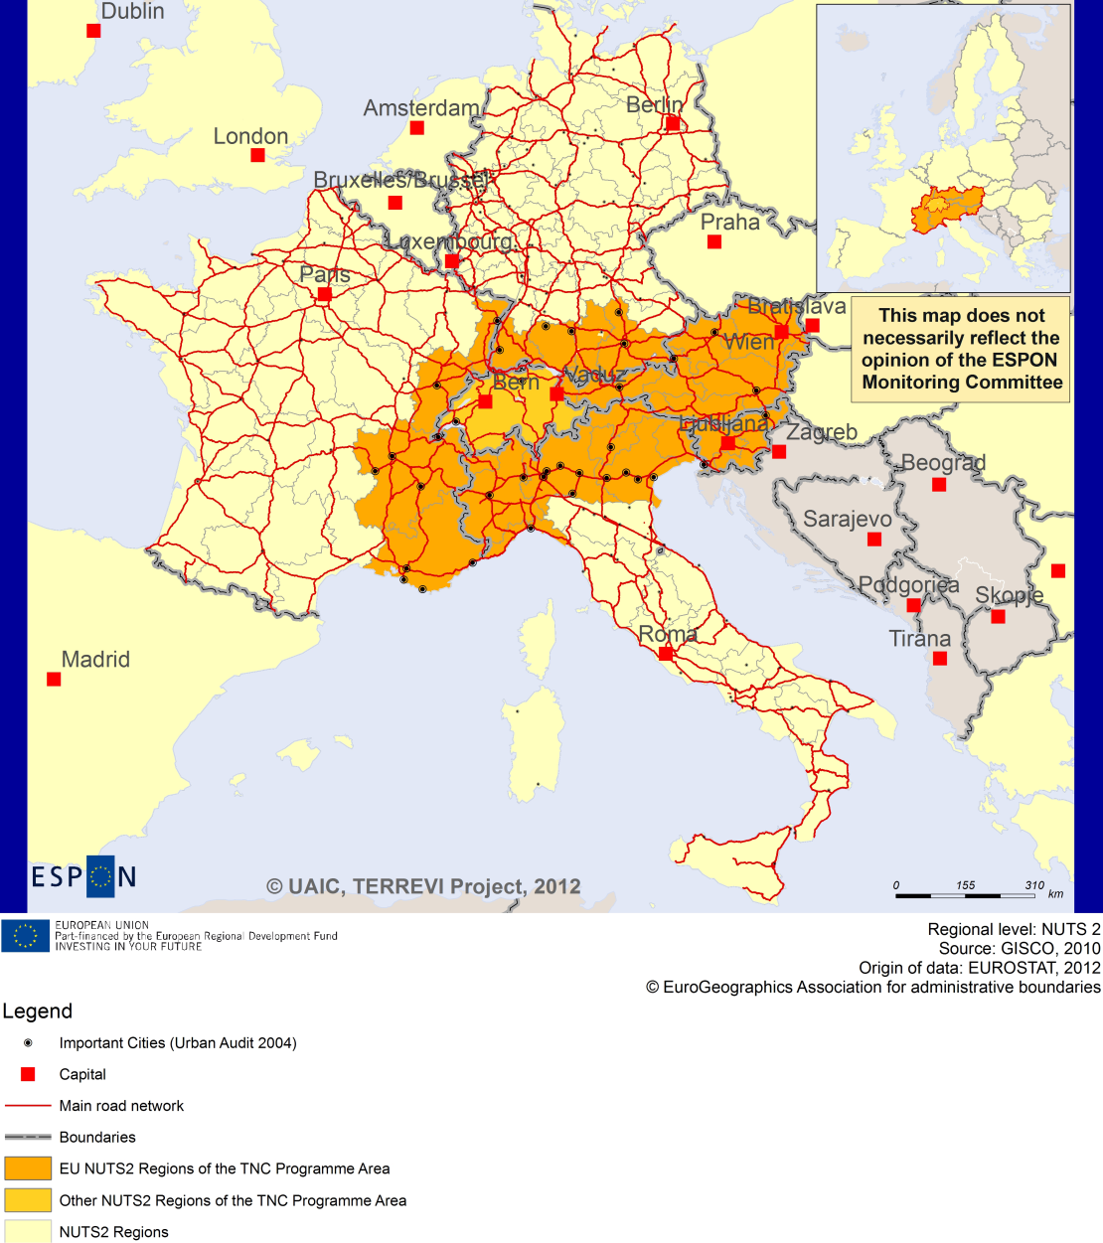

ESPON Project TERREVI
November 2012

Introduction
ESPON supports policy development in relation to the aim of territorial cohesion and a harmonious development of the European territory. It provides comparable information, evidence, analysis, and scenarios on territorial dynamics, which reveal territorial capitals and development potentials of regions and larger territories. Considering the programme area in its European context adds an important new perspective that can help shaping the programming and the places of implementing projects.
The ESPON TERREVI project focuses on producing evidence for Structural Funds programmes with the aim to support the development of the programmes to be carried out in the 2014-2020 period.
One milestone of this work consists in presenting selected ESPON research pieces in easy-to-understand factsheets for all territorial cooperation programme areas. The aim is to provide the reader with preliminary insight on types of territorial evidence ESPON holds at hand with regard to the possible investment priorities of future programmes. The factsheets certainly only give a first glimpse rather than fully present the work of the large number of ESPON projects that are currently underway. Likewise, each programme area includes diverse development potentials and challenges, which needs targeted information search. However, hopefully this factsheet will contain information, benchmarking the programme area in its larger, territorial context, that is of interest and help to better understand the programme area and to navigate within the richness of ESPON material available.
In addition to the programme factsheets there will be a number of specific programme case studies illustrating how ESPON material can be used to support the development of future programmes e.g. by giving a comparative European dimension to the envisaged SWOTs. These case studies will be carried out in early 2013
This factsheet is structured in three main parts. The first part presents a selection of indicators that help comparing the situation of the programme area in question with the European average, the average for all programme areas as well as the situation in the countries involved. The second part briefly presents the territorial factors of interest for the programme area. The final part offers guidance on the further use of ESPON results and tools. This is intended as an electronic publication so map quality is generally high to allow users to zoom into specific territories.
This factsheet does not necessarily reflect the opinion of the ESPON Monitoring Committee.

Europe 2020
Europe, with its member states and their regions, is more exposed to global shocks and international competition than at any time before. As the world becomes more interdependent this trend will continue and shape policy thinking across sectors, borders and geographical scales. At the same time, Europe is characterised by a large territorial diversity meaning that global developments can imply rather different development possibilities and challenges for different European regions and cities.
The differences are partly defined by major geographical structures such as urban systems, access and connectivity, the geographical specificity or population density. At the same time, the differences are also spelled out in the larger development trends that affect an area and the way and degree to which it is affected.
The data, indicators and territorial evidence provided by ESPON provides insight on both the main structures and larger territorial trends. The fine art is to identify what can actually be influenced by policy-making and, in particular, by place-based policy and territorial cooperation related to your programme area.
This chapter provides a selection of ESPON data related to Europe 2020 objectives of smart, sustainable and inclusive growth, giving also hints as regards the main thematic objectives envisaged in the draft regulations for the next period of EU Cohesion Policy. The Europe 2020 Strategy aims to enhance smart, sustainable and inclusive growth. This strategy has clear territorial dimensions. However, achieving these goals is challenging in the crisis-driven times. Furthermore, the economic disparities are growing as economic trends and the crisis have various impacts on different parts of Europe.
In the following the traffic light for each indicator represents how your programme territory compares to wider European medians where green = your programme area performs better for that indicator, yellow = similar, and red = worse.
The traffic lights below were created in order to graphically represent the situation of each analysed TNC Area compared to the one of the EU-27+4 space. The median value, calculated depending on the values registered for every NUTS 2/NUTS 3 region composing the programme area was used as the central value indicator. The median of the programme area was compared to the one computed for EU-27+4 territory.
EU 27+4 in traffic lights means the EU Member States as well as Iceland, Liechtenstein, Norway and Switzerland – the ESPON space.

Smart, Sustainable and Inclusive growth
Smart growth refers to developing an economy based on knowledge and innovation. In the framework of the Europe 2020 Strategy it means improving the EU's performance in education, research/innovation and digital society.
Sustainable growth refers to promoting a more resource efficient, greener and more competitive economy. Within the Europe 2020 Strategy it means e.g. building a more competitive low-carbon economy that makes efficient, sustainable use of resources, protecting the environment, reducing emissions and preventing biodiversity loss, capitalising on Europe's leadership in developing new green technologies and production methods, and introducing efficient smart electricity grids. In the framework of the Europe 2020 Strategy it means focus on competitiveness, resource efficiency, climate change and biodiversity.
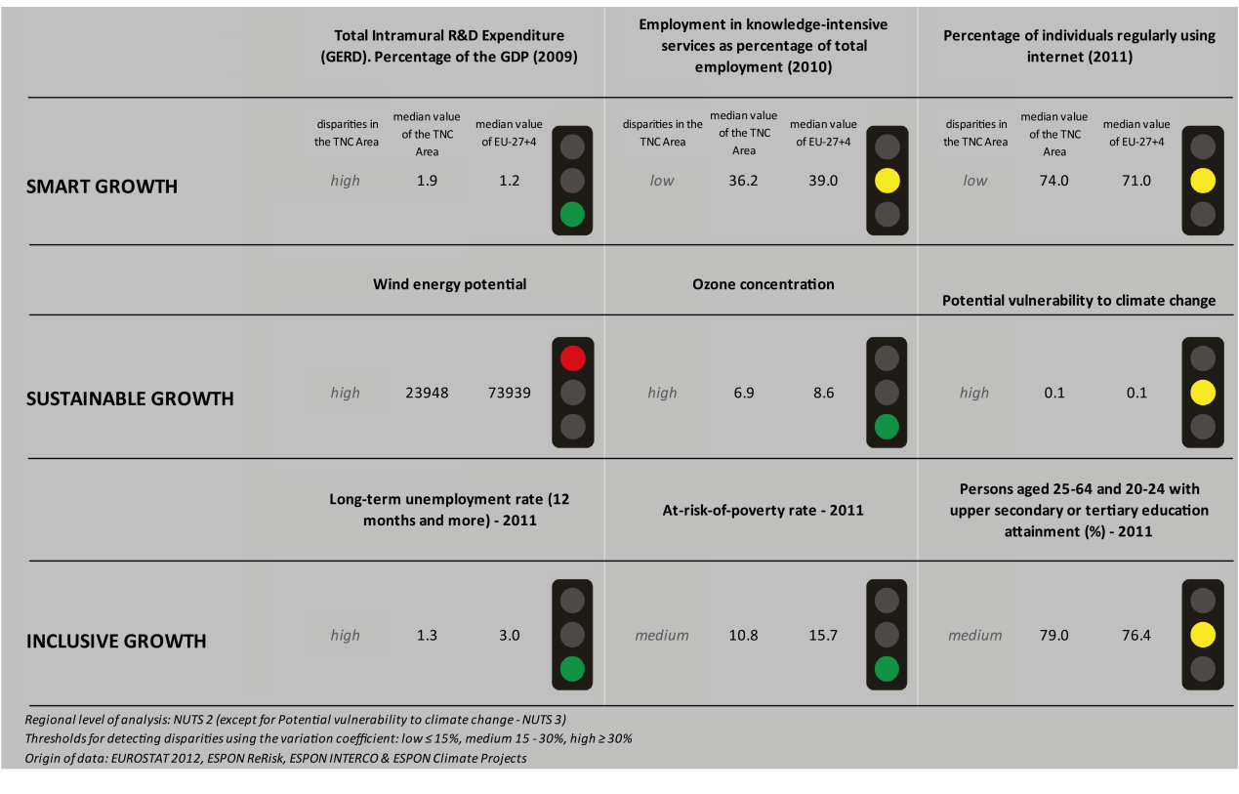
Inclusive growth refers to fostering a high-employment economy delivering social and territorial cohesion. Within the Europe 2020 Strategy it means raising Europe’s employment rate, helping people of all ages anticipate and manage change through investment in skills & training, modernising labour markets and welfare systems, and ensuring the benefits of growth reach all parts of the EU. In short the key factors are employment and avoiding risk of poverty and social exclusion.
Looking at the indicators for smart growth, the Alpine Space TNC area performs similarly to the EU27+4 (with regards to employment in knowledge-intensive services, and the number of persons regularly using the internet). With regards to R&D expenditure, the TNC area has positive values compared to the EU27+4 although it must be added that the disparities within the area are high.
Using the taxonomy of the KIT project, Map 1 shows a diversified and scattered situation in terms of patterns of innovation. In the centre of the Alpine Space area (south of Germany, Austria and Switzerland), many Nuts-2 regions of the TNC area are either rated as “applied science-“ or “European science-based” areas due to a high level of science-based local knowledge and a high degree of attractiveness of knowledge coming from other regions. The other regions are mainly qualified as smart and creative diversification areas or smart technological application areas. The eastern regions of the area are qualified as somewhat less advanced innovation areas.
The indicators for sustainable growth vary for the Alpine Space TNC area. The wind energy potential of the TNC area is lower than the potential of the EU27+4 and has a high level of diversity within the area. In terms of ozone concentration, the Alpine Space shows more positive values than the EU27+4; however the disparities within the area are high. The TNC area seems to be as vulnerable to climate change as the EU27+4 with high disparities across its regions.
The disparities within the Alpine Space TNC area are also striking when looking at Map 3 which highlights the adaptive capacity to climate change. The north of Italy and the eastern regions of the TNC area show lower capacity to adapt to climate change than the other regions.
The TNC area is generally not affected in terms of fossil fuel consumption by the Directive on the promotion of clean and energy-efficient road transport vehicles. The exceptions are a few regions in the north of Italy and the south of France which seem to witness a moderate positive impact and a few German regions which seem to experience minor impacts.

The Alpine Space area generally shows positive results in terms of inclusive growth. The long-term unemployment rate in the TNC area is lower than in the EU27+4. The at-risk-of-poverty rate is lower than in the EU27+4 and the share of persons aged 25-64 and 20-24 with upper secondary or tertiary education attainment is comparable to the rate of the EU27+4. Map 5 illustrates the diversity within the region with regards to the employment rates. Again, the regions at the centre of the TNC area (Germany, Austria and Luxembourg) experience higher employment rates than the outer regions within the Alpine Space area. In all four ESPON DEMIFER scenarios (Map 4), the north-eastern regions seem to experience more negative changes in labour market forces by 2050. Only in the scenarios “Growing social Europe” and “Expanding Market Europe” the changes in labour force seem to have positive outcomes also in Austria and the southern regions of Germany.
MAP 1 – Territorial Patterns of Innovation (ESPON KIT project) for the TNC Alpine Space

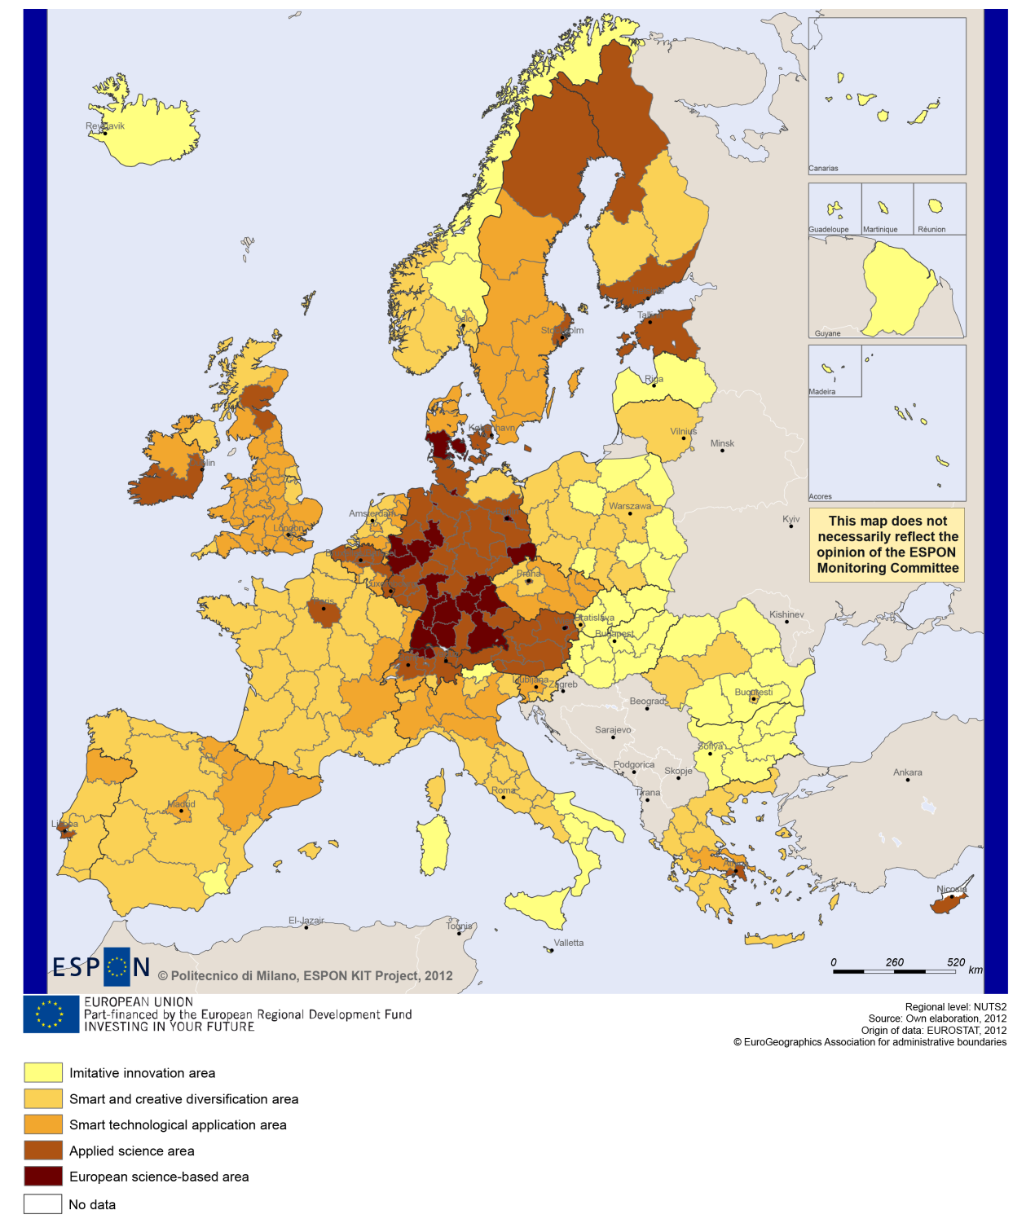

MAP 2 – Territorial impact on fossil fuel consumption of Directive on the promotion of clean and energy-efficient road transport vehicles (ESPON ARTS project) TNC Alpine Space

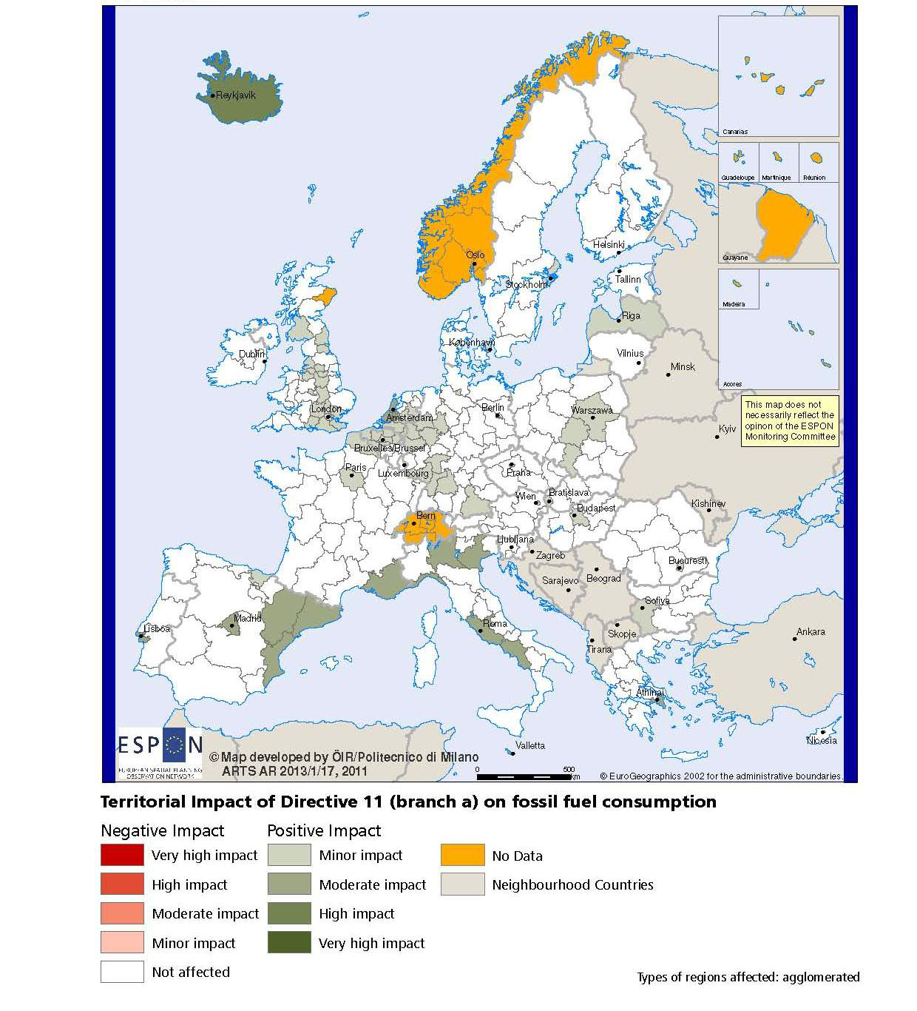

MAP 3 – Combined adaptive capacity to climate change (ESPON CLIMATE project) for the TNC Alpine Space
“Adaptive capacity (adaptability)” to climate change indicates the ability or potential of a system to respond successfully to climate change and variability, and includes adjustments in behaviour, resources and technologies.
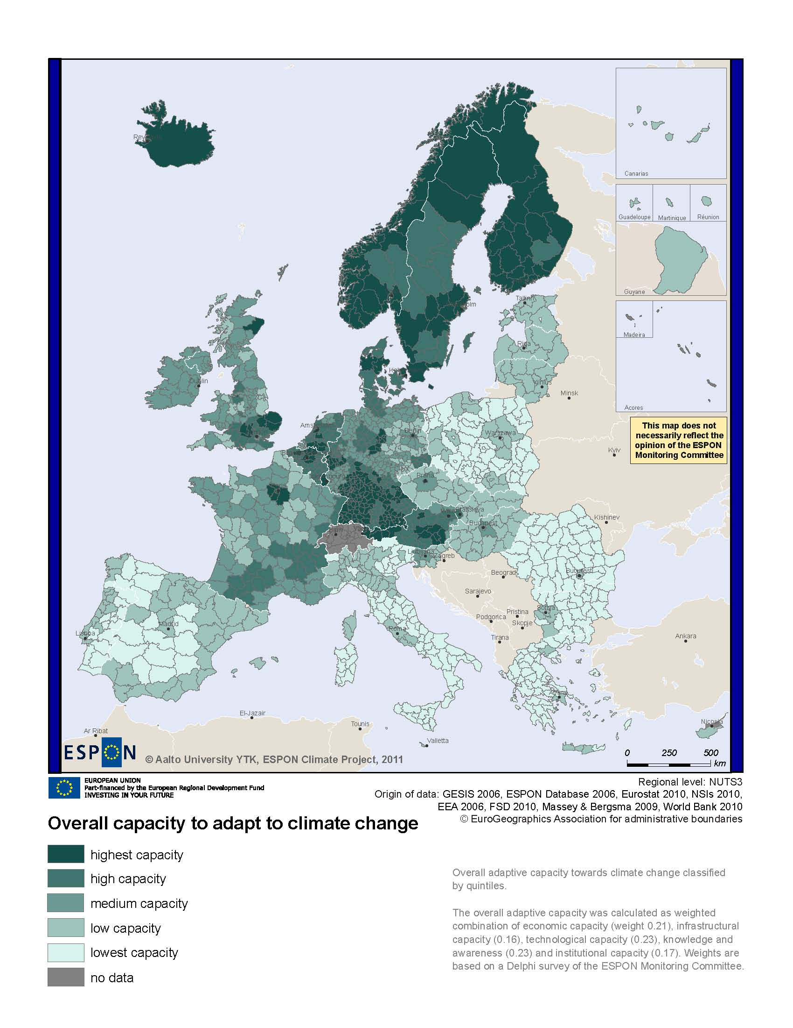

MAP 4 – Change in Labour Force 2005-2050 (ESPON DEMIFER project) for the TNC Alpine Space

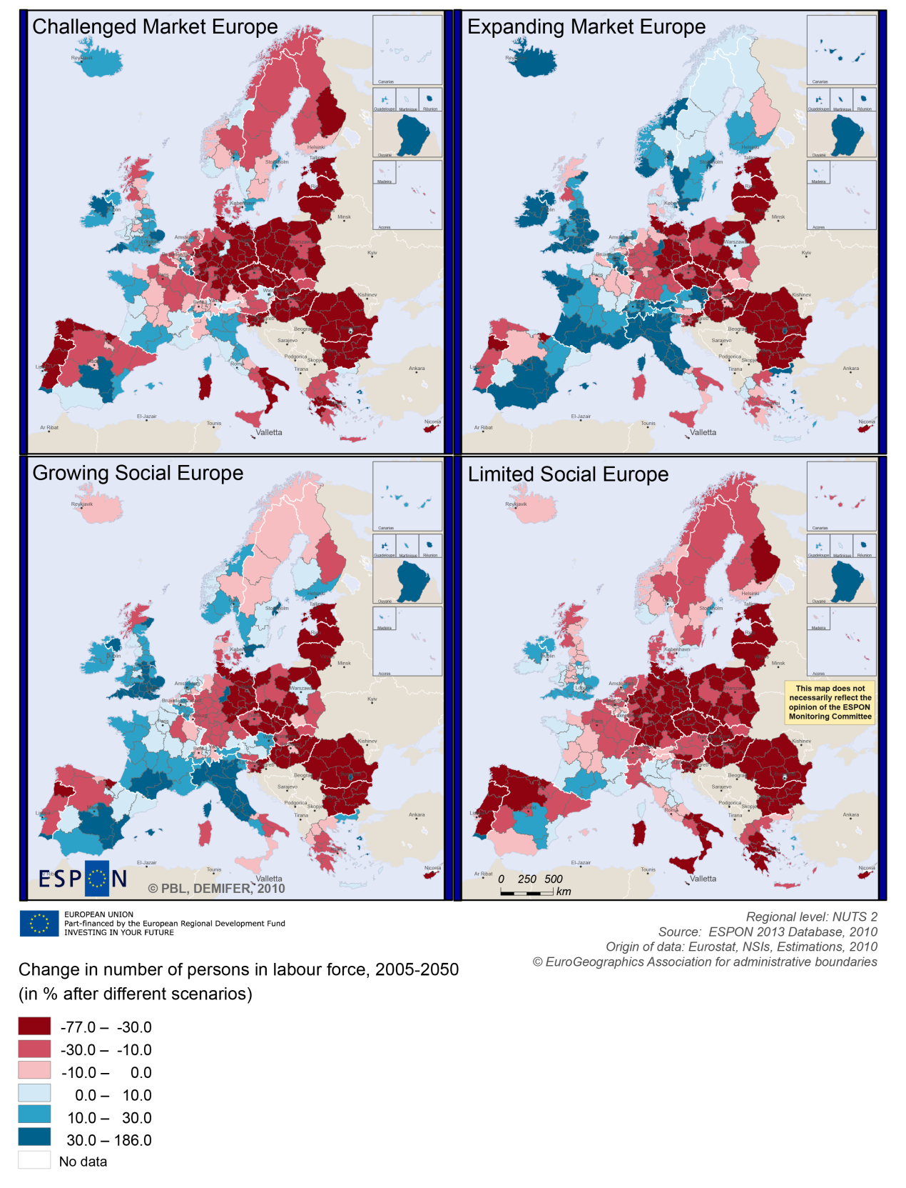

MAP 5 – Employment rate 2010 within the TNC Alpine Space

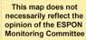
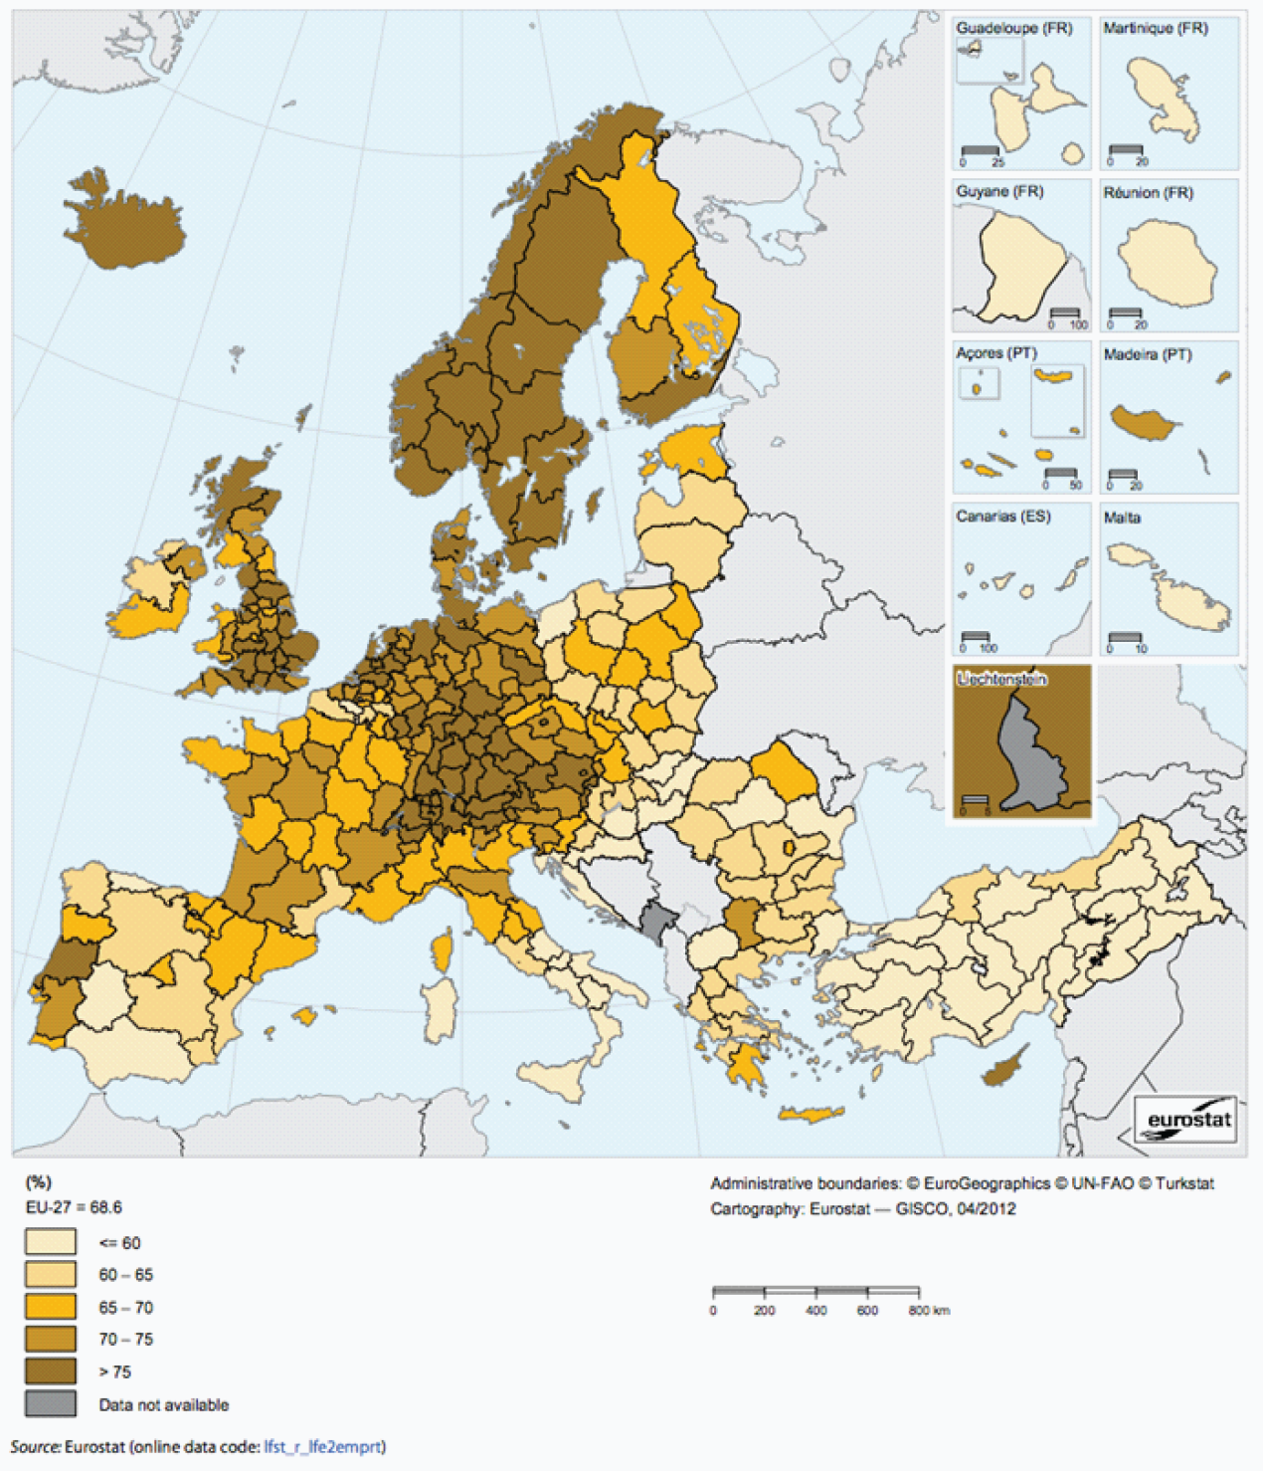

Territorial factors of interest for the programme area
Territorial cooperation programmes can make a difference for the future development of cross-border and transnational territories in Europe. Some of the factors can be analysed by European wide data sets and using some studies having specific maps, figures and tables concerning the areas of the cooperation region.
Besides a wide range of standard indicators frequently used in the context of European regional policies, ESPON has established various indicators which focus more on the territorial dimension. These indicators provide among others information on the development preconditions of an area. Two standard indicators in this field are rural-urban settings and accessibility.
The Alpine Space programme area comprises a number of the main metropolitan areas in Europe, which even play an important role in a worldwide perspective. Besides Milan, Munich, Vienna, Zurich, there are also Geneva, Torino, Genoa, Ljubljana, Bern, Lyon, Nice and Marseille. The map confirms the presence of both larger metropolitan areas and a number of smaller growth poles such as Grenoble, Salzburg, Maribor, Innsbruck, Trento, Bolzano and Klagenfurt.
However, urban areas are a minor part of the programme area, which is in a European perspective rather dominated by intermediate and rural areas and areas in close proximity to a city. Furthermore, there are a number of remote regions. The map illustrates also territorial differences within the programme area, basically showing a divide between urban centres and the less accessible parts of the Alpine Space.
Although the programme area is largely characterised by good accessibility, both in terms of multimodal accessibility and possibilities for one-day business trips, this is mainly limited to the metropolitan areas. Good accessibility is centred towards large urban agglomerations and major international airports or major train stations whereas other parts of the programme area have accessibility values below European average. Many remote regions of the programme area have considerably less favourable accessibility.
With regard to geographic specificities, the programme areas comprises in a European perspective, mainly the mountainous areas as well as the few areas which are considered as sparsely populated in a European perspective.
The mountainous character comes with advantages and challenges. Although it does not come with a specific economic structure, it appears that a significant proportion of mountain areas have high residential attractiveness. This is because of their environmental assets, and often also because of their social and cultural capital, including both history and the closely-knit communities found in small communities. Many mountain areas are also characterised by relatively high levels of biodiversity and protected areas. Furthermore, mountains are the water towers of Europe.

MAP 6 – Urban-rural typology of NUTS3 regions including remoteness (DG Regio) for the TNC Alpine Space

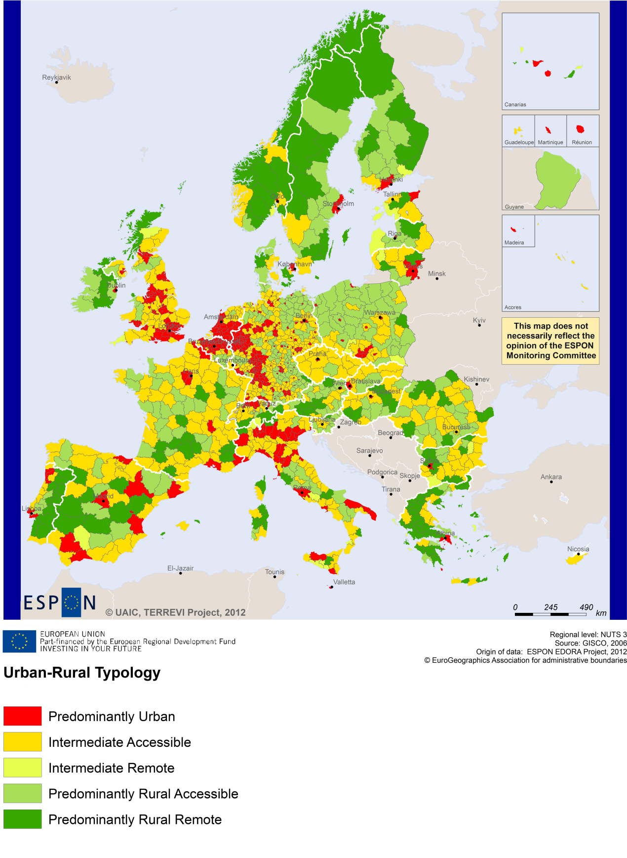

MAP 7 – Multimodal accessibilty (ESPON Accessibility Update) for the TNC Alpine Space
“Potential Accessibility Multimodal” scores accessibility of NUTS 3 regions by road, rail and air relative to the European average in an Accessibility Index.
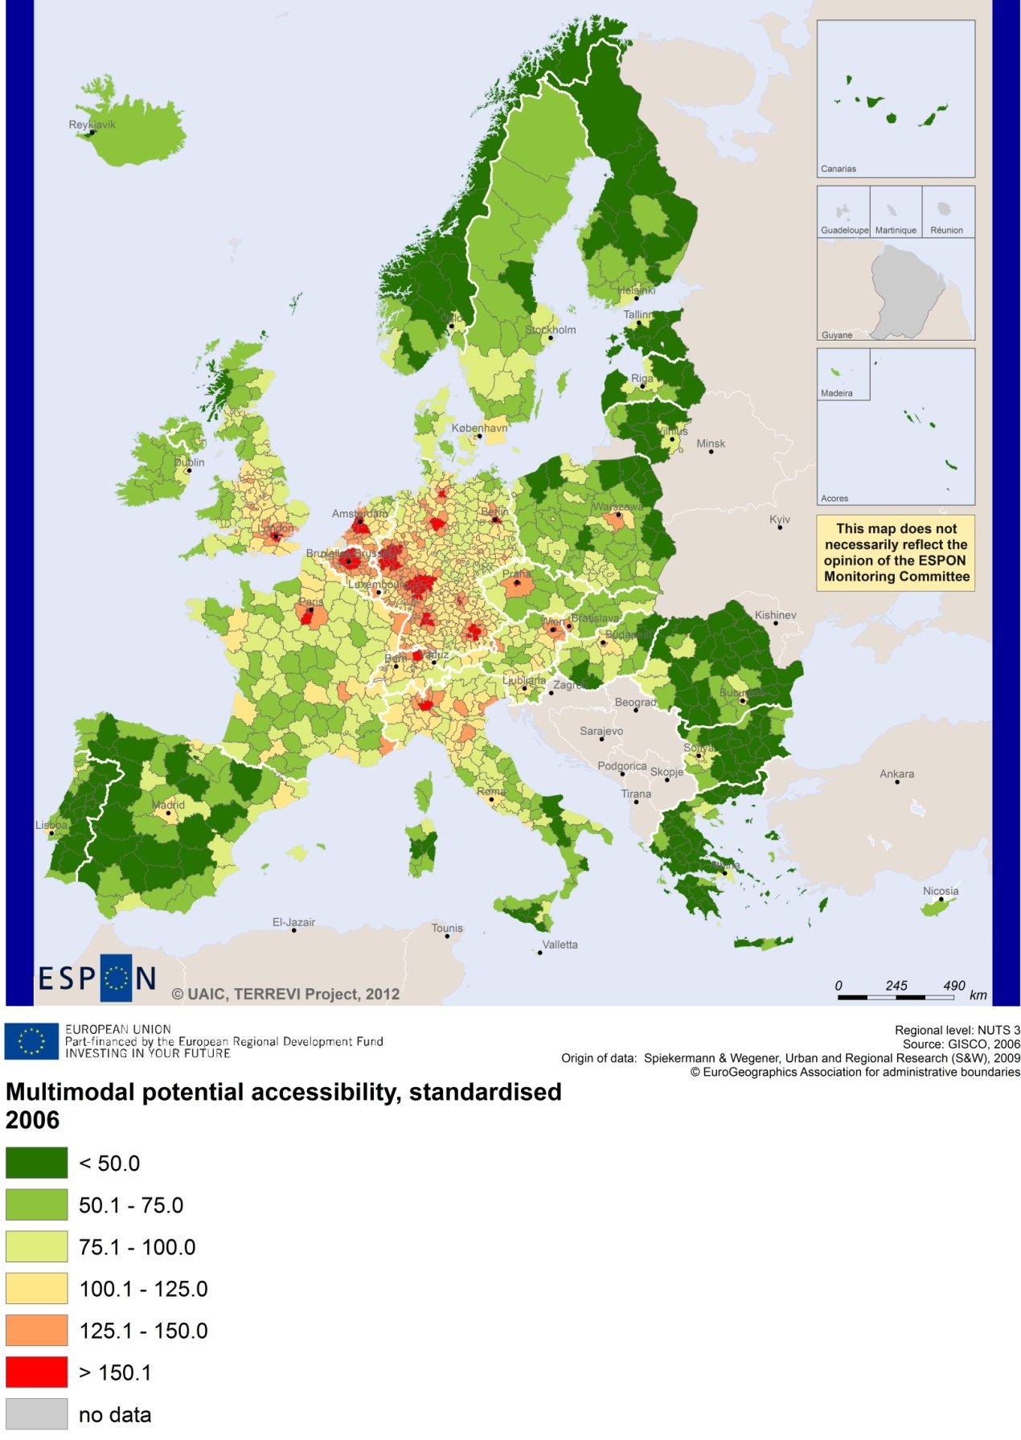

Recommended ESPON reading
ESPON provides an essential underpinning for translating into practice the calls for integrated and place-based approaches to economic development, when analysing a programme area or deciding about future programme priorities. ESPON has published a wide range of exciting reports providing valuable territorial evidence for future territorial cooperation initiatives.
The table below shows examples of relevant projects for the Cooperation Region. However, you have to study other ESPON reports as well in order to capitalise fully on the European information available for the transnational programming.
ESPON study | Topic | Content
CLIMATE | Climate change | It analyses how and to which degree climate change will impact on the competitiveness and cohesion of European regions and Europe as a whole. This study analysis Alpine space as a case study (see Annex 1 of the Final Report), including a survey on the adaptive capacity in the Alps.
SGPTD | Growth poles | It provides evidence on European secondary cities, their performance and functional roles in different parts of Europe, and the potential policy intervention affecting their performance (see from figure 2 to 2.12).The case studies include Munich and Turin (annex of the Scientific Report).
ATTREG | Attractiveness | It provides a better understanding of the contribution of European regions’ and cities’ attractiveness to economic performance and it identifies the key ingredients of attractiveness in different types of territories. The case studies include the region of Trento (see Annex 4/8) and Slovenia (see Annex 4/7).
GEOSPECS | Specific types of territories | It provides evidence on the strength, weaknesses and development opportunities of specific types of territories and regions incl. mountain areas. The case studies include the Jura massif (Annex 25 of the Scientific Report), and the Metropolitan Region of Geneva (Annex 38 of the Scientific Report).
DEMIFER | Demography | It provides evidence on the regional effects of migration on Europe's demographic future. The case studies include Munich (see Annex D12-2) and Torino (see Annex D12-7).
SS-LR or  SPAN-3 | Scenarios | The project develops and applies regional forecasting methodologies and instruments at the appropriate territorial scale, responding to functional local-regional territories. A particular focus is on the Latin Arc.
EATIA | Territorial impact assessment | It tests the practical use of existing methods and tools for Territorial Impact Assessment, by EU Member States, by the European Commission as well as within the ESPON 2006 and 2013 programmes. A particular focus is on Slovenia (Annex 2).
METROBORDER | Metropolitan regions | It identifies criteria, potentials and governance practices for polycentric cross-border metropolitan regions in Europe. One case study is on the “Upper Rhine”.
TeDi | Territorial diversity | It provides a better understanding of development processes in territories that are defined as insular, mountainous, sparsely populated or peripheral. The case studies include Jura and Valais in Switzerland.
POLYCE | Metropolitan regions | It studies characteristics of the polycentric system on regional and metropolitan level in order to identify competitive and cooperative aspects between the metropolises, and distinct characteristics and assessing their development potentials. The case studies include Ljubljana and Vienna.
ReRisk | Energy | It focuses on opportunities to support competitive and clean energy supplies for regions in Europe and to generate and strengthen sustainable energy sources. One of the case studies is the city of Freiburg in Germany.
KIT | Innovation | It describes patterns and potentials of regions in terms of knowledge and innovation economy and explores development opportunities (see from map 3.1.1 to 4.4.1). It provides some case studies on Cambridge, Oxford, Cardiff and West Wales (see Draft Final Scientific Report, Vol. 2, 3).
TRANSMEC | European cooperation | It develops a method providing guidance on how ESPON results can add value to support territorial cooperation programmes (see map 27 and from map 36 to 39 on potential accessibility indicators). The method is applied for the Northwest-Europe cooperation area.
Furthermore, some of overall ESPON products of particular interest for territorial cooperation are:
- ESPON Synthesis report “new evidence on smart, sustainable and inclusive territories” provides an easy to read overview on ESPON results available.
- ESPON Territorial Observations is a publication series, which on a few pages presents policy relevant findings deriving from latest ESPON research.
- ESPON 2013 Database provides regional information provided by ESPON projects and EUROSTAT.
- ESPON Hyperaltas allows comparing and analysing a region’s relative position at European, national and local scale for a wide range of criteria.
- ESPON MapFinder provides access to the most relevant ESPON maps resulting from ESPON projects and reports.
- ESPON Typologies provides nine regional typologies for additional analysis of regional data to be considered in the European context.
All ESPON reports and tools are freely available at
www.espon.eu

The ESPON 2013 Programme is part-financed by the European Regional Development Fund, the EU Member States and the Partner States Iceland, Liechtenstein, Norway and Switzerland. It shall support policy development in relation to the aim of territorial cohesion and a harmonious development of the European territory.

