Austria – Hungary
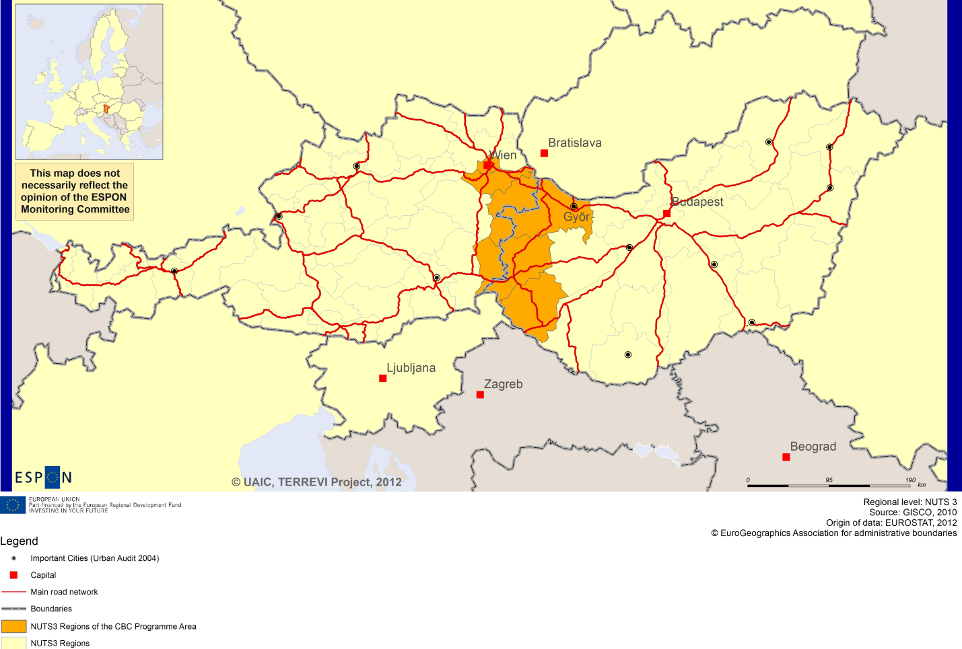

ESPON Project TERREVI
November 2012

Introduction
ESPON supports policy development in relation to the aim of territorial cohesion and a harmonious development of the European territory. It provides comparable information, evidence, analysis, and scenarios on territorial dynamics, which reveal territorial capitals and development potentials of regions and larger territories. Considering the programme area in its European context adds an important new perspective that can help shaping the programming and the places of implementing projects.
The ESPON TERREVI project focuses on producing evidence for Structural Funds programmes with the aim to support the development of the programmes to be carried out in the 2014-2020 period.
One milestone of this work consists in presenting selected ESPON research pieces in easy-to-understand factsheets for all territorial cooperation programme areas. The aim is to provide the reader with preliminary insight on types of territorial evidence ESPON holds at hand with regard to the possible investment priorities of future programmes. The factsheets certainly only give a first glimpse rather than fully present the work of the large number of ESPON projects that are currently underway. Likewise, each programme area includes diverse development potentials and challenges, which needs targeted information search. However, hopefully this factsheet will contain information, benchmarking the programme area in its larger, territorial context, that is of interest and help to better understand the programme area and to navigate within the richness of ESPON material available.
In addition to the programme factsheets there will be a number of specific programme case studies illustrating how ESPON material can be used to support the development of future programmes e.g. by giving a comparative European dimension to the envisaged SWOTs. These case studies will be carried out in early 2013.
This factsheet is structured in three main parts. The first part presents a selection of indicators that help comparing the situation of the programme area in question with the European average, the average for all programme areas as well as the situation in the countries involved. The second part briefly presents the territorial factors of interest for the programme area. The final part offers guidance on the further use of ESPON results and tools. This is intended as an electronic publication so map quality is generally high to allow users to zoom into specific territories.
This factsheet does not necessarily reflect the opinion of the ESPON Monitoring Committee.

Europe 2020
Europe, with its member states and their regions, is more exposed to global shocks and international competition than at any time before. As the world becomes more interdependent this trend will continue and shape policy thinking across sectors, borders and geographical scales. At the same time, Europe is characterised by a large territorial diversity meaning that global developments can imply rather different development possibilities and challenges for different European regions and cities.
The differences are partly defined by major geographical structures such as urban systems, access and connectivity, the geographical specificity or population density. At the same time, the differences are also spelled out in the larger development trends that affect an area, and the way and degree to which it is affected.
The data, indicators and territorial evidence provided by ESPON provides insight on both the main structures and larger territorial trends. The fine art is to identify what can actually be influenced by policy-making and, in particular, by place-based policy and territorial cooperation related to your programme area.
This chapter provides a selection of ESPON data related to Europe 2020 objectives of smart, sustainable and inclusive growth, giving also hints as regards the main thematic objectives envisaged in the draft regulations for the next period of EU Cohesion Policy. The Europe 2020 Strategy aims to enhance smart, sustainable and inclusive growth. This strategy has clear territorial dimensions. However, achieving these goals is challenging in the crisis-driven times. Furthermore, the economic disparities are growing as economic trends and the crisis have various impacts on different parts of Europe.
In the following the traffic light for each indicator represents how your programme territory compares to wider European and national medians where green = your programme area performs better for that indicator, yellow = similar, and red = worse.
In creating the traffic lights the median was used as central value indicator for all statistical variables due to its advantages (easy to interpret, it splits the statistical distribution in half) but especially due to the constraints linked to the impossibility of computing means for several indicators (Climate Change, Wind Energy Potential etc.). Therefore, a special attention should be given in reading the median values when the number of NUTS 2 regions is below 7. Using percentiles implies also a high dependence of the final results on the type of statistical distribution. This fact should be considered when establishing the relative position of a CBC Programme Area to a specific country.
EU 27+4 in Traffic Lights and box-plots means the EU Member States as well as Iceland, Liechtenstein, Norway and Switzerland – the ESPON space.

Smart growth
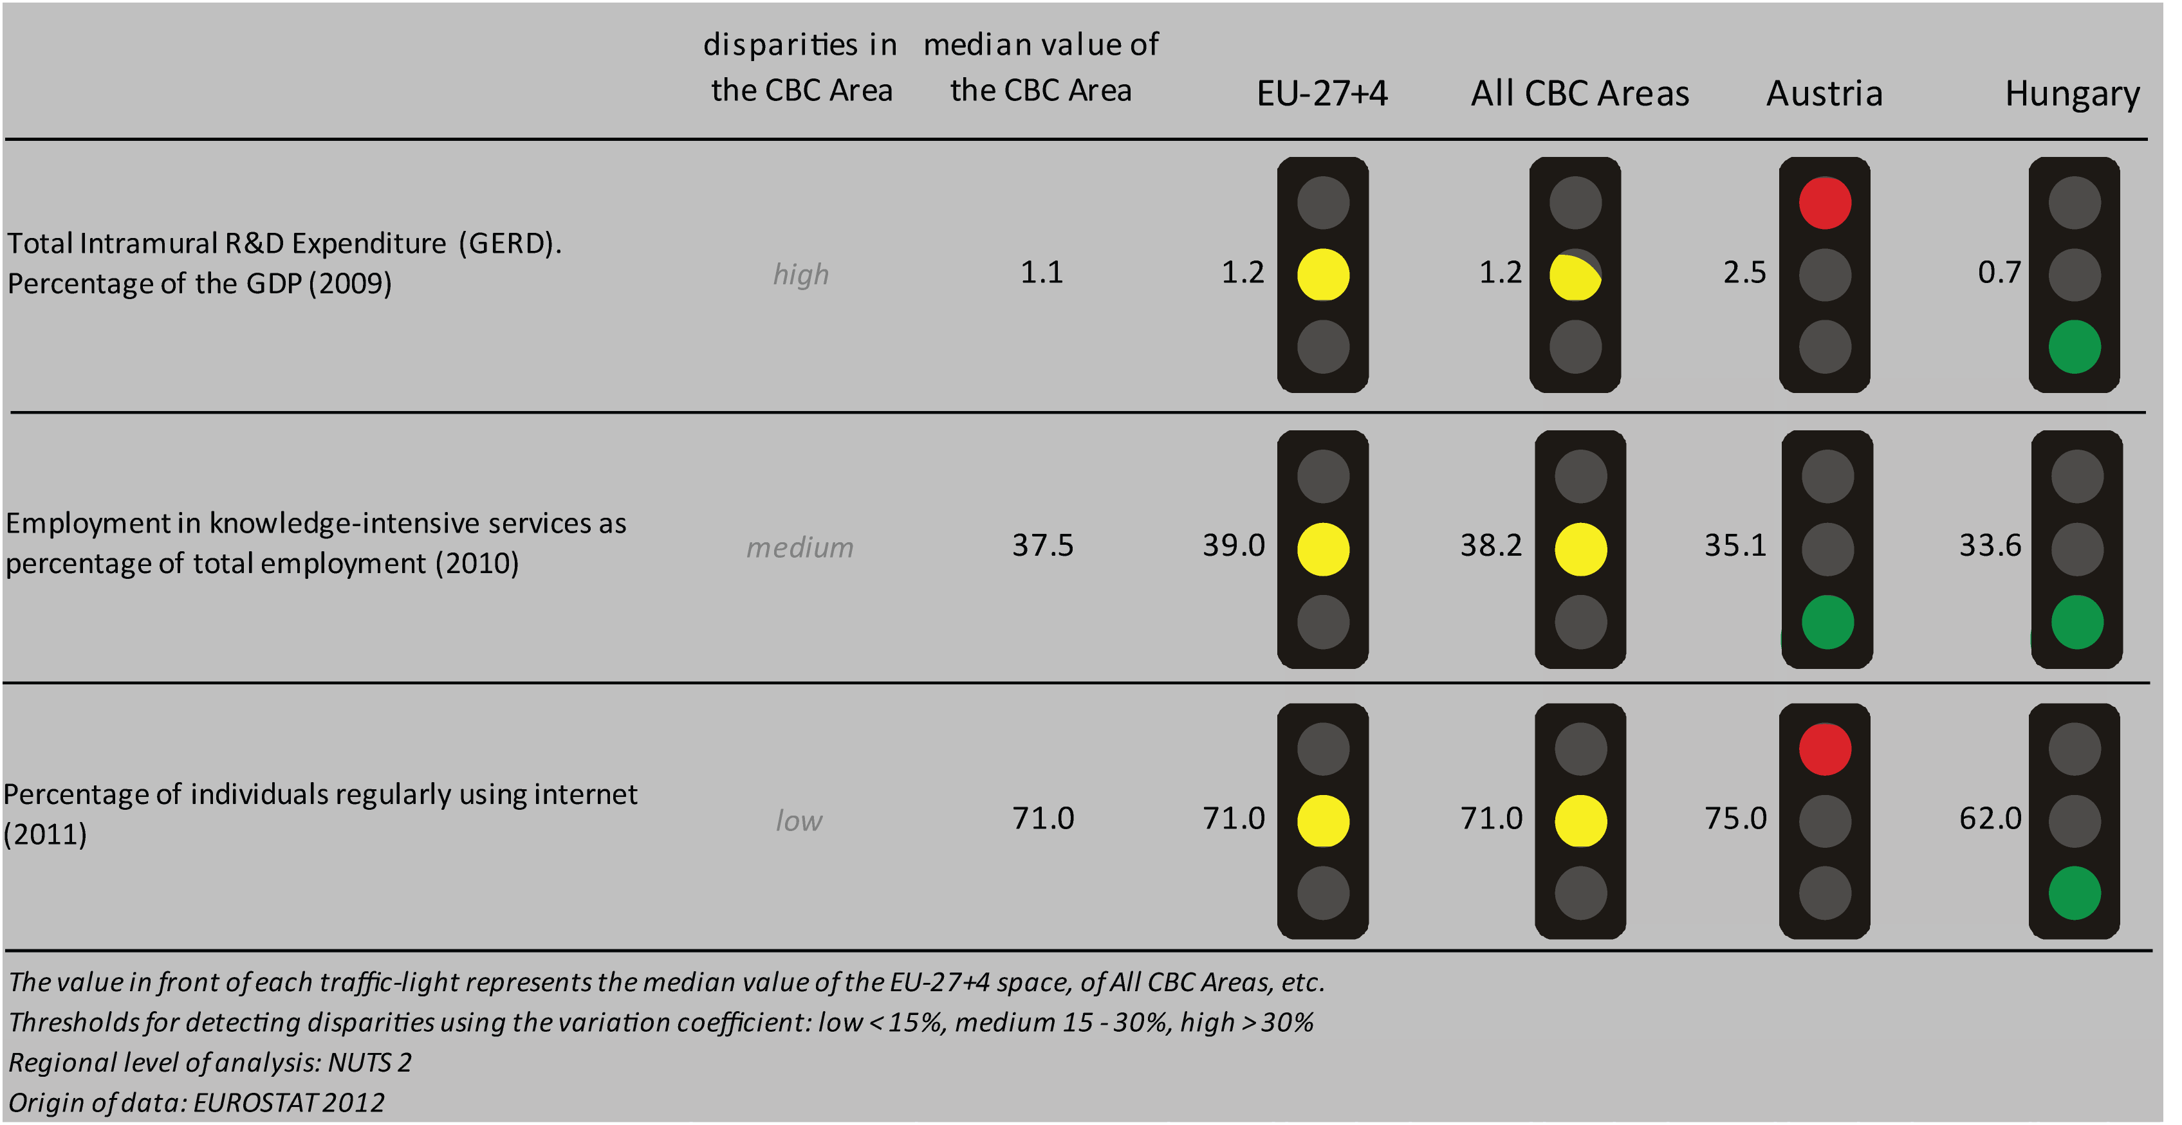
Smart growth refers to developing an economy based on knowledge and innovation. In the framework of the Europe 2020 Strategy it means improving the EU's performance in education, research/innovation and digital society.

According to all indicators reported above, the Austria-Hungary CBC area performs at a similar level to the EU27+4 space and all CBC ones. Considering the objective of R&D expenditure as percentage of the GDP - one of the five headline targets in the Europe 2020 Strategy - the CBC area is still lagging behind the EU27+4 space and all CBCs. Moreover, Austria-Hungary is characterised by a high level of internal disparity due to a better performance of the Austrian side and worse of the Hungarian one.
Concerning the ratio of employment in knowledge-intensive service to the total employment in 2010, the CBC area has the same values as both the EU27+4 space and all CBCs; slightly higher than both Austria and Hungary. The distribution inside the CBC results in a medium level of internal disparity.
In terms of percentage of individuals regularly using internet in 2011, the CBC has the same values as the EU27+4 space and all CBCs, but it performs slightly worse than Austria and better than Hungary, with a low internal disparity.
According to the classification of the KIT project, MAP 1 identifies two territorial patterns of innovation:
- ‘Imitative innovation area’ in the Hungarian side, i.e. the counties of Győr-Moson-Sopron, Vas and Zala. It is defined by a low knowledge and innovation intensity, entrepreneurship, creativity, a high attractiveness and a high innovation potentials;
- ‘Applied science area’, in the Austrian Länder of Burgenland and the region of Wiener Umland-Südteil. It is associated to a quite high generality and originality of science-based local knowledge, and a high degree of attractiveness of knowledge coming from other regions;
- ‘European science-based area’, concerning Wien, in the Austrian side. It is characterised by strong knowledge and innovation, specialized in general purpose technologies, with a high generality and originality of science-based local knowledge.

MAP 1 – Territorial Patterns of Innovation (ESPON KIT project) for the CBC Austria – Hungary

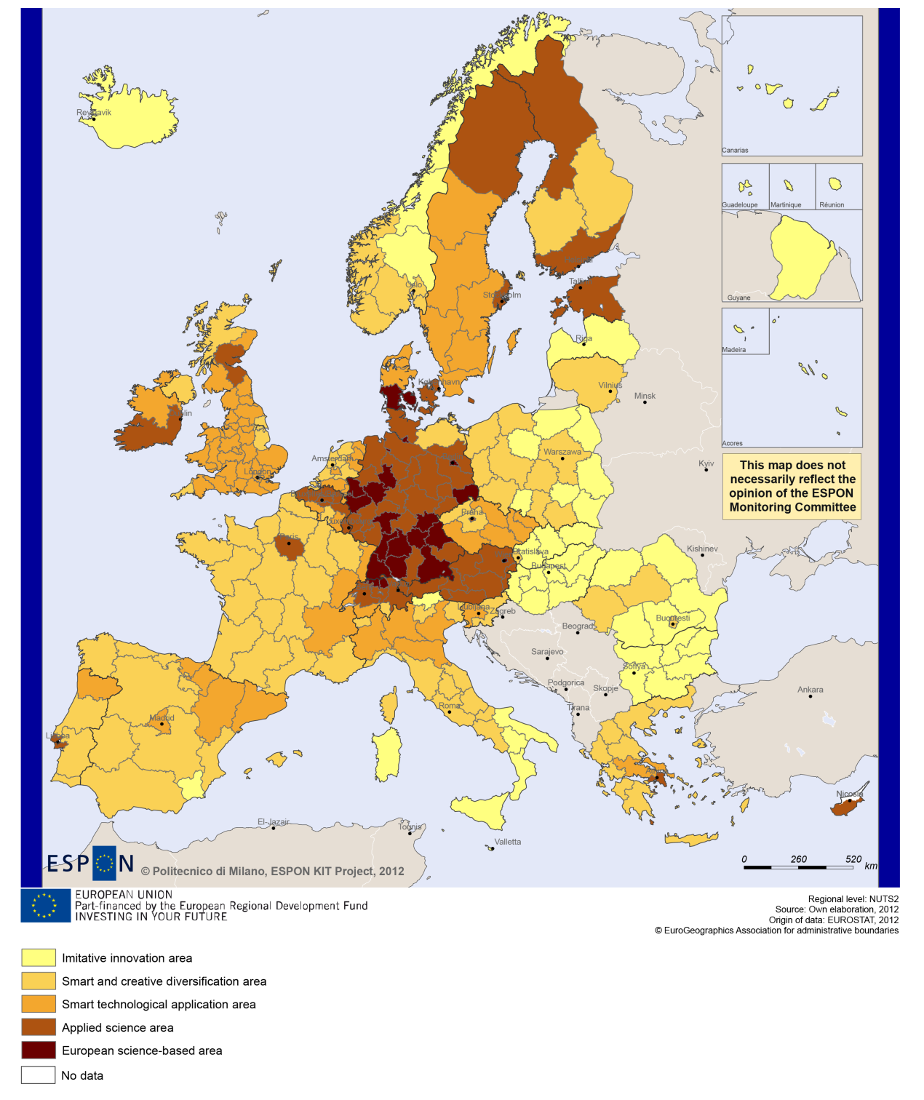

Sustainable growth
Sustainable growth refers to promoting a more resource efficient, greener and more competitive economy. Within the Europe 2020 Strategy it means e.g. building a more competitive low-carbon economy that makes efficient, sustainable use of resources, protecting the environment, reducing emissions and preventing biodiversity loss, capitalising on Europe's leadership in developing new green technologies and production methods, and introducing efficient smart electricity grids. In the framework of the Europe 2020 Strategy it means focus on competitiveness, resource efficiency, climate change and biodiversity.
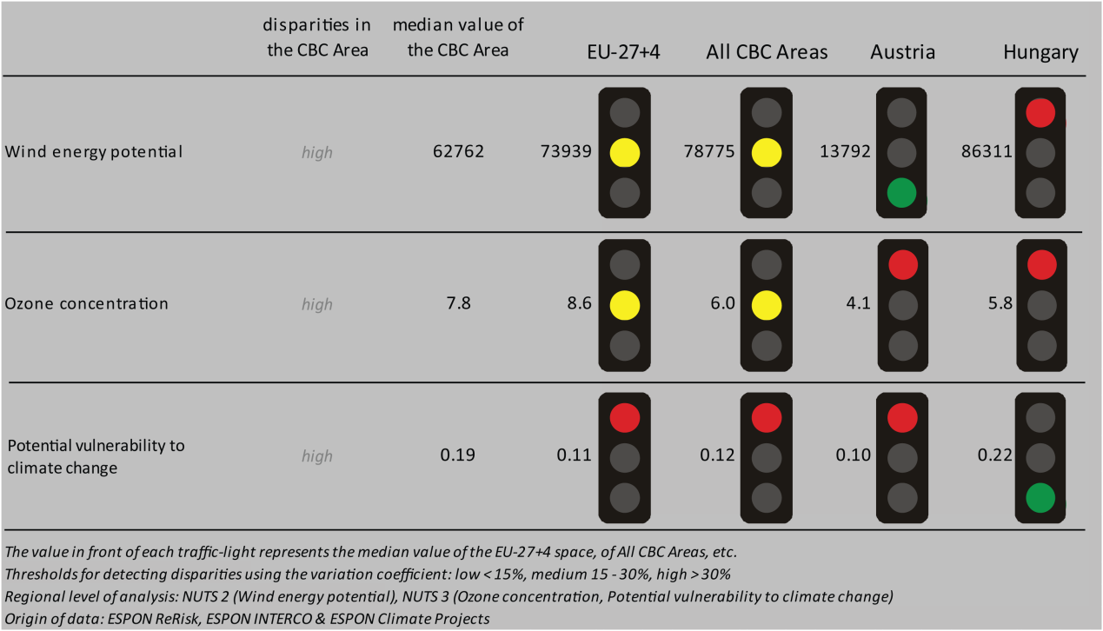
The Austria-Hungary CBC area has more wind energy potential than Austria, but less than in Hungary at national level. The level of wind energy potential of the Austria-Hungary CBC area is similar to the EU27+4 and the level of the CBC areas in general. The ozone concentration values of the Austria-Hungary CBC area are similar to the EU27+4 and all CBC areas’ in general, but higher than in Austria and Hungary. The CBC area is also more vulnerable to climate change than the EU27+4, the CBC areas in general and Austria, but less so compared to Hungary.
For all factors analysed in the traffic light system, the disparities in the CBC areas are high. This fact is also confirmed in Box Plot 1. Box Plot 1 shows that there are great differences between the Nuts 3 regions of the CBC area with regards to the capacity to adapt to climate change. The values for the region of Vienna are far above the average values of the EU27+4, the CBC areas, and the national levels of Austria and Hungary. In contrast, the Gyor-Moson-Sopron-Zala region in Hungary has a significantly lower capacity to adapt to climate change than the other regions. It is also below the EU27+4 and CBC areas’ averages, but higher than the Hungarian average.
Directive11 on fossil fuel consumption seems to have no impact on the Austria-Hungary CBC area (Map 2).

MAP 2 - Territorial impact on fossil fuel consumption of Directive on the promotion of clean and energy-efficient road transport vehicles (ESPON ARTS project) for the CBC Austria – Hungary

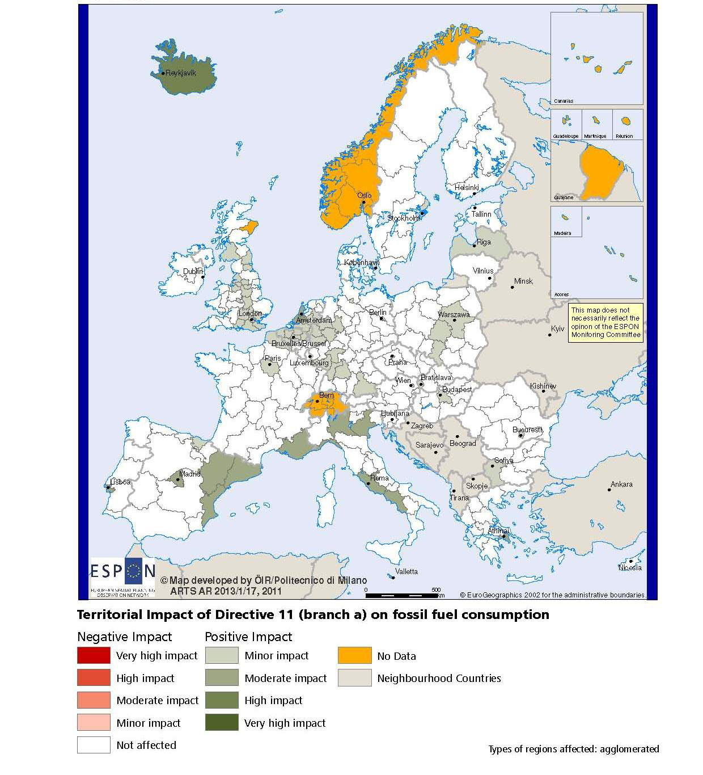

BOX-PLOT 1 – Combined adaptive capacity to climate change (ESPON CLIMATE project) for the CBC Austria – Hungary
“Adaptive capacity (adaptability)” to climate change indicates the ability or potential of a system to respond successfully to climate change and variability, and includes adjustments in behaviour, resources and technologies.
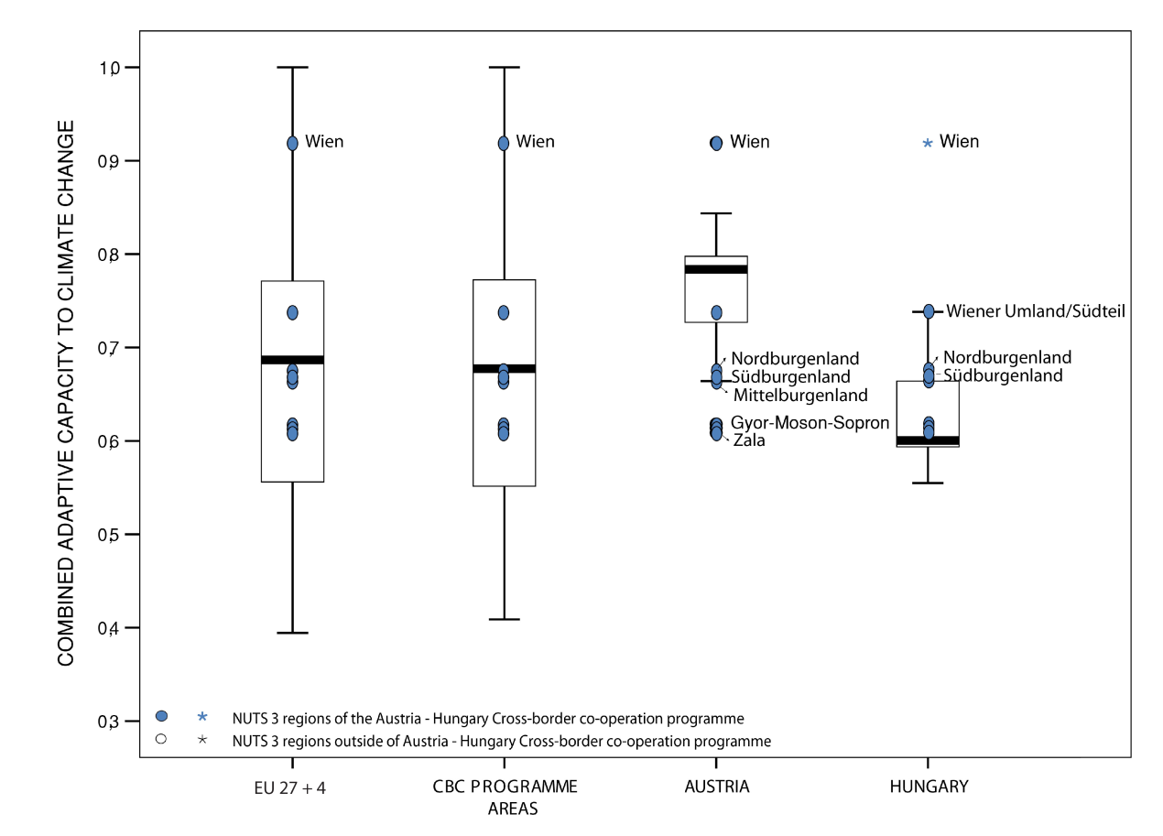

How to read the box-plots?
The box-plot is a statistical and mathematical tool used to visualize numerical data sets and to compare its statistical distribution.
Because it is used in exploratory analysis of databases, this representation is sensitive to the quality of the central value selected to explain the symmetry, shape and distribution variability. In the case of a box-plot, the most used central value is the median, because it has the quality of sectioning the data string into two halves, so that 50% of the cases will be above the central value and the other half will be below it. Since the purpose of the representation is to highlight outliers’ behavior, it uses a box that encompasses half of the cases, i.e. values that are in the range defined by the percentile of 25% and 75%. If a region has a value in this box then it can be considered that it has, according to the variable in question, a situation close to the average behavior of all regions analyzed.
When a region consistently deviates from the average profile of the analyzed territorial context, this behavior will be noted in the chart only when certain thresholds of statistical tolerances are exceeded, this being pointed in the diagram with segments perpendicular to the middle box, segments called the "whiskers".

Inclusive growth
Inclusive growth refers to fostering a high-employment economy delivering social and territorial cohesion. Within the Europe 2020 Strategy it means raising Europe’s employment rate, helping people of all ages anticipate and manage change through investment in skills & training, modernising labour markets and welfare systems, and ensuring the benefits of growth reach all parts of the EU. In short the key factors are employment and avoiding risk of poverty and social exclusion.
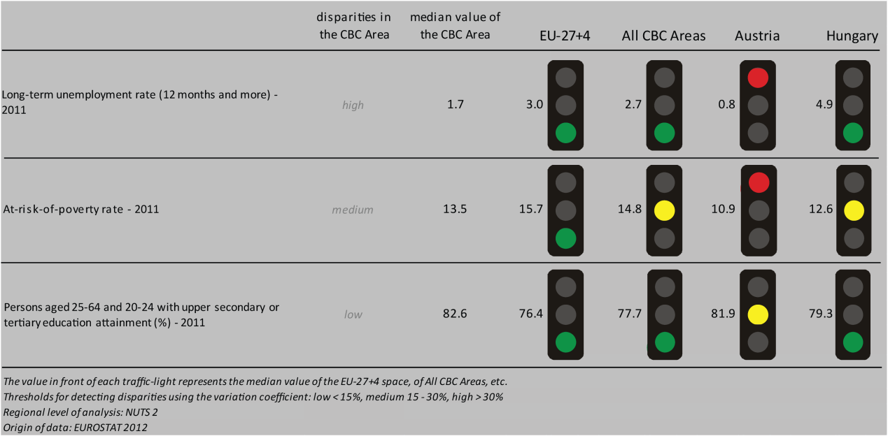
The long-term unemployment rate in the Austria-Hungary CBC area is lower than in the EU27+4, all the CBC areas in general and the national level in Hungary. The CBC area’s long-term unemployment rate is however higher than in Austria. The fact that the diversity within the Austria-Hungary CBC region is high, can also be seen from Box-Plot 2. In fact, the Box-Plot shows that there are considerable variations across the NUTS 3 regions of the CBC area with regards to employment rates. While the Wiener Umland (Viennese region) has an above-average employment rate, the Hungarian Zala region has a below-average employment rate and differs from the Wiener Umland region by around 7 percentage points.
The same is true for the at-risk-of-poverty rate in the CBC area. In fact, Austria-Hungary has a lower at-risk-of-poverty rate than the EU27+4 and a similar value to all CBC areas and Hungary. The situation seems to be slightly worse than in Austria.
The median value of the CBC area with regards to the percentage of persons aged 25-64 and 20-24 with upper secondary or tertiary education attainment is positive in the Austria-Hungary CBC area compared to the EU27+4, the CBC areas in general and the Hungarian national level.

For all the possible scenarios on the change in labour force until 2050 drawn in the ESPON DEMIFER project (Map 3), the outcome is always more positive on the Austrian side than on the Hungarian side, except for the scenario “Limited social Europe” where both sides witness negative chanegs in labour force.
MAP 3 – Change in Labour Force 2005-2050 (ESPON DEMIFER project) for the CBC Austria – Hungary

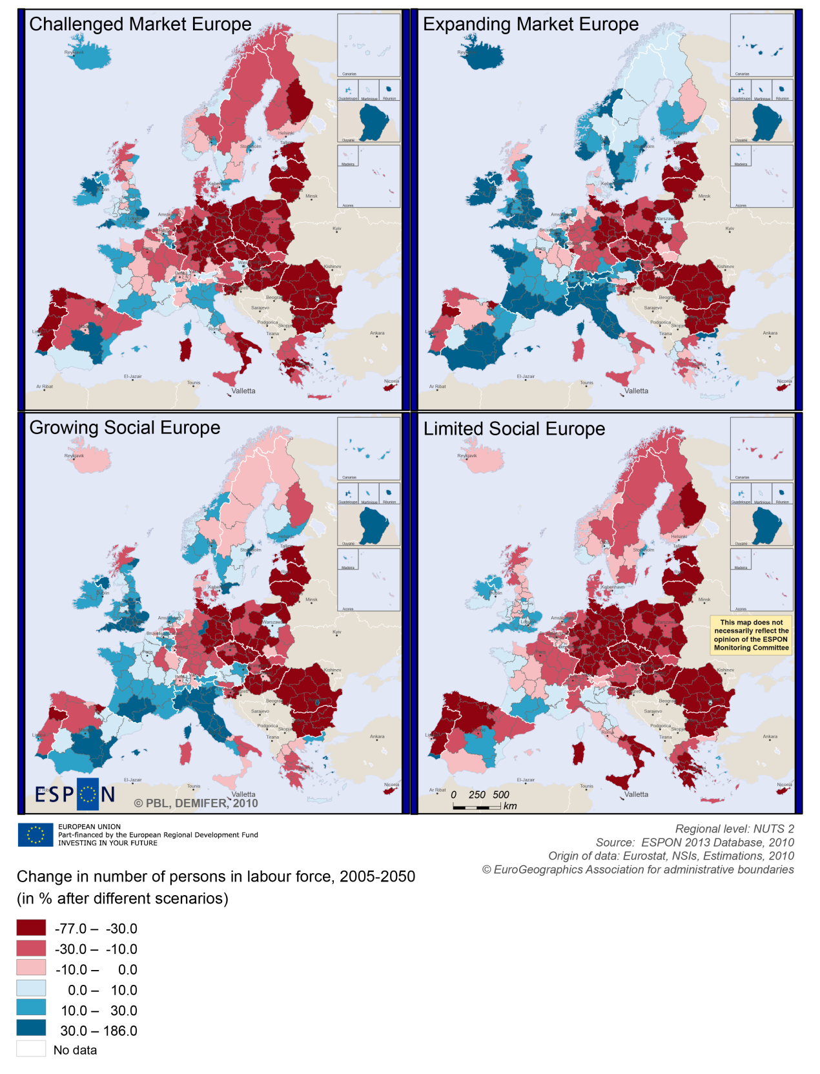

BOX-PLOT 2 – Employment rate 2010 within the CBC Austria – Hungary
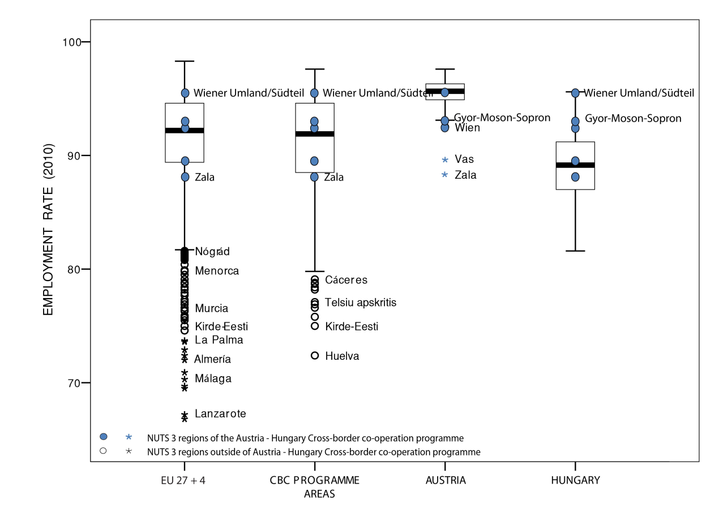

(see “How to read the box-plots?” on page 8)

Territorial factors of interest for the programme area
Territorial cooperation programmes can make a difference for the future development of cross-border and transnational territories in Europe. Some of the factors can be analysed by European wide data sets and using some studies having specific maps, figures and tables concerning the areas of the cooperation region.
In a European perspective the programme area comprises mainly rural areas close to a city, with Vienna being the urban exception. Furthermore Györ is an secondary city with importance for the programme area. However, in a European perspective it is mainly Vienna which is characterised as an urban region. Vienna is an important metropolitan area and hub in the European urban system, the close proximity to Vienna can be a particular advantage for the rural areas and secondary cities in the programme area.
This concerns both the access to services and infrastructure. Whereas most parts of the programme area have below European average accessibility and only limited opportunities for one-day business trips within the European urban network, Vienna is characterised by good accessibility and a wide range of international links allowing for one-day business trips.
The rural character with a lot of areas close to a city of the programme area comprises a wide range of development opportunities and challenges. In European perspective the area is characterised with some degree of mountainousness, where mountainous municipalities cover up to 25% of the area.
ESPON GEOSPECS has developed a nexus model for mountainous regions linking defining features via intermediary process to development challenges and opportunities (see figure). This model can be of interest for further developing the discussion about the challenges and opportunities in the programme area.
ESPON GEOSPECS PROJECT –FINAL REPORT, PAGE 102:
Nexus model for mountain areas
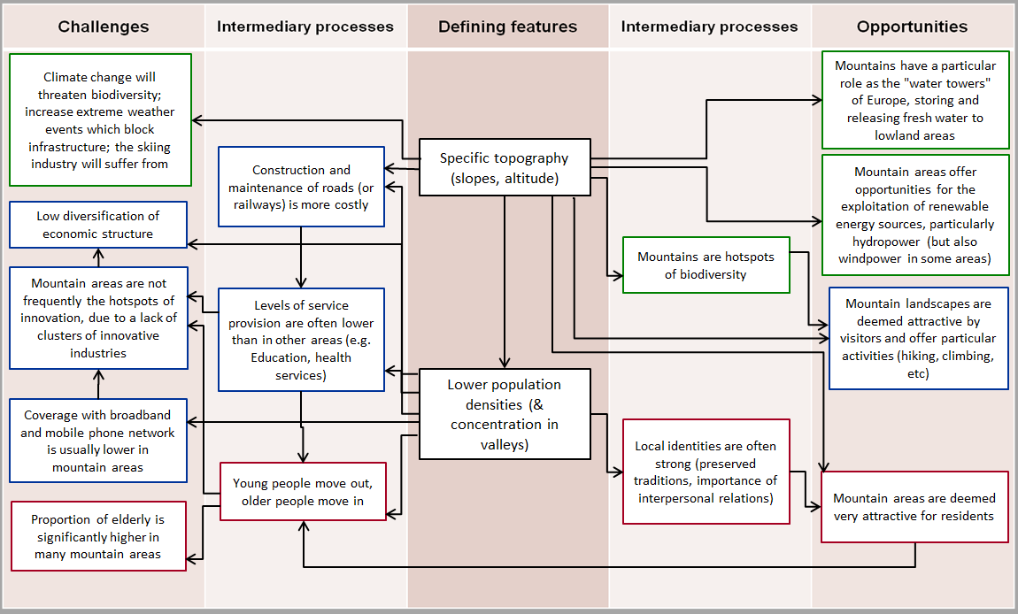

MAP 4 – Urban-rural typology of NUTS3 regions including remoteness (DG Regio) for the CBC Austria – Hungary

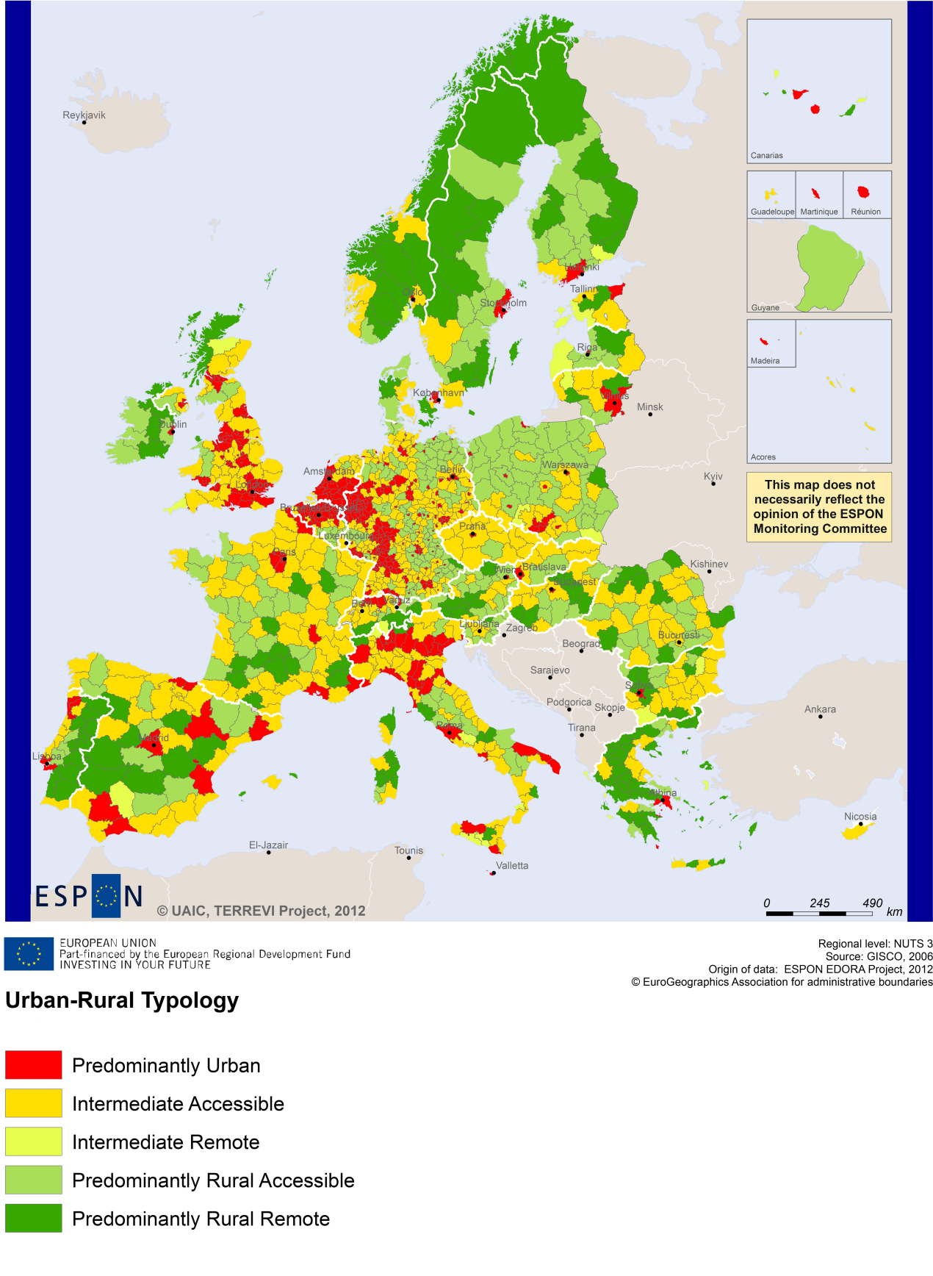
(Accessible=close to a city)

MAP 5 – Multimodal accessibilty (ESPON Accessibility Update) for the CBC Austria – Hungary
“Potential Accessibility Multimodal” scores accessibility of NUTS 3 regions by road, rail and air relative to the European average in an Accessibility Index.
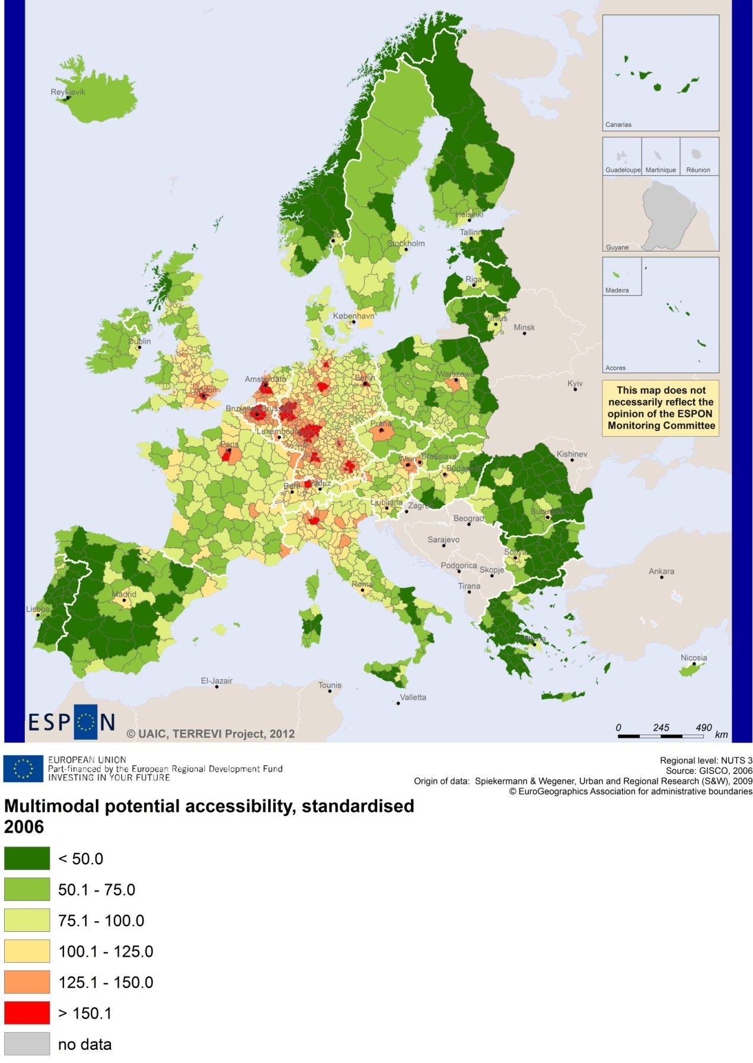

Recommended ESPON reading
ESPON provides an essential underpinning for translating into practice the calls for integrated and place-based approaches to economic development, when analysing a programme area or deciding about future programme priorities. ESPON has published a wide range of exciting reports providing valuable territorial evidence for future territorial cooperation initiatives.
The table below shows examples of relevant projects for the Cooperation Region. However, you have to study other ESPON reports as well in order to capitalise fully on the European information available for the cross-border programming.
ESPON study | Topic | Content
EDORA | Rural areas | It provides evidence on the development opportunities of diverse types of European rural areas and reveals competitiveness options (see maps in Appendix 1).
CLIMATE | Climate change | It analyses how and to which degree climate change will impact on the competitiveness and cohesion of European regions and Europe as a whole (see from map 1 to 23).
TIPTAP | Territorial impact assessment | It provides a tool for the ex-ante assessment of territorial impacts of policies to deliver evidence on the territorial impact of policies (see from map 2.3.1 to 2.3.9).
CAEE | Agglomerati-on economies | It aims at a better understanding of the economic costs and benefits of large urban agglomerations (see figure 1).
TRANSMEC | European cooperation | It develops a method providing guidance on how ESPON results can add value to support territorial cooperation programmes (see map 27 and from map 36 to 39 on potential accessibility indicators).
SEMIGRA | Rural migration | It identifies the main reasons and consequences of selective migration in rural regions in order to develop strategies for territorial development (see map 1, 4 and 5). It provides two case studies concerning the CBC, in particular Észak Alföldis and Eszak Magyarors.
KIT | Innovation | It describes patterns and potentials of regions in terms of knowledge and innovation economy and explores development opportunities (see from map 3.1.1 to 4.4.1).
SGPTD | Growth poles | It provides evidence about performance and roles of European secondary cities (see from figure 2 to 2.12).
POLYCE | Metropolitan regions | It studies the characteristics of the polycentric system on regional and metropolitan level. It provides a case study concerning Wien Metropolitan region (see figure 20).
Furthermore, some of overall ESPON products of particular interest for territorial cooperation are:
- ESPON Synthesis report “new evidence on smart, sustainable and inclusive territories” provides an easy to read overview on ESPON results available.
- ESPON Territorial Observations is a publication series, which on a few pages presents policy relevant findings deriving from latest ESPON research.
- ESPON 2013 Database provides regional information provided by ESPON projects and EUROSTAT.
- ESPON Hyperaltas allows comparing and analysing a region’s relative position at European, national and local scale for a wide range of criteria.
- ESPON MapFinder provides access to the most relevant ESPON maps resulting from ESPON projects and reports.
- ESPON Typologies provides nine regional typologies for additional analysis of regional data to be considered in the European context.
All ESPON reports and tools are freely available at
www.espon.eu

ISBN
The ESPON 2013 Programme is part-financed by the European Regional Development Fund, the EU Member States and the Partner States Iceland, Liechtenstein, Norway and Switzerland. It shall support policy development in relation to the aim of territorial cohesion and a harmonious development of the European territory.

