b

Belgium – France
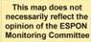
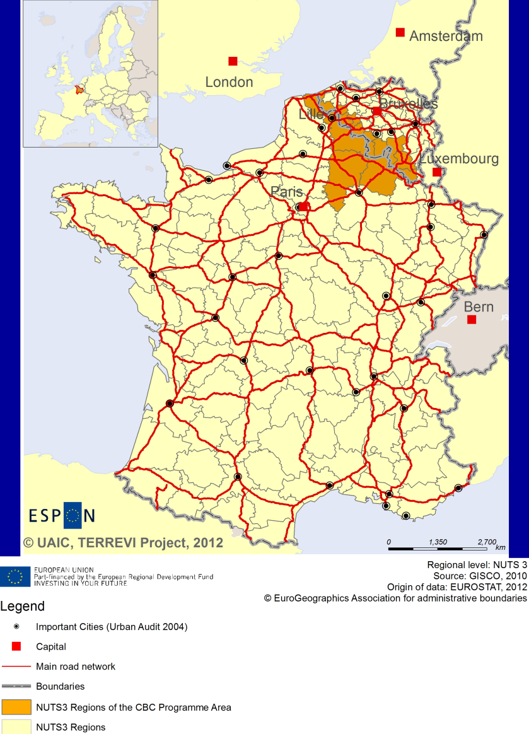

ESPON Project TERREVI
November 2012

Introduction
ESPON supports policy development in relation to the aim of territorial cohesion and a harmonious development of the European territory. It provides comparable information, evidence, analysis, and scenarios on territorial dynamics, which reveal territorial capitals and development potentials of regions and larger territories. Considering the programme area in its European context adds an important new perspective that can help shaping the programming and the places of implementing projects.
The ESPON TERREVI project focuses on producing evidence for Structural Funds programmes with the aim to support the development of the programmes to be carried out in the 2014-2020 period.
One milestone of this work consists in presenting selected ESPON research pieces in easy-to-understand factsheets for all territorial cooperation programme areas. The aim is to provide the reader with preliminary insight on types of territorial evidence ESPON holds at hand with regard to the possible investment priorities of future programmes. The factsheets certainly only give a first glimpse rather than fully present the work of the large number of ESPON projects that are currently underway. Likewise, each programme area includes diverse development potentials and challenges, which needs targeted information search. However, hopefully this factsheet will contain information, benchmarking the programme area in its larger, territorial context, that is of interest and help to better understand the programme area and to navigate within the richness of ESPON material available.
In addition to the programme factsheets there will be a number of specific programme case studies illustrating how ESPON material can be used to support the development of future programmes e.g. by giving a comparative European dimension to the envisaged SWOTs. These case studies will be carried out in early 2013.
This factsheet is structured in three main parts. The first part presents a selection of indicators that help comparing the situation of the programme area in question with the European average, the average for all programme areas as well as the situation in the countries involved. The second part briefly presents the territorial factors of interest for the programme area. The final part offers guidance on the further use of ESPON results and tools. This is intended as an electronic publication so map quality is generally high to allow users to zoom into specific territories.
This factsheet does not necessarily reflect the opinion of the ESPON Monitoring Committee.

Europe 2020
Europe, with its member states and their regions, is more exposed to global shocks and international competition than at any time before. As the world becomes more interdependent this trend will continue and shape policy thinking across sectors, borders and geographical scales. At the same time, Europe is characterised by a large territorial diversity meaning that global developments can imply rather different development possibilities and challenges for different European regions and cities.
The differences are partly defined by major geographical structures such as urban systems, access and connectivity, the geographical specificity or population density. At the same time, the differences are also spelled out in the larger development trends that affect an area, and the way and degree to which it is affected.
The data, indicators and territorial evidence provided by ESPON provides insight on both the main structures and larger territorial trends. The fine art is to identify what can actually be influenced by policy-making and, in particular, by place-based policy and territorial cooperation related to your programme area.
This chapter provides a selection of ESPON data related to Europe 2020 objectives of smart, sustainable and inclusive growth, giving also hints as regards the main thematic objectives envisaged in the draft regulations for the next period of EU Cohesion Policy. The Europe 2020 Strategy aims to enhance smart, sustainable and inclusive growth. This strategy has clear territorial dimensions. However, achieving these goals is challenging in the crisis-driven times. Furthermore, the economic disparities are growing as economic trends and the crisis have various impacts on different parts of Europe.
In the following the traffic light for each indicator represents how your programme territory compares to wider European and national medians where green = your programme area performs better for that indicator, yellow = similar, and red = worse.
In creating the traffic lights the median was used as central value indicator for all statistical variables due to its advantages (easy to interpret, it splits the statistical distribution in half) but especially due to the constraints linked to the impossibility of computing means for several indicators (Climate Change, Wind Energy Potential etc.). Therefore, a special attention should be given in reading the median values when the number of NUTS 2 regions is below 7. Using percentiles implies also a high dependence of the final results on the type of statistical distribution. This fact should be considered when establishing the relative position of a CBC Programme Area to a specific country.
EU 27+4 in Traffic Lights and box-plots means the EU Member States as well as Iceland, Liechtenstein, Norway and Switzerland – the ESPON space.

Smart growth
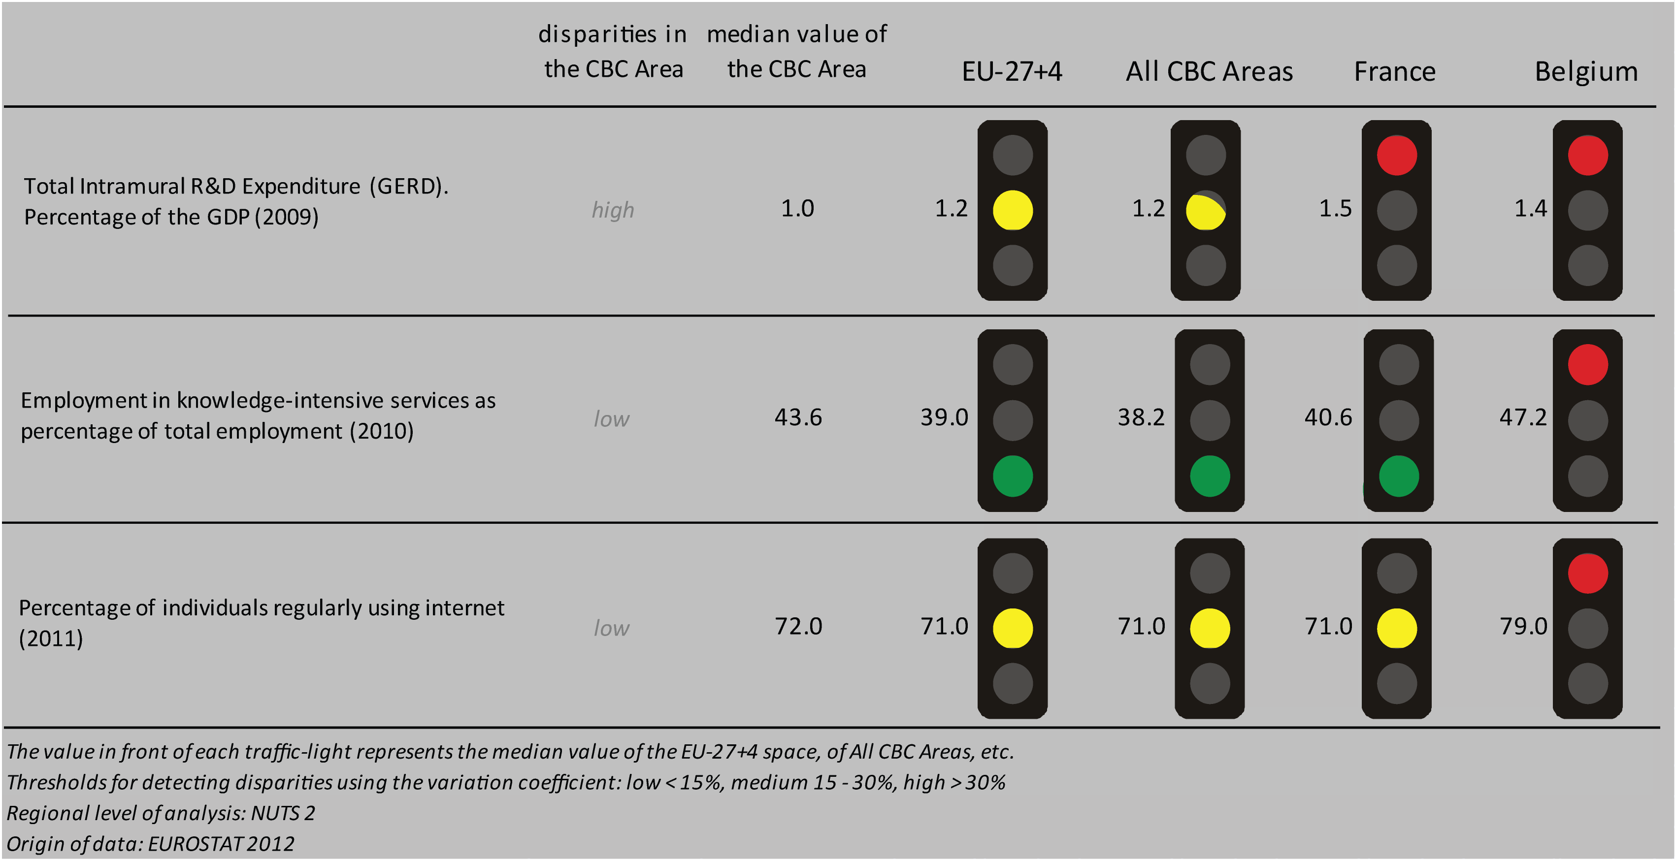
Smart growth refers to developing an economy based on knowledge and innovation. In the framework of the Europe 2020 Strategy it means improving the EU's performance in education, research/innovation and digital society.
According to all indicators reported above, the France-Wallonie-Vlaanderen CBC area performs similarly to the EU27+4 space and all CBC areas.
Considering the objective of R&D expenditure of percentage of the GDP - one of the five headline targets in the Europe 2020 Strategy - the CBC area is doing as good as the EU27+4 space and all CBCs. However, the CBC area is characterised by a high level of internal disparity and underperforms when compared to Belgium and France. Concerning the ratio of employment in knowledge-intensive service to the total employment in 2010, the CBC area has higher values than the EU27+4 space and all CBCs; slightly lower than Belgium but higher than France. The distribution inside the CBC results in a low level of internal disparity. In terms of the percentage of individuals regularly using internet in 2011, the CBC area the same values than EU27+4 space, all CBCs, and France, but it performs slightly worse than Belgium, with a low internal disparity.
According to the classification of the KIT project, MAP 1 identifies two territorial patterns of innovation:
- ‘Applied science area’, in Belgian Flanders. It is associated to a quite high generality and originality of science-based local knowledge, and a high degree of attractiveness of knowledge coming from other regions.
- ‘Smart and creative diversification area’ in the French side plus the two Walloon districts of Philippeville and Dinant. It is defined by a low degree of local diversified applied knowledge, internal innovation capacity, high degree of local competences, creativity and entrepreneurship, external knowledge embedded in technical and organizational capabilities;
- ‘Smart technological application area’, in the remaining Belgian parts. It is defined by a high product innovation level, with a limited degree of local applied science and R&D endowment, and a high creativity which allows translating external basic science and applied science knowledge into innovation.

MAP 1 – Territorial Patterns of Innovation (ESPON KIT project) for the CBC Belgium – France

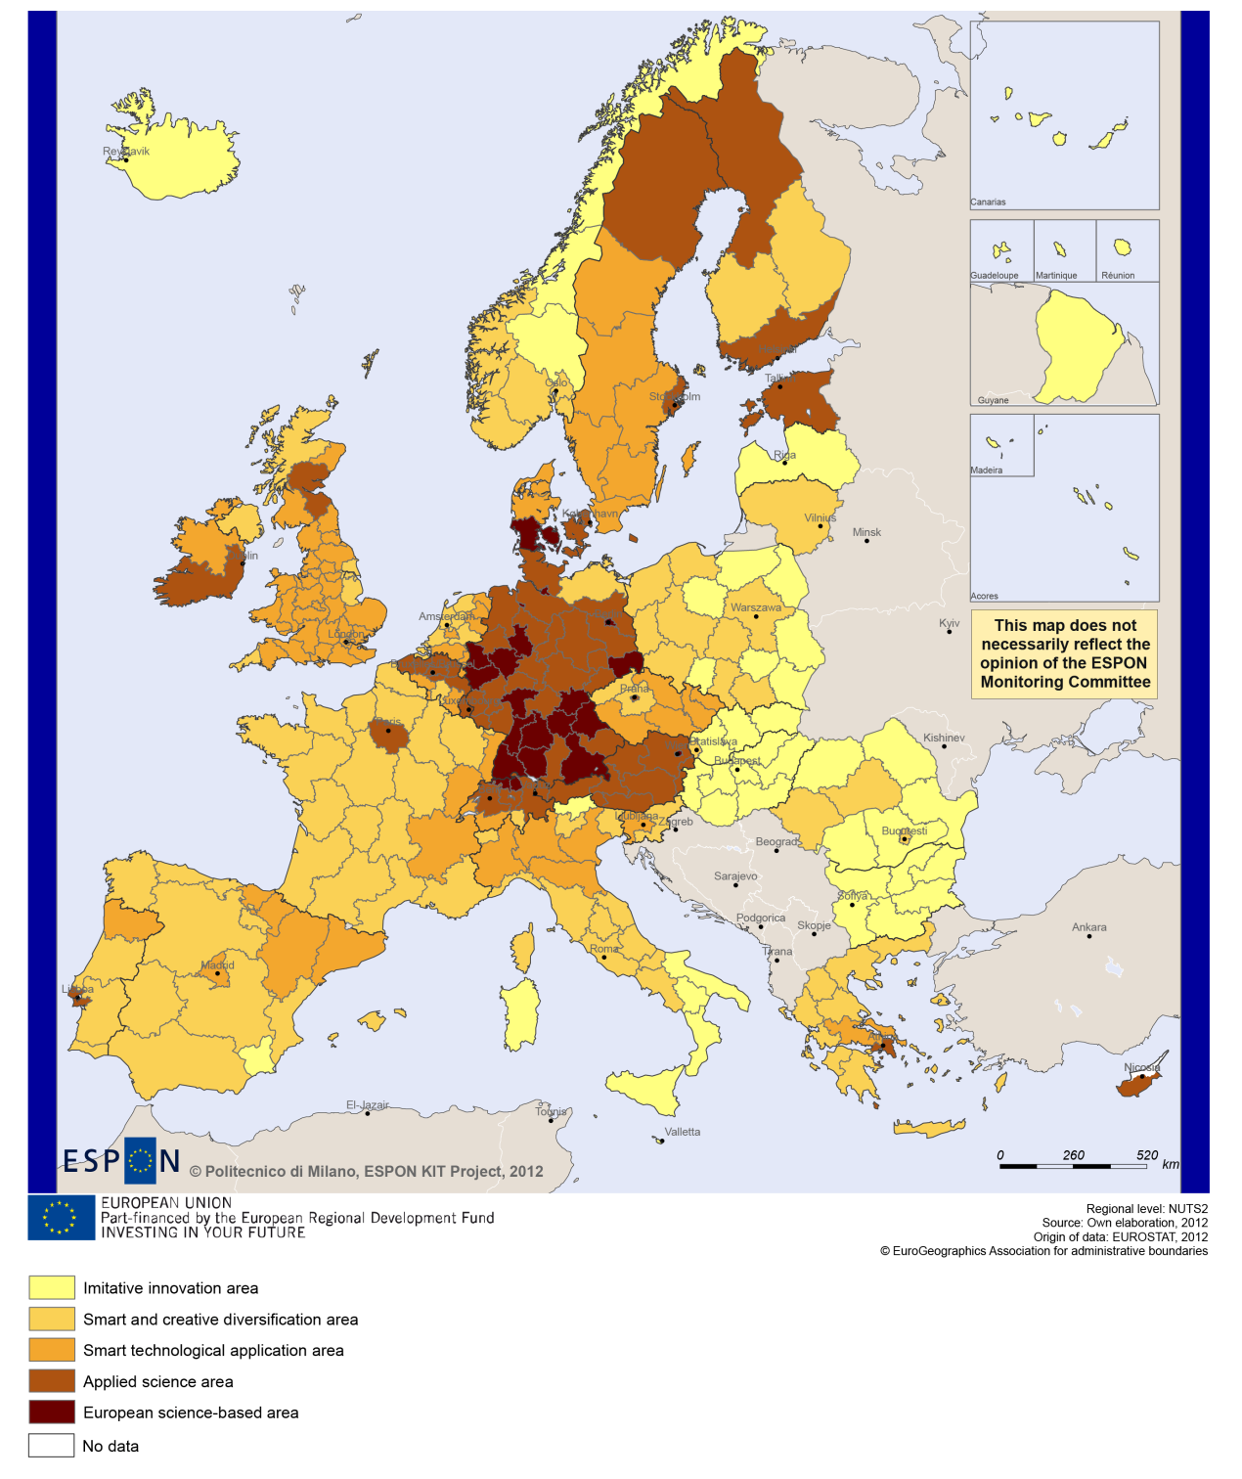

Sustainable growth
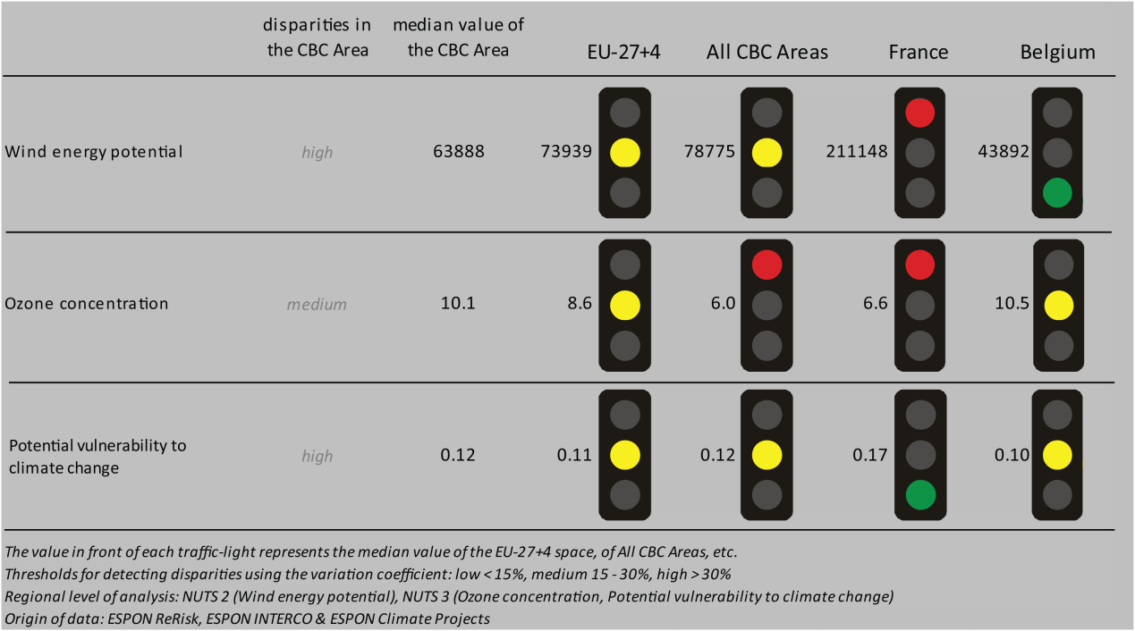
Sustainable growth refers to promoting a more resource efficient, greener and more competitive economy. Within the Europe 2020 Strategy it means e.g. building a more competitive low-carbon economy that makes efficient, sustainable use of resources, protecting the environment, reducing emissions and preventing biodiversity loss, capitalising on Europe's leadership in developing new green technologies and production methods, and introducing efficient smart electricity grids. In the framework of the Europe 2020 Strategy it means focus on competitiveness, resource efficiency, climate change and biodiversity.

The use of wind energy potential could be one of the cornerstones in building a competitive low-carbon economy in the EU. Disparities concerning wind energy potential within the Belgium-France CBC area are high. The median value is at around the same level (slightly lower) than that of the EU27+4 or all CBC areas. At the same time it is lower than the level of France and higher than the level of Belgium. The ozone concentration in the CBC region is at around the same level than in the EU-27+4 in general and very close to the level of Belgium; while it is higher than the value of all CBC areas and that of France. The CBC area is characterised by a level of vulnerability to climate change that is similar to the level of other EU-27+4, other CBC regions or that of Belgium and slightly lower than that of France. Disparities among the CBC regions are again high in this regard.
Directive 11 has minor positive territorial impact on fossil fuel consumption only in the region of Nord on the French side of the border, and in the Belgian NUTS3 regions bordering Nord (MAP 2); no impact has been identified in the other border regions. The combined adaptive capacity of NUTS3 regions of the CBC programme varies and regional values are more or less evenly spread around the median value of both the EU-27+4 and other CBC regions (BOX-PLOT 1). The Belgian NUTS3 Arrondissement of Kortrijk is identified as having the highest level of adaptive capacity within the programme area. Overall, Belgian border-regions are characterised by a higher combined adaptive capacity to climate change than their French counterparts (based on national median values). In this regard the French region of Nord is having a considerably weaker than average performance, especially when compared to the Belgian national median; but it is also among the weakest regions in the French national context.

MAP 2 - Territorial impact on fossil fuel consumption of Directive on the promotion of clean and energy-efficient road transport vehicles (ESPON ARTS project) for the CBC Belgium – France

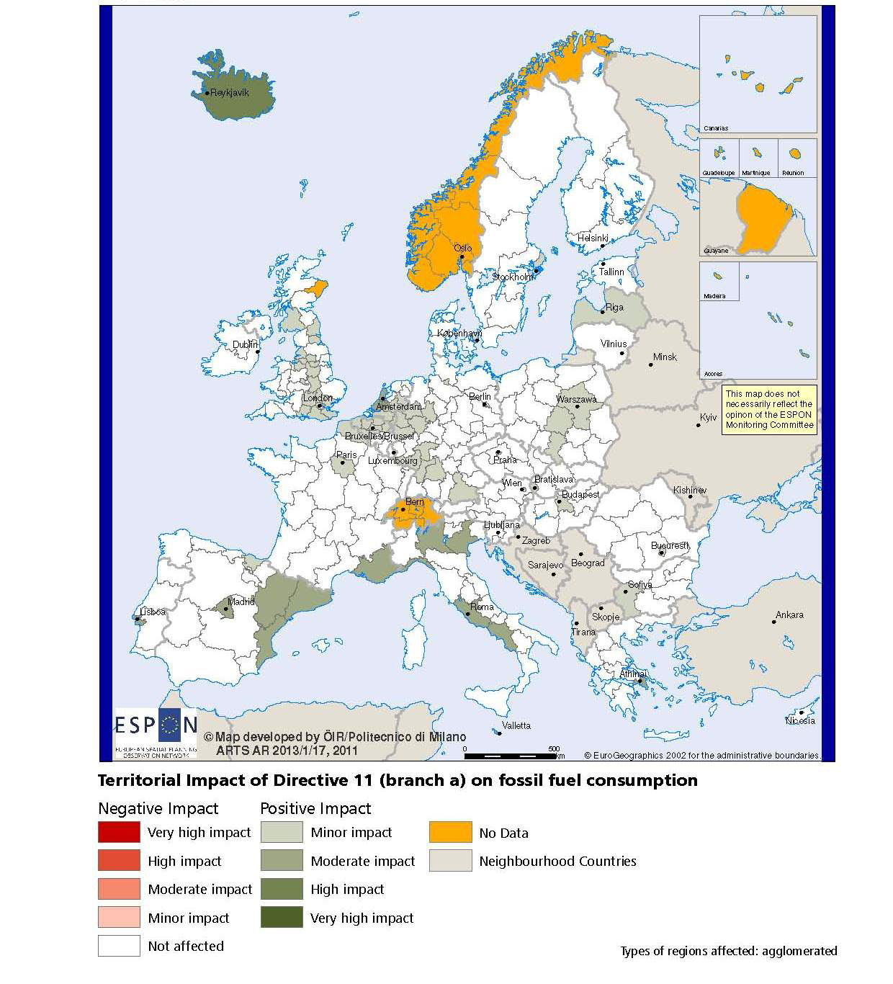

BOX-PLOT 1 – Combined adaptive capacity to climate change (ESPON CLIMATE project) for the CBC Belgium – France
“Adaptive capacity (adaptability)” to climate change indicates the ability or potential of a system to respond successfully to climate change and variability, and includes adjustments in behaviour, resources and technologies.
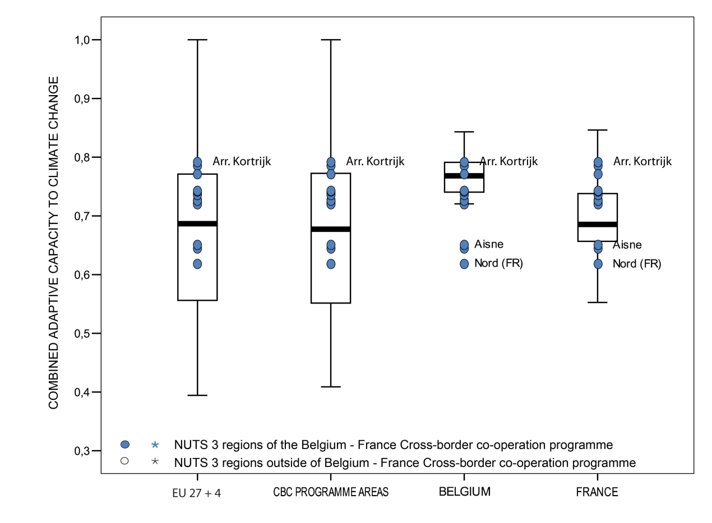

How to read the box-plots?
The box-plot is a statistical and mathematical tool used to visualize numerical data sets and to compare its statistical distribution.
Because it is used in exploratory analysis of databases, this representation is sensitive to the quality of the central value selected to explain the symmetry, shape and distribution variability. In the case of a box-plot, the most used central value is the median, because it has the quality of sectioning the data string into two halves, so that 50% of the cases will be above the central value and the other half will be below it. Since the purpose of the representation is to highlight outliers’ behavior, it uses a box that encompasses half of the cases, i.e. values that are in the range defined by the percentile of 25% and 75%. If a region has a value in this box then it can be considered that it has, according to the variable in question, a situation close to the average behavior of all regions analyzed.
When a region consistently deviates from the average profile of the analyzed territorial context, this behavior will be noted in the chart only when certain thresholds of statistical tolerances are exceeded, this being pointed in the diagram with segments perpendicular to the middle box, segments called the "whiskers".

Inclusive growth
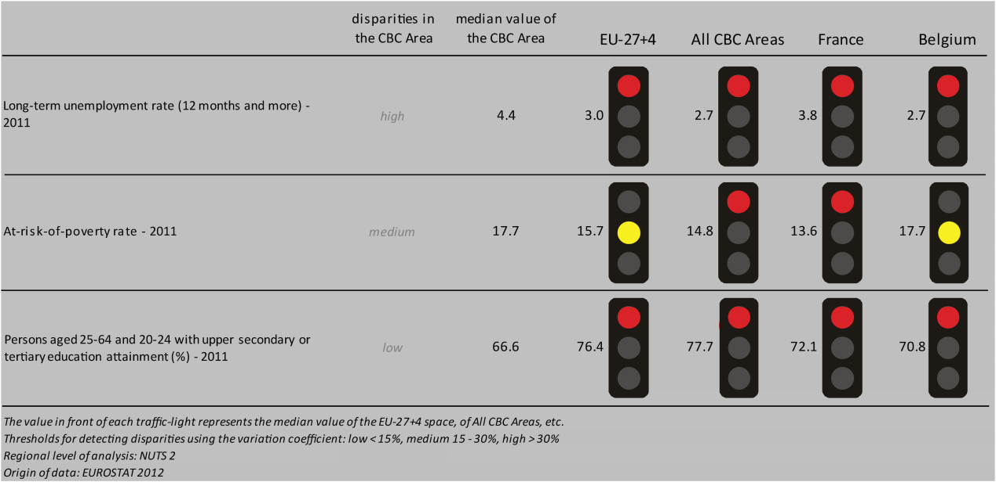
Inclusive growth refers to fostering a high-employment economy delivering social and territorial cohesion. Within the Europe 2020 Strategy it means raising Europe’s employment rate, helping people of all ages anticipate and manage change through investment in skills & training, modernising labour markets and welfare systems, and ensuring the benefits of growth reach all parts of the EU. In short the key factors are employment and avoiding risk of poverty and social exclusion.

When we consider any of the three selected employment indicators (long-term employment, people at risk of poverty or persons with upper secondary or tertiary education), we can generally state that CBC regions have mostly a weaker level of performance than the median of the EU-27+4, all CBC areas, France or Belgium. Employment rate in 2010 (only presented for the French border regions in BOX-PLOT 2) is much below the EU-27+4, all CBC areas median values, as well as the relevant data for French regions. Overall the employment rate of the French border-regions is similar to that of the Belgian median.
Three out of four scenarios (Limited Social Europe is an exception) predict positive changes in the labour force until 2050 in most of the Belgian NUTS3 border-regions (MAP 3). An opposite trend is observed in the French border-regions, where mostly a reduction of low to medium level in the labour force is foreseen by most scenarios (the ‘Growing Social Europe’ scenario expect a small increase in the NUTS3 regions of Aisne and Nord, and the ‘Expending Market Europe’ in Aisne only).

MAP 3 – Change in Labour Force 2005-2050 (ESPON DEMIFER project) for the CBC Belgium – France

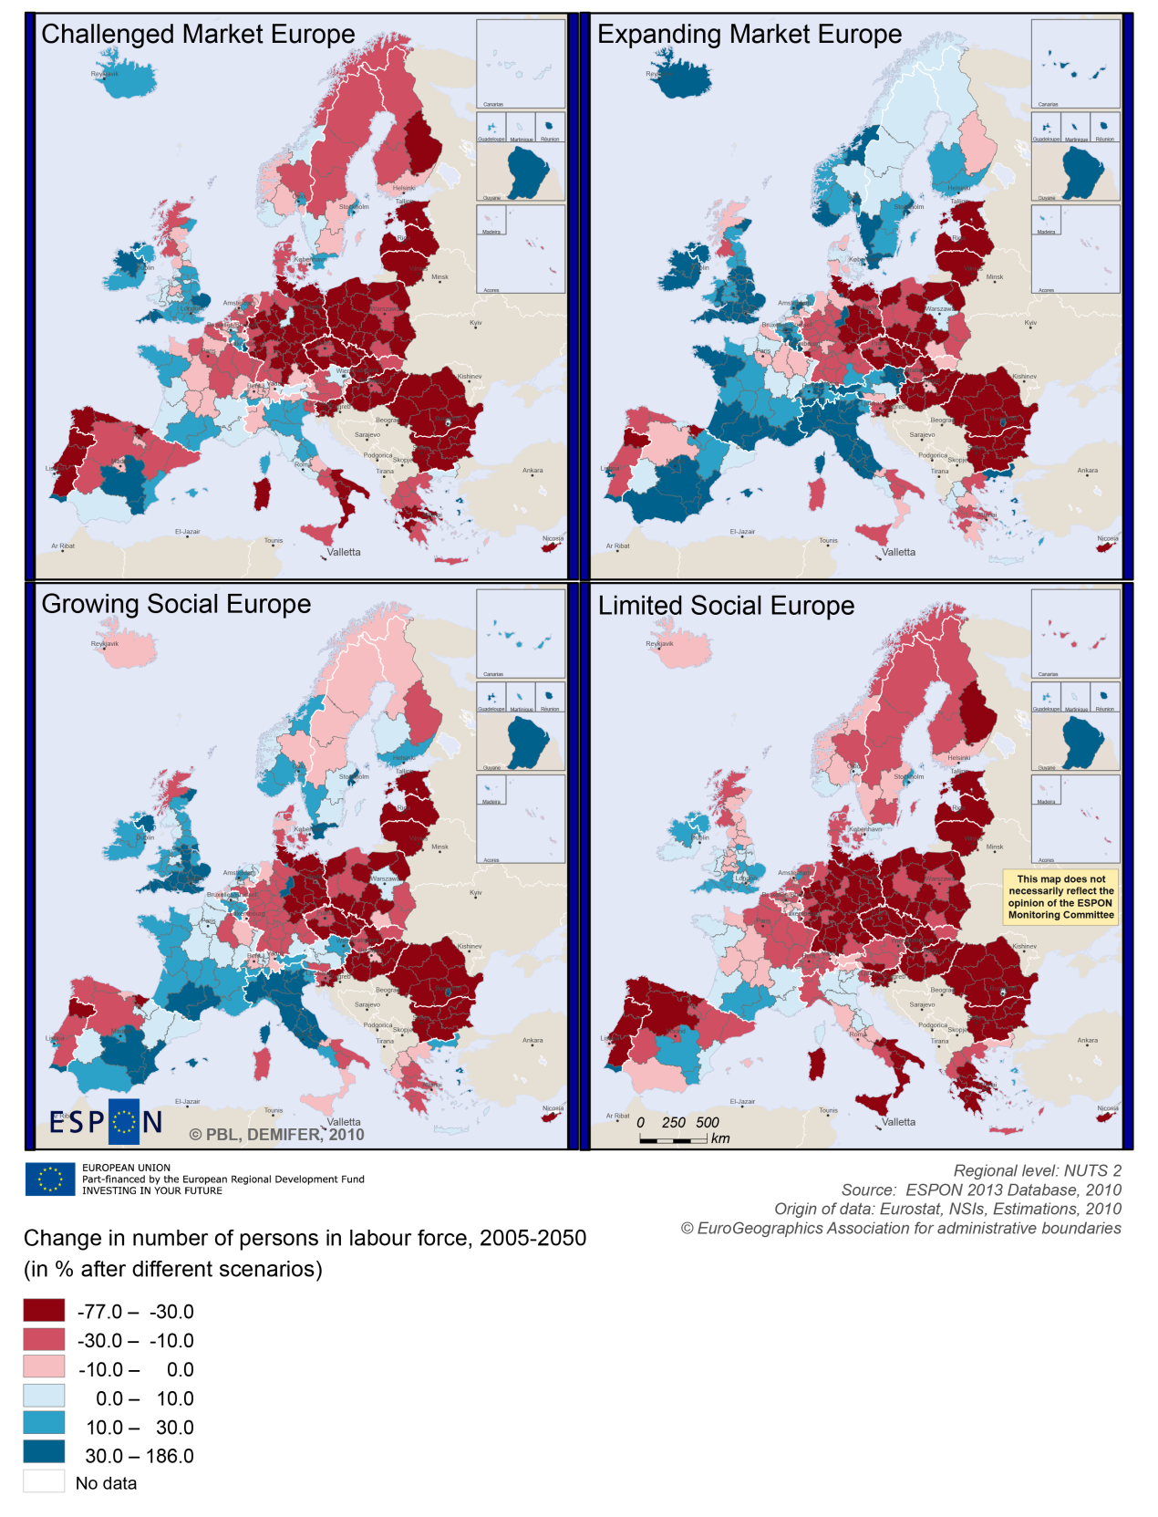

BOX-PLOT 2 – Employment rate 2010 within the CBC Belgium – France
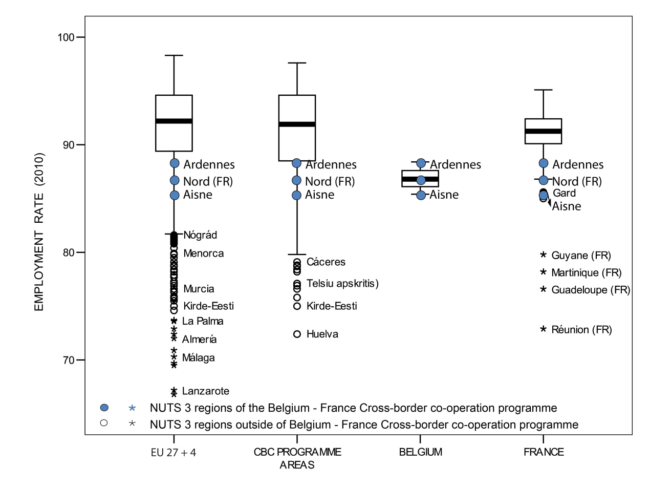
(see “How to read the box-plots?” on page 8)

Territorial factors of interest for the programme area

Territorial cooperation programmes can make a difference for the future development of cross-border and transnational territories in Europe. Some of the factors can be analysed by European wide data sets and using some studies having specific maps, figures and tables concerning the areas of the cooperation region.
For the programme area ESPON TERCO is of particular interest. It comprises a case study focusing on a border region concerning the cross-border cooperation between France and Belgium. The full case study including a lot of detailed analysis of the area and cooperation activities in the area is available in the annex to the (Draft) Final Report of the TERCO project. The below box provides only a short extract from the case study summary.
ESPON TERCO PROJECT – ANNEX TO THE DRAFT FINAL REPORT, PAGE 518-523:
Extracts from the text describing the programme area
Inside the programme area the high population densities draws two axes, one along the former coal basin, from Béthune to Charleroi, through Douai-Lens, Valenciennes, the Borinage and the Centre basin and the other one, perpendicular to the previous one, from Lille to Kortrijk and further North along the Leie valley, continuing to Ghent outside our study region. Dots of high densities appear also around the cities along the coast, but the map of the densities underestimates the urbanisation of the Belgian coast, as many buildings are occupied only as secondary residences.
Three ports are important, even if only mid-sized inside the whole Northern Range between Le Havre and Hamburg: Dunkerque (58 million tons in 2008), Zeebrugge (42) and Calais (40) (to be compared with 421 for Rotterdam, 189 for Antwerp and 140 for Hamburg). Zeebrugge, with a strong specialisation in containers, and Dunkerque are both important freight ports of the North Range, including the development of a seaside iron industry in Dunkerque from the end of the Fifties. Calais remains the most important ferry port for the links with Great-Britain, despite of the Chunnel, followed by Zeebrugge; and moreover Oostende, Nieuwpoort and Boulogne are three other secondary ports, the first one having however lost its position as one of the main passenger trans-Channel ports due to the opening of the Channel.
The urban structure of the area is very dense, but not without presenting challenges. Lille is undoubtedly the main pole of the area. Lille's morphological urban area (MUA) includes Roubaix and Tourcoing. The functional urban area (i.e. the employment basin, FUA) is limited to the South by the former coal basin's FUAs, even if Lille is more and more attracting commuters from this last deprived area. Lille's FUA is not really a true trans-border one, only Comines (Belgium) being included in its FUA, despite of the contiguity between Lille and Mouscron, on the Belgian side.
In a European perspective the programme area is mainly composed urban areas with Lille even being one of the European Metropolitan Growth Areas (see map below). Furthermore the programme area lies in relatively close proximity to Paris and Brussels which offers additional development opportunities. Despite the urban focus the programme areas includes also intermediate and rural areas in close proximity or urban centres.
In terms of infrastructure the region is compared to many other cross-border areas in Europe well endowed with transport infrastructure and has a multimodal accessibility which is above the European average. This is partially also thanks to the high-speed railway connections of Lille, allowing for a good integration in the European transport network and good access to main European metropolitan areas.
MAP 4 – Urban-rural typology of NUTS3 regions including remoteness (DG Regio) for the CBC Belgium – France

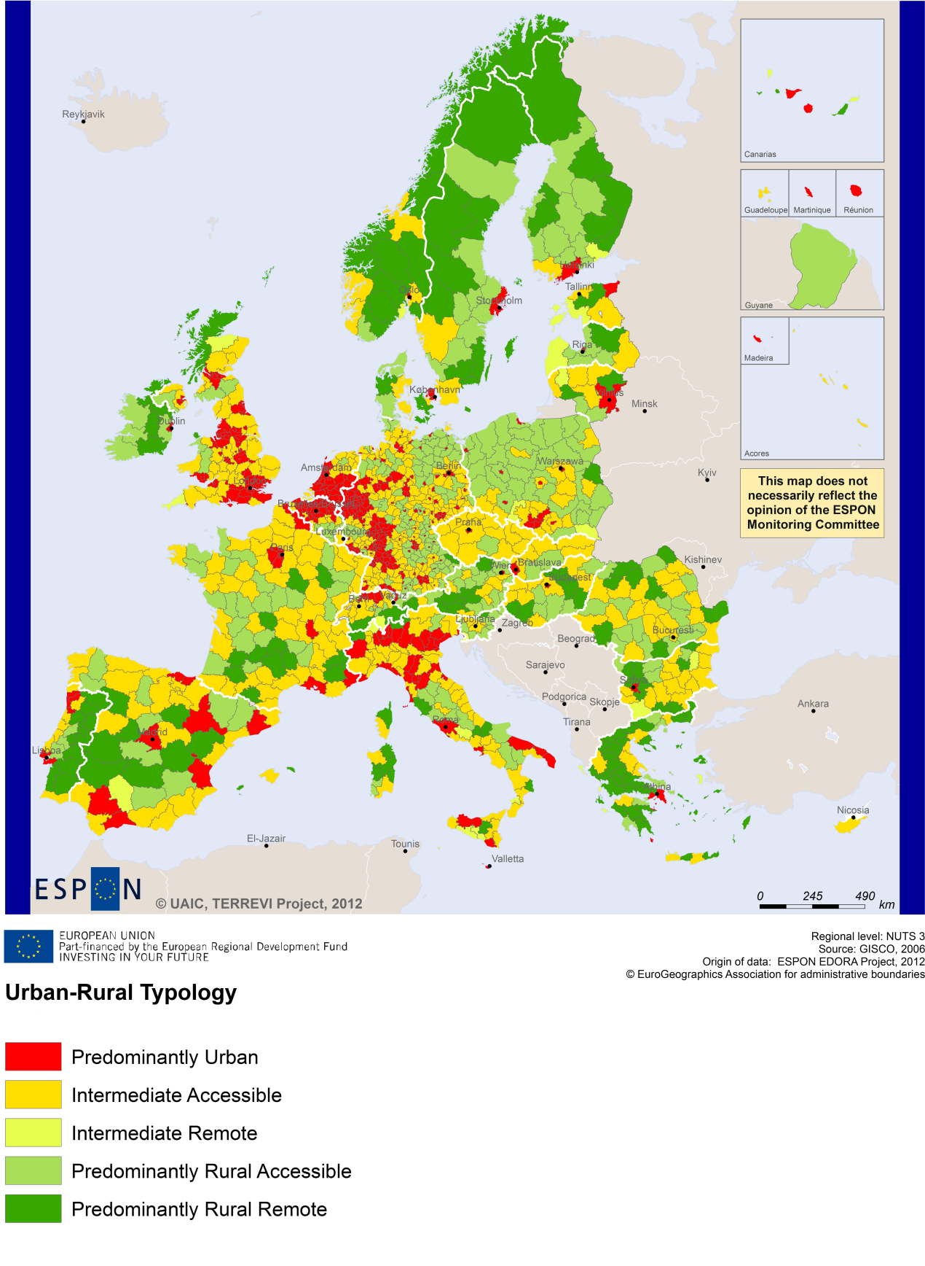
(Accessible=close to a city)

MAP 5 – Multimodal accessibilty (ESPON Accessibility Update) for the CBC Belgium – France
“Potential Accessibility Multimodal” scores accessibility of NUTS 3 regions by road, rail and air relative to the European average in an Accessibility Index.
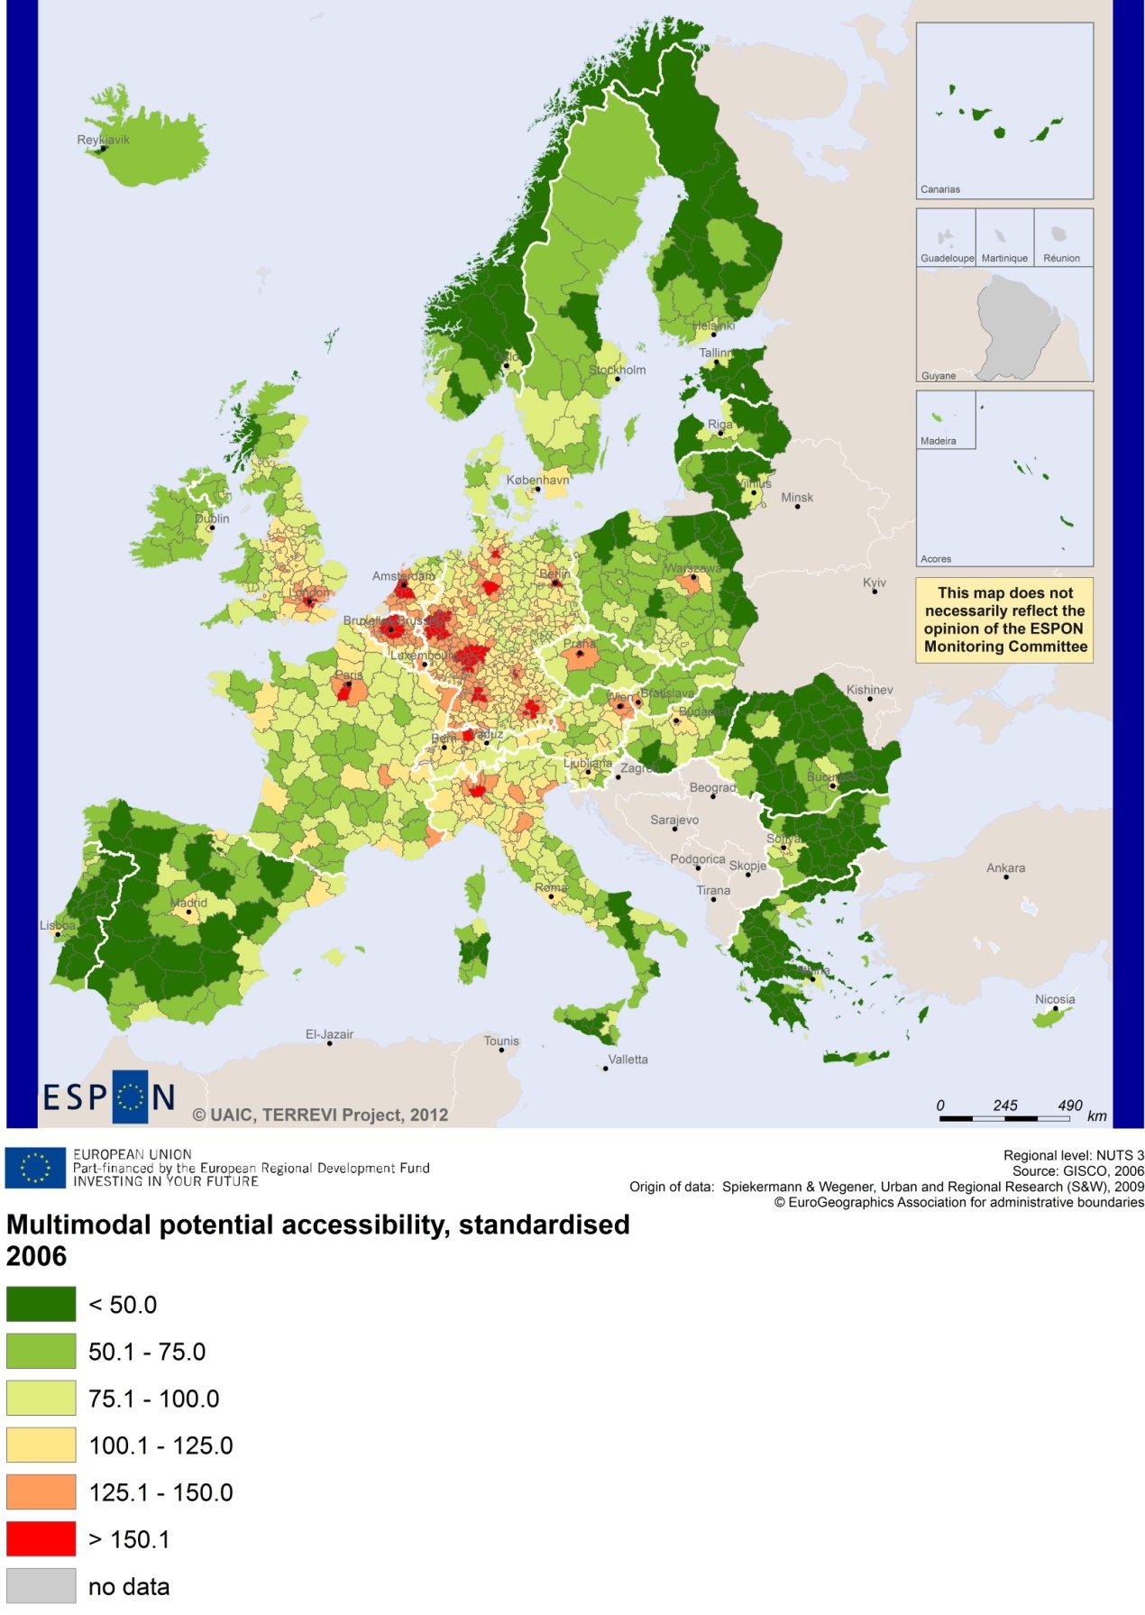

Recommended ESPON reading
ESPON provides an essential underpinning for translating into practice the calls for integrated and place-based approaches to economic development, when analysing a programme area or deciding about future programme priorities. ESPON has published a wide range of exciting reports providing valuable territorial evidence for future territorial cooperation initiatives.
The table below shows examples of relevant projects for the Cooperation Region. However, you have to study other ESPON reports as well in order to capitalise fully on the European information available for the cross-border programming.
ESPON study | Topic | Content
EDORA | Rural areas | It provides evidence on the development opportunities of diverse types of European rural areas and reveals competitiveness options (see maps in Appendix 1).
CLIMATE | Climate change | It analyses how and to which degree climate change will impact on the competitiveness and cohesion of European regions and Europe as a whole (see from map 1 to 23).
TIPTAP | Territorial impact assessment | It provides a tool for the ex-ante assessment of territorial impacts of policies to deliver evidence on the territorial impact of policies (see from map 2.3.1 to 2.3.9).
CAEE | Agglomerati-on economies | It aims at a better understanding of the economic costs and benefits of large urban agglomerations (see figure 1).
TRANSMEC | European cooperation | It develops a method providing guidance on how ESPON results can add value to support territorial cooperation programmes (see map 27 and from map 36 to 39).
SEMIGRA | Rural migration | It describes migration in rural regions in order to develop strategies for territorial development (see map 1, 4 and 5).
KIT | Innovation | It describes patterns and potentials of regions in terms of knowledge and innovation economy and explores development opportunities (see from map 3.1.1 to 4.4.1).
SGPTD | Growth poles | It provides evidence about performance and roles of European secondary cities (see from figure 2 to 2.12).
TERCO | Territorial cooperation | It delivers evidence concerning accessibility, demography and competitiveness. It has a case study 2.3.6 on the border region of France, Belgium and Luxembourg.
TPM | Territorial performance | It establishes knowledge of macro challenges at the regional level. A case study concerns the region of Flanders.
GEOSPECS | Specific types of territories | It provides describes the specific types of territories. The project reports the Belgian Coast Region of Luxembourg as a case study in the Annex 35 of the Scientific Report.
Furthermore, some of overall ESPON products of particular interest for territorial cooperation are:
- ESPON Synthesis report “new evidence on smart, sustainable and inclusive territories” provides an easy to read overview on ESPON results available.
- ESPON Territorial Observations is a publication series, which on a few pages presents policy relevant findings deriving from latest ESPON research.
- ESPON 2013 Database provides regional information provided by ESPON projects and EUROSTAT.
- ESPON Hyperaltas allows comparing and analysing a region’s relative position at European, national and local scale for a wide range of criteria.
- ESPON MapFinder provides access to the most relevant ESPON maps resulting from ESPON projects and reports.
- ESPON Typologies provides nine regional typologies for additional analysis of regional data to be considered in the European context.
All ESPON reports and tools are freely available at
www.espon.eu
The ESPON 2013 Programme is part-financed by the European Regional Development Fund, the EU Member States and the Partner States Iceland, Liechtenstein, Norway and Switzerland. It shall support policy development in relation to the aim of territorial cohesion and a harmonious development of the European territory.

