Germany Saxony - Poland
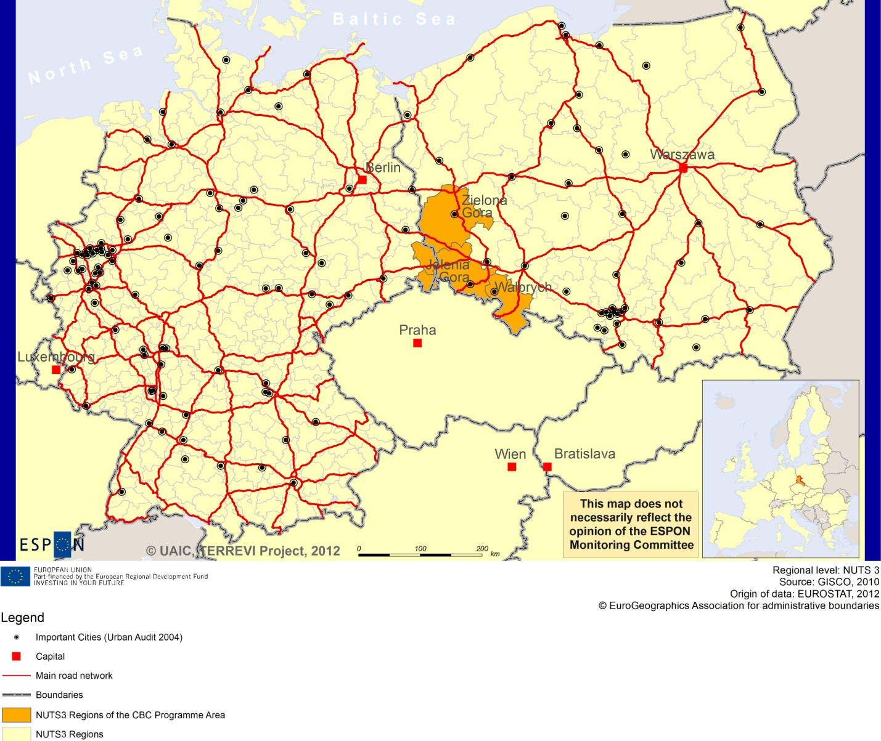

ESPON Project TERREVI
November 2012

Introduction
ESPON supports policy development in relation to the aim of territorial cohesion and a harmonious development of the European territory. It provides comparable information, evidence, analysis, and scenarios on territorial dynamics, which reveal territorial capitals and development potentials of regions and larger territories. Considering the programme area in its European context adds an important new perspective that can help shaping the programming and the places of implementing projects.
The ESPON TERREVI project focuses on producing evidence for Structural Funds programmes with the aim to support the development of the programmes to be carried out in the 2014-2020 period.
One milestone of this work consists in presenting selected ESPON research pieces in easy-to-understand factsheets for all territorial cooperation programme areas. The aim is to provide the reader with preliminary insight on types of territorial evidence ESPON holds at hand with regard to the possible investment priorities of future programmes. The factsheets certainly only give a first glimpse rather than fully present the work of the large number of ESPON projects that are currently underway. Likewise, each programme area includes diverse development potentials and challenges, which needs targeted information search. However, hopefully this factsheet will contain information, benchmarking the programme area in its larger, territorial context, that is of interest and help to better understand the programme area and to navigate within the richness of ESPON material available.
In addition to the programme factsheets there will be a number of specific programme case studies illustrating how ESPON material can be used to support the development of future programmes e.g. by giving a comparative European dimension to the envisaged SWOTs. These case studies will be carried out in early 2013.
This factsheet is structured in three main parts. The first part presents a selection of indicators that help comparing the situation of the programme area in question with the European average, the average for all programme areas as well as the situation in the countries involved. The second part briefly presents the territorial factors of interest for the programme area. The final part offers guidance on the further use of ESPON results and tools. This is intended as an electronic publication so map quality is generally high to allow users to zoom into specific territories.
This factsheet does not necessarily reflect the opinion of the ESPON Monitoring Committee.

Europe 2020
Europe, with its member states and their regions, is more exposed to global shocks and international competition than at any time before. As the world becomes more interdependent this trend will continue and shape policy thinking across sectors, borders and geographical scales. At the same time, Europe is characterised by a large territorial diversity meaning that global developments can imply rather different development possibilities and challenges for different European regions and cities.
The differences are partly defined by major geographical structures such as urban systems, access and connectivity, the geographical specificity or population density. At the same time, the differences are also spelled out in the larger development trends that affect an area, and the way and degree to which it is affected.
The data, indicators and territorial evidence provided by ESPON provides insight on both the main structures and larger territorial trends. The fine art is to identify what can actually be influenced by policy-making and, in particular, by place-based policy and territorial cooperation related to your programme area.
This chapter provides a selection of ESPON data related to Europe 2020 objectives of smart, sustainable and inclusive growth, giving also hints as regards the main thematic objectives envisaged in the draft regulations for the next period of EU Cohesion Policy. The Europe 2020 Strategy aims to enhance smart, sustainable and inclusive growth. This strategy has clear territorial dimensions. However, achieving these goals is challenging in the crisis-driven times. Furthermore, the economic disparities are growing as economic trends and the crisis have various impacts on different parts of Europe.
In the following the traffic light for each indicator represents how your programme territory compares to wider European and national medians where green = your programme area performs better for that indicator, yellow = similar, and red = worse.
In creating the traffic lights the median was used as central value indicator for all statistical variables due to its advantages (easy to interpret, it splits the statistical distribution in half) but especially due to the constraints linked to the impossibility of computing means for several indicators (Climate Change, Wind Energy Potential etc.). Therefore, a special attention should be given in reading the median values when the number of NUTS 2 regions is below 7. Using percentiles implies also a high dependence of the final results on the type of statistical distribution. This fact should be considered when establishing the relative position of a CBC Programme Area to a specific country.
EU 27+4 in Traffic Lights and box-plots means the EU Member States as well as Iceland, Liechtenstein, Norway and Switzerland – the ESPON space.

Smart growth
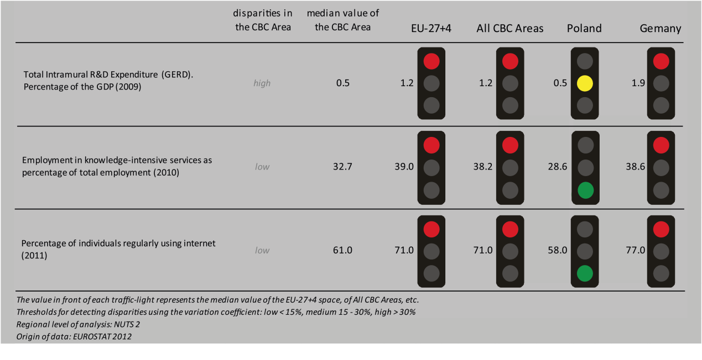
Smart growth refers to developing an economy based on knowledge and innovation. In the framework of the Europe 2020 Strategy it means improving the EU's performance in education, research/innovation and digital society.

According to all indicators reported above, the Germany Saxony - Poland CBC area performs at worse level than both the EU27+4 space and all CBC ones. Considering the objective of R&D expenditure of percentage of the GDP - one of the five headline targets in the Europe 2020 Strategy - the CBC area is still lagging behind the EU27+4 space and all CBC. Moreover, the CBC area is characterized by a high internal disparity and has similar level to Poland.
Concerning the ratio of employment in knowledge-intensive service to the total employment in 2010, the CBC area has lower values than both the EU27+4 space and all CBCs; slightly higher than Poland. The distribution inside the CBC results in a low level of internal disparity.
In terms of the percentage of individuals regularly using internet in 2011, the CBC has lower values than both the EU27+4 space and all CBCs, but it performs slightly better than Poland, with a low) internal disparity.
According to the classification of the KIT project, MAP 1 identifies two territorial patterns of innovation, which are moreover keeping up with national borders:
- ‘Smart and creative diversification area’ in the Polish side, i.e. the sub-regions of Jeleniogórsko-Wałbrzyski and Zielonogórski. It is defined by a low degree of local diversified applied knowledge, internal innovation capacity, high degree of local competences, creativity and entrepreneurship, external knowledge embedded in technical and organizational capabilities;
- ‘European science-based area’ in the German side, i.e. the regions of Niederschlesischer Oberlausitzkreis, Löbau – Zittau and Kreisfreie Stadt Görlitz. It is characterised by strong knowledge and innovation, specialized in general purpose technologies, with a high generality and originality of science-based local knowledge.

MAP 1 – Territorial Patterns of Innovation (ESPON KIT project) for the CBC Germany Saxony - Poland

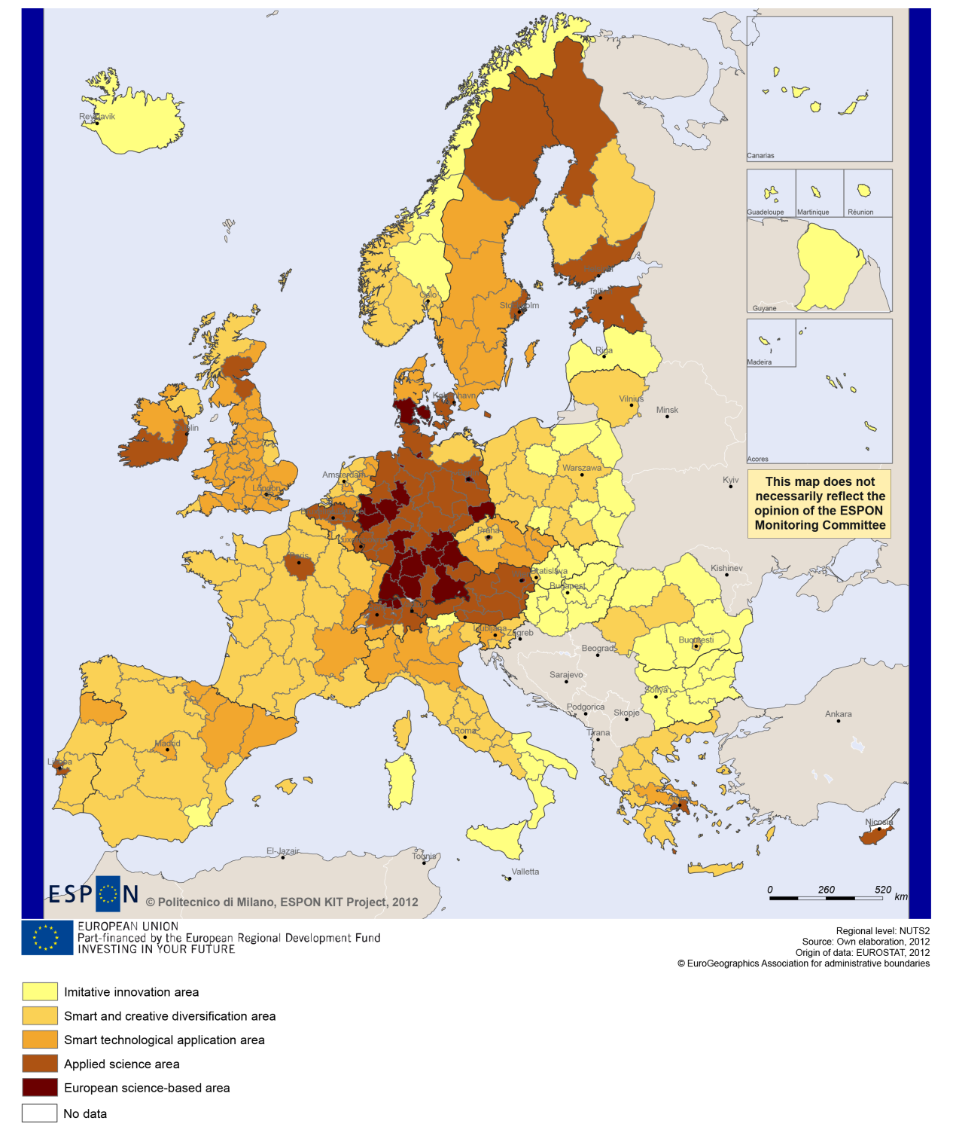

Sustainable growth
Sustainable growth refers to promoting a more resource efficient, greener and more competitive economy. Within the Europe 2020 Strategy it means e.g. building a more competitive low-carbon economy that makes efficient, sustainable use of resources, protecting the environment, reducing emissions and preventing biodiversity loss, capitalising on Europe's leadership in developing new green technologies and production methods, and introducing efficient smart electricity grids. In the framework of the Europe 2020 Strategy it means focus on competitiveness, resource efficiency, climate change and biodiversity.
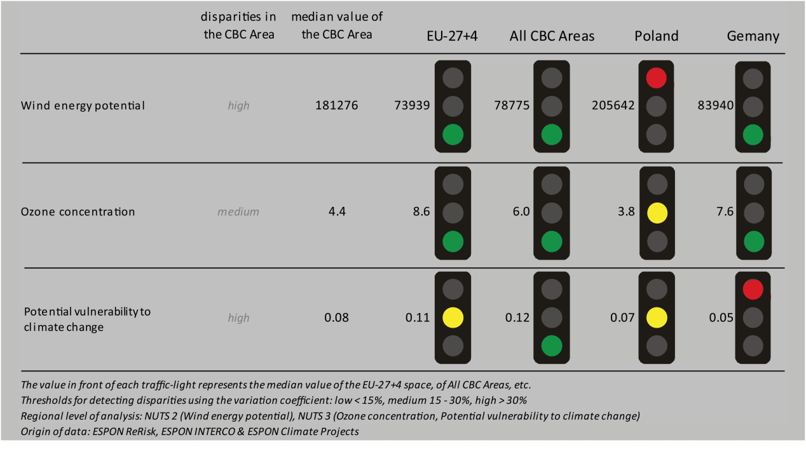
The use of wind energy potential could be one of the cornerstones in building a competitive low-carbon economy in the EU. The programme area as a whole shows a median value that is significantly higher than the EU 27+4 and all the CBC programme areas in Europe. The CBC area shows a significantly higher value than the national level of Germany. Regarding the ozone concentration the CBC are shows lower value than the EU 27+4 and all the CBC programme areas as well as compared to German national levels. Both indicators show high disparities within the CBC area.
The Poland - Germany programme is less vulnerable to potential climate change compared to the EU 27+4 and all the CBC regions whereas compared to the German and Polish national levels the cooperation area is more vulnerable. Both sides of the border in the CBC area are not affected by territorial impact of Directive 11 on fossil fuel consumption (MAP 2) and their combined adaptive capacity to climate change (BOX-PLOT 1) in general similar to the national levels. On the Polish side the NUTS3 region of Walbrzyskie shows a lower capacity compared to the respective national values.

MAP 2 - Territorial impact on fossil fuel consumption of Directive on the promotion of clean and energy-efficient road transport vehicles (ESPON ARTS project) for the CBC Germany Saxony - Poland

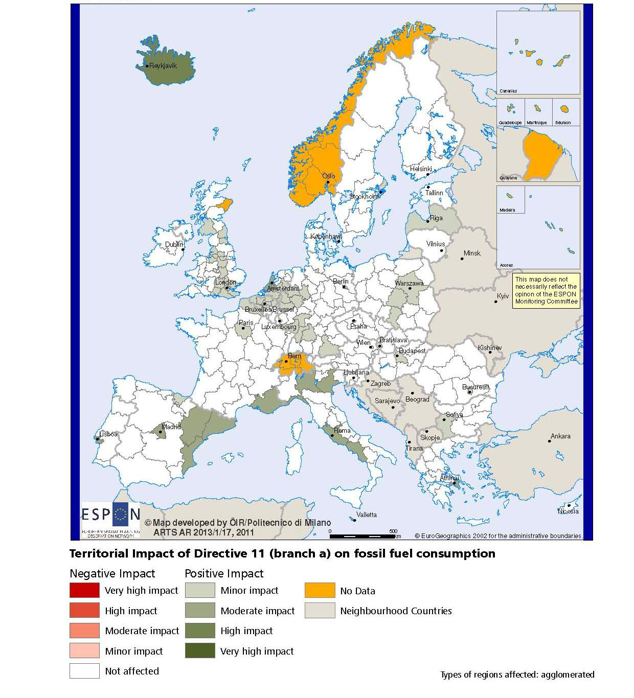

BOX-PLOT 1 – Combined adaptive capacity to climate change (ESPON CLIMATE project) for the CBC Germany Saxony – Poland
“Adaptive capacity (adaptability)” to climate change indicates the ability or potential of a system to respond successfully to climate change and variability, and includes adjustments in behaviour, resources and technologies.
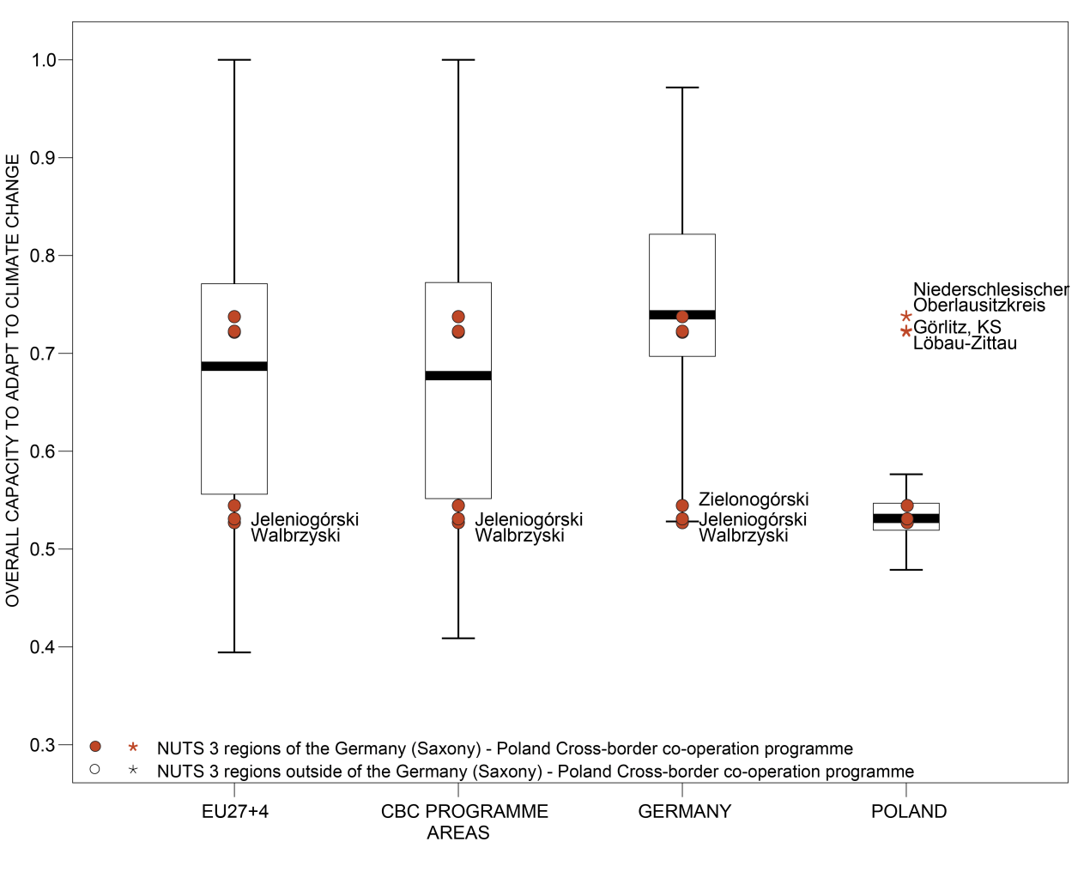

How to read the box-plots?
The box-plot is a statistical and mathematical tool used to visualize numerical data sets and to compare its statistical distribution.
Because it is used in exploratory analysis of databases, this representation is sensitive to the quality of the central value selected to explain the symmetry, shape and distribution variability. In the case of a box-plot, the most used central value is the median, because it has the quality of sectioning the data string into two halves, so that 50% of the cases will be above the central value and the other half will be below it. Since the purpose of the representation is to highlight outliers’ behavior, it uses a box that encompasses half of the cases, i.e. values that are in the range defined by the percentile of 25% and 75%. If a region has a value in this box then it can be considered that it has, according to the variable in question, a situation close to the average behavior of all regions analyzed.
When a region consistently deviates from the average profile of the analyzed territorial context, this behavior will be noted in the chart only when certain thresholds of statistical tolerances are exceeded, this being pointed in the diagram with segments perpendicular to the middle box, segments called the "whiskers".

Inclusive growth
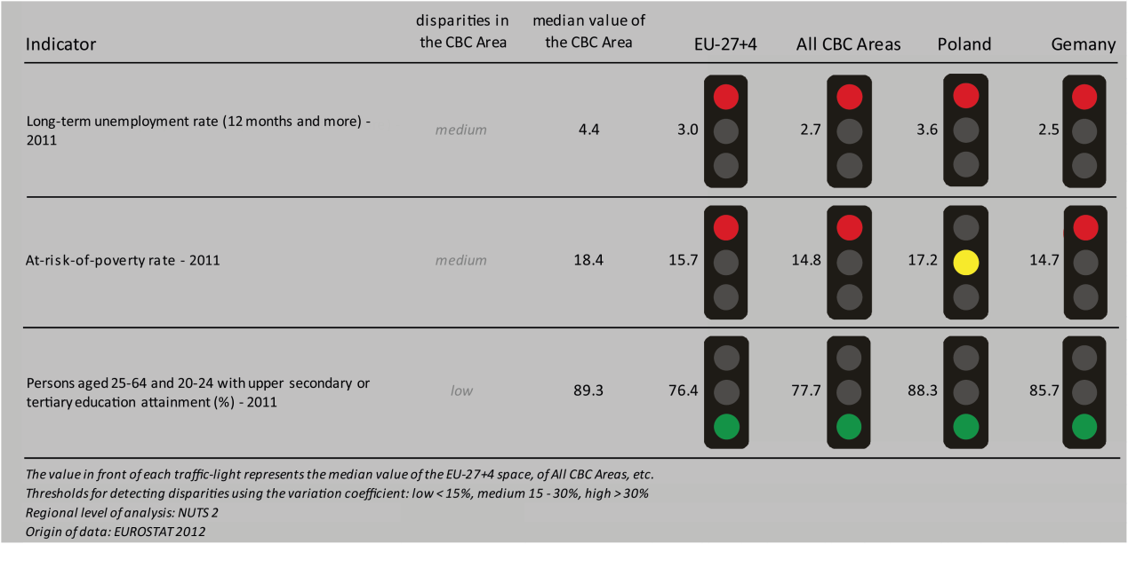
Inclusive growth refers to fostering a high-employment economy delivering social and territorial cohesion. Within the Europe 2020 Strategy it means raising Europe’s employment rate, helping people of all ages anticipate and manage change through investment in skills & training, modernising labour markets and welfare systems, and ensuring the benefits of growth reach all parts of the EU. In short the key factors are employment and avoiding risk of poverty and social exclusion.

The CBC area of Poland- Germany in general shows higher values in the case of long-term unemployed persons and persons at risk of poverty compared to the EU27+4 and the other CBC regions in Europe. Looking at the employment rates (BOX-PLOT 2) in the programme area compared to the EU27+4 and the CBC areas as a whole, the majority of NUTS3 regions in Bulgaria-Greece have a lower employment rate. The German region of Görlitz has an employment rate that is lower than all the other NUTS3 regions of the CBC area. Analysing the different scenarios highlighted in the ESPON DEMIFER project (MAP 3) regarding the change in labour force until 2050, it can be stated that the situation is very similar between the Polish and the German part of the cooperation area. Whatever scenario will take place, there are significantly negative changes on both sides of the border. The Polish part of Poland -Germany shows less negative effects in the case of the change in labour force in three out of four scenarios.

MAP 3 – Change in Labour Force 2005-2050 (ESPON DEMIFER project) for the CBC Germany Saxony - Poland

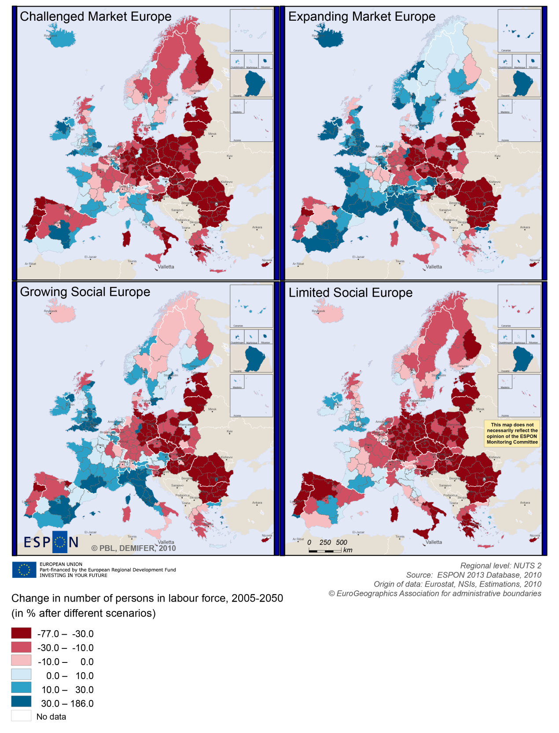

BOX-PLOT 2 – Employment rate 2010 within the CBC Germany Saxony - Poland
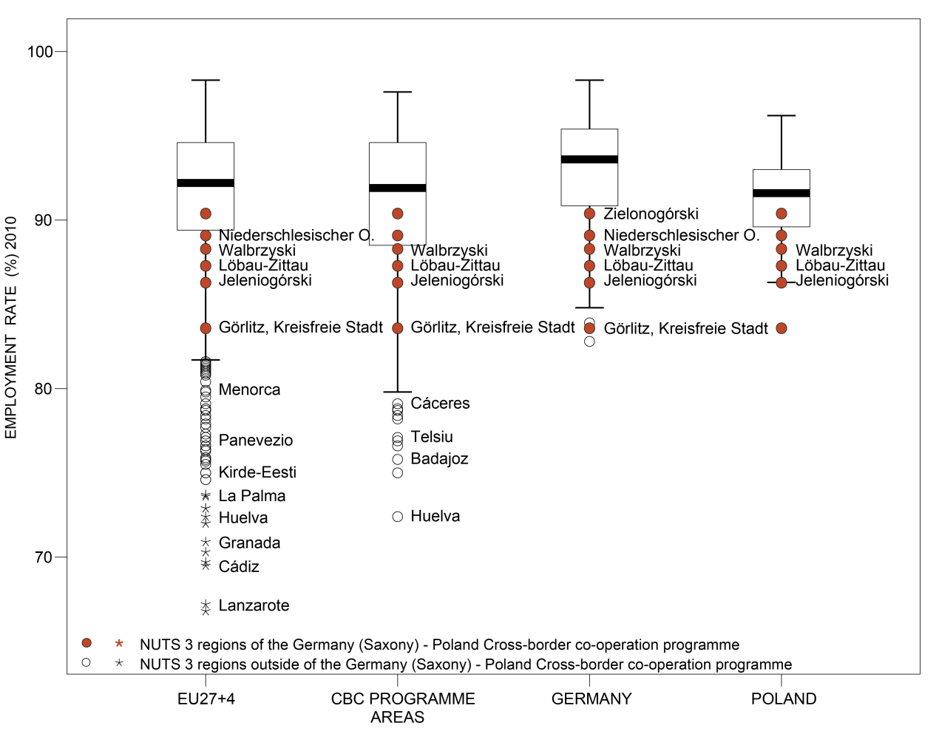

(see “How to read the box-plots?” on page 8)

Territorial factors of interest for the programme area
Territorial cooperation programmes can make a difference for the future development of cross-border and transnational territories in Europe. Some of the factors can be analysed by European wide data sets and using some studies having specific maps, figures and tables concerning the areas of the cooperation region.
In a European perspective the programme area is mainly characterised by intermediate regions (i.e. in-between urban and rural) close to a city. The urban centres in the programme area are Zielona Gora, Jelenia Gora Walbrzych and Gorlitz. However, the development of the programme area benefits also from the close proximity to urban centres such as Cottbus and Wroclaw.
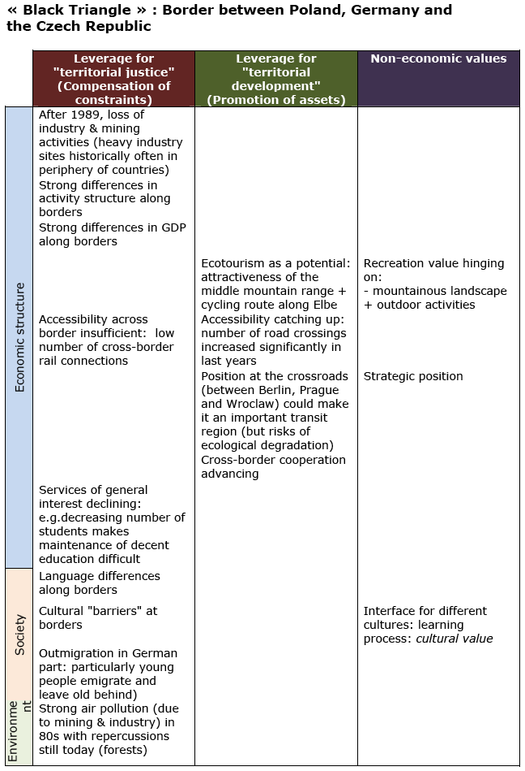
This concerns both the access to services and infrastructure. At present, most parts of the programme areas area have below European average accessibility and only limited opportunities for one-day business trips within the European urban network. When it comes to ICT infrastructure, the level of internet use and connections appears to be moderate in a European perspective.
At the same time, the mainly ‘intermediate, close to a city’ character and of the programme area comprises a wide range of development opportunities and challenges. The final report of ESPON GEOSPECS contains a case study on the Czech-German-Polish border area, including economic, cultural, demographic and environmental challenges and potentials. Also the final report of ESPON TERCO includes a case study on the Czech-German-Polish border area.
(The table comes for the ESPON GEOSPECS Final Report, page 121)

MAP 4 – Urban-rural typology of NUTS3 regions including remoteness (DG Regio) for the CBC Germany Saxony - Poland

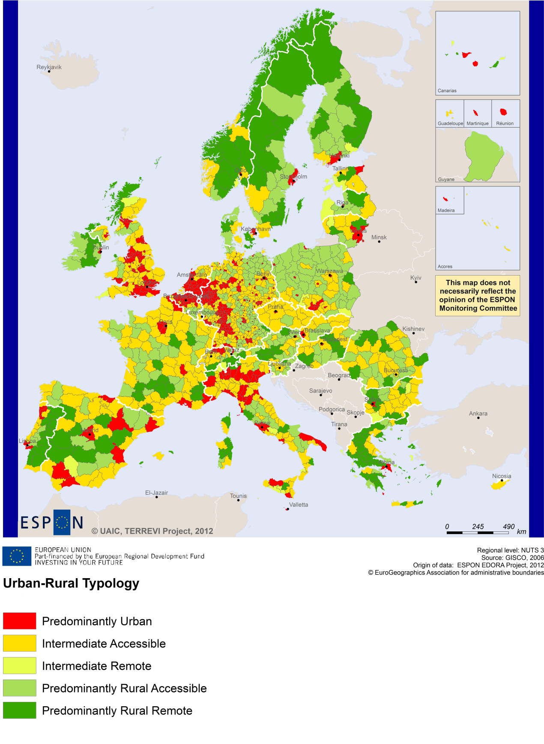

(Accessible=close to a city)

MAP 5 – Multimodal accessibilty (ESPON Accessibility Update) for the CBC Germany Saxony – Poland
“Potential Accessibility Multimodal” scores accessibility of NUTS 3 regions by road, rail and air relative to the European average in an Accessibility Index.
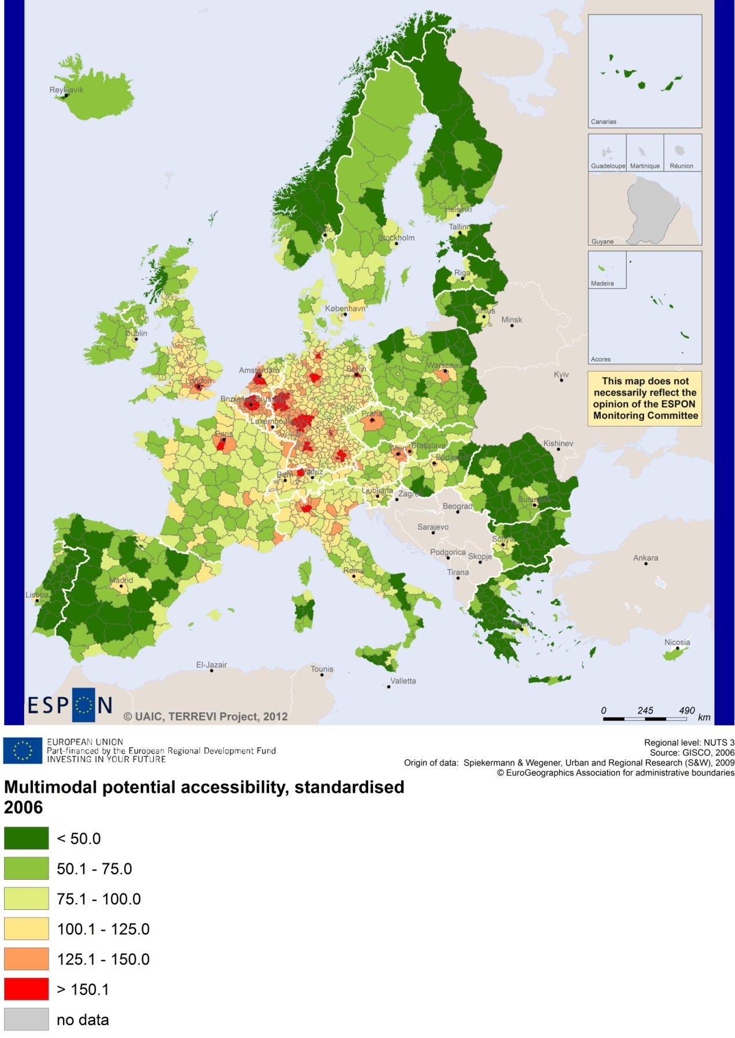

Recommended ESPON reading
ESPON provides an essential underpinning for translating into practice the calls for integrated and place-based approaches to economic development, when analysing a programme area or deciding about future programme priorities. ESPON has published a wide range of exciting reports providing valuable territorial evidence for future territorial cooperation initiatives.
The table below shows examples of relevant projects for the Cooperation Region. However, you have to study other ESPON reports as well in order to capitalise fully on the European information available for the cross-border programming.
ESPON study | Topic | Content
EDORA | Rural areas | It provides evidence on the development opportunities of diverse types of European rural areas and reveals competitiveness options (see maps in Appendix 1).
CLIMATE | Climate change | It analyses the impact of climate change will on European regions (see from map 1 to 23).
TIPTAP | Territorial impact assessment | It provides a tool for the ex-ante assessment of territorial impacts of policies to deliver evidence on the territorial impact of policies (see from map 2.3.1 to 2.3.9).
CAEE | Agglomerati-on economies | It aims at a better understanding of the economic costs and benefits of large urban agglomerations (see figure 1).
TRANSMEC | European cooperation | It develops a method providing guidance on how ESPON results can add value to support territorial cooperation programmes (see map 27 and from map 36 to 39).
SEMIGRA | Rural migration | It identifies the main reasons and consequences of selective migration in rural regions in order to develop strategies for territorial development (see map 1, 4 and 5). It focuses on the region of Sachsen-Anhalt.
KIT | Innovation | It describes patterns and potentials of regions in terms of knowledge and innovation economy and explores development opportunities (see from map 3.1.1 to 4.4.1).
SGPTD | Growth poles | It provides evidence about performance and roles of European secondary cities (see from figure 2 to 2.12).
TERCO | Territorial cooperation | It provides an assessment of the adequacy of existing territorial cooperation areas (see the annex 2.3.4 on the border region between Germany and Czech Republic).
GEOSPECS | Specific types of territories | It analyses specific types of territories and regions (see the Scientific report on the Czech-German-Polish border).
Furthermore, some of overall ESPON products of particular interest for territorial cooperation are:
- ESPON Synthesis report “new evidence on smart, sustainable and inclusive territories” provides an easy to read overview on ESPON results available.
- ESPON Territorial Observations is a publication series, which on a few pages presents policy relevant findings deriving from latest ESPON research.
- ESPON 2013 Database provides regional information provided by ESPON projects and EUROSTAT.
- ESPON Hyperaltas allows comparing and analysing a region’s relative position at European, national and local scale for a wide range of criteria.
- ESPON MapFinder provides access to the most relevant ESPON maps resulting from ESPON projects and reports.
- ESPON Typologies provides nine regional typologies for additional analysis of regional data to be considered in the European context.
All ESPON reports and tools are freely available at
www.espon.eu

The ESPON 2013 Programme is part-financed by the European Regional Development Fund, the EU Member States and the Partner States Iceland, Liechtenstein, Norway and Switzerland. It shall support policy development in relation to the aim of territorial cohesion and a harmonious development of the European territory.

