Greece – Bulgaria
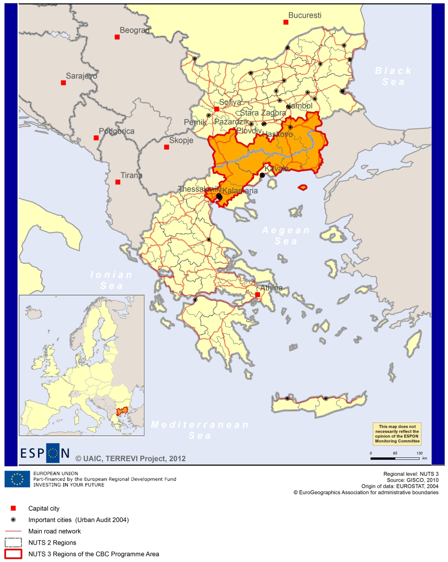

ESPON Project TERREVI
November 2012

Introduction
ESPON supports policy development in relation to the aim of territorial cohesion and a harmonious development of the European territory. It provides comparable information, evidence, analysis, and scenarios on territorial dynamics, which reveal territorial capitals and development potentials of regions and larger territories. Considering the programme area in its European context adds an important new perspective that can help shaping the programming and the places of implementing projects.
The ESPON TERREVI project focuses on producing evidence for Structural Funds programmes with the aim to support the development of the programmes to be carried out in the 2014-2020 period.
One milestone of this work consists in presenting selected ESPON research pieces in easy-to-understand factsheets for all territorial cooperation programme areas. The aim is to provide the reader with preliminary insight on types of territorial evidence ESPON holds at hand with regard to the possible investment priorities of future programmes. The factsheets certainly only give a first glimpse rather than fully present the work of the large number of ESPON projects that are currently underway. Likewise, each programme area includes diverse development potentials and challenges, which needs targeted information search. However, hopefully this factsheet will contain information, benchmarking the programme area in its larger, territorial context, that is of interest and help to better understand the programme area and to navigate within the richness of ESPON material available.
In addition to the programme factsheets there will be a number of specific programme case studies illustrating how ESPON material can be used to support the development of future programmes e.g. by giving a comparative European dimension to the envisaged SWOTs. These case studies will be carried out in early 2013.
This factsheet is structured in three main parts. The first part presents a selection of indicators that help comparing the situation of the programme area in question with the European average, the average for all programme areas as well as the situation in the countries involved. The second part briefly presents the territorial factors of interest for the programme area. The final part offers guidance on the further use of ESPON results and tools. This is intended as an electronic publication so map quality is generally high to allow users to zoom into specific territories.
This factsheet does not necessarily reflect the opinion of the ESPON Monitoring Committee

Europe 2020
Europe, with its member states and their regions, is more exposed to global shocks and international competition than at any time before. As the world becomes more interdependent this trend will continue and shape policy thinking across sectors, borders and geographical scales. At the same time, Europe is characterised by a large territorial diversity meaning that global developments can imply rather different development possibilities and challenges for different European regions and cities.
The differences are partly defined by major geographical structures such as urban systems, access and connectivity, the geographical specificity or population density. At the same time, the differences are also spelled out in the larger development trends that affect an area, and the way and degree to which it is affected.
The data, indicators and territorial evidence provided by ESPON provides insight on both the main structures and larger territorial trends. The fine art is to identify what can actually be influenced by policy-making and, in particular, by place-based policy and territorial cooperation related to your programme area.
This chapter provides a selection of ESPON data related to Europe 2020 objectives of smart, sustainable and inclusive growth, giving also hints as regards the main thematic objectives envisaged in the draft regulations for the next period of EU Cohesion Policy. The Europe 2020 Strategy aims to enhance smart, sustainable and inclusive growth. This strategy has clear territorial dimensions. However, achieving these goals is challenging in the crisis-driven times. Furthermore, the economic disparities are growing as economic trends and the crisis have various impacts on different parts of Europe.
In the following the traffic light for each indicator represents how your programme territory compares to wider European and national medians where green = your programme area performs better for that indicator, yellow = similar, and red = worse.
In creating the traffic lights the median was used as central value indicator for all statistical variables due to its advantages (easy to interpret, it splits the statistical distribution in half) but especially due to the constraints linked to the impossibility of computing means for several indicators (Climate Change, Wind Energy Potential etc.). Therefore, a special attention should be given in reading the median values when the number of NUTS 2 regions is below 7. Using percentiles implies also a high dependence of the final results on the type of statistical distribution. This fact should be considered when establishing the relative position of a CBC Programme Area to a specific country.
EU 27+4 in Traffic Lights and box-plots means the EU Member States as well as Iceland, Liechtenstein, Norway and Switzerland – the ESPON space.

Smart growth
Smart growth refers to developing an economy based on knowledge and innovation. In the framework of the Europe 2020 Strategy it means improving the EU's performance in education, research/innovation and digital society.
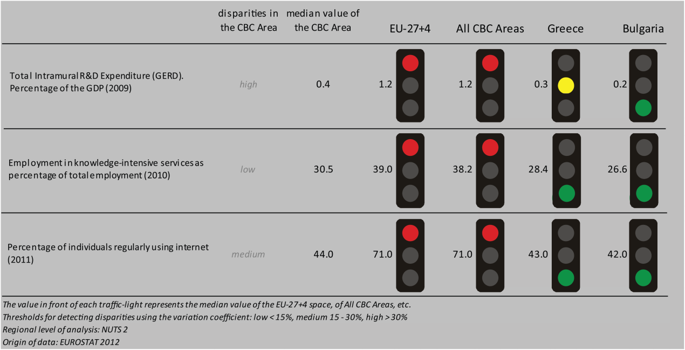
According to all indicators reported above, the Greece – Bulgaria CBC area performs at a lower level than the EU27+4 space and all CBC ones. Considering the objective of R&D expenditure of percent of the GDP - one of the five headline targets in the Europe 2020 Strategy - the CBC area is still lagging behind the EU27+4 space and all CBC. Moreover, Greece – Bulgaria is characterized by a high level of internal disparity and by a performance similar to Greece and substantially better than Bulgaria.
Concerning the ratio of employment in knowledge-intensive service to the total employment in 2010, the CBC area has lower values than the EU27+4 space and all CBC level; higher than both Greece and Bulgaria. The distribution inside the TNC is rather homogenous resulting in a low level of internal disparity.
In terms of the percentage of individuals regularly using internet in 2011, the CBC is significantly behind the EU27+4 space and all CBC, but it performs better than Greece and Bulgaria, with an internal disparity.
According to the classification of the KIT project, MAP 1 identifies two territorial patterns of innovation, which are moreover keeping up with national borders:
- ‘Smart and creative diversification area’ in the Greek side. It is defined by a low degree of local diversified applied knowledge, internal innovation capacity, high degree of local competences, creativity and entrepreneurship, external knowledge embedded in technical and organizational capabilities;
- ‘Creative imitation area’, in the Bulgarian part. It is associated to a low knowledge and innovation intensity, entrepreneurship, creativity, a high attractiveness and a high innovation potential.

MAP 1 – Territorial Patterns of Innovation (ESPON KIT project) for the CBC Greece-Bulgaria

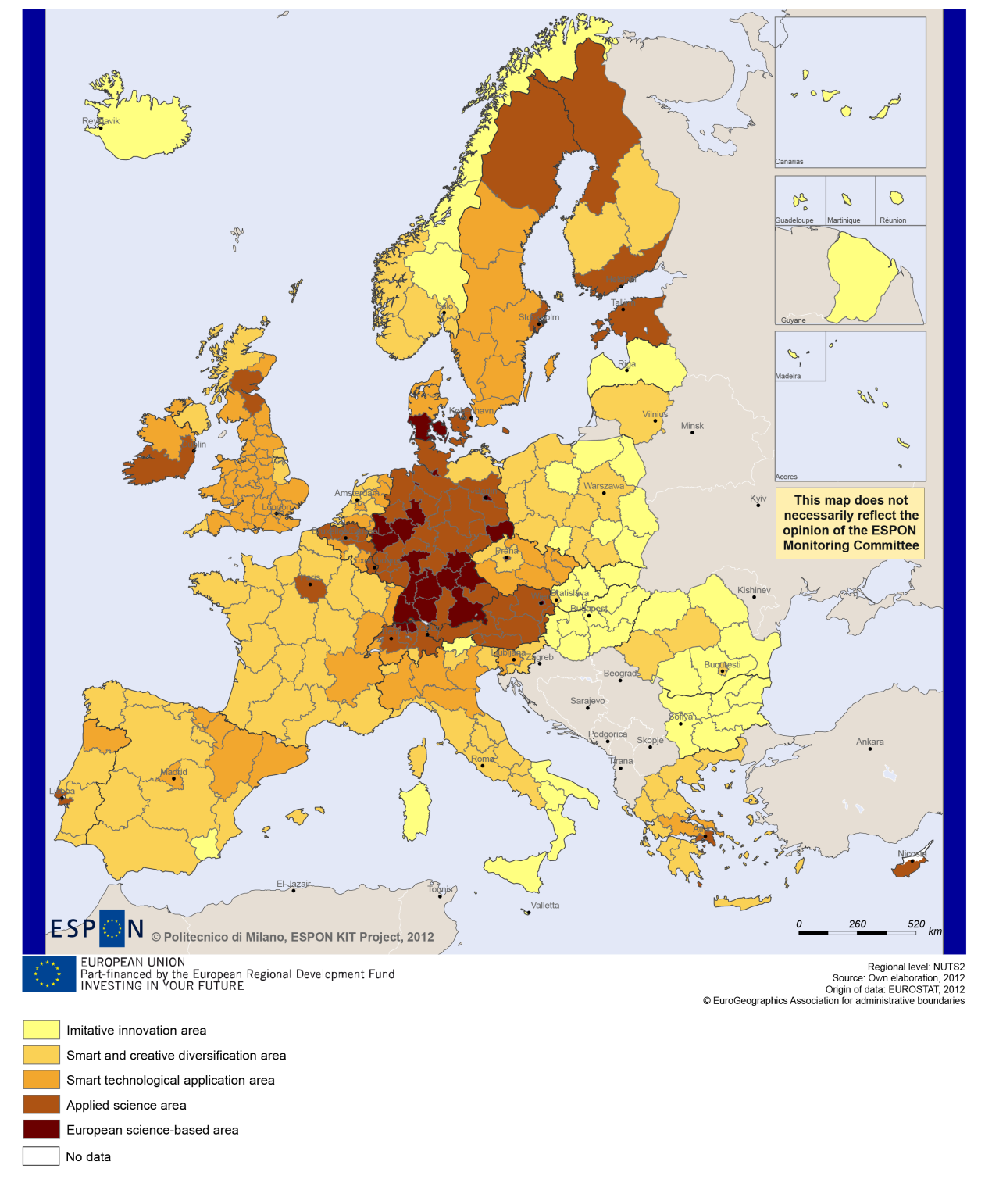

Sustainable growth
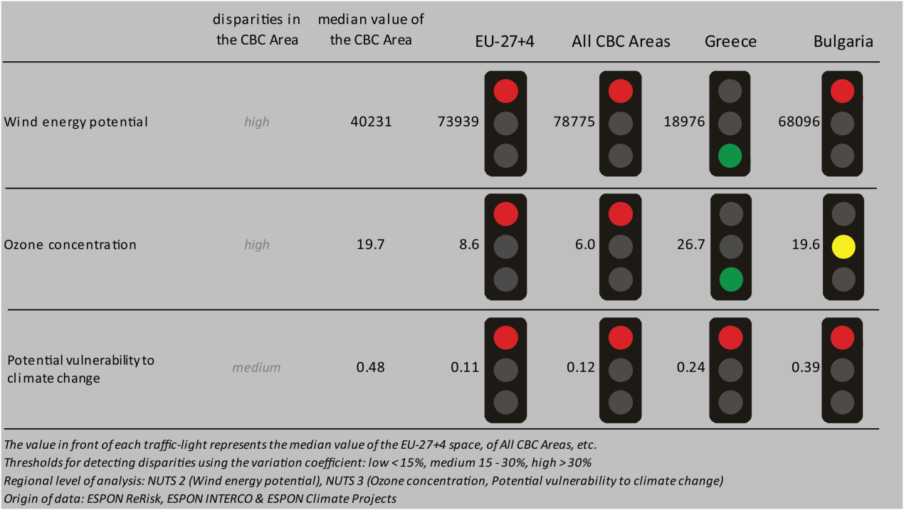
Sustainable growth refers to promoting a more resource efficient, greener and more competitive economy. Within the Europe 2020 Strategy it means e.g. building a more competitive low-carbon economy that makes efficient, sustainable use of resources, protecting the environment, reducing emissions and preventing biodiversity loss, capitalising on Europe's leadership in developing new green technologies and production methods, and introducing efficient smart electricity grids. In the framework of the Europe 2020 Strategy it means focus on competitiveness, resource efficiency, climate change and biodiversity.

The use of wind energy potential could be one of the cornerstones in building a competitive low-carbon economy in the EU. The programme area as a whole shows a median value that is significantly lower than the EU 27+4 and all the CBC programme areas in Europe. The CBC area shows a significantly lower value than the national level of Bulgaria whereas there is a higher potential in using this sustainable resource compared to the Greek national values. The same picture exists for the CBC compared to the Greek national numbers regarding the ozone concentration. The programme area and Bulgaria are on a similar level. Both indicators show high disparities within the CBC area.
The Greece – Bulgaria programme is substantially vulnerable to potential climate change compared to the EU 27+4 and all the CBC regions together. Also compared to the Greek and Bulgarian national levels the cooperation area is highly vulnerable. Both sides of the border in the CBC area are not affected by territorial impact of Directive 11 on fossil fuel consumption (MAP 2) and their combined adaptive capacity to climate change (BOX-PLOT 1) in general similar to the national levels. On the Greek side the NUTS3 region of Thessaloniki and on Bulgarian side the NUTS3 region of Blagoevgrad show a high to very high capacity compared to the respective national values.

MAP 2 - Territorial impact on fossil fuel consumption of Directive on the promotion of clean and energy-efficient road transport vehicles (ESPON ARTS project) for the CBC Greece-Bulgaria

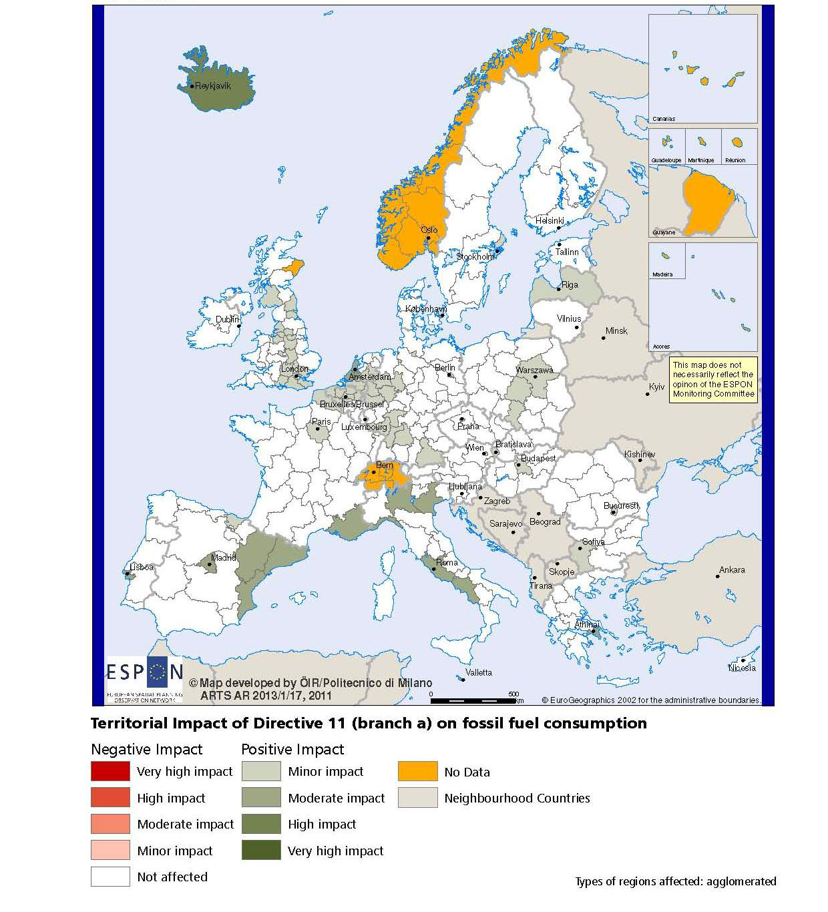

BOX-PLOT 1 – Combined adaptive capacity to climate change (ESPON CLIMATE project) for the CBC Greece-Bulgaria
“Adaptive capacity (adaptability)” to climate change indicates the ability or potential of a system to respond successfully to climate change and variability, and includes adjustments in behaviour, resources and technologies.
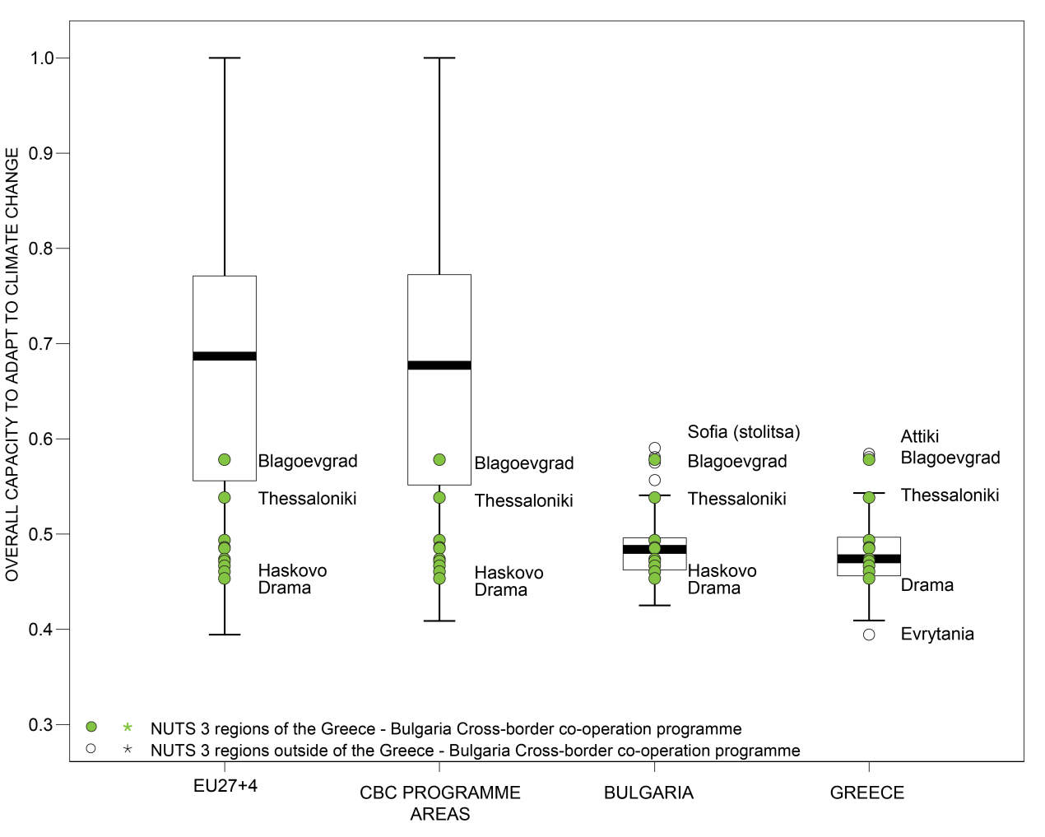

How to read the box-plots?
The box-plot is a statistical and mathematical tool used to visualize numerical data sets and to compare its statistical distribution.
Because it is used in exploratory analysis of databases, this representation is sensitive to the quality of the central value selected to explain the symmetry, shape and distribution variability. In the case of a box-plot, the most used central value is the median, because it has the quality of sectioning the data string into two halves, so that 50% of the cases will be above the central value and the other half will be below it. Since the purpose of the representation is to highlight outliers’ behavior, it uses a box that encompasses half of the cases, i.e. values that are in the range defined by the percentile of 25% and 75%. If a region has a value in this box then it can be considered that it has, according to the variable in question, a situation close to the average behavior of all regions analyzed.
When a region consistently deviates from the average profile of the analyzed territorial context, this behavior will be noted in the chart only when certain thresholds of statistical tolerances are exceeded, this being pointed in the diagram with segments perpendicular to the middle box, segments called the "whiskers".

Inclusive growth
Inclusive growth refers to fostering a high-employment economy delivering social and territorial cohesion. Within the Europe 2020 Strategy it means raising Europe’s employment rate, helping people of all ages anticipate and manage change through investment in skills & training, modernising labour markets and welfare systems, and ensuring the benefits of growth reach all parts of the EU. In short the key factors are employment and avoiding risk of poverty and social exclusion.
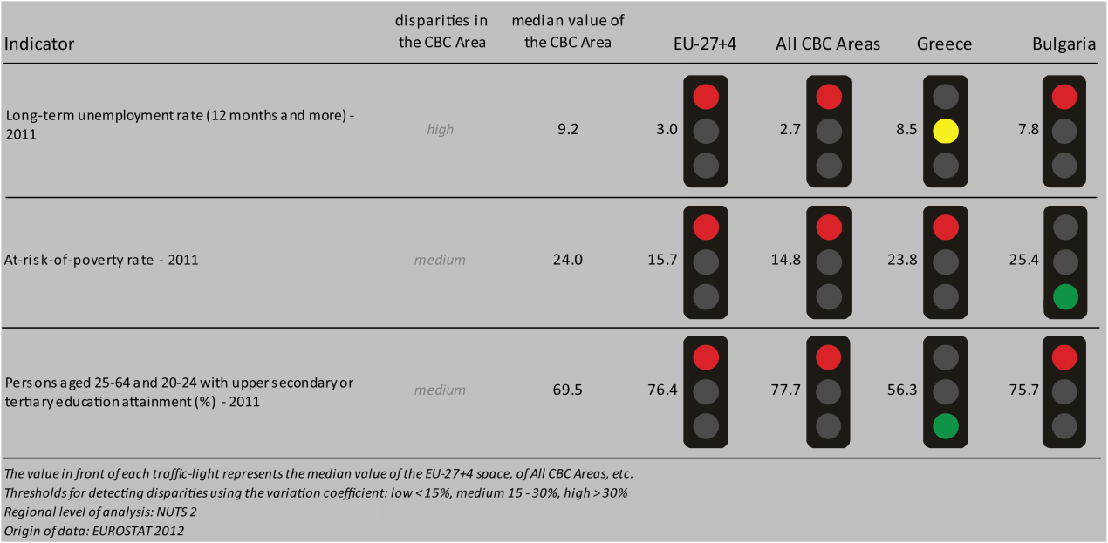
The CBC area of Greece – Bulgaria in general shows significantly higher values in the case of long-term unemployed persons and persons at risk of poverty compared to the EU27+4 and the other CBC regions in Europe. Exeptional cases are the long-term unemployment rate of the CBC area compared to the Greek national level and persons who are at risk of poverty in Greece – Bulgaria compared to the Bulgarian national value. Looking at the employment rates (BOX-PLOT 2) in the programme area compared to the EU27+4 and the CBC areas as a whole, the majority of NUTS3 regions in Greece – Bulgaria have a lower employment rate. Also, compared to the national levels in Greece and Bulgaria most of the NUTS3 regions of the CBC area count less employed persons than the two countries altogether. The Bulgarian region of Blagoevgrad has an employment rate that is higher than all the other NUTS3 regions of the CBC area.
Analysing the different scenarios highlighted in the ESPON DEMIFER project (MAP 3) regarding the change in labour force until 2050, it can be stated that the situation differes between the Greek and the Bulgarian part of the cooperation area. Whatever scenario will take place, there are significantly negative changes on the Bulgarian side of the border. The Greek part of Greece – Bulgaria shows positive effects in the case of the change in labour force in three out of four scenarios. Only in the scenario “Limited Social Europe”, a slightly negative impact on the greek side has to be considered a possibility.

MAP 3 – Change in Labour Force 2005-2050 (ESPON DEMIFER project) for the CBC Greece-Bulgaria

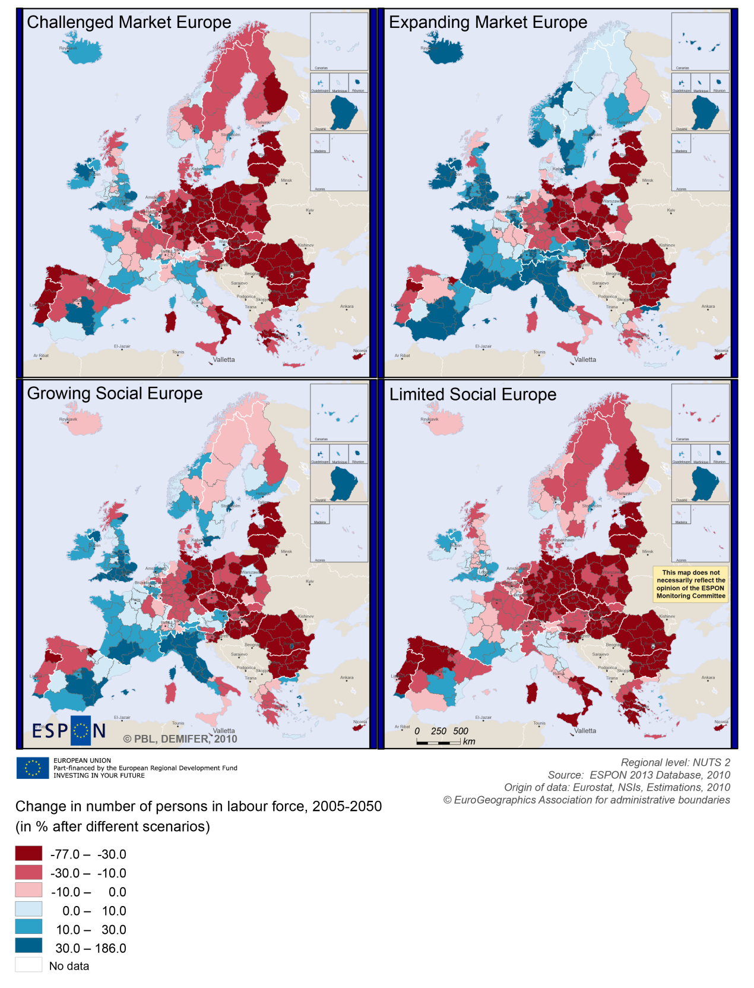

BOX-PLOT 2 – Employment rate 2010 within the CBC Greece-Bulgaria
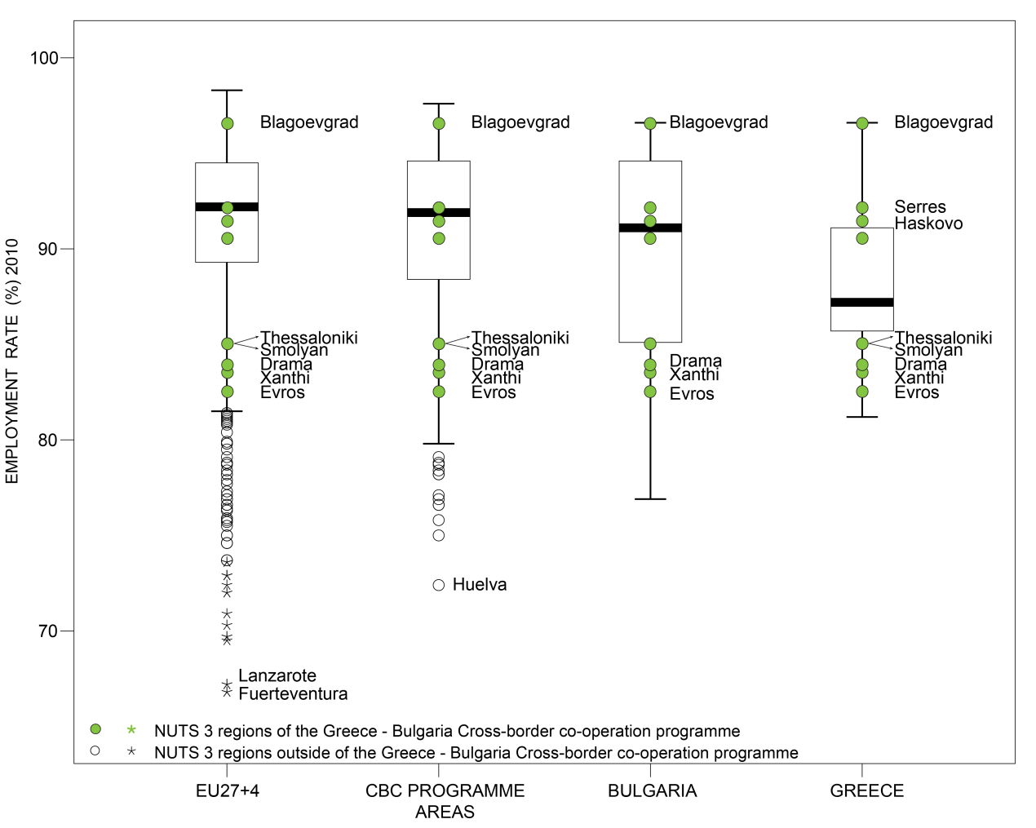

(see “How to read the box-plots?” on page 7)

Territorial factors of interest for the programme area
Territorial cooperation programmes can make a difference for the future development of cross-border and transnational territories in Europe. Some of the factors can be analysed by European wide data sets and using some studies having specific maps, figures and tables concerning the areas of the cooperation region.
For the programme area ESPON TERCO is of particular interest. It comprises a case study focusing on a border region concerning some parts of Bulgaria, Greece and Turkey, including the programme area Greece – Bulgaria. The full case study including a lot of detailed analysis of the area and cooperation activities in the area is available in the annex to the (Draft) Final Report of the TERCO project. The below box provides only a short extract from the case study summary.
ESPON TERCO PROJECT – ANNEX TO THE DRAFT FINAL REPORT, PAGE 569:
Territorial structures and specific border co-operation
Strengths: The protected areas (e.g. NATURA 2000 network), the river basins (e.g. Evros or Nestos), the Sea basin (e.g. Black Sea) and the major transport networks (e.g. Egnatia motorway or EU-Corridors) appear to be the most desirable territorial structures. The evidence suggests that the local actors are more effective in overcoming antagonistic interests at international level, functioning in a more pragmatic manner. The interaction between the actors of the participating countries has been intensified in several fields at institutional level over the last years.
Weaknesses: Usually the ITC actions stop at the moment the project ends, with small follow-up value added and with no further perspective. Despite the fact that cooperation has been intensified, so far these ITC initiatives haven‘t resulted in joint actions or common strategies. ITC does not seem to have a clear impact on ―external‖ relations since the emphasis of State agencies of ―national interests‖ eliminates the local actors‘ flexibility. Moreover, influential ―external‖ relations are very limited because most of the ITC projects are designed and prepared by consultants without a ―real‖ involvement of the local governments‘ staff.
Future: The critical question is how all the ITC initiatives can create stable synergies and networks with a long-term perspective. The procedures for participating and implementing an ITC project should be simplified. Capacity building actions for local institutions, consultancy of government and an efficient top-down communication and dissemination strategy could increase the competitiveness of the cooperating regions. The main challenge for the ITC in the future is to create common approaches for all the domains, adapted to the needs and characteristics of each area.
In a European perspective the programme area is mainly composed by predominately rural remote regions (see map below). Thessaloniki is the urban exception, and it even acts as European gateway with a global profile related to its port. Apart from Thessaloniki the programme area is not so strong on large and medium-sized cities, but with a, in a European perspective, wide-spread network of sparsely populated and/or mountainous areas.
This goes together with challenges related to infrastructure and access to services. Again apart from Thessaloniki, the programme area offers no possibilities for one-day business trips within the European urban system. Overall, the European multi-modal accessibility of the programme area is below the average for EU27+4. Indeed, even Thessaloniki shows a comparably low international accessibility as shown in the below map. Considering the access to internet and the Information Society the picture is similar.

MAP 4 – Urban-rural typology of NUTS3 regions including remoteness (DG Regio) for the CBC Greece-Bulgaria

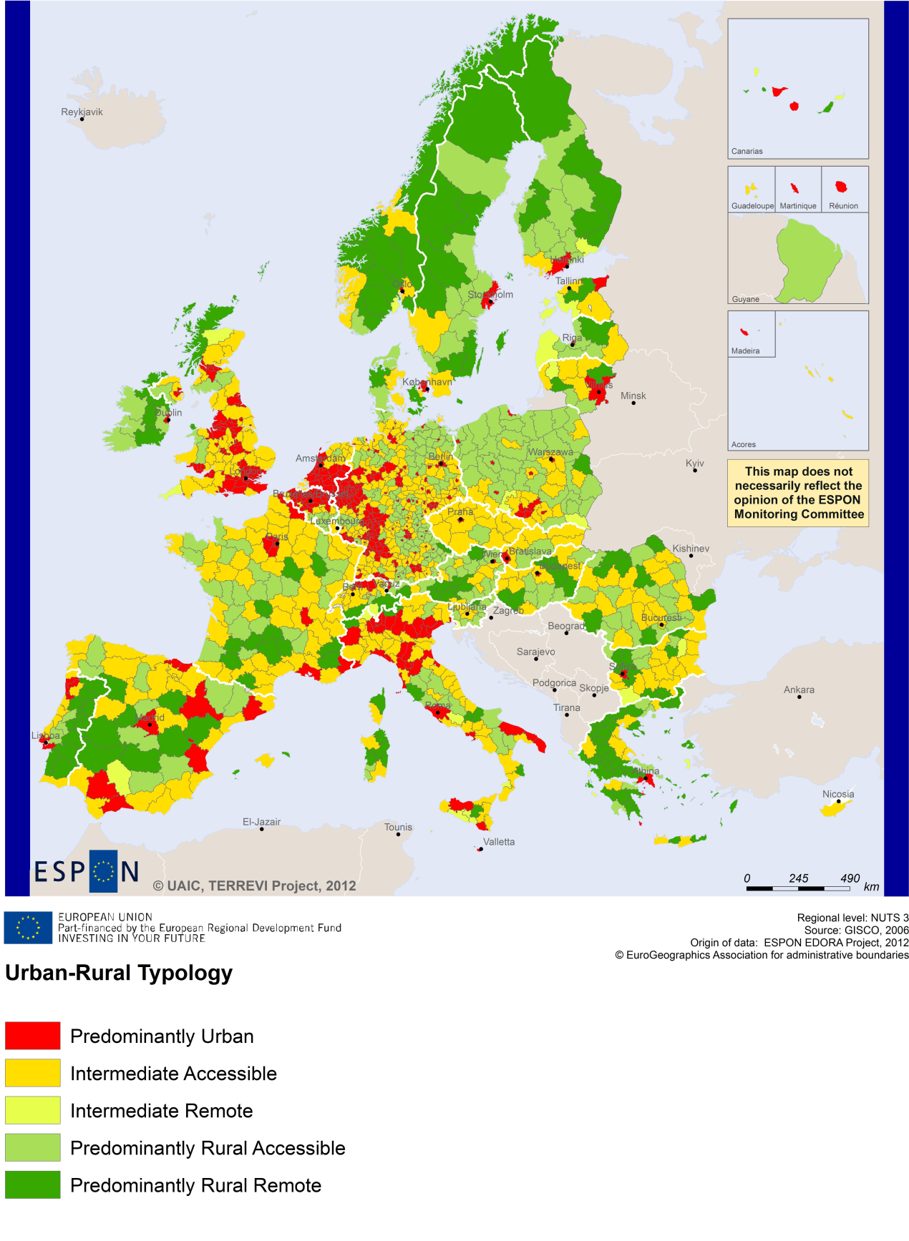
(Accessible=close to a city)

MAP 5 – Multimodal accessibilty (ESPON Accessibility Update) for the CBC Greece-Bulgaria
“Potential Accessibility Multimodal” scores accessibility of NUTS 3 regions by road, rail and air relative to the European average in an Accessibility Index.
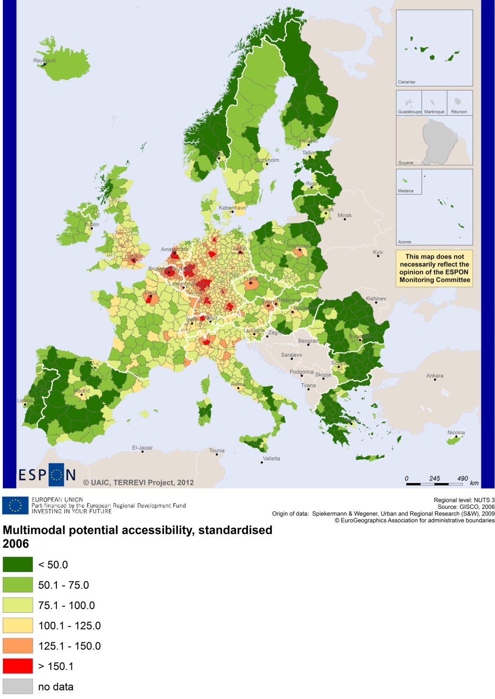

Recommended ESPON reading
ESPON provides an essential underpinning for translating into practice the calls for integrated and place-based approaches to economic development, when analysing a programme area or deciding about future programme priorities. ESPON has published a wide range of exciting reports providing valuable territorial evidence for future territorial cooperation initiatives.
The table below shows examples of relevant projects for the Cooperation Region. However, you have to study other ESPON reports as well in order to capitalise fully on the European information available for the cross-border programming.
ESPON study | Topic | Content
EDORA | Rural areas | It provides evidence on the development opportunities of diverse types of European rural areas and reveals competitiveness options (see maps in Appendix 1).
CLIMATE | Climate change | It analyses how and to which degree climate change will impact on the competitiveness and cohesion of European regions and Europe as a whole (see from map 1 to 23).
TIPTAP | Territorial impact assessment | It provides a tool for the ex-ante assessment of territorial impacts of policies to deliver evidence on the territorial impact of policies (see from map 2.3.1 to 2.3.9).
CAEE | Agglomerati-on economies | It aims at a better understanding of the economic costs and benefits of large urban agglomerations (see figure 1).
TRANSMEC | European cooperation | It develops a method providing guidance on how ESPON results can add value to support territorial cooperation programmes (see map 27 and from map 36 to 39 on potential accessibility indicators).
SEMIGRA | Rural migration | It identifies the main reasons and consequences of selective migration in rural regions in order to develop strategies for territorial development (see map 1, 4 and 5).
KIT | Innovation | It describes patterns and potentials of regions in terms of knowledge and innovation economy and explores development opportunities (see from map 3.1.1 to 4.4.1).
SGPTD | Growth poles | It provides evidence about performance and roles of European secondary cities (see from figure 2 to 2.12).
TERCO | Territorial cooperation | It delivers evidence concerning transports, accessibility, demography, competitiveness and labour market. The project reports a case study including some parts of the CBC area (see the Scientific Report of the Draft Final Report).
Furthermore, some of overall ESPON products of particular interest for territorial cooperation are:
- ESPON Synthesis report “new evidence on smart, sustainable and inclusive territories” provides an easy to read overview on ESPON results available.
- ESPON Territorial Observations is a publication series, which on a few pages presents policy relevant findings deriving from latest ESPON research.
- ESPON 2013 Database provides regional information provided by ESPON projects and EUROSTAT.
- ESPON Hyperaltas allows comparing and analysing a region’s relative position at European, national and local scale for a wide range of criteria.
- ESPON MapFinder provides access to the most relevant ESPON maps resulting from ESPON projects and reports.
- ESPON Typologies provides nine regional typologies for additional analysis of regional data to be considered in the European context.
All ESPON reports and tools are freely available at
www.espon.eu
The ESPON 2013 Programme is part-financed by the European Regional Development Fund, the EU Member States and the Partner States Iceland, Liechtenstein, Norway and Switzerland. It shall support policy development in relation to the aim of territorial cohesion and a harmonious development of the European territory.

