Hungary – Slovak Republic
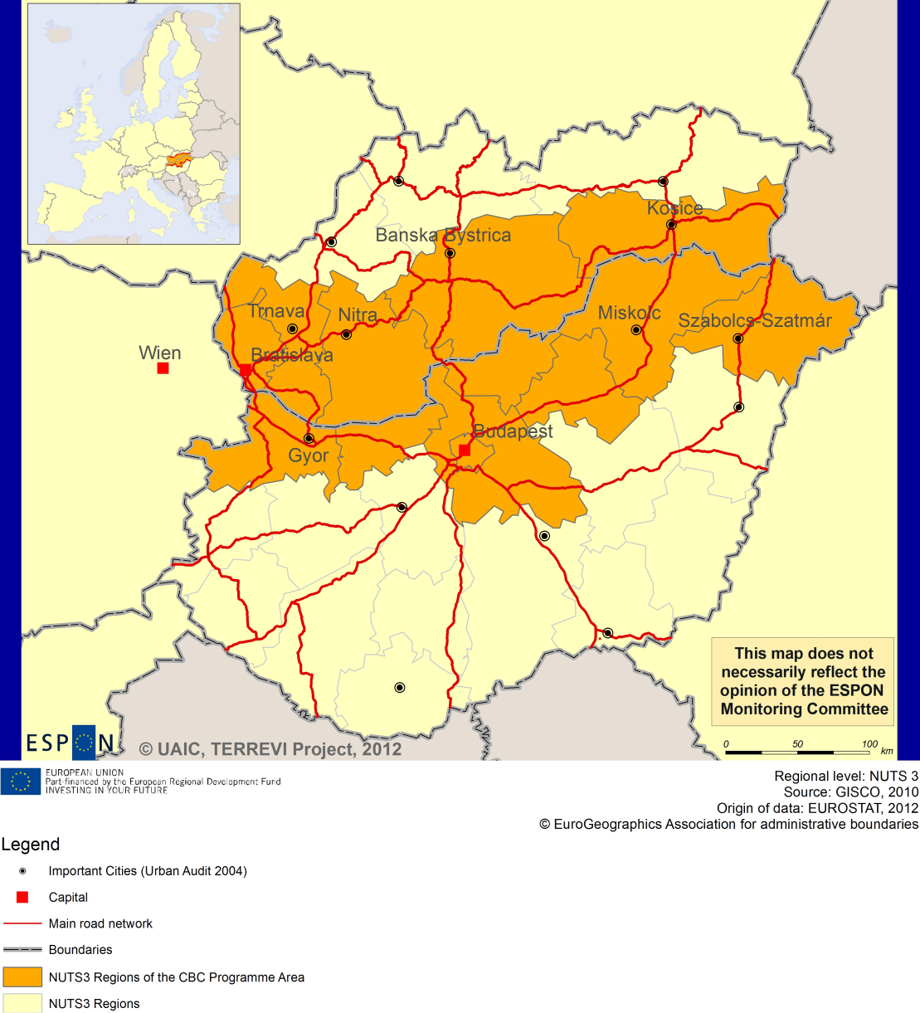

ESPON Project TERREVI
November 2012

Introduction
ESPON supports policy development in relation to the aim of territorial cohesion and a harmonious development of the European territory. It provides comparable information, evidence, analysis, and scenarios on territorial dynamics, which reveal territorial capitals and development potentials of regions and larger territories. Considering the programme area in its European context adds an important new perspective that can help shaping the programming and the places of implementing projects.
The ESPON TERREVI project focuses on producing evidence for Structural Funds programmes with the aim to support the development of the programmes to be carried out in the 2014-2020 period.
One milestone of this work consists in presenting selected ESPON research pieces in easy-to-understand factsheets for all territorial cooperation programme areas. The aim is to provide the reader with preliminary insight on types of territorial evidence ESPON holds at hand with regard to the possible investment priorities of future programmes. The factsheets certainly only give a first glimpse rather than fully present the work of the large number of ESPON projects that are currently underway. Likewise, each programme area includes diverse development potentials and challenges, which needs targeted information search. However, hopefully this factsheet will contain information, benchmarking the programme area in its larger, territorial context, that is of interest and help to better understand the programme area and to navigate within the richness of ESPON material available.
In addition to the programme factsheets there will be a number of specific programme case studies illustrating how ESPON material can be used to support the development of future programmes e.g. by giving a comparative European dimension to the envisaged SWOTs. These case studies will be carried out in early 2013.
This factsheet is structured in three main parts. The first part presents a selection of indicators that help comparing the situation of the programme area in question with the European average, the average for all programme areas as well as the situation in the countries involved. The second part briefly presents the territorial factors of interest for the programme area. The final part offers guidance on the further use of ESPON results and tools. This is intended as an electronic publication so map quality is generally high to allow users to zoom into specific territories.
This factsheet does not necessarily reflect the opinion of the ESPON Monitoring Committee.

Europe 2020
Europe, with its member states and their regions, is more exposed to global shocks and international competition than at any time before. As the world becomes more interdependent this trend will continue and shape policy thinking across sectors, borders and geographical scales. At the same time, Europe is characterised by a large territorial diversity meaning that global developments can imply rather different development possibilities and challenges for different European regions and cities.
The differences are partly defined by major geographical structures such as urban systems, access and connectivity, the geographical specificity or population density. At the same time, the differences are also spelled out in the larger development trends that affect an area, and the way and degree to which it is affected.
The data, indicators and territorial evidence provided by ESPON provides insight on both the main structures and larger territorial trends. The fine art is to identify what can actually be influenced by policy-making and, in particular, by place-based policy and territorial cooperation related to your programme area.
This chapter provides a selection of ESPON data related to Europe 2020 objectives of smart, sustainable and inclusive growth, giving also hints as regards the main thematic objectives envisaged in the draft regulations for the next period of EU Cohesion Policy. The Europe 2020 Strategy aims to enhance smart, sustainable and inclusive growth. This strategy has clear territorial dimensions. However, achieving these goals is challenging in the crisis-driven times. Furthermore, the economic disparities are growing as economic trends and the crisis have various impacts on different parts of Europe.
In the following the traffic light for each indicator represents how your programme territory compares to wider European and national medians where green = your programme area performs better for that indicator, yellow = similar, and red = worse.
In creating the traffic lights the median was used as central value indicator for all statistical variables due to its advantages (easy to interpret, it splits the statistical distribution in half) but especially due to the constraints linked to the impossibility of computing means for several indicators (Climate Change, Wind Energy Potential etc.). Therefore, a special attention should be given in reading the median values when the number of NUTS 2 regions is below 7. Using percentiles implies also a high dependence of the final results on the type of statistical distribution. This fact should be considered when establishing the relative position of a CBC Programme Area to a specific country.
EU 27+4 in Traffic Lights and box-plots means the EU Member States as well as Iceland, Liechtenstein, Norway and Switzerland – the ESPON space.

Smart growth
Smart growth refers to developing an economy based on knowledge and innovation. In the framework of the Europe 2020 Strategy it means improving the EU's performance in education, research/innovation and digital society.
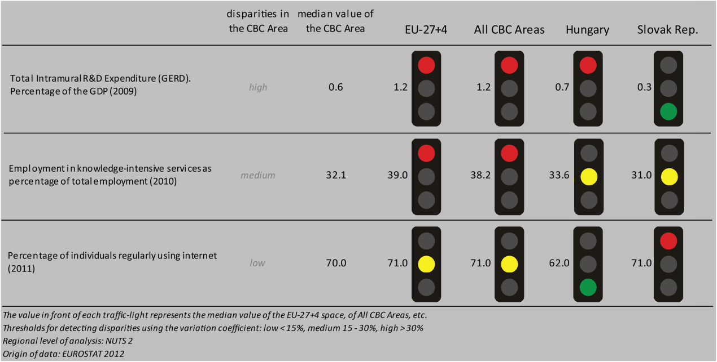
According to all indicators reported above, the Hungary-Slovak Republic CBC area performs at a not better level than both the EU27+4 space and all CBC ones. Considering the objective of R&D expenditure of percentage of the GDP - one of the five headline targets in the Europe 2020 Strategy - the CBC area is still lagging behind the EU27+4 space and all CBC. Moreover, the CBC is characterised by a high level of internal disparity due, with a better performance of Hungary and worse of Slovak Republic.
Concerning the ratio of employment in knowledge-intensive services to the total employment in 2010, the CBC area has lower values than EU27+4 space and all CBCs; similar to both Hungary and Slovak Republic. The distribution inside the CBC results in a medium level of internal disparity.
In terms of percentage of individuals regularly using internet in 2011, the CBC has the same values as both EU27+4 space and all CBCs, but it performs slightly better than Hungary and slightly worse than Slovak Republic, with a low internal disparity.
According to the classification of the KIT project, MAP 1 identifies as territorial pattern of innovation ‘Creative imitation area’. It is associated to a low knowledge and innovation intensity, entrepreneurship, creativity, a high attractiveness and a high innovation potential.

MAP 1 – Territorial Patterns of Innovation (ESPON KIT project) for the CBC Hungary – Slovak Republic

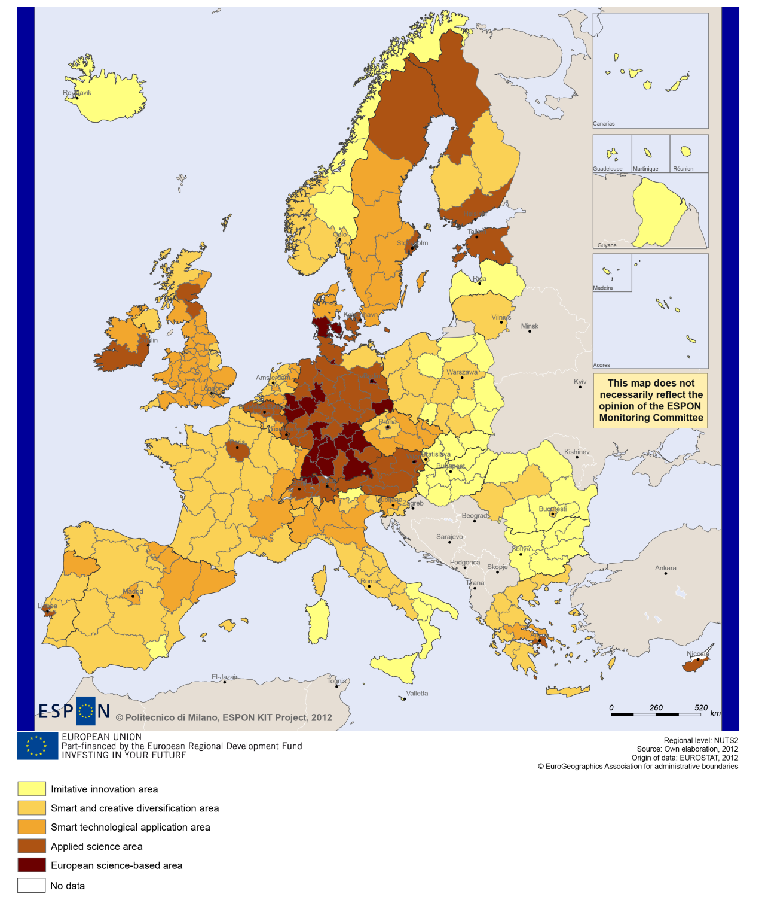

Sustainable growth
Sustainable growth refers to promoting a more resource efficient, greener and more competitive economy. Within the Europe 2020 Strategy it means e.g. building a more competitive low-carbon economy that makes efficient, sustainable use of resources, protecting the environment, reducing emissions and preventing biodiversity loss, capitalising on Europe's leadership in developing new green technologies and production methods, and introducing efficient smart electricity grids. In the framework of the Europe 2020 Strategy it means focus on competitiveness, resource efficiency, climate change and biodiversity.
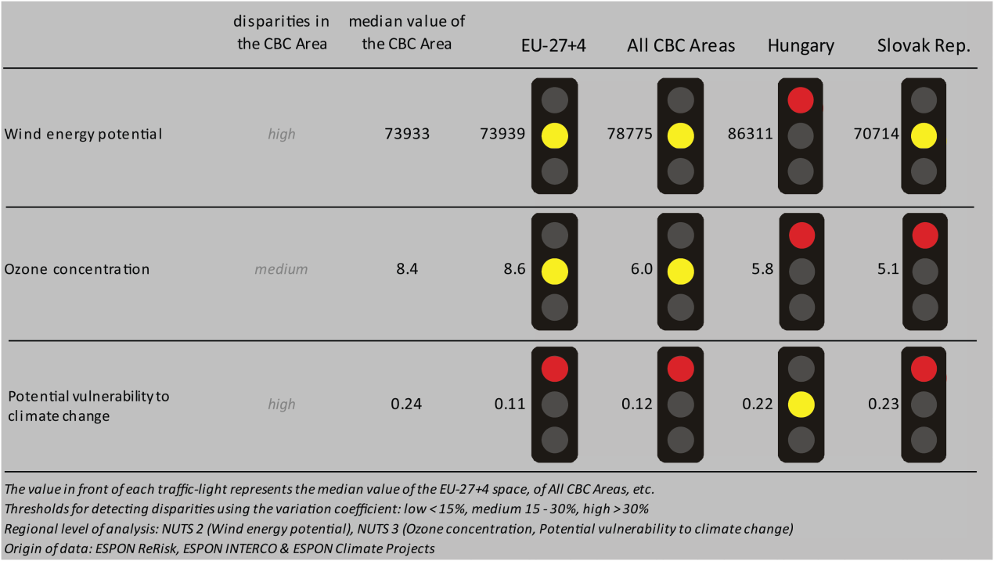
The Hungary-Slovakia CBC region as a whole shows a median value with regard to wind energy potential that is similar to the EU-27+4, to all CBC programme areas’ and to Slovakia’s median values. At the same time the CBC area shows a considerably lower potential than the national level of Hungary. The ozone concentration is at an average level compared to European (EU-27+4 and CBC) data, but it is relatively high when compared to the national contexts. The level of potential vulnerability to climate change of the CBC region is similar to the national median-level of Hungary, while it is considerably higher than that of the EU-27+4, all CBC areas and slightly higher than the Slovak national median level.
Directive 11 seem to have no impact on fossil fuel consumption in most of the NUTS3 regions of the Hungary-Slovakia CBC area (MAP 2). However, a positive territorial impact of the Directive has been identified in the NUTS3 regions of Pest (Hungary) and Bratislava (Slovakia). Looking at the combined adaptive capacity of the NUTS3 border regions to climate change (BOX-PLOT 1), we also find that the capital regions of Pest and of Bratislava have a higher capacity than the median values of European regions (and a very high capacity in the national contexts), while the other regions are at a low to very low level in this regard.

MAP 2 - Territorial impact on fossil fuel consumption of Directive on the promotion of clean and energy-efficient road transport vehicles (ESPON ARTS project) for the CBC Hungary – Slovak Republic

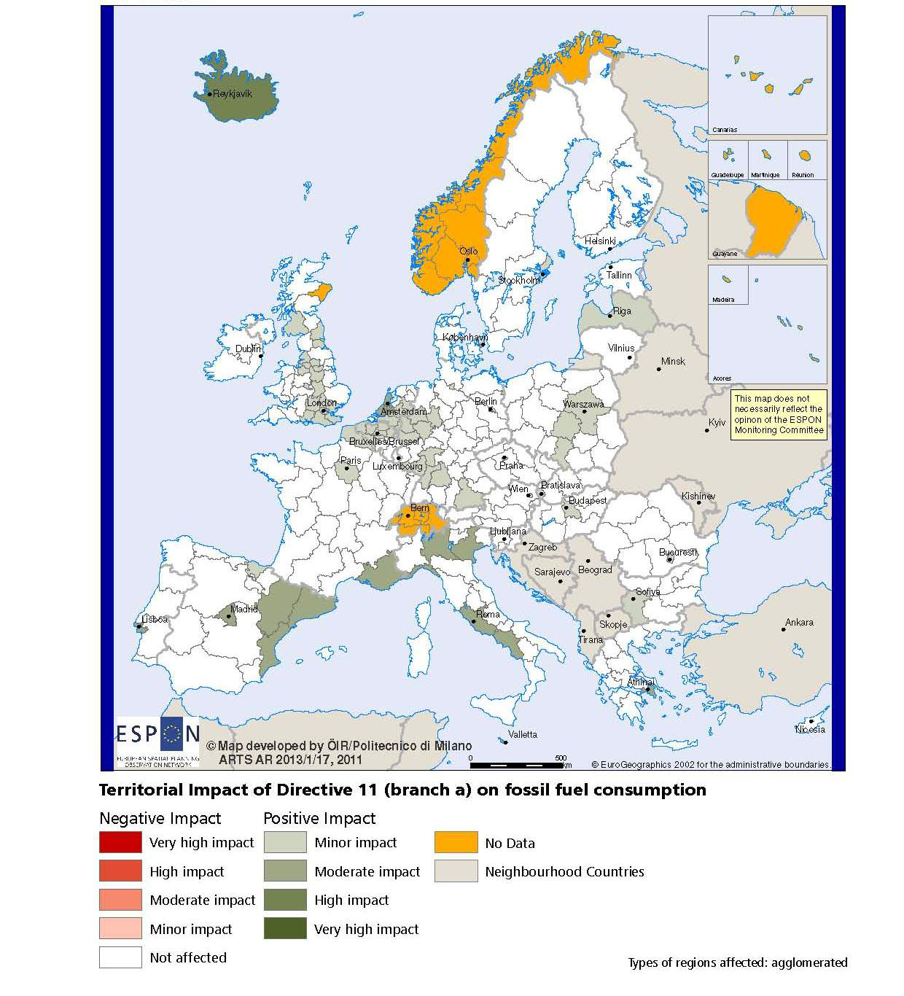

BOX-PLOT 1 – Combined adaptive capacity to climate change (ESPON CLIMATE project) for the CBC Hungary – Slovak Republic
“Adaptive capacity (adaptability)” to climate change indicates the ability or potential of a system to respond successfully to climate change and variability, and includes adjustments in behaviour, resources and technologies.
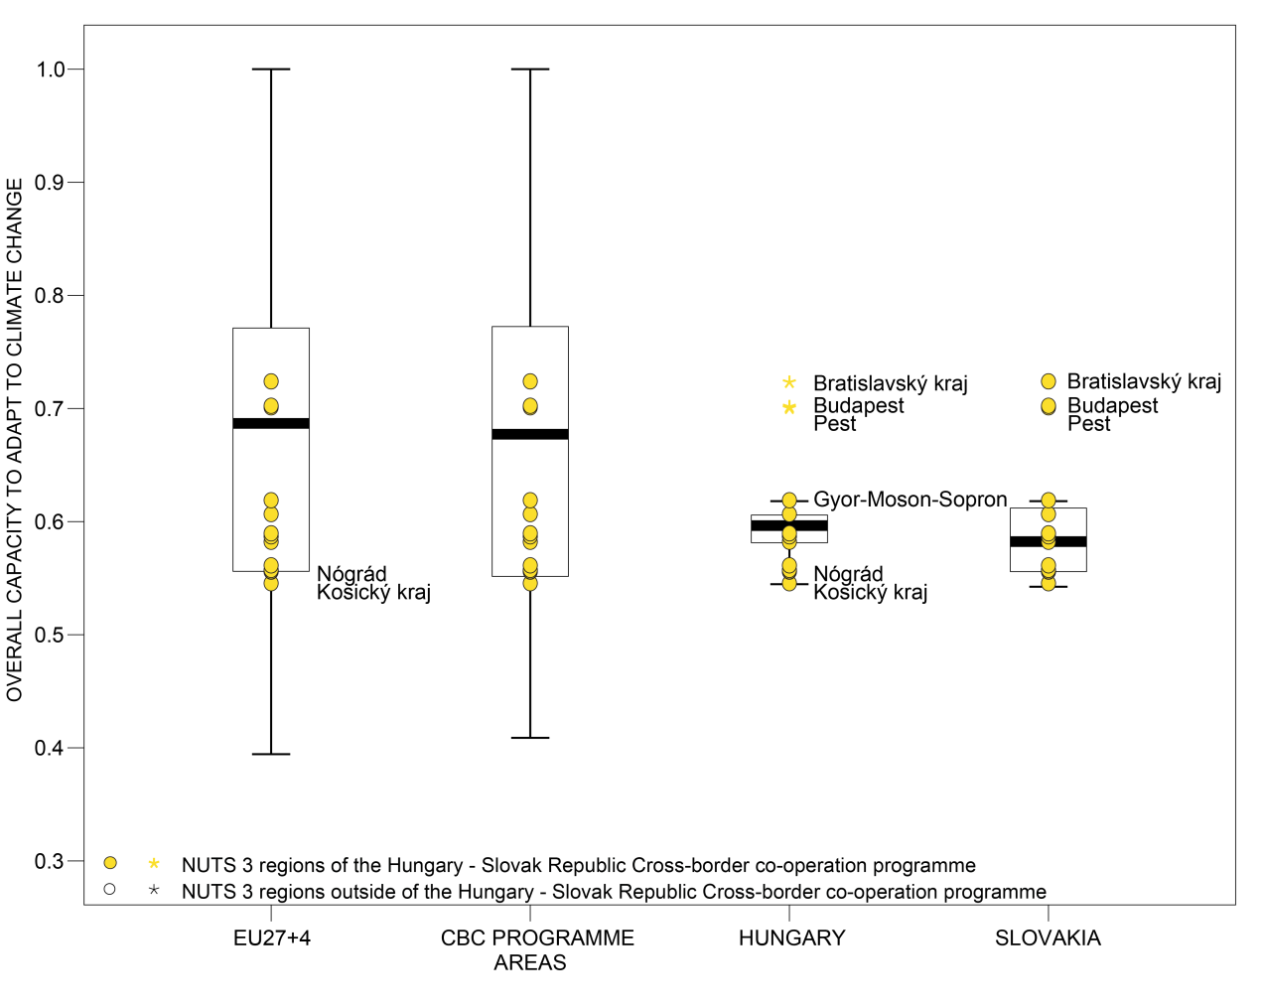

How to read the box-plots?
The box-plot is a statistical and mathematical tool used to visualize numerical data sets and to compare its statistical distribution.
Because it is used in exploratory analysis of databases, this representation is sensitive to the quality of the central value selected to explain the symmetry, shape and distribution variability. In the case of a box-plot, the most used central value is the median, because it has the quality of sectioning the data string into two halves, so that 50% of the cases will be above the central value and the other half will be below it. Since the purpose of the representation is to highlight outliers’ behavior, it uses a box that encompasses half of the cases, i.e. values that are in the range defined by the percentile of 25% and 75%. If a region has a value in this box then it can be considered that it has, according to the variable in question, a situation close to the average behavior of all regions analyzed.
When a region consistently deviates from the average profile of the analyzed territorial context, this behavior will be noted in the chart only when certain thresholds of statistical tolerances are exceeded, this being pointed in the diagram with segments perpendicular to the middle box, segments called the "whiskers".

Inclusive growth
Inclusive growth refers to fostering a high-employment economy delivering social and territorial cohesion. Within the Europe 2020 Strategy it means raising Europe’s employment rate, helping people of all ages anticipate and manage change through investment in skills & training, modernising labour markets and welfare systems, and ensuring the benefits of growth reach all parts of the EU. In short the key factors are employment and avoiding risk of poverty and social exclusion.
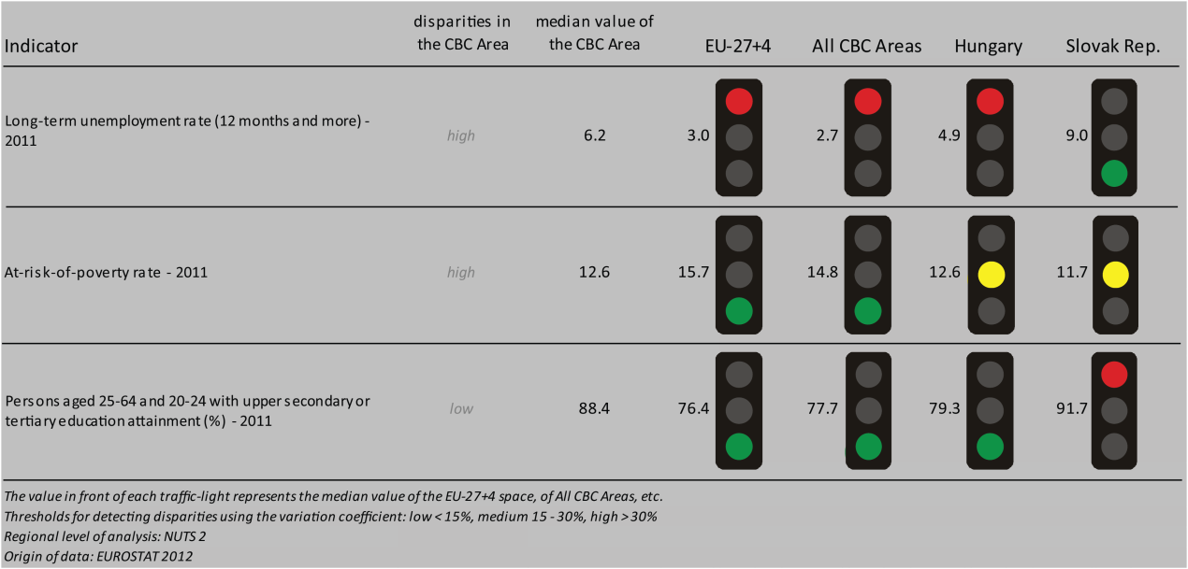
The long-term unemployment rate of the Hungary-Slovakia programme area is considerably higher than the EU-27+4, than all CBC areas and the Hungarian rate, but it is at a lower level than the Slovakian national median value. Disparities of the indicator are high in the CBC area. The employment rates (2010) also vary (BOX-PLOT 2) spreading out between very high and very low levels in the national contexts. The rate of persons at risk of poverty is lower than in the EU-27+4 and in all CBC areas, and it is at an average level in national contexts. Disparities of this indicator are also high within the CBC area. As far as the indicator of persons aged 25-64 and aged 20-24 with upper secondary or tertiary education is concerned, it can be stated that the CBC area is at a high level except when compared to Slovakia, where this indicator has a particularly high value.
Looking at the different scenarios highlighted in the ESPON DEMIFER project (MAP 3), we can state that all four scenarios predict high labour force reductions by 2050 for the CBC area of Hungary-Slovakia. Only the two scenarios of ‘Expanding Market Europe’ and ‘Growing Social Europe’ outline a somewhat less pessimistic picture in the capital regions, with minor reduction foreseen for the region of Pest and medium-level reduction in the labour force in the region of Bratislava.

MAP 3 – Change in Labour Force 2005-2050 (ESPON DEMIFER project) for the CBC Hungary – Slovak Republic

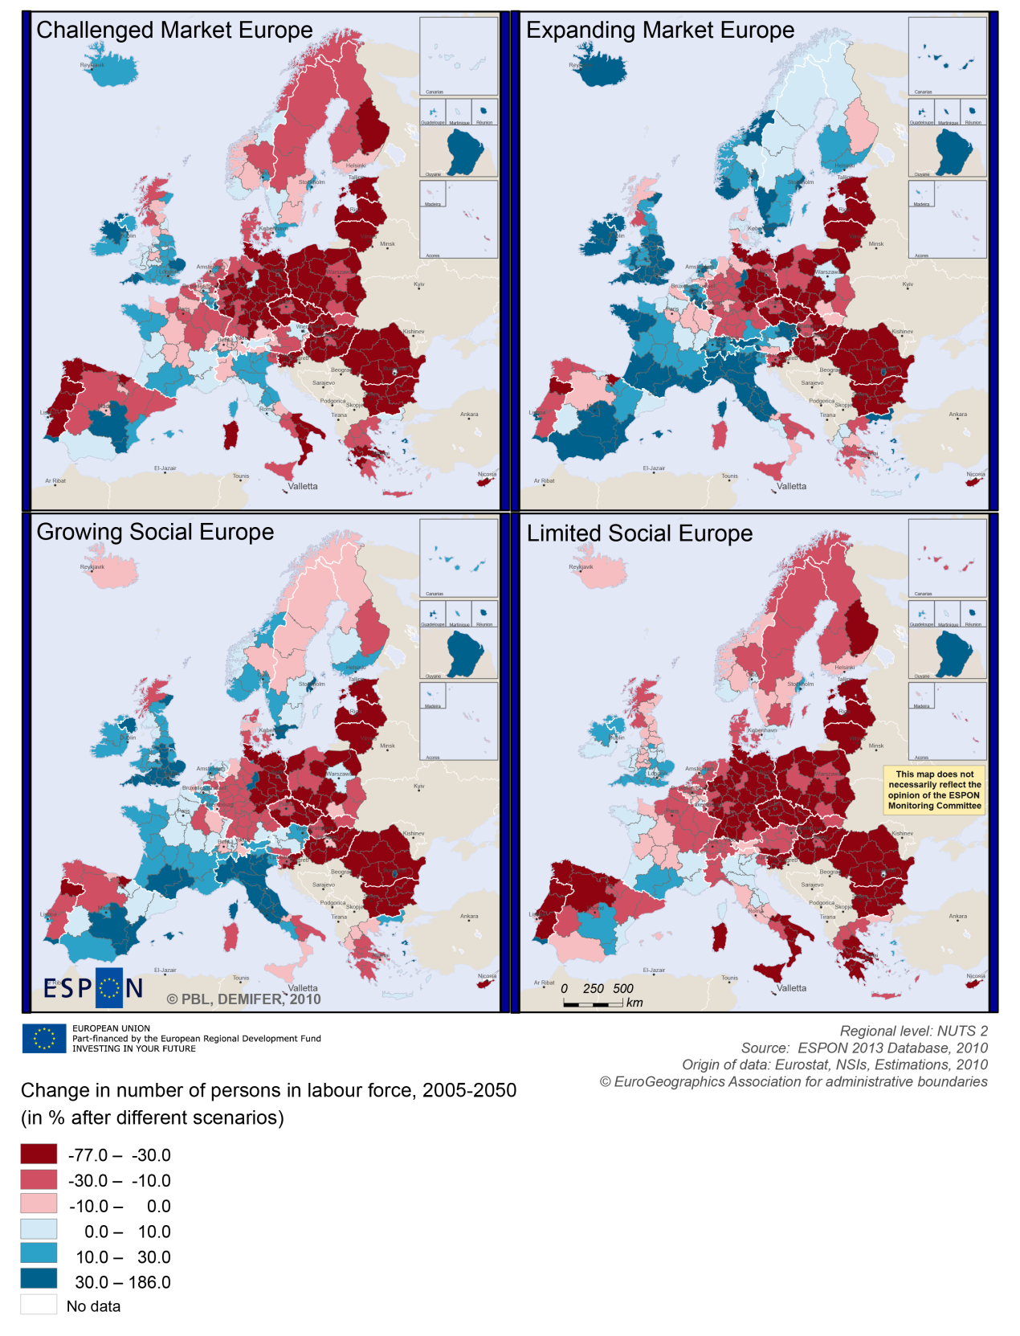

BOX-PLOT 2 – Employment rate 2010 within the CBC Hungary – Slovak Republic
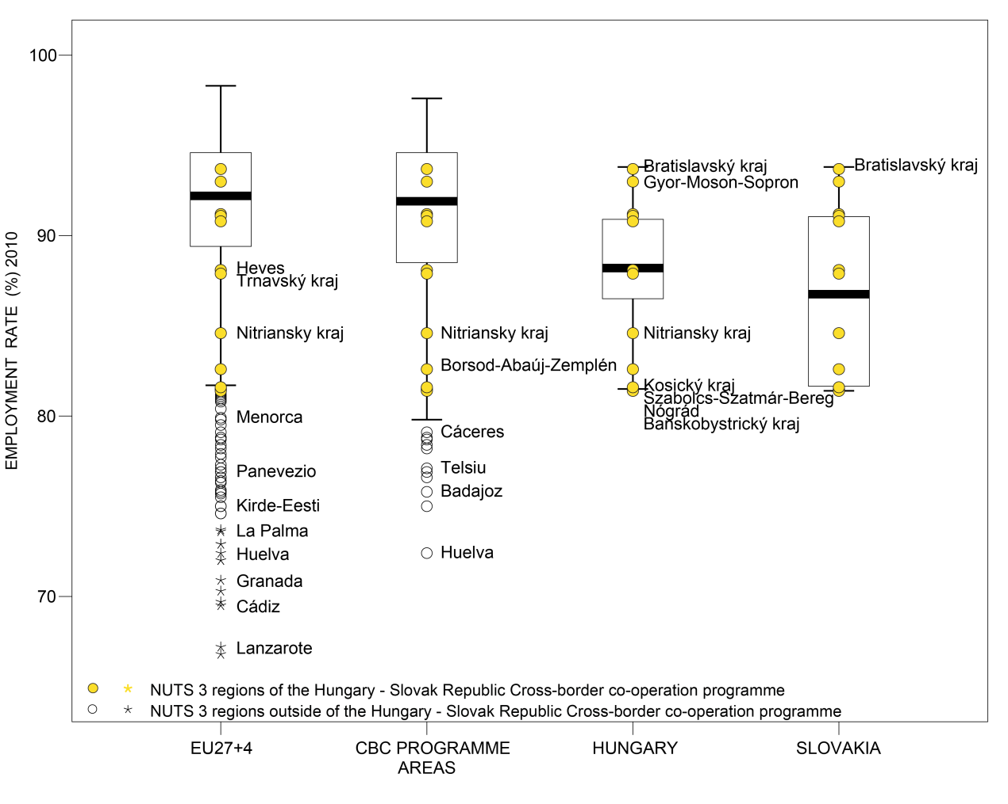

(see “How to read the box-plots?” on page 8)

Territorial factors of interest for the programme area
Territorial cooperation programmes can make a difference for the future development of cross-border and transnational territories in Europe. Some of the factors can be analysed by European wide data sets and using some studies having specific maps, figures and tables concerning the areas of the cooperation region.
In a European perspective the programme area comprises mainly rural regions close to a city, some intermediate regions and two urban regions. Bratislava and Budapest belong to the main European metropolitan growth areas (MEGAs) and are important drivers and hubs in the European urban system. Furthermore the programme area comprises a range of secondary growth poles including Gyor, Trnava, Nitra, Banska Bystrica, Kosice, Miskolc and Sazablocs-Szatmár. In particular Budapest and Bratislava but also the proximity to Vienna for some parts of the programme area can be an advantage for the rural areas and secondary cities in the programme area.
This concerns both the access to services and infrastructure. In a European perspective most parts of the programme area have below average multimodal accessibility. Only the capital city regions and their direct neighbourhood have accessibility values above European average. Furthermore, the locations in Budapest and Bratislava offer good opportunities for one-day business trips to many other cities in Europe. Another advantage is that most parts of the programme area have above European average numbers of border crossings per 100 km, which allows for the development of cross-border functional areas.
The rural parts of the programme area can probably profit from the close proximity to major European centres. At the same time the urban centres can profit from the qualities of the rural areas in close proximity. In European perspective the area is characterised with some degree of mountainousness, where at least up to 25% of the total area is covered by mountainous municipalities. ESPON GEOSPECS has developed a nexus model for mountainous regions linking defining features via intermediary process to development challenges and opportunities (see figure). This model can be of interest for further developing the discussion about the challenges and opportunities in the programme area.
ESPON GEOSPECS PROJECT – FINAL REPORT, PAGE 102:
Nexus model for mountain areas
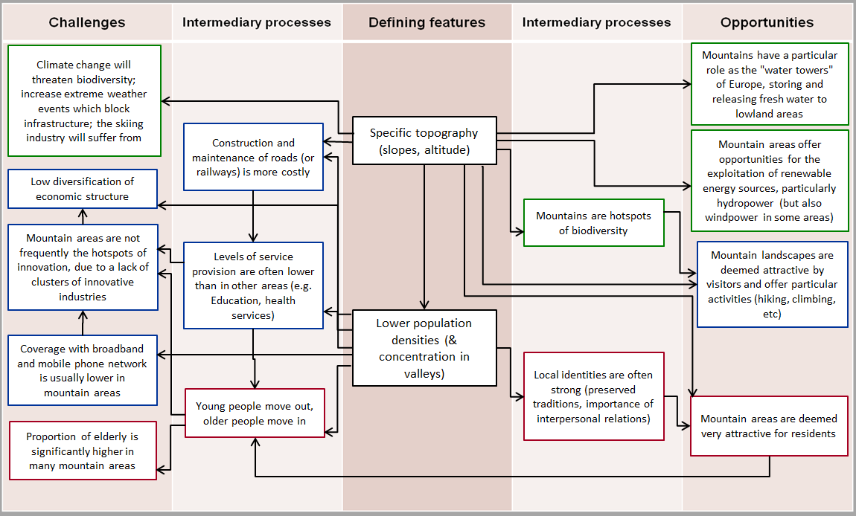

MAP 4 – Urban-rural typology of NUTS3 regions including remoteness (DG Regio) for the CBC Hungary – Slovak Republic

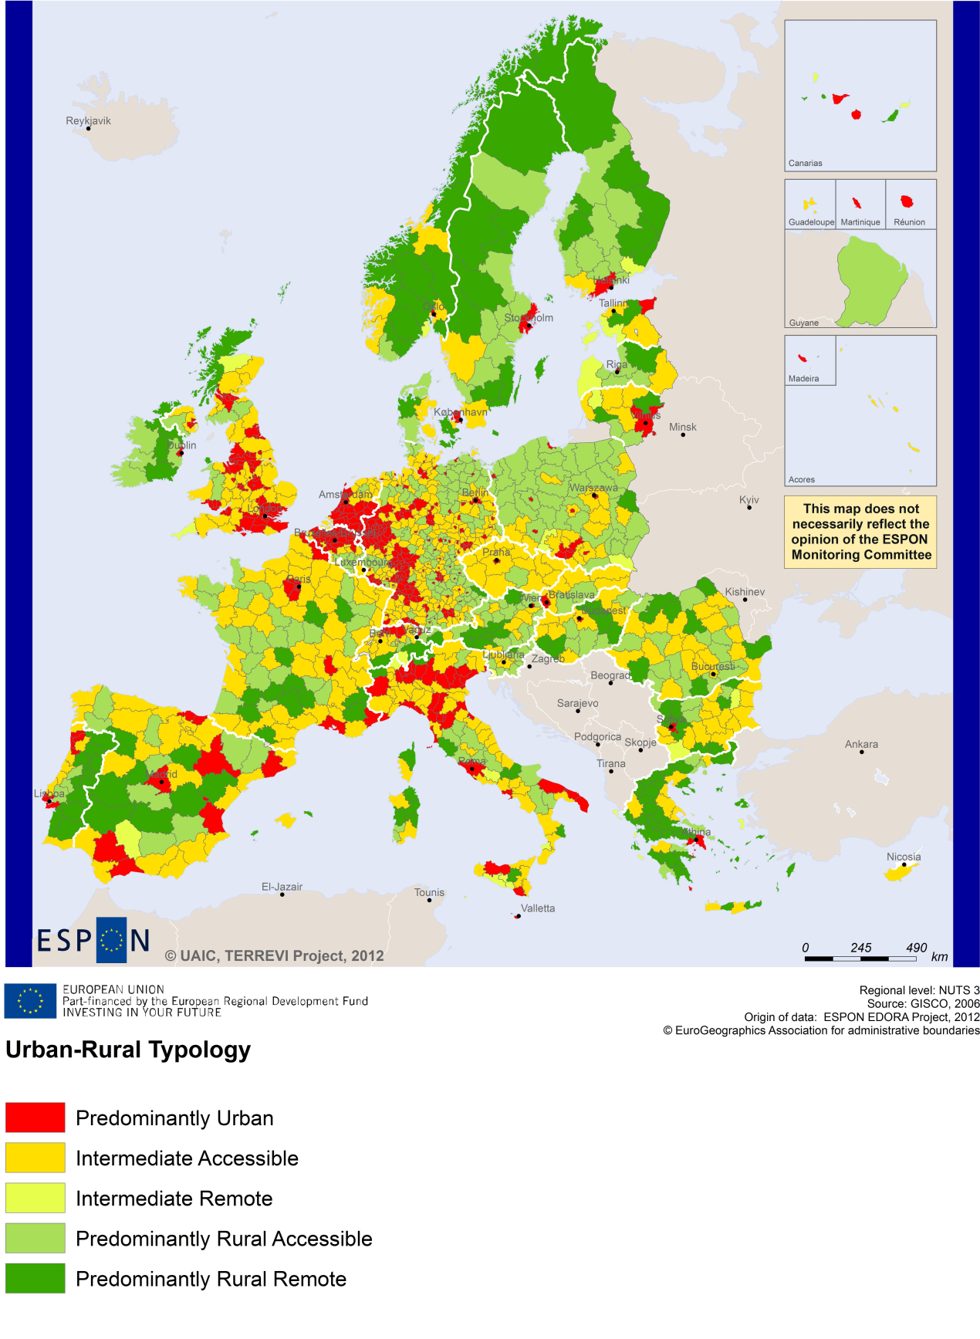
(Accessible=close to a city)

MAP 5 – Multimodal accessibilty (ESPON Accessibility Update) for the CBC Hungary – Slovak Republic
“Potential Accessibility Multimodal” scores accessibility of NUTS 3 regions by road, rail and air relative to the European average in an Accessibility Index.
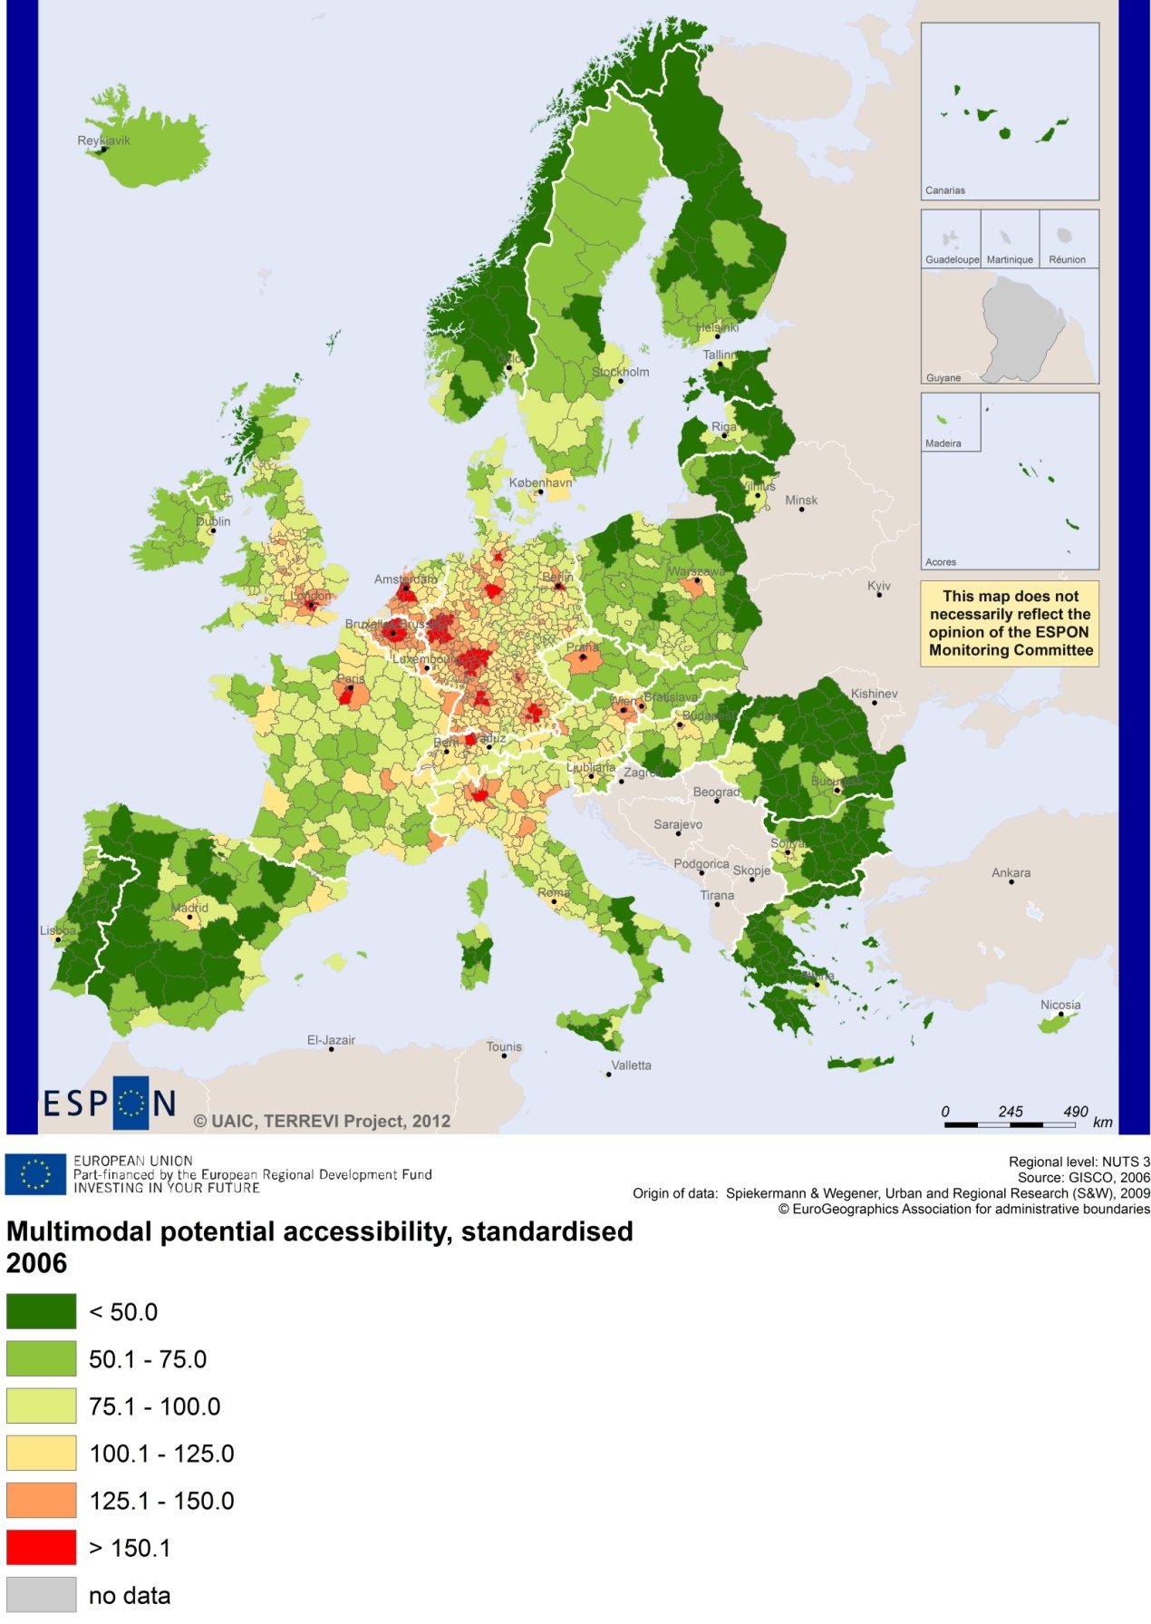

Recommended ESPON reading
ESPON provides an essential underpinning for translating into practice the calls for integrated and place-based approaches to economic development, when analysing a programme area or deciding about future programme priorities. ESPON has published a wide range of exciting reports providing valuable territorial evidence for future territorial cooperation initiatives.
The table below shows examples of relevant projects for the Cooperation Region. However, you have to study other ESPON reports as well in order to capitalise fully on the European information available for the cross-border programming.
ESPON study | Topic | Content
EDORA | Rural areas | It provides evidence on the development opportunities of diverse types of European rural areas and reveals competitiveness options (see maps in Appendix 1).
CLIMATE | Climate change | It analyses how and to which degree climate change will impact on the competitiveness and cohesion of European regions and Europe as a whole (see from map 1 to 23).
TIPTAP | Territorial impact assessment | It provides a tool for the ex-ante assessment of territorial impacts of policies to deliver evidence on the territorial impact of policies (see from map 2.3.1 to 2.3.9).
CAEE | Agglomerati-on economies | It aims at a better understanding of the economic costs and benefits of large urban agglomerations (see figure 1).
TRANSMEC | European cooperation | It develops a method providing guidance on how ESPON results can add value to support territorial cooperation programmes (see map 27 and from map 36 to 39 on potential accessibility indicators).
SEMIGRA | Rural migration | It identifies the main reasons and consequences of selective migration in rural regions in order to develop strategies for territorial development (see map 1, 4 and 5).
KIT | Innovation | It describes patterns and potentials of regions in terms of knowledge and innovation economy and explores development opportunities (see from map 3.1.1 to 4.4.1). The capital city of Bratislava is a case study (Scientific report).
SGPTD | Growth poles | It provides evidence about performance and roles of European secondary cities (see from figure 2 to 2.12).
POLYCE | Metropolitan regions | It explores polycentric systems characteristics at regional and metropolitan level. Budapest and Bratislava are two capital cities addressed by this study.
Furthermore, some of overall ESPON products of particular interest for territorial cooperation are:
- ESPON Synthesis report “new evidence on smart, sustainable and inclusive territories” provides an easy to read overview on ESPON results available.
- ESPON Territorial Observations is a publication series, which on a few pages presents policy relevant findings deriving from latest ESPON research.
- ESPON 2013 Database provides regional information provided by ESPON projects and EUROSTAT.
- ESPON Hyperaltas allows comparing and analysing a region’s relative position at European, national and local scale for a wide range of criteria.
- ESPON MapFinder provides access to the most relevant ESPON maps resulting from ESPON projects and reports.
- ESPON Typologies provides nine regional typologies for additional analysis of regional data to be considered in the European context.
All ESPON reports and tools are freely available at
www.espon.eu

The ESPON 2013 Programme is part-financed by the European Regional Development Fund, the EU Member States and the Partner States Iceland, Liechtenstein, Norway and Switzerland. It shall support policy development in relation to the aim of territorial cohesion and a harmonious development of the European territory.

