Italy – France ALCOTRA
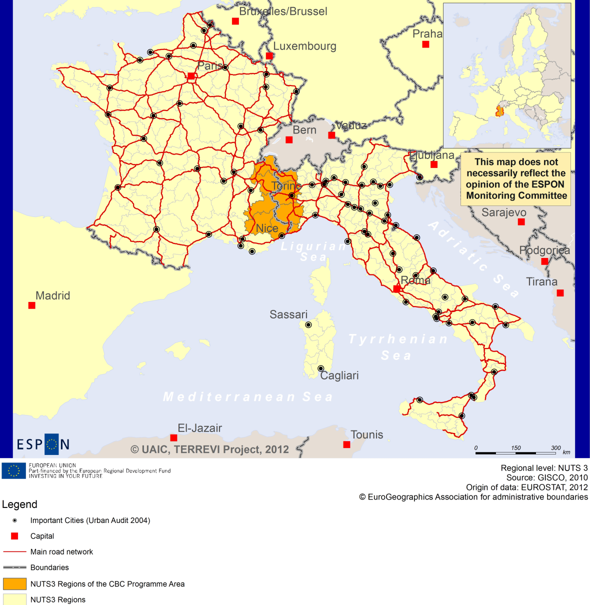

ESPON Project TERREVI
November 2012

Introduction
ESPON supports policy development in relation to the aim of territorial cohesion and a harmonious development of the European territory. It provides comparable information, evidence, analysis, and scenarios on territorial dynamics, which reveal territorial capitals and development potentials of regions and larger territories. Considering the programme area in its European context adds an important new perspective that can help shaping the programming and the places of implementing projects.
The ESPON TERREVI project focuses on producing evidence for Structural Funds programmes with the aim to support the development of the programmes to be carried out in the 2014-2020 period.
One milestone of this work consists in presenting selected ESPON research pieces in easy-to-understand factsheets for all territorial cooperation programme areas. The aim is to provide the reader with preliminary insight on types of territorial evidence ESPON holds at hand with regard to the possible investment priorities of future programmes. The factsheets certainly only give a first glimpse rather than fully present the work of the large number of ESPON projects that are currently underway. Likewise, each programme area includes diverse development potentials and challenges, which needs targeted information search. However, hopefully this factsheet will contain information, benchmarking the programme area in its larger, territorial context, that is of interest and help to better understand the programme area and to navigate within the richness of ESPON material available.
In addition to the programme factsheets there will be a number of specific programme case studies illustrating how ESPON material can be used to support the development of future programmes e.g. by giving a comparative European dimension to the envisaged SWOTs. These case studies will be carried out in early 2013.
This factsheet is structured in three main parts. The first part presents a selection of indicators that help comparing the situation of the programme area in question with the European average, the average for all programme areas as well as the situation in the countries involved. The second part briefly presents the territorial factors of interest for the programme area. The final part offers guidance on the further use of ESPON results and tools. This is intended as an electronic publication so map quality is generally high to allow users to zoom into specific territories.
This factsheet does not necessarily reflect the opinion of the ESPON Monitoring Committee.

Europe 2020
Europe, with its member states and their regions, is more exposed to global shocks and international competition than at any time before. As the world becomes more interdependent this trend will continue and shape policy thinking across sectors, borders and geographical scales. At the same time, Europe is characterised by a large territorial diversity meaning that global developments can imply rather different development possibilities and challenges for different European regions and cities.
The differences are partly defined by major geographical structures such as urban systems, access and connectivity, the geographical specificity or population density. At the same time, the differences are also spelled out in the larger development trends that affect an area, and the way and degree to which it is affected.
The data, indicators and territorial evidence provided by ESPON provides insight on both the main structures and larger territorial trends. The fine art is to identify what can actually be influenced by policy-making and, in particular, by place-based policy and territorial cooperation related to your programme area.
This chapter provides a selection of ESPON data related to Europe 2020 objectives of smart, sustainable and inclusive growth, giving also hints as regards the main thematic objectives envisaged in the draft regulations for the next period of EU Cohesion Policy. The Europe 2020 Strategy aims to enhance smart, sustainable and inclusive growth. This strategy has clear territorial dimensions. However, achieving these goals is challenging in the crisis-driven times. Furthermore, the economic disparities are growing as economic trends and the crisis have various impacts on different parts of Europe.
In the following the traffic light for each indicator represents how your programme territory compares to wider European and national medians where green = your programme area performs better for that indicator, yellow = similar, and red = worse.
In creating the traffic lights the median was used as central value indicator for all statistical variables due to its advantages (easy to interpret, it splits the statistical distribution in half) but especially due to the constraints linked to the impossibility of computing means for several indicators (Climate Change, Wind Energy Potential etc.). Therefore, a special attention should be given in reading the median values when the number of NUTS 2 regions is below 7. Using percentiles implies also a high dependence of the final results on the type of statistical distribution. This fact should be considered when establishing the relative position of a CBC Programme Area to a specific country.
EU 27+4 in Traffic Lights and box-plots means the EU Member States as well as Iceland, Liechtenstein, Norway and Switzerland – the ESPON space.

Smart growth
Smart growth refers to developing an economy based on knowledge and innovation. In the framework of the Europe 2020 Strategy it means improving the EU's performance in education, research/innovation and digital society.
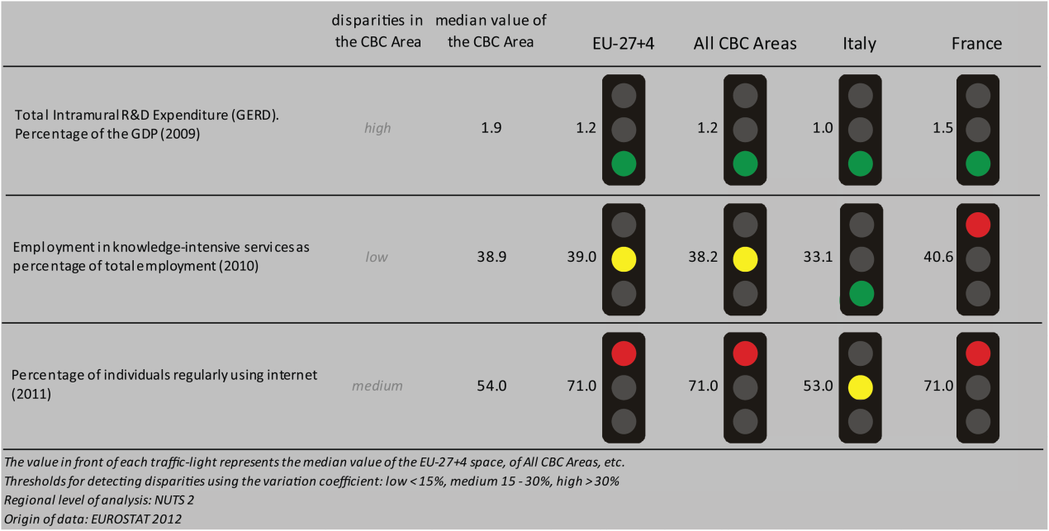
According to all indicators reported above, the Italy-France ALCOTRA CBC area performs similarly to the EU27+4 space and all CBC ones, though it pretty much vary according to the observed indicator.
Considering the objective of R&D expenditure as a percentage of GDP - one of the five headline targets in the Europe 2020 Strategy - the CBC area has higher values than the EU27+4 space and all CBC. Although the CBC area is characterised by a high level of internal disparity, it performs better than both Italy and France. Concerning the ratio of employment in knowledge-intensive services to the total employment in 2010, the CBC area has similar values to the EU27+4 space and all CBCs, but it is doing better than Italy and less well than France, with a low level of internal disparity. In terms of percentage of individuals regularly using internet in 2011, the CBC has lower values than the EU27+4 space, all CBCs and France, but it performs similarly to Italy, with a medium level of internal disparities.
According to the classification of the KIT project, MAP 1 identifies two territorial patterns of innovation, which are not keeping up with national borders:
- ‘Smart and creative diversification area’ in both sides, i.e. in Italy the region of Aosta Valley, the province of Imperia, and Liguria and in the French parts of the PACA region (Alpes-de-Haute-Provence, Hautes-Alpes, Alpes-Maritimes). It is defined by a low degree of local diversified applied knowledge, internal innovation capacity, high degree of local competences, creativity and entrepreneurship, external knowledge embedded in technical and organizational capabilities;
- ‘Smart technological application area’, in the Italian parts of Piedmont region (the province of Turin and Cuneo) and the French parts of Rhône-Alpes (Savoie, Haute-Savoie). It is defined by a high product innovation level, with a limited degree of local applied science and R&D endowment, and a high creativity which allows translating external basic science and applied science knowledge into innovation.

MAP 1 – Territorial Patterns of Innovation (ESPON KIT project) for the CBC Italy – France ALCOTRA

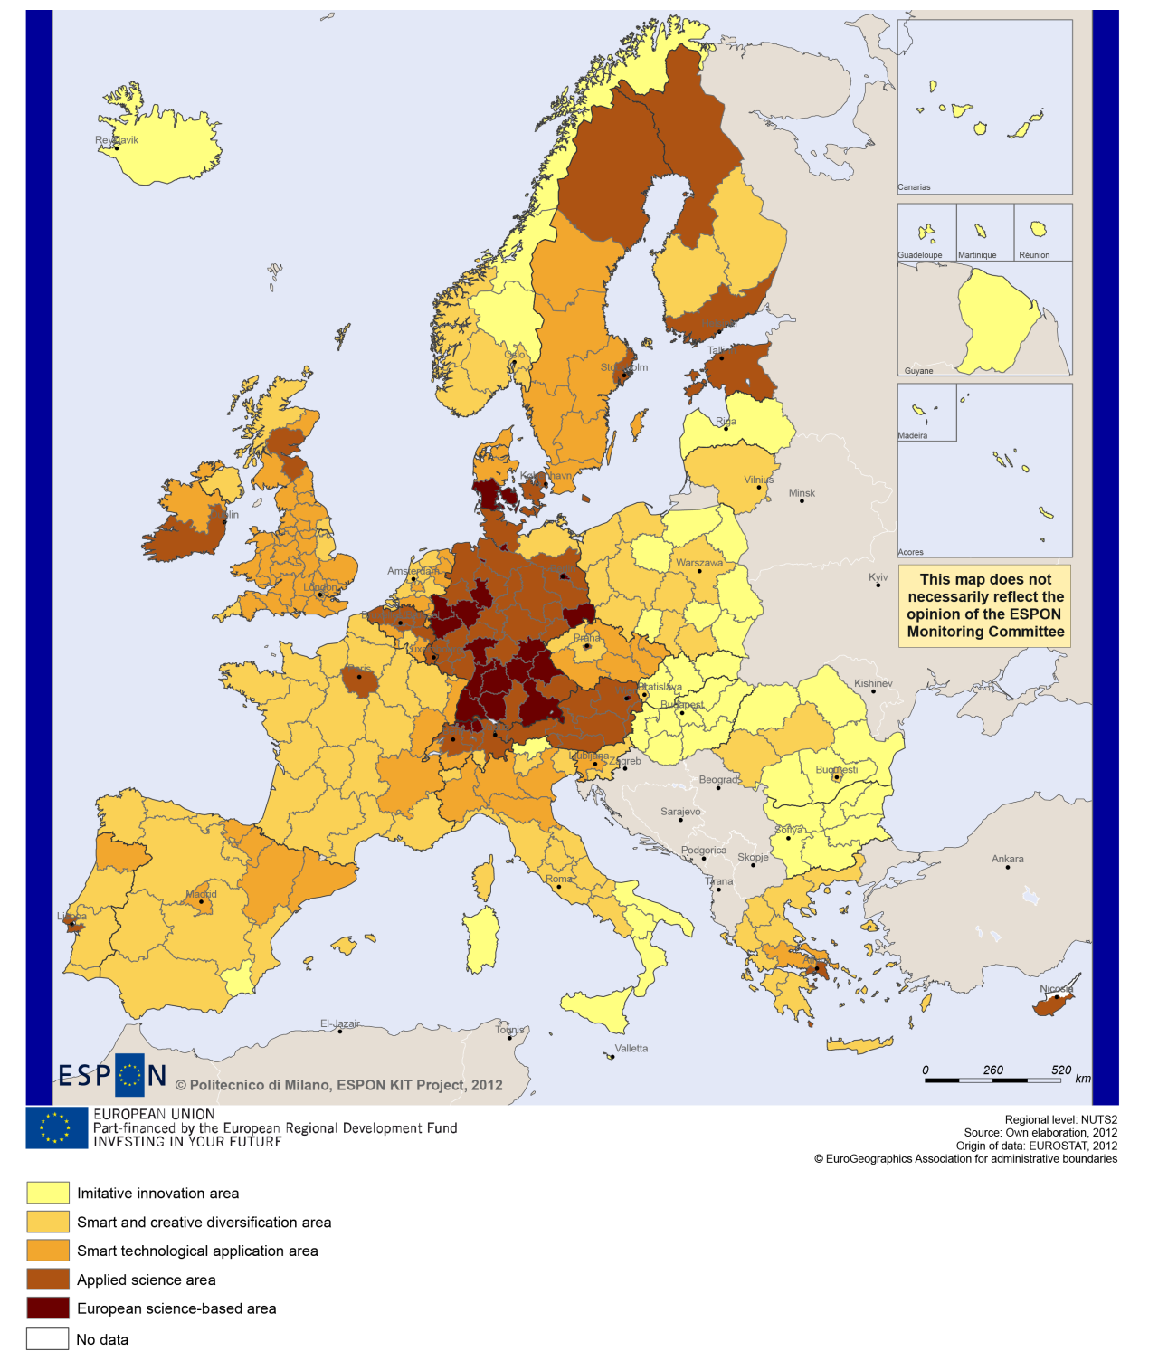

Sustainable growth
Sustainable growth refers to promoting a more resource efficient, greener and more competitive economy. Within the Europe 2020 Strategy it means e.g. building a more competitive low-carbon economy that makes efficient, sustainable use of resources, protecting the environment, reducing emissions and preventing biodiversity loss, capitalising on Europe's leadership in developing new green technologies and production methods, and introducing efficient smart electricity grids. In the framework of the Europe 2020 Strategy it means focus on competitiveness, resource efficiency, climate change and biodiversity.
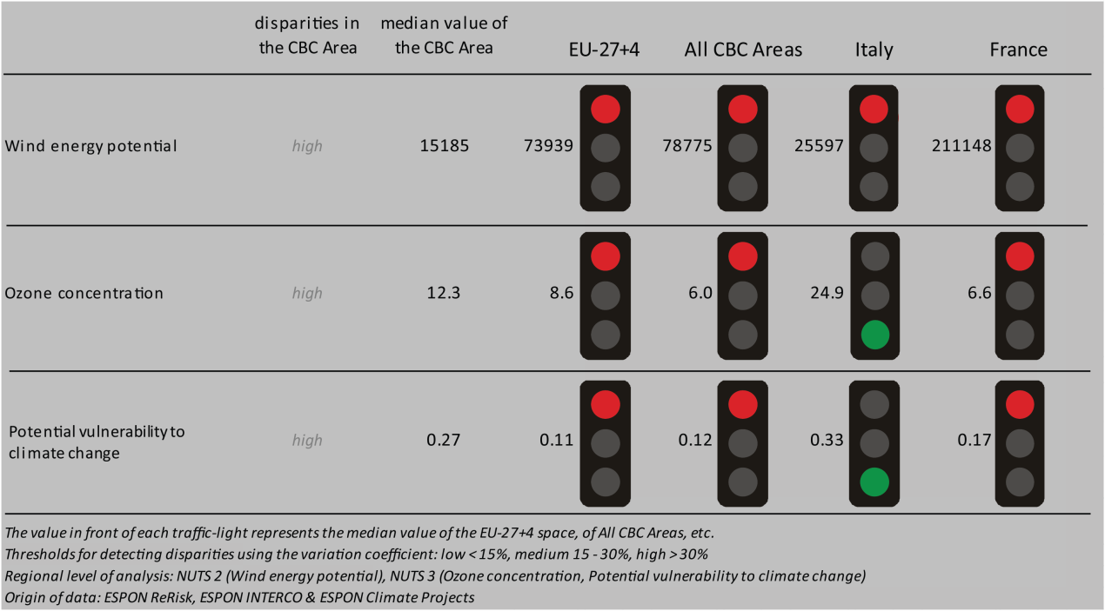
The programme area of Italy-France ALCOTRA is generally characterised by considerably weaker sustainable growth indicators than the EU-27+4, all CBC areas or France. Wind energy potential is very low in the European (EU-27+4 and all CBC) context, and considerably lower than the level of France. The ozone concentration is very high in comparison to the EU-27+4, all CBC and French medians; however, it is much lower than the ozone concentration in Italy. The programme area is also more vulnerable to climate change than the EU-27+4, all CBC or French regions in general, but it is slightly less vulnerable than Italy. The same picture emerges looking at the combined adaptive capacity to climate change of the NUTS3 regions of the CBC area (BOX-PLOT 1). All four Italian NUTS3 regions of the border-area (Torino, Cueno, Valle d’Aosta and Imperia) show low to extremely low capacities in the European context. At the same time, the French regions have similar or higher level of adaptive capacity than the median of EU-27+4 or all CBC regions.
Directive 11 has a high impact on fossil fuel consumption in all regions on the French side of the border and in the NUTS3 region of Imperia (Italy), while it has no impact in the other three Italian border regions.

MAP 2 - Territorial impact on fossil fuel consumption of Directive on the promotion of clean and energy-efficient road transport vehicles (ESPON ARTS project) for the CBC Italy – France ALCOTRA

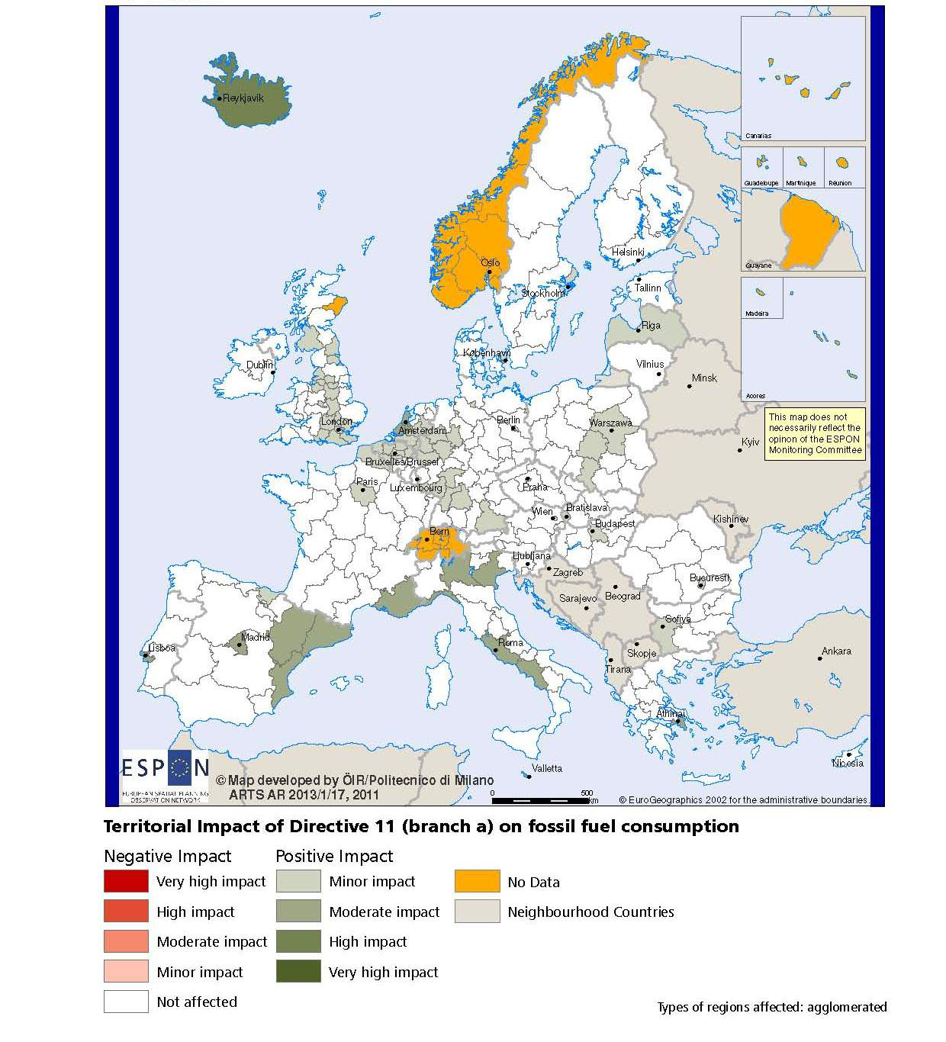

BOX-PLOT 1 – Combined adaptive capacity to climate change (ESPON CLIMATE project) for the CBC Italy – France ALCOTRA
“Adaptive capacity (adaptability)” to climate change indicates the ability or potential of a system to respond successfully to climate change and variability, and includes adjustments in behaviour, resources and technologies.
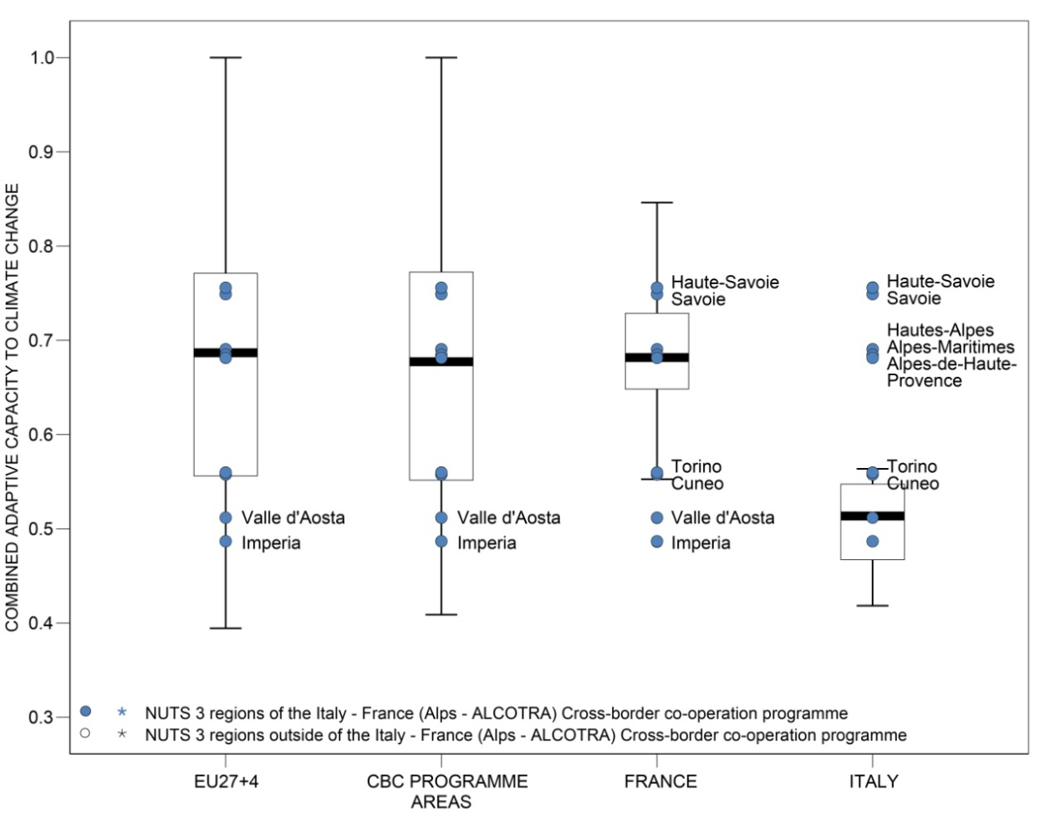

How to read the box-plots?
The box-plot is a statistical and mathematical tool used to visualize numerical data sets and to compare its statistical distribution.
Because it is used in exploratory analysis of databases, this representation is sensitive to the quality of the central value selected to explain the symmetry, shape and distribution variability. In the case of a box-plot, the most used central value is the median, because it has the quality of sectioning the data string into two halves, so that 50% of the cases will be above the central value and the other half will be below it. Since the purpose of the representation is to highlight outliers’ behavior, it uses a box that encompasses half of the cases, i.e. values that are in the range defined by the percentile of 25% and 75%. If a region has a value in this box then it can be considered that it has, according to the variable in question, a situation close to the average behavior of all regions analyzed.
When a region consistently deviates from the average profile of the analyzed territorial context, this behavior will be noted in the chart only when certain thresholds of statistical tolerances are exceeded, this being pointed in the diagram with segments perpendicular to the middle box, segments called the "whiskers".

Inclusive growth
Inclusive growth refers to fostering a high-employment economy delivering social and territorial cohesion. Within the Europe 2020 Strategy it means raising Europe’s employment rate, helping people of all ages anticipate and manage change through investment in skills & training, modernising labour markets and welfare systems, and ensuring the benefits of growth reach all parts of the EU. In short the key factors are employment and avoiding risk of poverty and social exclusion.
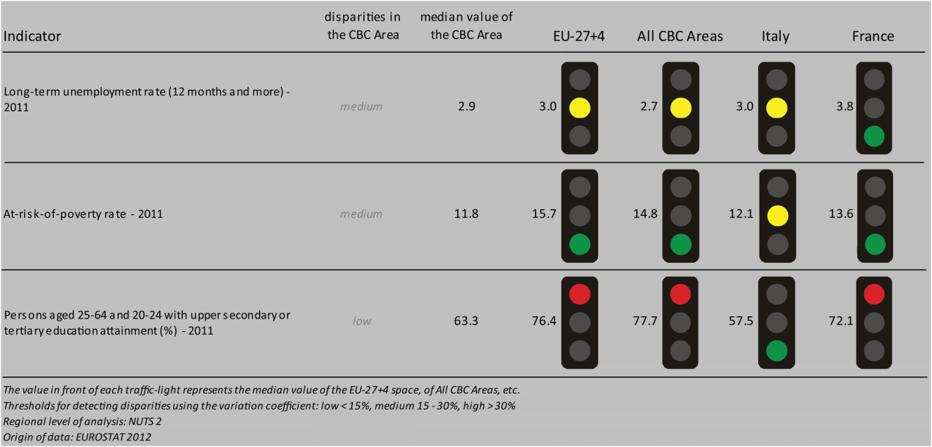
The long-term unemployment rate in the Italy-France ALCOTRA border-area is similar to that of the EU-27+4, all CBC areas and Italy (while it is at a lower level than that of France). The rate of people at risk of poverty is lower than the European (EU-27+4 and all CBC) medians, and it is at the same level as that of Italy. The CBC area counts relatively fewer persons aged 25-64 and 20-24 with upper secondary or tertiary education than the EU-27+4, all CBC areas or France, while it has a higher rate than that of Italy.
The employment rates of the NUTS3 regions of the Italy-France ALCOTRA area are at an average level in both the European and national contexts, except for the regions of Cueno and Val d’Aosta, which have particularly high employment rates in all contexts (BOX-PLOT 2).
Two out of the four scenarios (namely ‘Expanding Market Europe’ and ‘Growing Social Europe’) of the ESPON DEMIFER project foresee significant increase in the labour force until 2050 in all of the Italy-France ALCOTRA border-regions (MAP 3). The two other scenarios (namely ‘Challenged Market Europe’ and ‘Limited Social Europe’) predict minor increase of the labour force on the French side, but envisage minor to significant decrease on the Italian side of the border.

MAP 3 – Change in Labour Force 2005-2050 (ESPON DEMIFER project) for the CBC Italy – France ALCOTRA

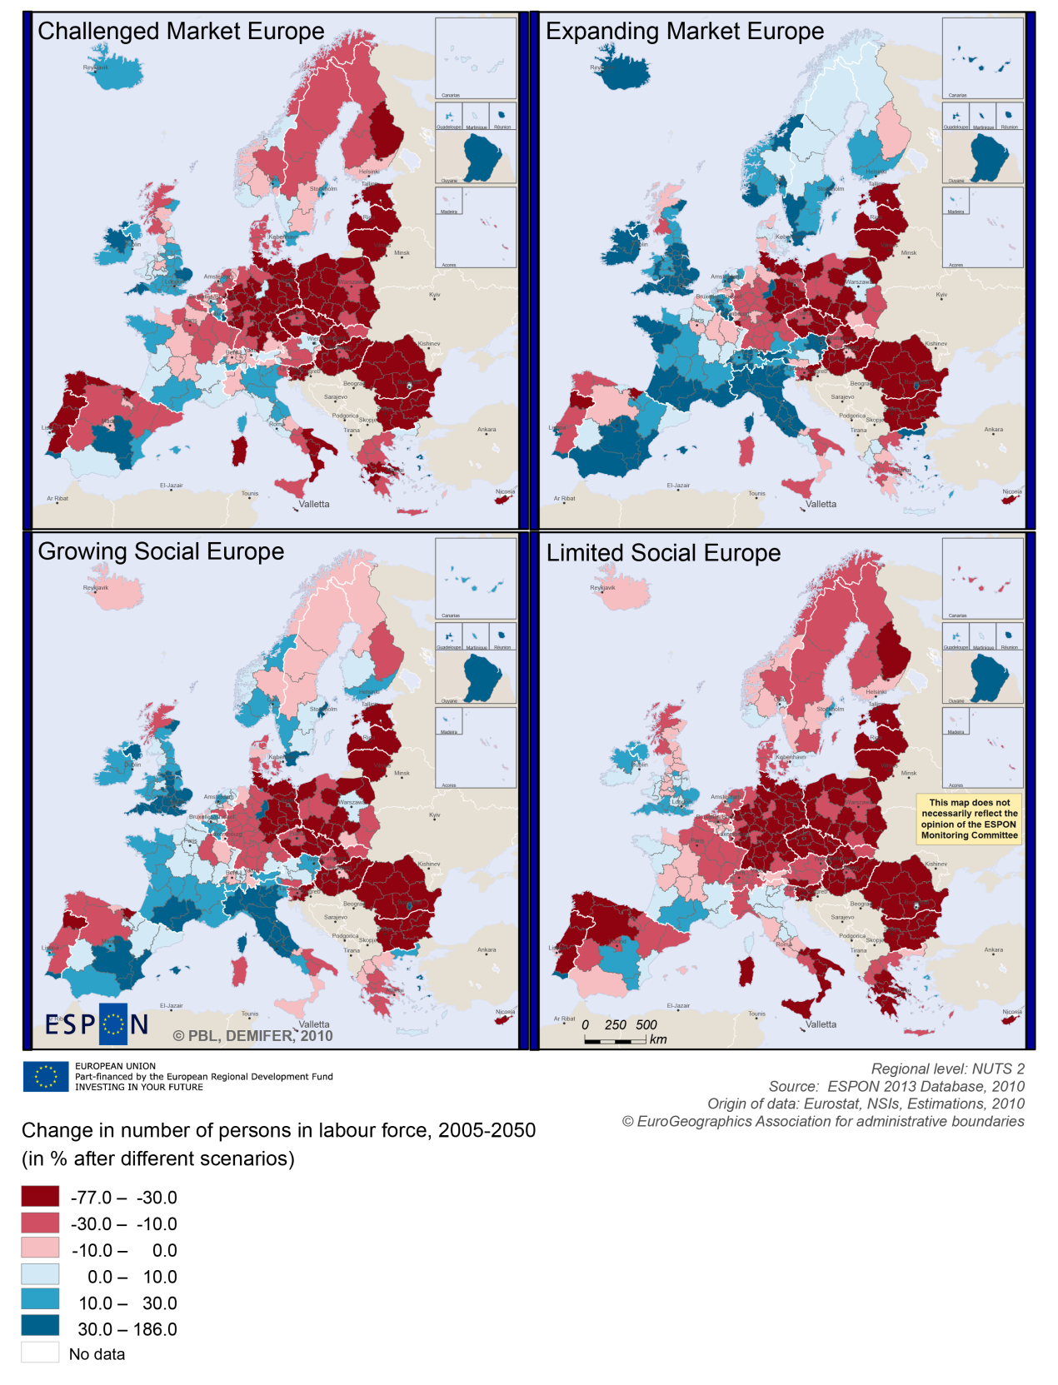

BOX-PLOT 2 – Employment rate 2010 within the CBC Italy – France ALCOTRA
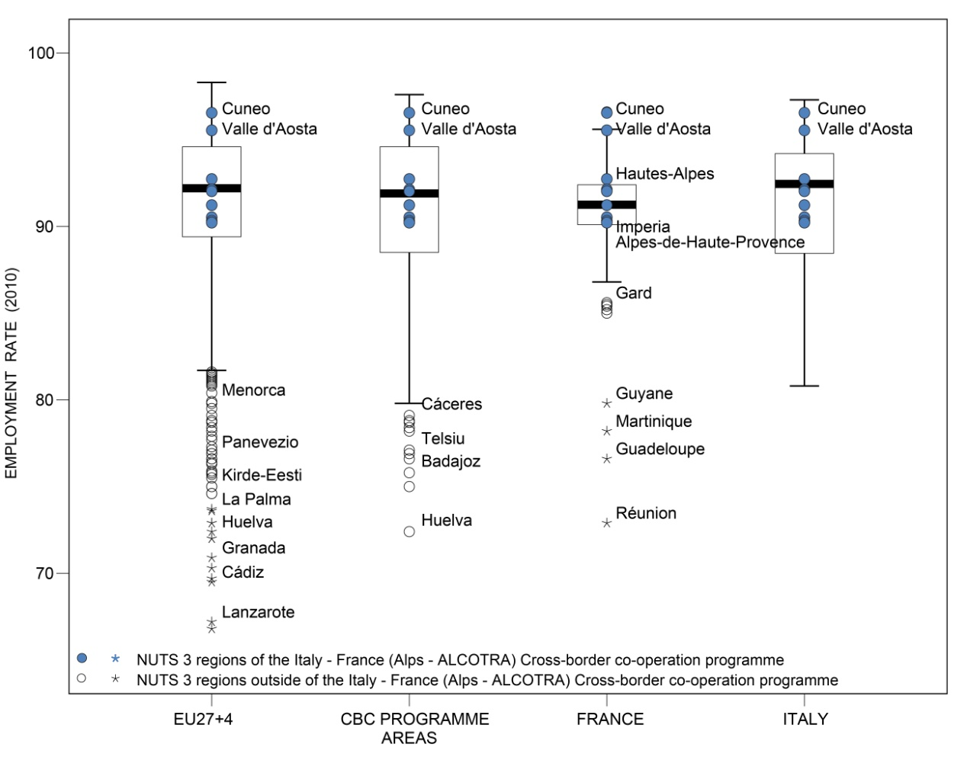

(see “How to read the box-plots?” on page 8)

Territorial factors of interest for the programme area
Territorial cooperation programmes can make a difference for the future development of cross-border and transnational territories in Europe. Some of the factors can be analysed by European wide data sets and using some studies having specific maps, figures and tables concerning the areas of the cooperation region.
In a European perspective the programme area comprises a range of different types for regions, from the urban regions of Torino and Nice, via intermediate regions (in-between urban and rural) to rural regions. Some of the rural and intermediate regions are even characterised as remote in a European perspective. As Metropolitan European Growth Areas, Nice and Tornio are important hubs in the programme region. In addition, the programme area benefits from close proximity to other urban larger centres such as e.g. Geneva, Marseille, Genoa or Milan.
This concerns both the access to services and infrastructure. Whereas most parts of the programme area have above average European accessibility, Torino and Nice stand out with their good international accessibility. They offer also good opportunities for one-day business trips within the European urban network.
The partly rural and remote character of the programme area, with Torino and Nice as exceptions, implies a range of development opportunities and challenges. One of these concerns the low urban potential for strengthening cross-border functional areas and the below European average number of border crossings per 100 km of border.
In European perspective the area is widely characterised as mountainous. ESPON GEOSPECS has developed a nexus model for mountainous regions linking defining features via intermediary process to development challenges and opportunities (see figure). This model can be of interest for further developing the discussion about the challenges and opportunities in the programme area.
ESPON GEOSPECS PROJECT – FINAL REPORT, PAGE 102:
Nexus model for mountain areas
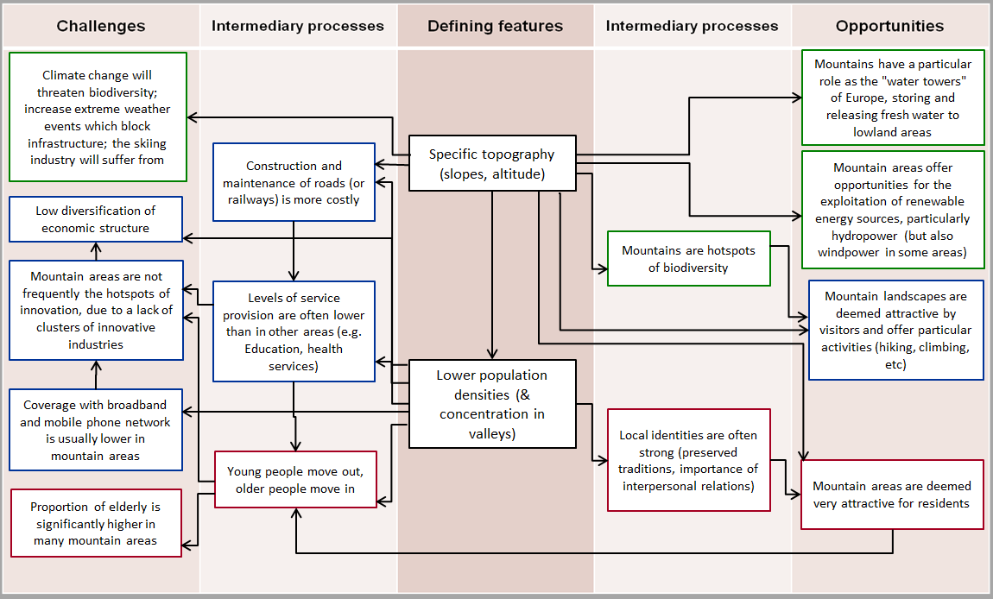

MAP 4 – Urban-rural typology of NUTS3 regions including remoteness (DG Regio) for the CBC Italy – France ALCOTRA

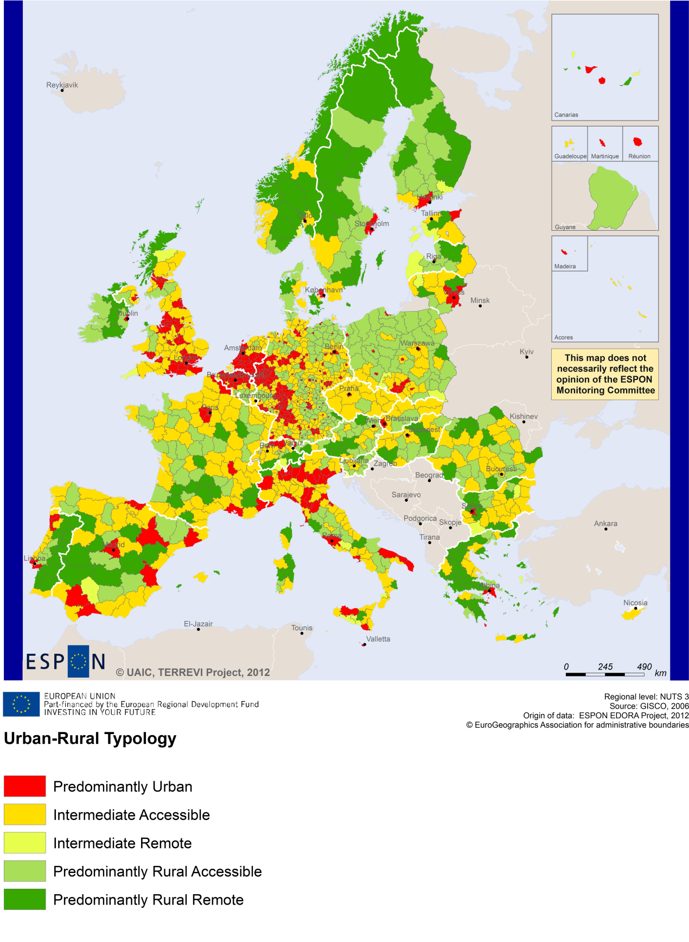
(Accessible=close to a city)

MAP 5 – Multimodal accessibilty (ESPON Accessibility Update) for the CBC Italy – France ALCOTRA
“Potential Accessibility Multimodal” scores accessibility of NUTS 3 regions by road, rail and air relative to the European average in an Accessibility Index.
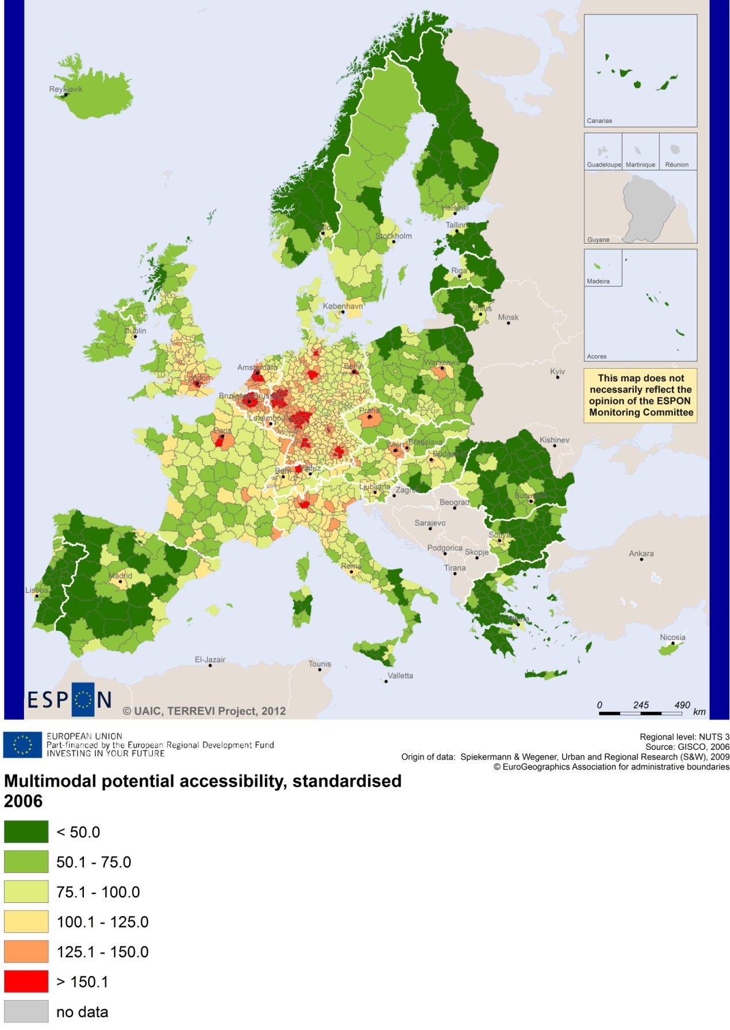

Recommended ESPON reading
ESPON provides an essential underpinning for translating into practice the calls for integrated and place-based approaches to economic development, when analysing a programme area or deciding about future programme priorities. ESPON has published a wide range of exciting reports providing valuable territorial evidence for future territorial cooperation initiatives.
The table below shows examples of relevant projects for the Cooperation Region. However, you have to study other ESPON reports as well in order to capitalise fully on the European information available for the cross-border programming.
ESPON study | Topic | Content
EDORA | Rural areas | It provides evidence on the development opportunities of diverse types of European rural areas and reveals competitiveness options (see maps in Appendix 1).
CLIMATE | Climate change | It analyses the impact of climate change on the competitiveness and cohesion of Europe (see from map 1 to 23). This study presents Alpine Space as a case study area.
TIPTAP | Territorial impact assessment | It provides a tool for the ex-ante assessment of territorial impacts of policies to deliver evidence on the territorial impact of policies (see from map 2.3.1 to 2.3.9).
CAEE | Agglomerati-on economies | It aims at a better understanding of the economic costs and benefits of large urban agglomerations (see figure 1).
TRANSMEC | European cooperation | It develops a method providing guidance on how ESPON results can add value to support territorial cooperation programmes (see map 27 and from map 36 to 39).
SEMIGRA | Rural migration | It identifies the main reasons and consequences of selective migration in rural regions in order to develop strategies for territorial development (see map 1, 4 and 5).
KIT | Innovation | It describes patterns and potentials of regions in terms of knowledge and innovation economy and explores development opportunities (see from map 3.1.1 to 4.4.1).
SGPTD | Growth poles | It provides evidence about performance and roles of European secondary cities (see from figure 2 to 2.12). This project proposes a case study on the city of Turin.
SS-LR | Scenario | It develops and applies regional forecasting methodologies at the appropriate territorial scale. The project analyses the Latin Arc as a case study area.
DEMIFER | Demography | It provides evidence on the regional effects of migration on Europe's demographic future. The study proposes Piedmont as a case study region (Annex D12-7).
Furthermore, some of overall ESPON products of particular interest for territorial cooperation are:
- ESPON Synthesis report “new evidence on smart, sustainable and inclusive territories” provides an easy to read overview on ESPON results available.
- ESPON Territorial Observations is a publication series, which on a few pages presents policy relevant findings deriving from latest ESPON research.
- ESPON 2013 Database provides regional information provided by ESPON projects and EUROSTAT.
- ESPON Hyperaltas allows comparing and analysing a region’s relative position at European, national and local scale for a wide range of criteria.
- ESPON MapFinder provides access to the most relevant ESPON maps resulting from ESPON projects and reports.
- ESPON Typologies provides nine regional typologies for additional analysis of regional data to be considered in the European context.
All ESPON reports and tools are freely available at
www.espon.eu

The ESPON 2013 Programme is part-financed by the European Regional Development Fund, the EU Member States and the Partner States Iceland, Liechtenstein, Norway and Switzerland. It shall support policy development in relation to the aim of territorial cohesion and a harmonious development of the European territory.

