Madeira – Azores – Canary Islands (Macronesia)
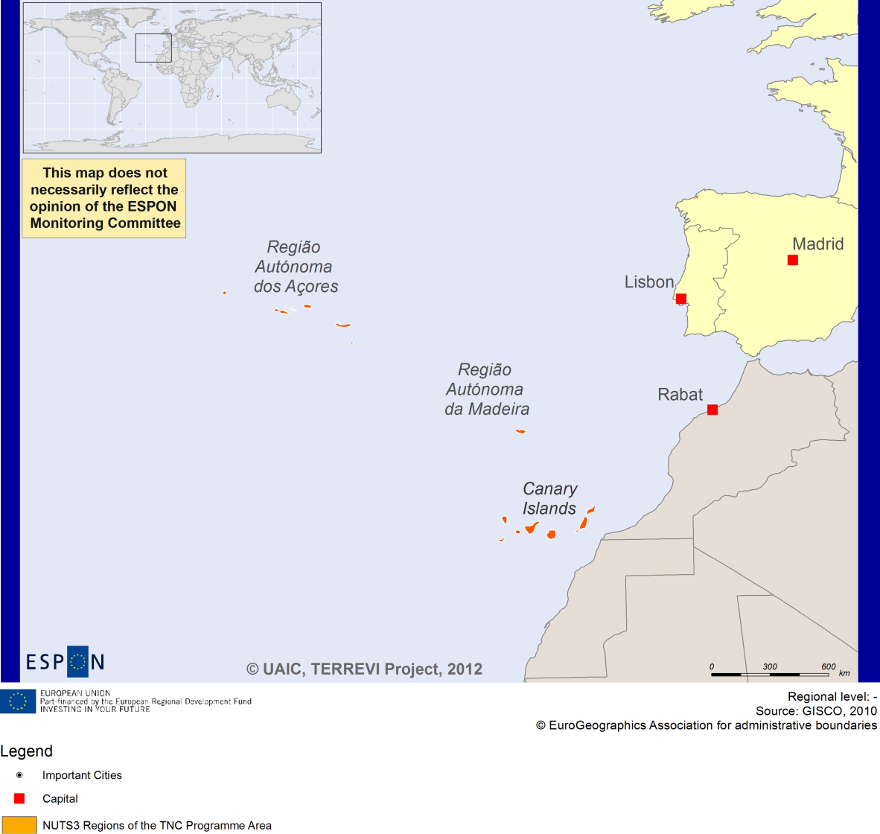

ESPON Project TERREVI
November 2012

Introduction
ESPON supports policy development in relation to the aim of territorial cohesion and a harmonious development of the European territory. It provides comparable information, evidence, analysis, and scenarios on territorial dynamics, which reveal territorial capitals and development potentials of regions and larger territories. Considering the programme area in its European context adds an important new perspective that can help shaping the programming and the places of implementing projects.
The ESPON TERREVI project focuses on producing evidence for Structural Funds programmes with the aim to support the development of the programmes to be carried out in the 2014-2020 period.
One milestone of this work consists in presenting selected ESPON research pieces in easy-to-understand factsheets for all territorial cooperation programme areas. The aim is to provide the reader with preliminary insight on types of territorial evidence ESPON holds at hand with regard to the possible investment priorities of future programmes. The factsheets certainly only give a first glimpse rather than fully present the work of the large number of ESPON projects that are currently underway. Likewise, each programme area includes diverse development potentials and challenges, which needs targeted information search. However, hopefully this factsheet will contain information, benchmarking the programme area in its larger, territorial context, that is of interest and help to better understand the programme area and to navigate within the richness of ESPON material available.
In addition to the programme factsheets there will be a number of specific programme case studies illustrating how ESPON material can be used to support the development of future programmes e.g. by giving a comparative European dimension to the envisaged SWOTs. These case studies will be carried out in early 2013
This factsheet is structured in three main parts. The first part presents a selection of indicators that help comparing the situation of the programme area in question with the European average, the average for all programme areas as well as the situation in the countries involved. The second part briefly presents the territorial factors of interest for the programme area. The final part offers guidance on the further use of ESPON results and tools. This is intended as an electronic publication so map quality is generally high to allow users to zoom into specific territories.
This factsheet does not necessarily reflect the opinion of the ESPON Monitoring Committee.

Europe 2020
Europe, with its member states and their regions, is more exposed to global shocks and international competition than at any time before. As the world becomes more interdependent this trend will continue and shape policy thinking across sectors, borders and geographical scales. At the same time, Europe is characterised by a large territorial diversity meaning that global developments can imply rather different development possibilities and challenges for different European regions and cities.
The differences are partly defined by major geographical structures such as urban systems, access and connectivity, the geographical specificity or population density. At the same time, the differences are also spelled out in the larger development trends that affect an area and the way and degree to which it is affected.
The data, indicators and territorial evidence provided by ESPON provides insight on both the main structures and larger territorial trends. The fine art is to identify what can actually be influenced by policy-making and, in particular, by place-based policy and territorial cooperation related to your programme area.
This chapter provides a selection of ESPON data related to Europe 2020 objectives of smart, sustainable and inclusive growth, giving also hints as regards the main thematic objectives envisaged in the draft regulations for the next period of EU Cohesion Policy. The Europe 2020 Strategy aims to enhance smart, sustainable and inclusive growth. This strategy has clear territorial dimensions. However, achieving these goals is challenging in the crisis-driven times. Furthermore, the economic disparities are growing as economic trends and the crisis have various impacts on different parts of Europe.
In the following the traffic light for each indicator represents how your programme territory compares to wider European medians where green = your programme area performs better for that indicator, yellow = similar, and red = worse.
The traffic lights below were created in order to graphically represent the situation of each analysed TNC Area compared to the one of the EU-27+4 space. The median value, calculated depending on the values registered for every NUTS 2/NUTS 3 region composing the programme area was used as the central value indicator. The median of the programme area was compared to the one computed for EU-27+4 territory.
EU 27+4 in traffic lights means the EU Member States as well as Iceland, Liechtenstein, Norway and Switzerland – the ESPON space.

Smart, Sustainable and Inclusive growth
Smart growth refers to developing an economy based on knowledge and innovation. In the framework of the Europe 2020 Strategy it means improving the EU's performance in education, research/innovation and digital society.
Sustainable growth refers to promoting a more resource efficient, greener and more competitive economy. Within the Europe 2020 Strategy it means e.g. building a more competitive low-carbon economy that makes efficient, sustainable use of resources, protecting the environment, reducing emissions and preventing biodiversity loss, capitalising on Europe's leadership in developing new green technologies and production methods, and introducing efficient smart electricity grids. In the framework of the Europe 2020 Strategy it means focus on competitiveness, resource efficiency, climate change and biodiversity.
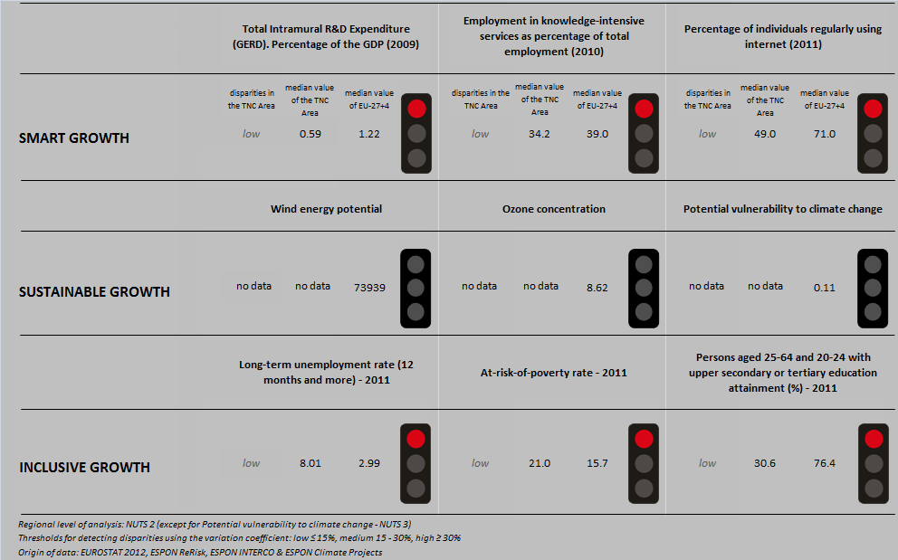
Inclusive growth refers to fostering a high-employment economy delivering social and territorial cohesion. Within the Europe 2020 Strategy it means raising Europe’s employment rate, helping people of all ages anticipate and manage change through investment in skills & training, modernising labour markets and welfare systems, and ensuring the benefits of growth reach all parts of the EU. In short the key factors are employment and avoiding risk of poverty and social exclusion.

Looking at the indicators for smart growth, the Macronesia TNC area performs worse than the EU27+4 with regards to all populated indicators included in the traffic lights graph above: R&D expenditure, the employment in knowledge-intensive services and the number of persons regularly using the internet.
There is no data about the wind energy potential, the ozone concentration nor the potential vulnerability to climate change of the Macronesia TNC area which is why it is not possible to compare the area with the EU27+4 or all TNC areas and the traffic lights for the sustainable growth indicators are empty.
With regards to the inclusive growth indicators, the Macronesia TNC area has a higher long-term unemployment rate, a higher at-risk-of-poverty rate and a lower number of persons aged 25-64 and 20-24 with upper secondary or tertiary education attainment than the EU27+4 and all TNC areas.

MAP 1 – Territorial Patterns of Innovation (ESPON KIT project) for the TNC Macronesia

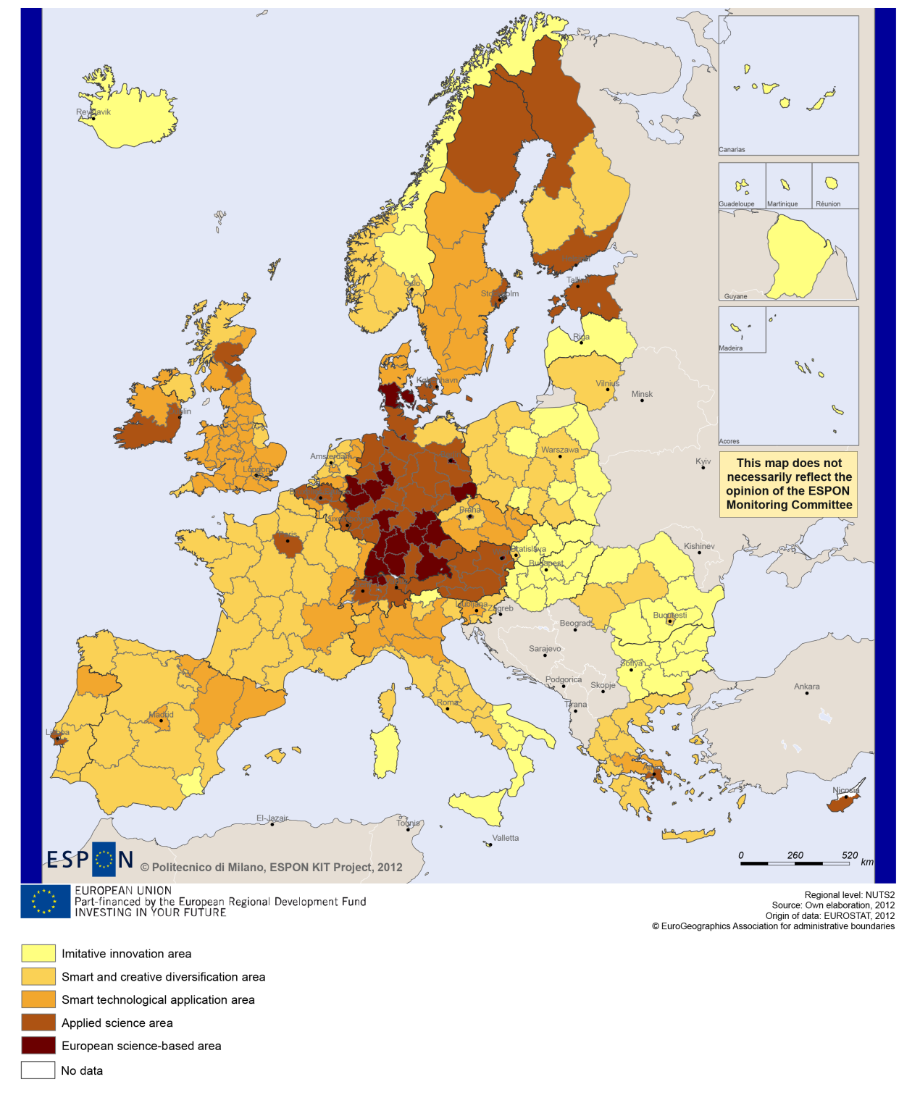

MAP 2 – Territorial impact on fossil fuel consumption of Directive on the promotion of clean and energy-efficient road transport vehicles (ESPON ARTS project) TNC Macronesia

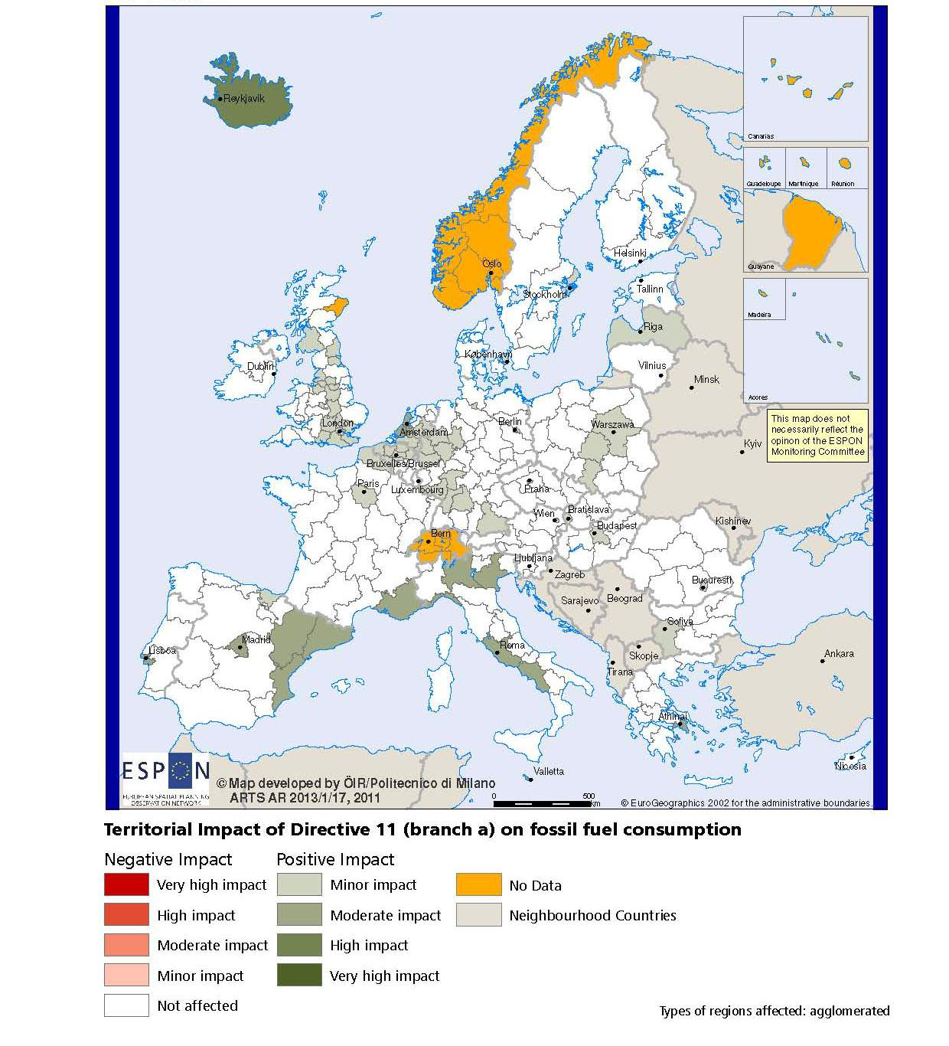

MAP 3 – Combined adaptive capacity to climate change (ESPON CLIMATE project) for the TNC Macronesia
“Adaptive capacity (adaptability)” to climate change indicates the ability or potential of a system to respond successfully to climate change and variability, and includes adjustments in behaviour, resources and technologies.
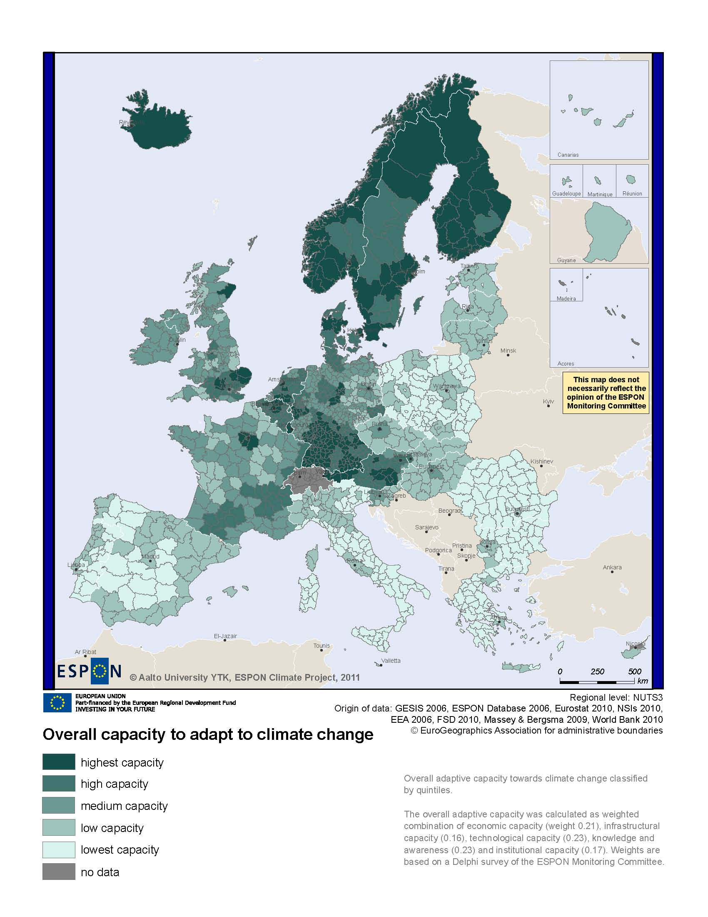
MAP 4 – Change in Labour Force 2005-2050 (ESPON DEMIFER project) for the TNC Macronesia

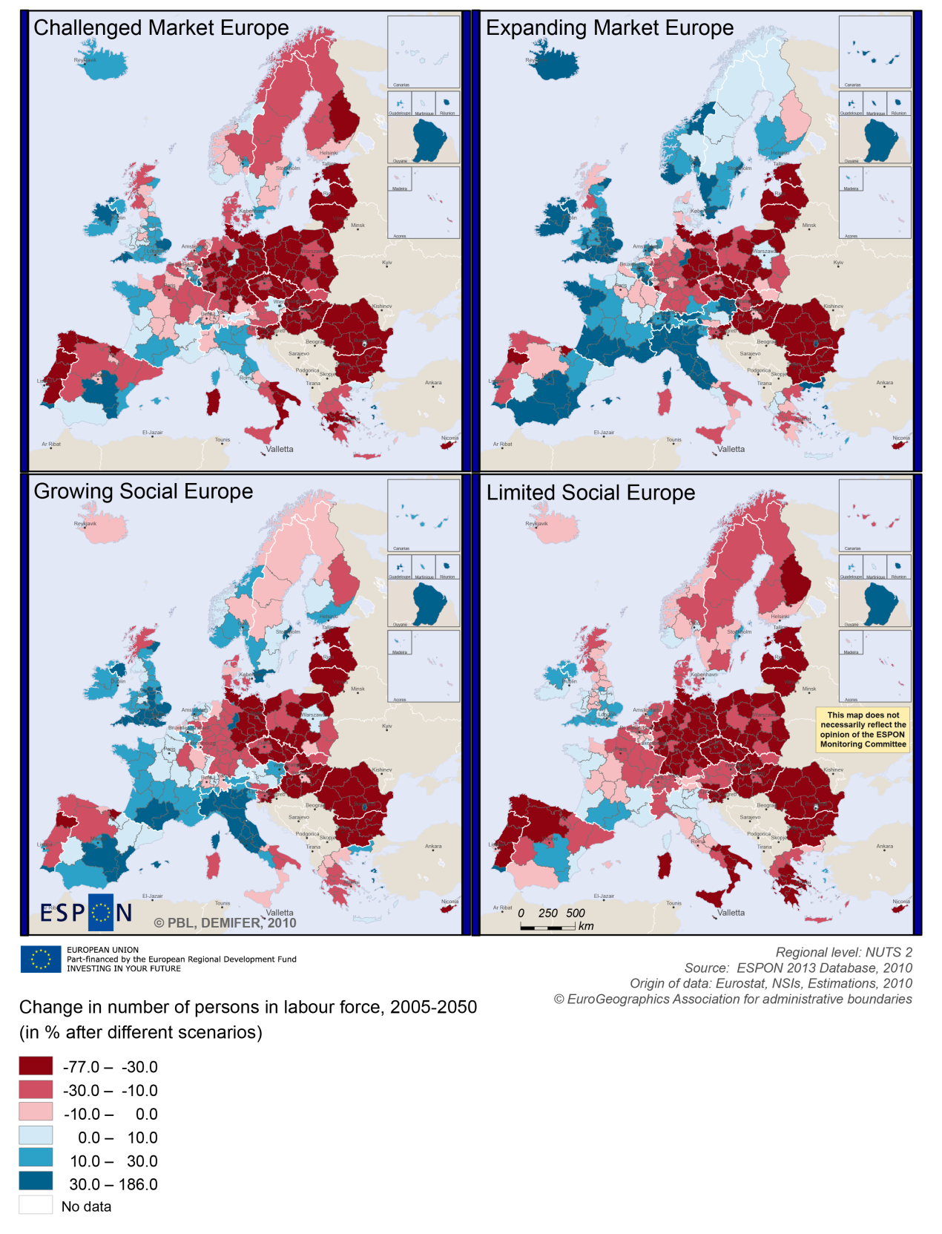

MAP 5 – Employment rate 2010 within the TNC Macronesia

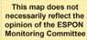
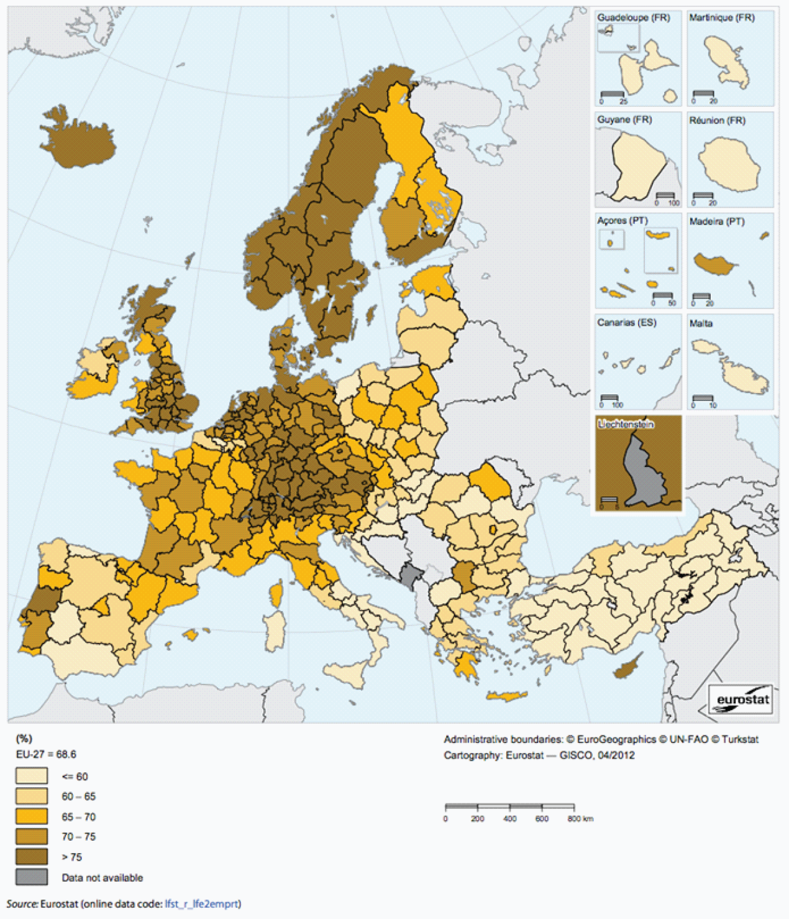

Territorial factors of interest for the programme area
Territorial cooperation programmes can make a difference for the future development of cross-border and transnational territories in Europe. Some of the factors can be analysed by European wide data sets and using some studies having specific maps, figures and tables concerning the areas of the cooperation region.
Besides a wide range of standard indicators frequently used in the context of European regional policies, ESPON has established various indicators which focus more on the territorial dimension. These indicators provide among others information on the development preconditions of an area. Two standard indicators in this field are rural-urban settings and accessibility.
However many ESPON maps and data sets are only of partial interest for outermost areas and the territorial cooperation programmes they are involved in. Overseas territories are, first, remote from continental EU. Besides, these territories are all both insular and mountainous (except for French Guyana).
In territorial terms the programme area of Macronesia can be characterised by remoteness, insularity (even with double insularity), small territory, complex territorial morphology, specific climate conditions and natural risks, as well as vulnerability to climate change.
As the ESPON GEOSPECS report points out, insularity can be considered as another dimension in remoteness. It necessarily brings accessibility and transportation issues, and various types of constraints as regards resources (e.g., energy water generation and storage/use, waste management). Double insularity makes these issues even more acute, and creates additional ones: internal accessibility issues must be addressed (by boat or air, which is more expensive); it is often necessary to duplicate infrastructures (e.g., for health or education); and it is also expensive to maintain several small structures. What is true for public infrastructures is equally true for private ones, and represents a burden for the development of economic activities (notably industrial activities).
ESPON GEOSPECS has developed a nexus model for outermost regions linking defining features via intermediary process to development challenges and opportunities (see figure below).
FIGURE – NEXUS MODEL OUTERMOST REGIONS (ESPON GEOSPECS)
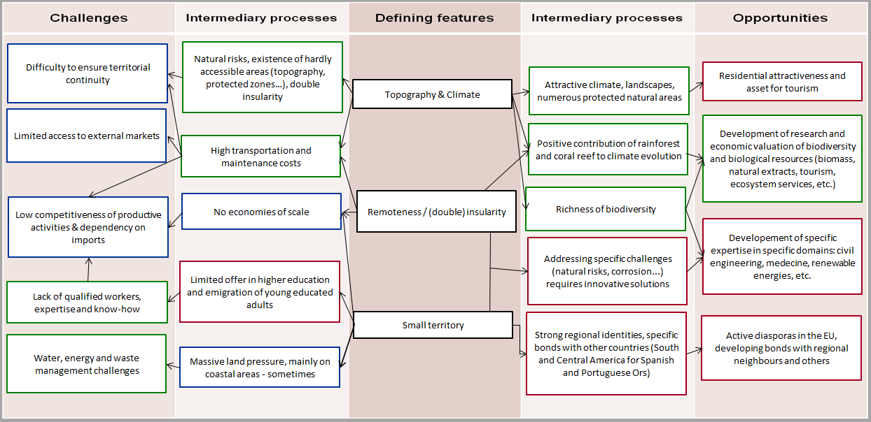

MAP 6 – Urban-rural typology of NUTS3 regions including remoteness (DG Regio) for the TNC Macronesia

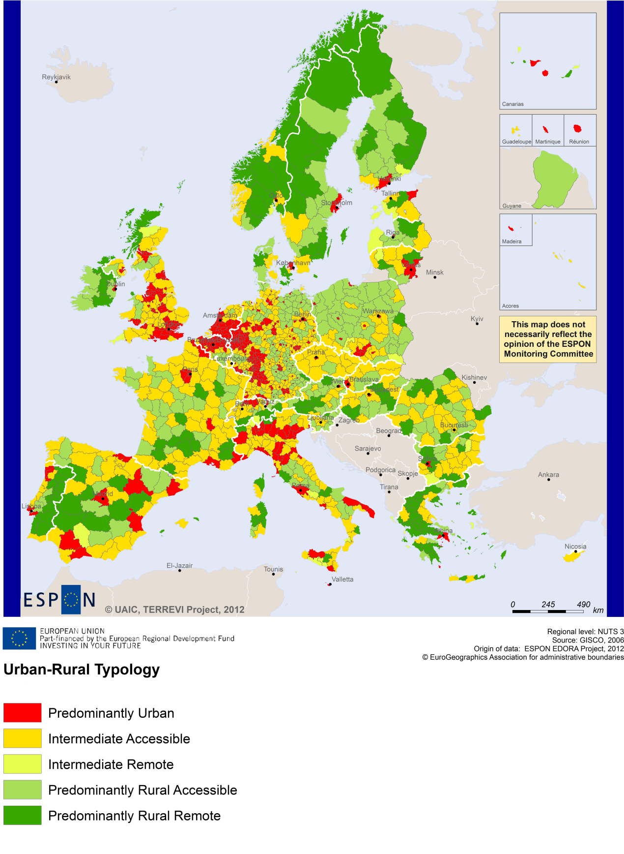

MAP 7 – Multimodal accessibilty (ESPON Accessibility Update) for the TNC Macronesia
“Potential Accessibility Multimodal” scores accessibility of NUTS 3 regions by road, rail and air relative to the European average in an Accessibility Index.
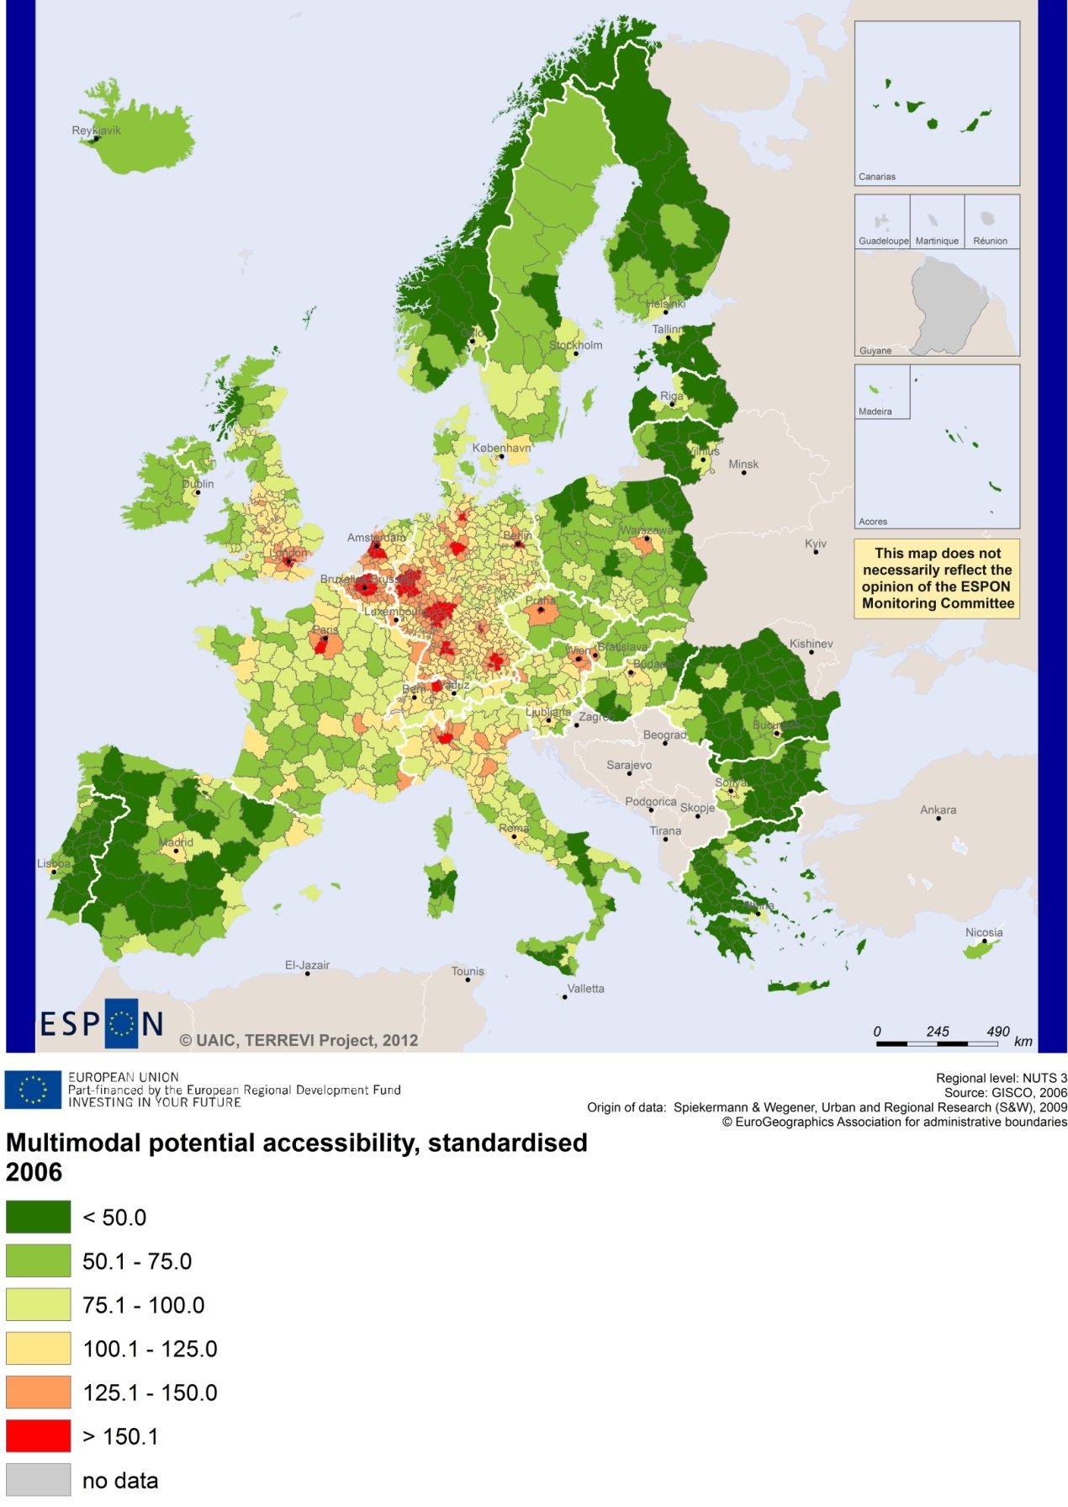

Recommended ESPON reading
ESPON provides an essential underpinning for translating into practice the calls for integrated and place-based approaches to economic development, when analysing a programme area or deciding about future programme priorities. ESPON has published a wide range of exciting reports providing valuable territorial evidence for future territorial cooperation initiatives.
The table below shows examples of relevant projects for the Cooperation Region. However, you have to study other ESPON reports as well in order to capitalise fully on the European information available for the transnational programming.
ESPON study | Topic | Content
EDORA | Rural areas | It provides evidence on the development opportunities of diverse types of European rural areas and reveals competitiveness options (see maps in Appendix 1).
CLIMATE | Climate change | It analyses how and to which degree climate change will impact on the competitiveness and cohesion of European regions and Europe as a whole (see from map 1 to 23).
TIPTAP | Territorial impact assessment | It provides a tool for the ex-ante assessment of territorial impacts of policies to deliver evidence on the territorial impact of policies (see from map 2.3.1 to 2.3.9).
CAEE | Agglomeration economies | It aims at a better understanding of the economic costs and benefits of large urban agglomerations (see figure 1).
TRANSMEC | European cooperation | It develops a method providing guidance on how ESPON results can add value to support territorial cooperation programmes (see map 27 and from map 36 to 39 on potential accessibility indicators). The method is applied for the Northwest-Europe cooperation area.
SEMIGRA | Rural migration | It identifies the main reasons and consequences of selective migration in rural regions in order to develop strategies for territorial development (see map 1, 4 and 5).
KIT | Innovation | It describes patterns and potentials of regions in terms of knowledge and innovation economy and explores development opportunities (see from map 3.1.1 to 4.4.1).
SGPTD | Growth poles | It provides evidence about performance and roles of European secondary cities (see from figure 2 to 2.12 t).
GEOSPECS | Specific types of territories | It provides evidence on the strength, weaknesses and development opportunities of specific types of territories and regions (e.g. border areas, highly or sparsely populated areas). It includes a case study on the Canary Islands in the Scientific Report.
Furthermore, some of overall ESPON products of particular interest for territorial cooperation are:
- ESPON Synthesis report “new evidence on smart, sustainable and inclusive territories” provides an easy to read overview on ESPON results available.
- ESPON Territorial Observations is a publication series, which on a few pages presents policy relevant findings deriving from latest ESPON research.
- ESPON 2013 Database provides regional information provided by ESPON projects and EUROSTAT.
- ESPON Hyperaltas allows comparing and analysing a region’s relative position at European, national and local scale for a wide range of criteria.
- ESPON MapFinder provides access to the most relevant ESPON maps resulting from ESPON projects and reports.
- ESPON Typologies provides nine regional typologies for additional analysis of regional data to be considered in the European context.
All ESPON reports and tools are freely available at
www.espon.eu

The ESPON 2013 Programme is part-financed by the European Regional Development Fund, the EU Member States and the Partner States Iceland, Liechtenstein, Norway and Switzerland. It shall support policy development in relation to the aim of territorial cohesion and a harmonious development of the European territory.

