Mediterranean (MED)
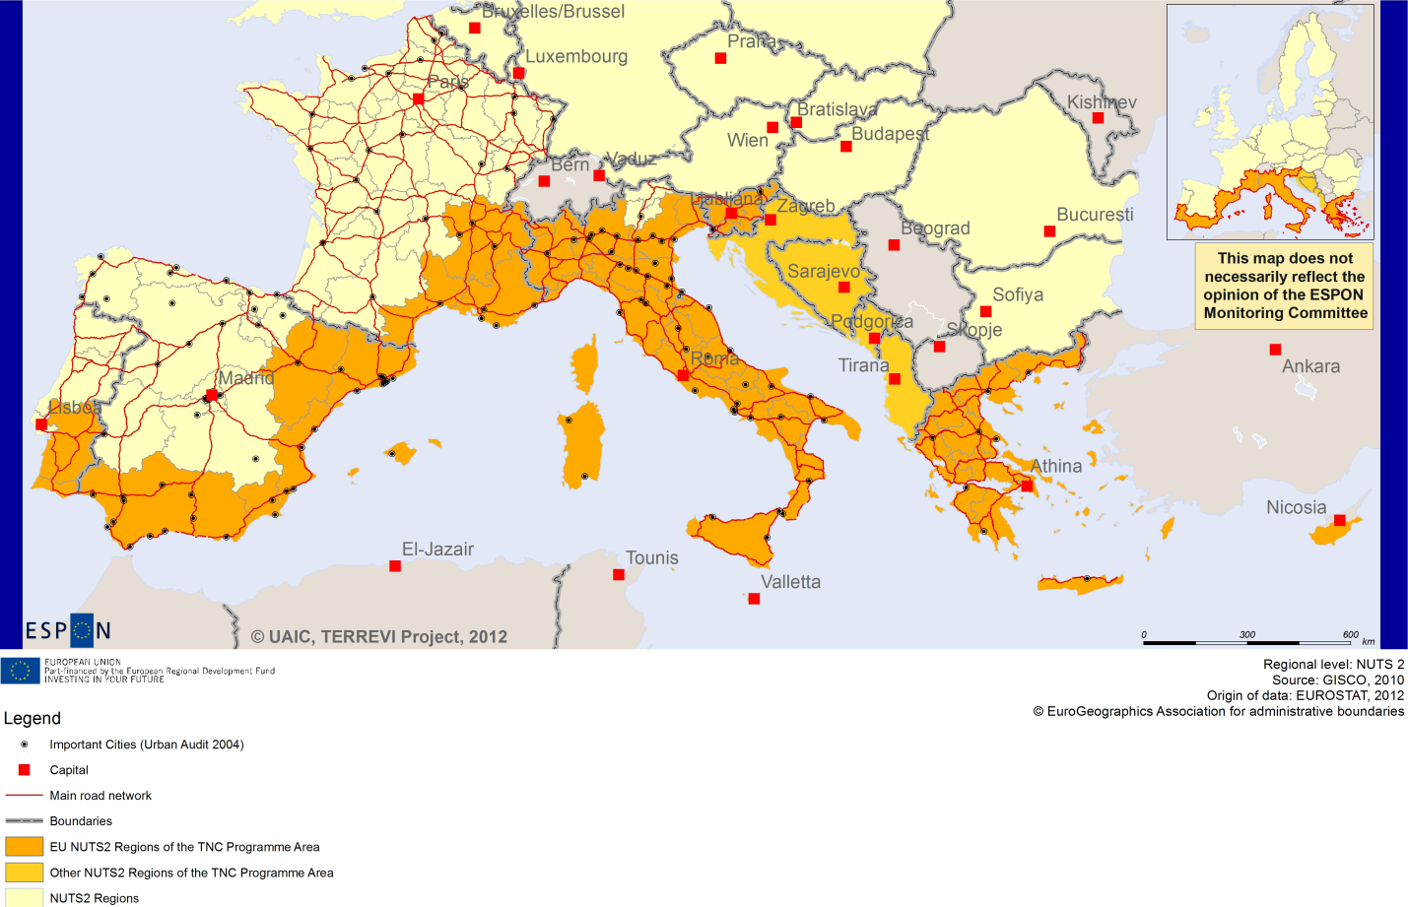

ESPON Project TERREVI
November 2012

Introduction
ESPON supports policy development in relation to the aim of territorial cohesion and a harmonious development of the European territory. It provides comparable information, evidence, analysis, and scenarios on territorial dynamics, which reveal territorial capitals and development potentials of regions and larger territories. Considering the programme area in its European context adds an important new perspective that can help shaping the programming and the places of implementing projects.
The ESPON TERREVI project focuses on producing evidence for Structural Funds programmes with the aim to support the development of the programmes to be carried out in the 2014-2020 period.
One milestone of this work consists in presenting selected ESPON research pieces in easy-to-understand factsheets for all territorial cooperation programme areas. The aim is to provide the reader with preliminary insight on types of territorial evidence ESPON holds at hand with regard to the possible investment priorities of future programmes. The factsheets certainly only give a first glimpse rather than fully present the work of the large number of ESPON projects that are currently underway. Likewise, each programme area includes diverse development potentials and challenges, which needs targeted information search. However, hopefully this factsheet will contain information, benchmarking the programme area in its larger, territorial context, that is of interest and help to better understand the programme area and to navigate within the richness of ESPON material available.
In addition to the programme factsheets there will be a number of specific programme case studies illustrating how ESPON material can be used to support the development of future programmes e.g. by giving a comparative European dimension to the envisaged SWOTs. These case studies will be carried out in early 2013
This factsheet is structured in three main parts. The first part presents a selection of indicators that help comparing the situation of the programme area in question with the European average, the average for all programme areas as well as the situation in the countries involved. The second part briefly presents the territorial factors of interest for the programme area. The final part offers guidance on the further use of ESPON results and tools. This is intended as an electronic publication so map quality is generally high to allow users to zoom into specific territories.
This factsheet does not necessarily reflect the opinion of the ESPON Monitoring Committee.

Europe 2020
Europe, with its member states and their regions, is more exposed to global shocks and international competition than at any time before. As the world becomes more interdependent this trend will continue and shape policy thinking across sectors, borders and geographical scales. At the same time, Europe is characterised by a large territorial diversity meaning that global developments can imply rather different development possibilities and challenges for different European regions and cities.
The differences are partly defined by major geographical structures such as urban systems, access and connectivity, the geographical specificity or population density. At the same time, the differences are also spelled out in the larger development trends that affect an area and the way and degree to which it is affected.
The data, indicators and territorial evidence provided by ESPON provides insight on both the main structures and larger territorial trends. The fine art is to identify what can actually be influenced by policy-making and, in particular, by place-based policy and territorial cooperation related to your programme area.
This chapter provides a selection of ESPON data related to Europe 2020 objectives of smart, sustainable and inclusive growth, giving also hints as regards the main thematic objectives envisaged in the draft regulations for the next period of EU Cohesion Policy. The Europe 2020 Strategy aims to enhance smart, sustainable and inclusive growth. This strategy has clear territorial dimensions. However, achieving these goals is challenging in the crisis-driven times. Furthermore, the economic disparities are growing as economic trends and the crisis have various impacts on different parts of Europe.
In the following the traffic light for each indicator represents how your programme territory compares to wider European medians where green = your programme area performs better for that indicator, yellow = similar, and red = worse.
The traffic lights below were created in order to graphically represent the situation of each analysed TNC Area compared to the one of the EU-27+4 space. The median value, calculated depending on the values registered for every NUTS 2/NUTS 3 region composing the programme area was used as the central value indicator. The median of the programme area was compared to the one computed for EU-27+4 territory.
EU 27+4 in traffic lights means the EU Member States as well as Iceland, Liechtenstein, Norway and Switzerland – the ESPON space.

Smart, Sustainable and Inclusive growth
Smart growth refers to developing an economy based on knowledge and innovation. In the framework of the Europe 2020 Strategy it means improving the EU's performance in education, research/innovation and digital society.
Sustainable growth refers to promoting a more resource efficient, greener and more competitive economy. Within the Europe 2020 Strategy it means e.g. building a more competitive low-carbon economy that makes efficient, sustainable use of resources, protecting the environment, reducing emissions and preventing biodiversity loss, capitalising on Europe's leadership in developing new green technologies and production methods, and introducing efficient smart electricity grids. In the framework of the Europe 2020 Strategy it means focus on competitiveness, resource efficiency, climate change and biodiversity.
Inclusive growth refers to fostering a high-employment economy delivering social and territorial cohesion. Within the Europe 2020 Strategy it means raising Europe’s employment rate, helping people of all ages anticipate and manage change through investment in skills & training, modernising labour markets and welfare systems, and ensuring the benefits of growth reach all parts of the EU. In short the key factors are employment and avoiding risk of poverty and social exclusion.
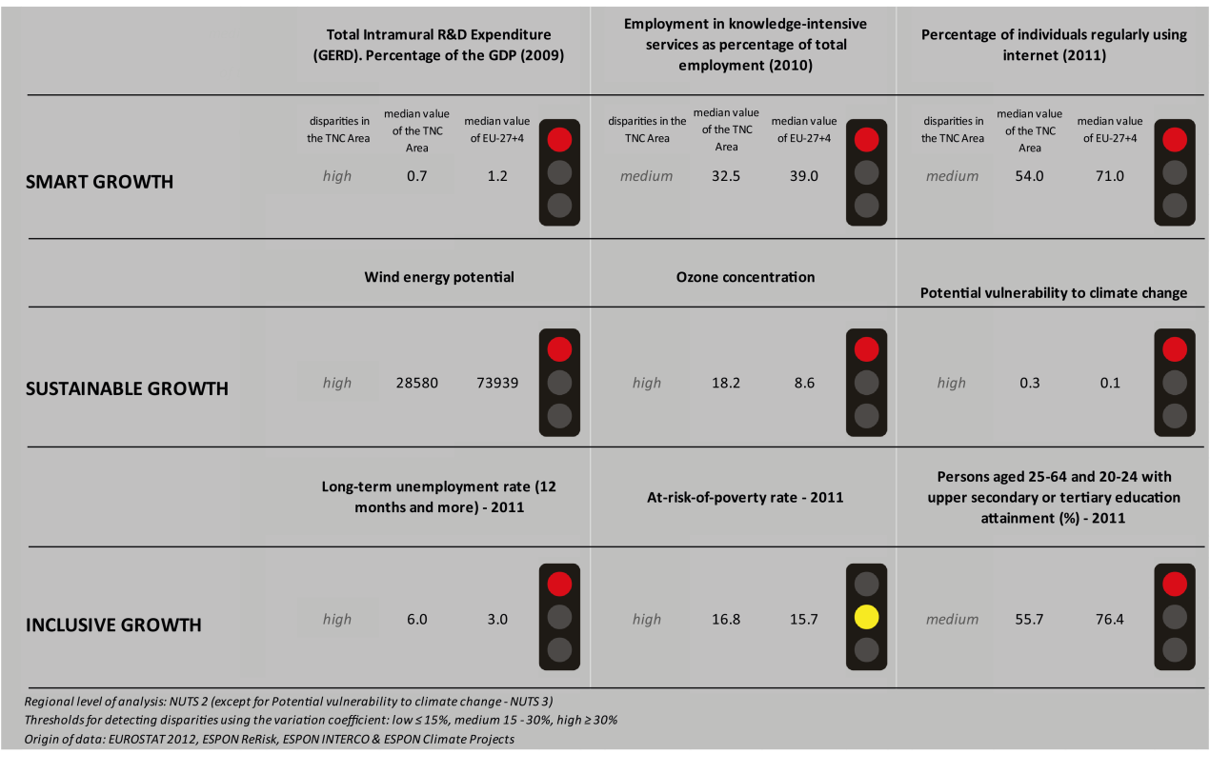
Looking at the indicators for smart growth, the Mediterranean TNC area performs worse than the EU27+4 for all indicators, although the variations within the area are medium to high. In fact, it has a lower share of R&D expenditure than the EU27+4, a lower rate of employment in knowledge-intensive services (as a percentage of total employment) than the EU27+4 by 6.5 percentage points and a much lower percentage of individuals using the internet than the EU27+4.
Map 1 (ESPON KIT project) shows that the Mediterranean TNC area is mainly colored in various shades of yellow, meaning that the member-regions are qualified as smart and creative diversification areas or smart technological application areas. The southern regions of Italy are qualified as somewhat less advanced innovation areas. There are however exceptions such as Cyprus which is qualified as an applied science area.
Also in terms of sustainable growth the Mediterranean TNC area has worse results than the EU27+4. The area has much lower wind energy potential (although the disparities within the area are high); a much higher ozone concentration (with high disparities within the area) and it is more vulnerable to climate change.
For the latter indicator, the disparities within the area are high which is also confirmed in Map 3 which highlights the adaptive capacity to climate change. In fact the regions in Italy and Greece seem to have a low ability to adapt to climate change. The French regions that are part of the TNC area range between medium and high ability to adapt to climate change.
The TNC area is generally not affected in terms of fossil fuel consumption by the Directive on the promotion of clean and energy-efficient road transport vehicles. The exceptions are a few regions in the north and centre of Italy (Lombardia, Veneto, Toscana, and Lazio), the south of France (Provence) and Spain (Aragon, Catalunia, Comunidad Valenciana) which seem to witness a moderate positive impact.
The inclusive growth indicators show a similar to worse performance in the Mediterranean TNC area compared to the EU27+4. The long-term unemployment rate is higher in the area than in the EU27+4 by 3 percentage points. The fact that there are high disparities within the area is confirmed in Map 5. The map shows that the employment rate is low in the south-west of Spain and the south of Italy with less than 60% and higher (ranging between 65% and 75%) in the centre and north of Italy, the French part of the TNC area as well as the south of Greece and Cyprus.
The at-risk-of-poverty rate is similar for the Mediterranean area and the EU27+4 (with high disparities within the area). The share of persons aged 25-64 and 20-24 with upper secondary or tertiary education attainment is lower in the TNC area than in the EU27+4.
In all four ESPON DEMIFER scenarios (Map 4), the south-east of the Mediterranean TNC area (i.e. south of Italy, Slovenia, Greece and Cyprus) seems to experience a negative change in labour force. The northern regions of Italy and the southern regions of France on the other hand seem to experience positive changes on labour force in all four scenarios.
MAP 1 – Territorial Patterns of Innovation (ESPON KIT project) for the TNC Mediterranean (MED)

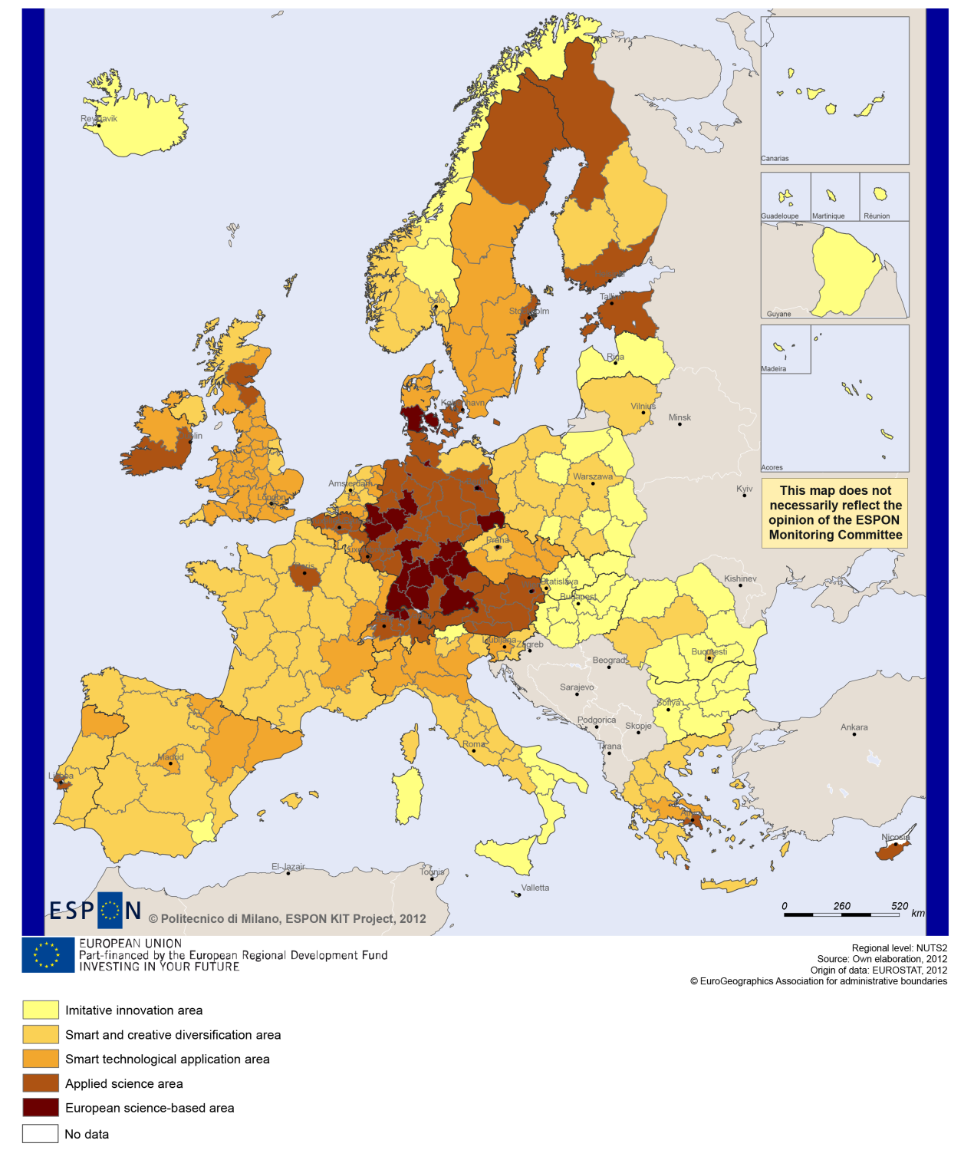

MAP 2 – Territorial impact on fossil fuel consumption of Directive on the promotion of clean and energy-efficient road transport vehicles (ESPON ARTS project) TNC Mediterranean (MED)

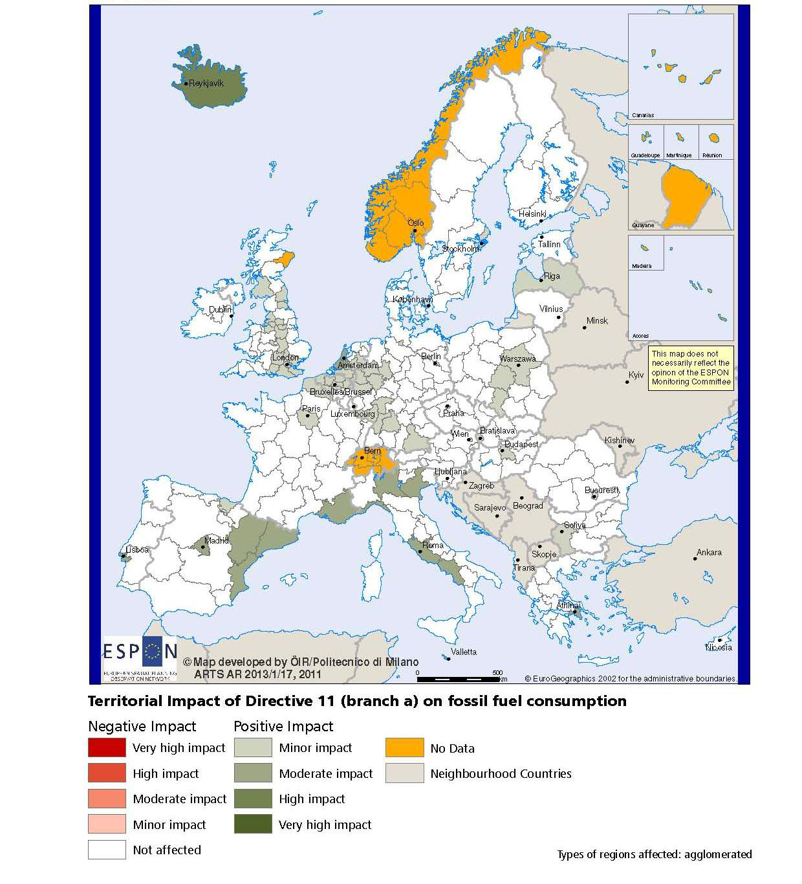

MAP 3 – Combined adaptive capacity to climate change (ESPON CLIMATE project) for the TNC Mediterranean (MED)
“Adaptive capacity (adaptability)” to climate change indicates the ability or potential of a system to respond successfully to climate change and variability, and includes adjustments in behaviour, resources and technologies.
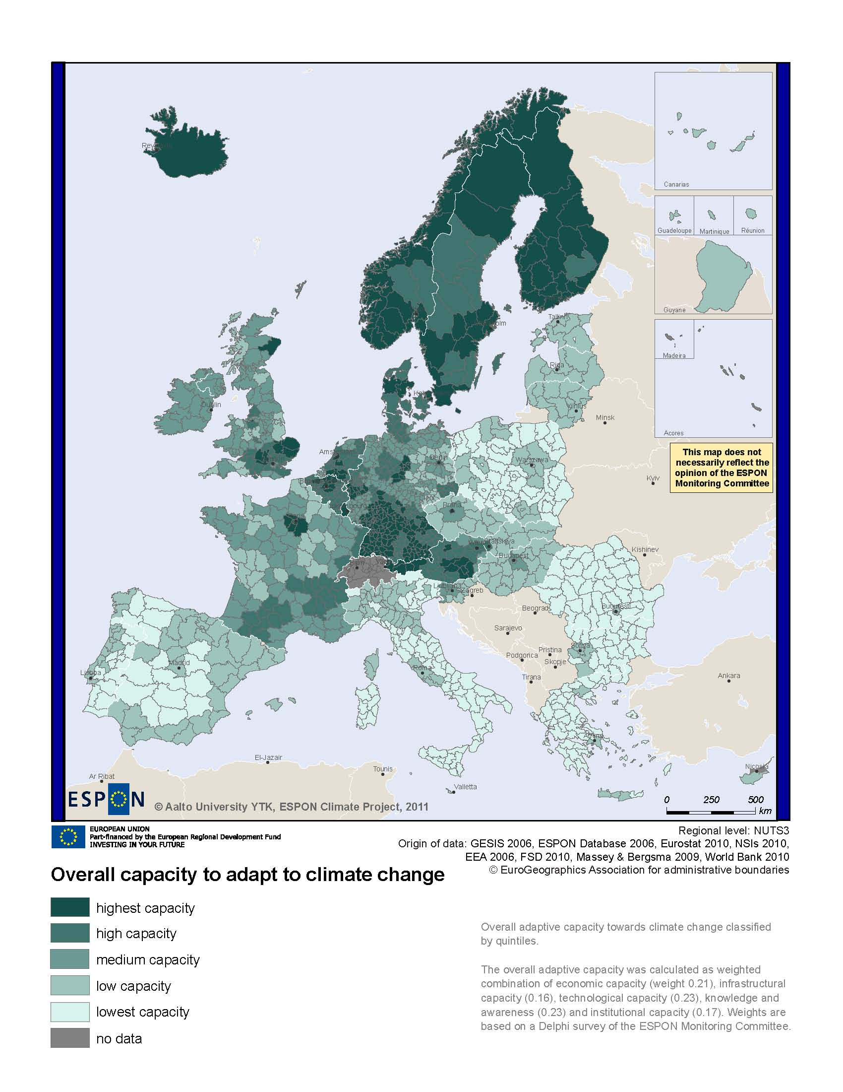
MAP 4 – Change in Labour Force 2005-2050 (ESPON DEMIFER project) for the TNC Mediterranean (MED)

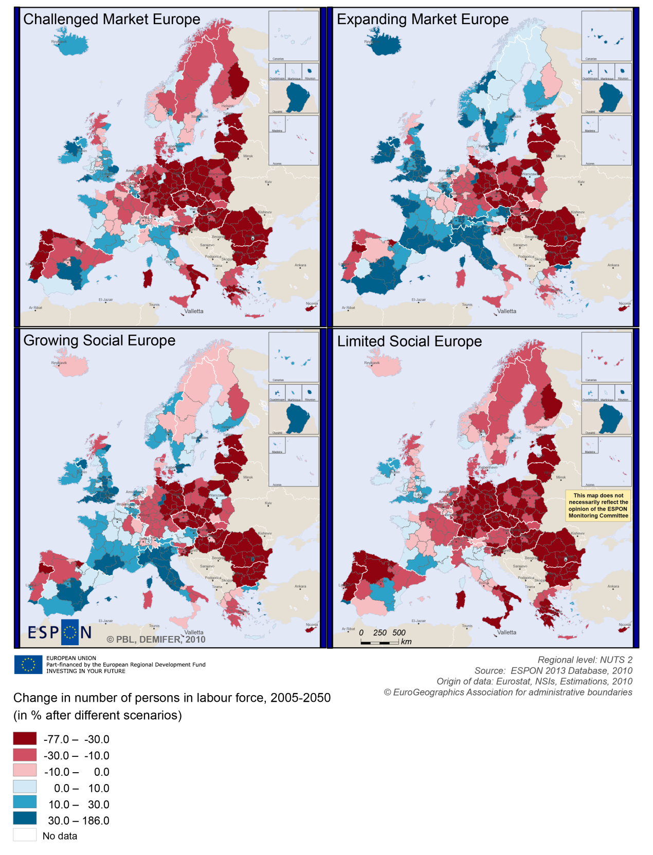

MAP 5 – Employment rate 2010 within the TNC Mediterranean (MED)

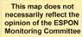
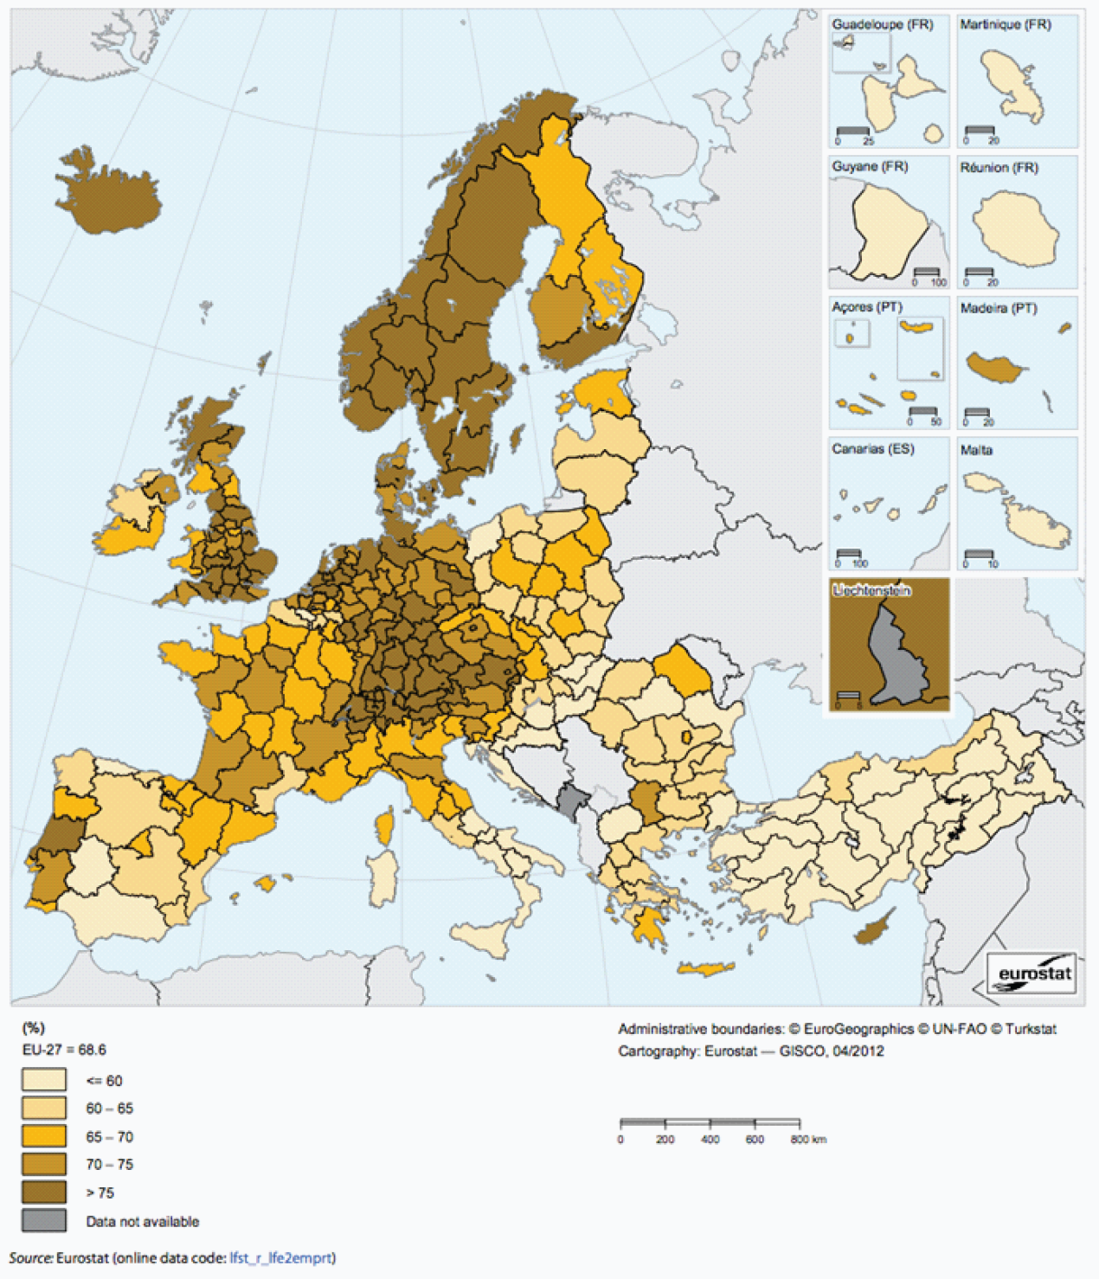

Territorial factors of interest for the programme area
Territorial cooperation programmes can make a difference for the future development of cross-border and transnational territories in Europe. Some of the factors can be analysed by European wide data sets and using some studies having specific maps, figures and tables concerning the areas of the cooperation region.
Besides a wide range of standard indicators frequently used in the context of European regional policies, ESPON has established various indicators which focus more on the territorial dimension. These indicators provide among others information on the development preconditions of an area. Two standard indicators in this field are rural-urban settings and accessibility.
The Mediterranean programme area of comprises a number of the main metropolitan areas in Europe, which even play an important role in a worldwide perspective, e.g. Barcelona, Marseille, Milan, Rome, Naples or Athens. Furthermore there is a wide range of secondary growth poles along the Mediterranean. As the map confirms there are wide range of urban areas and a lot of intermediate areas close to a city. There are only a small number of rural areas and in particular remote areas, which tend to be located more towards the inland and in particular Greece has a comparably high share of rural areas. The high level of urbanity along the coast is both strength and in particular in environmental terms also a challenge for the programme areas.
- Although the area programme area does not comprise any major European transport hubs, it has generally good accessibility and some of the urban areas have a multimodal accessibility well above European average, they have also good opportunities for one-day business trips within the European urban network. As the map shows, areas outside the metropoles are less accessibility and some islands and coastal areas in Greece as well as Cyprus have among the lowest accessibility values in Europe.
With regard to geographic specific, most of the programme area is characterised as mountainous and/or coastal, furthermore there are the islands and a few sparsely populated spots - in a European perspective. The mountainous and coastal character comes with advantages and challenges. Although it does not come with a specific economic structure, it appears that a significant proportion of those areas have high residential attractiveness. Many mountain and coastal areas are also characterised by relatively high levels of biodiversity and protected areas. Furthermore, coastal ecosystems provide not only food but habitats for diverse economic-valuable and other species, and mountains are the water towers of Europe. Last but not least, it has to be noted that coastal areas and islands are often particularly vulnerable to climate change.
As for the future development potentials, the ESPON SS-LR project developed different scenarios for the Latin Arc with a time horizon of 2025. In doing so the project identified three main forms of “platforms”: infrastructure platforms, knowledge platforms and identity platforms (the fourth category of territorial capital, namely relational capital, providing at the same time a sort of precondition for success and a policy implementation method.
Furthermore, the ESPON GEOSPECS project developed a nexus models for mountain areas (Final Report page 49), coastal areas (page 103) and islands (page 103). This is certainly of interest for the programme area. The model interlinks defining features with relevant processes and territorial development opportunities and challenges.

MAP 6 – Urban-rural typology of NUTS3 regions including remoteness (DG Regio) for the TNC Mediterranean (MED)

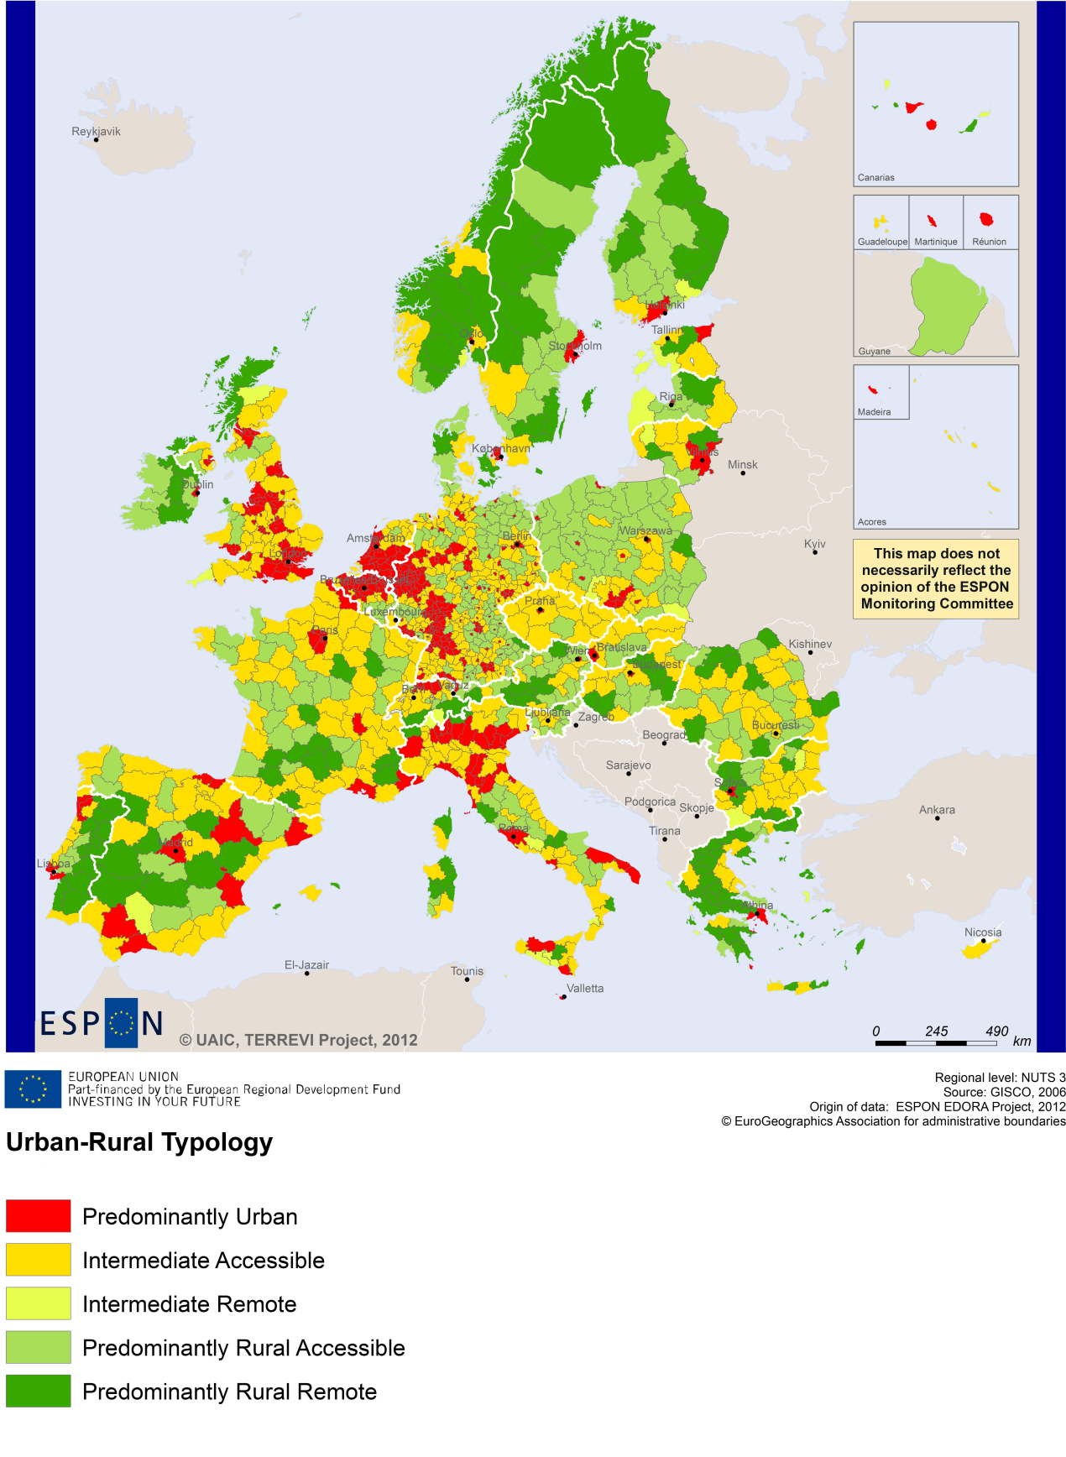

MAP 7 – Multimodal accessibilty (ESPON Accessibility Update) for the TNC Mediterranean (MED)
“Potential Accessibility Multimodal” scores accessibility of NUTS 3 regions by road, rail and air relative to the European average in an Accessibility Index.
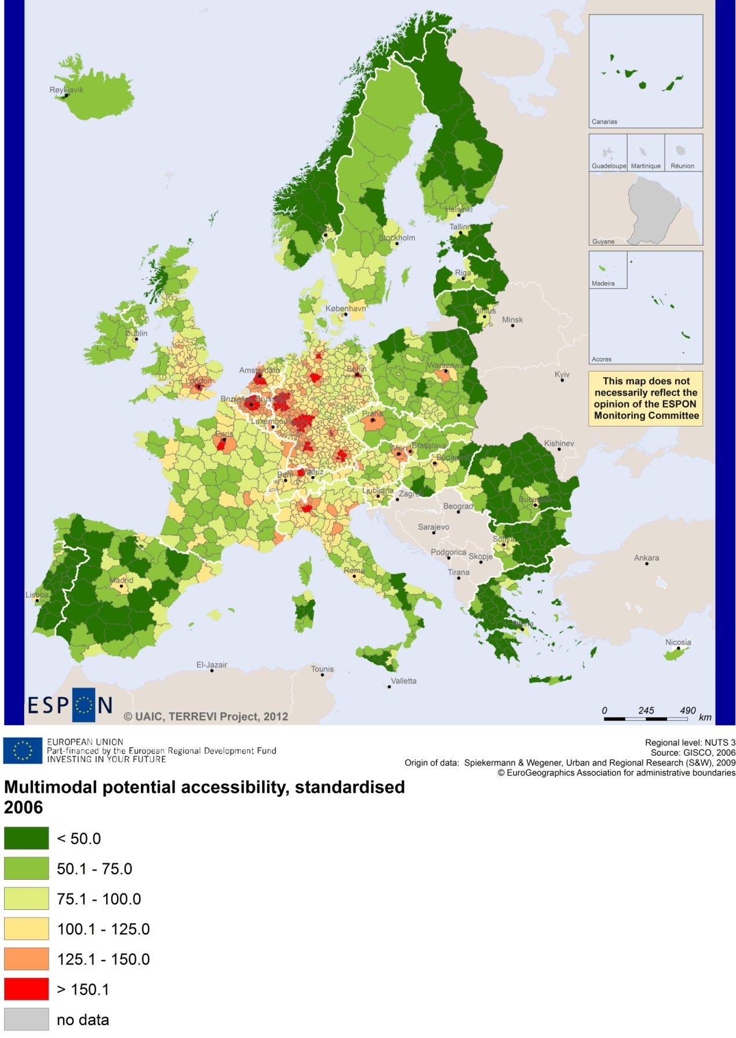

Recommended ESPON reading
ESPON provides an essential underpinning for translating into practice the calls for integrated and place-based approaches to economic development, when analysing a programme area or deciding about future programme priorities. ESPON has published a wide range of exciting reports providing valuable territorial evidence for future territorial cooperation initiatives.
The table below shows examples of relevant projects for the Cooperation Region. However, you have to study other ESPON reports as well in order to capitalise fully on the European information available for the transnational programming.
ESPON study | Topic | Content
CLIMATE | Climate change | It analyses how and to which degree climate change will impact on the competitiveness and cohesion of European regions and Europe as a whole (see from map 1 to 23). It includes case studies on the coastal Mediterranean Spain & Balearic Islands (see Map 1-12 of the Annex 4).
CAEE | Agglomeration economies | It aims at a better understanding of the economic costs and benefits of large urban agglomerations. It includes a case study on Barcelona (Appendix-C4).
TRANSMEC | European cooperation | It develops tools to support territorial cooperation programmes in capitalisation and considerations on future strategic project development (see map 27 and from map 36 to 39 on potential accessibility indicators). The method is applied for the Northwest-Europe cooperation area.
SGPTD | Growth poles | It provides evidence on European secondary cities, their performance and functional roles in different parts of Europe, and the potential policy intervention affecting their performance (see from figure 2 to 2.12). It includes cases studies in Barcelona (Annex 3.4) and Turin (Annex 3.6).
FOCI | Cities | It identifies the driving forces of urban development. The project addresses particularly Barcelona and Athens (Chapter 9 of the Scientific Report).
ATTREG | Attractiveness | It provides a better understanding of the contribution of European regions’ and cities’ attractiveness to economic performance and it identifies the key ingredients of attractiveness in different types of territories. It includes cases studies on the Algarve region (Annex 4/1) and Slovenia (Annex 4/7).
GEOSPECS | Specific types of territories | It provides evidence on the strength, weaknesses and development opportunities of specific types of territories and regions (e.g. border areas, highly or sparsely populated areas). The project focuses on Sicily, in Italy, as a case study (see Draft Scientific Report Annex 26).
KIT | Innovation | It takes analyses territorial patterns of the knowledge and innovation economy and identifies development opportunities (see from map 3.1.1 to 4.4.1). It includes case studies on Tuscany, Piedmont, Arezzo, and Lombardy.
EUROISLANDS | Islands | It gives evidence on the divergence of island's situation from the European average and on existing policy measures for the islands. It includes case studies on Mallorca, Kalymnos & Lipsi, Malta, Sardegna, Lipari, Aeolian Islands, and Cyprus.
SURE | Convergence regions | It focuses on the specific challenges of development of convergence regions within the EU. It includes case studies on East Macedonia-Thrace, Campania and Valencia (Chapter 3, Final Report).
TeDi | Territorial diversity | It provides a better understanding of development processes in territories that are defined as insular, mountainous, sparsely populated or peripheral. Includes case studies on Malta and Marathasa and Tylliria, in Cyprus.
EATIA | Impact assessment | It tests the practical use of existing methods and tools for Territorial Impact Assessment. A particular focus of the study is on Portugal.
TPM | Territorial performance | The study establishes knowledge on how territorial impacts of macro challenges translate at the regional level and how to deal with these challenges. One of the regional highlights of the project is Cataluña, in Spain.
Furthermore, some of overall ESPON products of particular interest for territorial cooperation are:
- ESPON Synthesis report “new evidence on smart, sustainable and inclusive territories” provides an easy to read overview on ESPON results available.
- ESPON Territorial Observations is a publication series, which on a few pages presents policy relevant findings deriving from latest ESPON research.
- ESPON 2013 Database provides regional information provided by ESPON projects and EUROSTAT.
- ESPON Hyperaltas allows comparing and analysing a region’s relative position at European, national and local scale for a wide range of criteria.
- ESPON MapFinder provides access to the most relevant ESPON maps resulting from ESPON projects and reports.
- ESPON Typologies provides nine regional typologies for additional analysis of regional data to be considered in the European context.
All ESPON reports and tools are freely available at
www.espon.eu

The ESPON 2013 Programme is part-financed by the European Regional Development Fund, the EU Member States and the Partner States Iceland, Liechtenstein, Norway and Switzerland. It shall support policy development in relation to the aim of territorial cohesion and a harmonious development of the European territory.

