North West Europe
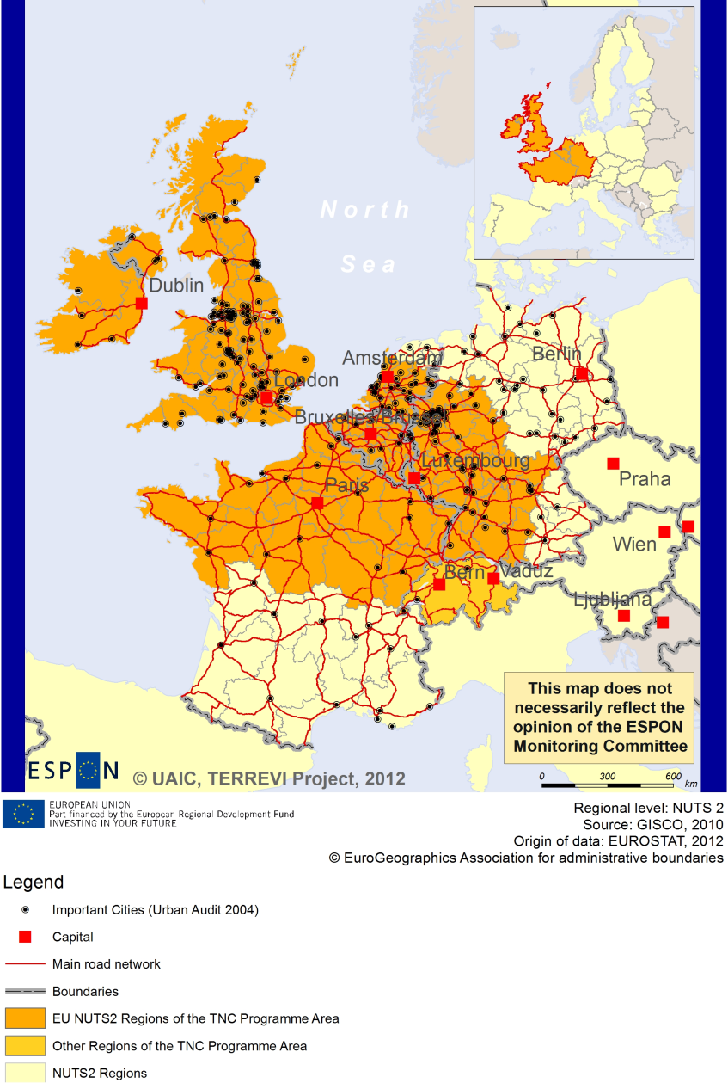

ESPON Project TERREVI
November 2012

Introduction
ESPON supports policy development in relation to the aim of territorial cohesion and a harmonious development of the European territory. It provides comparable information, evidence, analysis, and scenarios on territorial dynamics, which reveal territorial capitals and development potentials of regions and larger territories. Considering the programme area in its European context adds an important new perspective that can help shaping the programming and the places of implementing projects.
The ESPON TERREVI project focuses on producing evidence for Structural Funds programmes with the aim to support the development of the programmes to be carried out in the 2014-2020 period.
One milestone of this work consists in presenting selected ESPON research pieces in easy-to-understand factsheets for all territorial cooperation programme areas. The aim is to provide the reader with preliminary insight on types of territorial evidence ESPON holds at hand with regard to the possible investment priorities of future programmes. The factsheets certainly only give a first glimpse rather than fully present the work of the large number of ESPON projects that are currently underway. Likewise, each programme area includes diverse development potentials and challenges, which needs targeted information search. However, hopefully this factsheet will contain information, benchmarking the programme area in its larger, territorial context, that is of interest and help to better understand the programme area and to navigate within the richness of ESPON material available.
In addition to the programme factsheets there will be a number of specific programme case studies illustrating how ESPON material can be used to support the development of future programmes e.g. by giving a comparative European dimension to the envisaged SWOTs. These case studies will be carried out in early 2013
This factsheet is structured in three main parts. The first part presents a selection of indicators that help comparing the situation of the programme area in question with the European average, the average for all programme areas as well as the situation in the countries involved. The second part briefly presents the territorial factors of interest for the programme area. The final part offers guidance on the further use of ESPON results and tools. This is intended as an electronic publication so map quality is generally high to allow users to zoom into specific territories.
This factsheet does not necessarily reflect the opinion of the ESPON Monitoring Committee.

Europe 2020
Europe, with its member states and their regions, is more exposed to global shocks and international competition than at any time before. As the world becomes more interdependent this trend will continue and shape policy thinking across sectors, borders and geographical scales. At the same time, Europe is characterised by a large territorial diversity meaning that global developments can imply rather different development possibilities and challenges for different European regions and cities.
The differences are partly defined by major geographical structures such as urban systems, access and connectivity, the geographical specificity or population density. At the same time, the differences are also spelled out in the larger development trends that affect an area and the way and degree to which it is affected.
The data, indicators and territorial evidence provided by ESPON provides insight on both the main structures and larger territorial trends. The fine art is to identify what can actually be influenced by policy-making and, in particular, by place-based policy and territorial cooperation related to your programme area.
This chapter provides a selection of ESPON data related to Europe 2020 objectives of smart, sustainable and inclusive growth, giving also hints as regards the main thematic objectives envisaged in the draft regulations for the next period of EU Cohesion Policy. The Europe 2020 Strategy aims to enhance smart, sustainable and inclusive growth. This strategy has clear territorial dimensions. However, achieving these goals is challenging in the crisis-driven times. Furthermore, the economic disparities are growing as economic trends and the crisis have various impacts on different parts of Europe.
In the following the traffic light for each indicator represents how your programme territory compares to wider European medians where green = your programme area performs better for that indicator, yellow = similar, and red = worse.
The traffic lights below were created in order to graphically represent the situation of each analysed TNC Area compared to the one of the EU-27+4 space. The median value, calculated depending on the values registered for every NUTS 2/NUTS 3 region composing the programme area was used as the central value indicator. The median of the programme area was compared to the one computed for EU-27+4 territory.
EU 27+4 in traffic lights means the EU Member States as well as Iceland, Liechtenstein, Norway and Switzerland – the ESPON space.

Smart, Sustainable and Inclusive growth
Smart growth refers to developing an economy based on knowledge and innovation. In the framework of the Europe 2020 Strategy it means improving the EU's performance in education, research/innovation and digital society.
Sustainable growth refers to promoting a more resource efficient, greener and more competitive economy. Within the Europe 2020 Strategy it means e.g. building a more competitive low-carbon economy that makes efficient, sustainable use of resources, protecting the environment, reducing emissions and preventing biodiversity loss, capitalising on Europe's leadership in developing new green technologies and production methods, and introducing efficient smart electricity grids. In the framework of the Europe 2020 Strategy it means focus on competitiveness, resource efficiency, climate change and biodiversity.
Inclusive growth refers to fostering a high-employment economy delivering social and territorial cohesion. Within the Europe 2020 Strategy it means raising Europe’s employment rate, helping people of all ages anticipate and manage change through investment in skills & training, modernising labour markets and welfare systems, and ensuring the benefits of growth reach all parts of the EU. In short the key factors are employment and avoiding risk of poverty and social exclusion.
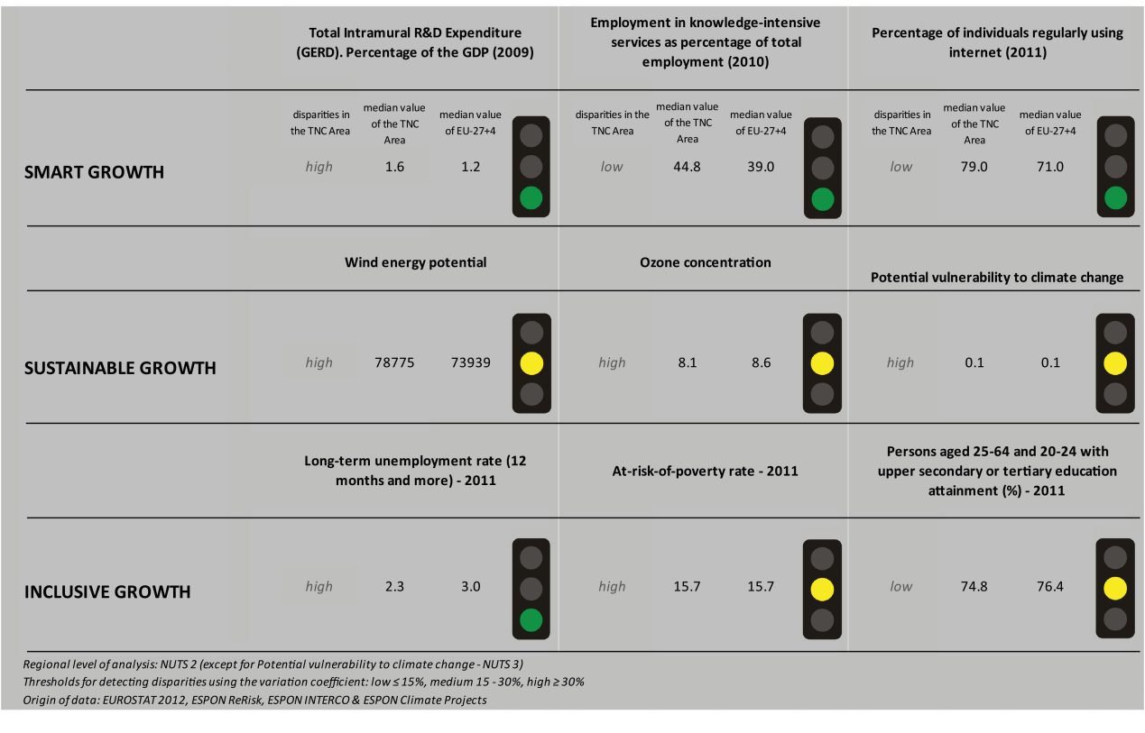
Looking at the indicators for smart growth the North West Europe TNC has a general better performance than the EU27+4 space. Considering the objective of R&D expenditure of 3 percent of the GDP – one of the five headline targets in the Europe 2020 Strategy - the TNC area is performing better than the EU27+4 space with a high level of disparity due to significant internal differences. Regarding employment, considering the ratio of the employment in knowledge-intensive service to the total employment in 2010, the TNC area has a better performance than the EU27+4 space. The internal distribution results in a low level of internal disparity. Considering the percentage of individuals regularly using internet in 2011, the TNC area has a better performance than the EU27+4 space, with a low level of internal disparity.
By using the taxonomy of the KIT project, MAP 1 on page 5 illustrates a diversified and scattered situation in terms of patterns of innovation. In the part of the area, located on the borders of Belgium, Netherlands, Germany and France, many Nuts-2 regions of the TNC area are either applied science or even European science-based areas, due to a quite high generality and originality of science-based local knowledge, and a high degree of attractiveness of knowledge coming from other regions. The Eastern part of Scotland, the Southern and Eastern Ireland and the Ile de France (the region of Paris) are also applied science areas. East Anglia, Northern Ireland, Highlands and Islands and the rest of France and Netherlands are mainly smart and creative diversification areas due to low innovation intensity and high innovation potentials. The rest of the UK is mainly characterized by smart technological application areas due to high product innovation rate and a limited degree of local applied science.
The indicators for sustainable growth show three yellow traffic lights for North West Europe. The TNC is in the fields of wind energy potential, ozone concentration and potential vulnerability to climate change on a similar level as the EU27+4. But it is necessary to consider the high disparities within the programme area. This is getting visible looking at MAP 3 highlighting the combined adaptive capacity to climate change. The southeast of Germany, the Benelux countries or East Anglia show a significantly higher capacity than the rest of the TNC area. This distribution of climate change impact in the programme area is of importance regarding the use of the ERDF. It shows where in the TNC area ERDF financed projects make most sense.
Inclusive growth indicators draw a positive picture for the long-term unemployment rate in North West Europa and a similar picture as the EU27+4 for people at risk of poverty and persons with upper secondary or tertiary education attainment. But especially in questions of employment and labour force the high disparities within the programme area have to be considered. The north and the east of the TNC area display higher employment rates (MAP 5) than the rest of North West Europe. Also the potential change in labour force until 2050 (MAP 4) shows a diverse picture. All four DEMIFER scenarios predict the highest negative values for potential change in the east of the TNC while the north-west (except the very north of Great Britain) could experience positive percentages of persons in labour force in the next decades.

MAP 1 – Territorial Patterns of Innovation (ESPON KIT project) for the TNC North West Europe

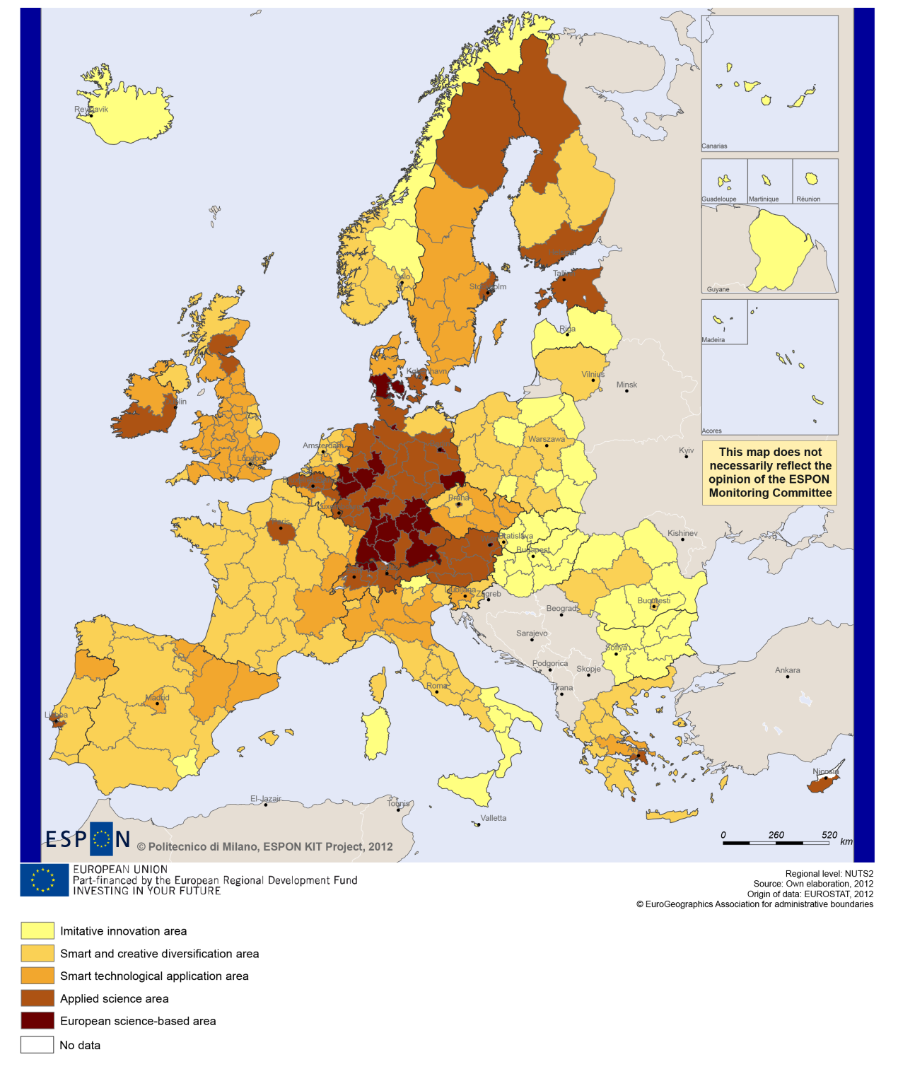

MAP 2 – Territorial impact on fossil fuel consumption of Directive on the promotion of clean and energy-efficient road transport vehicles (ESPON ARTS project) TNC North West Europe

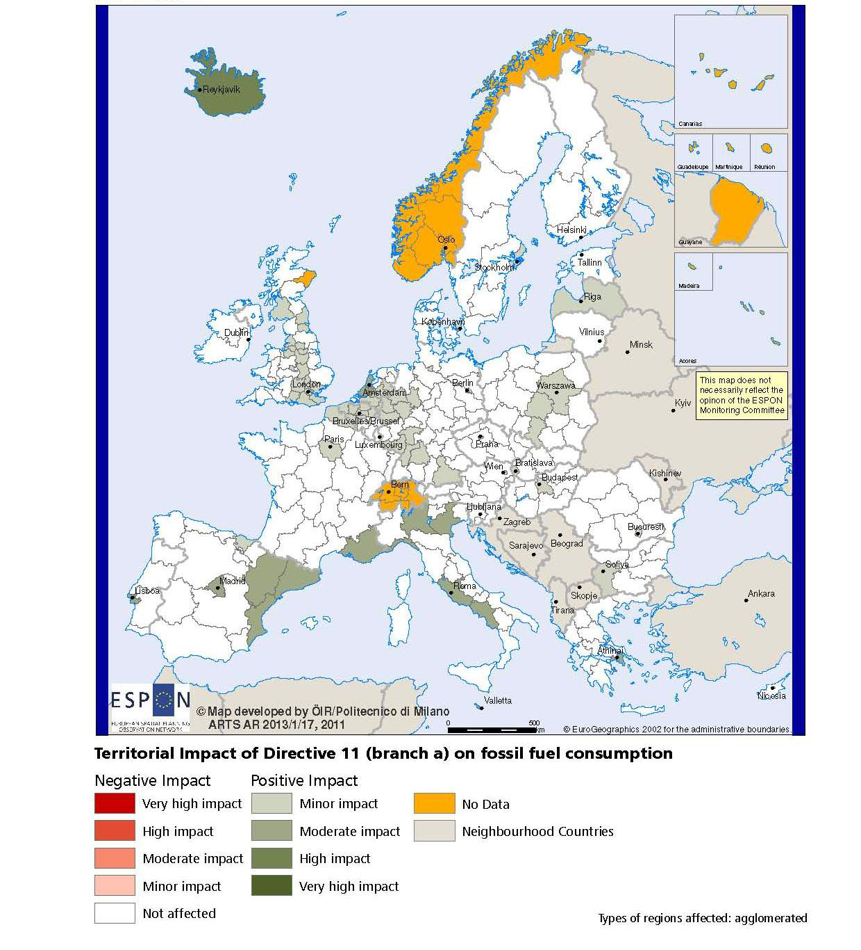

MAP 3 – Combined adaptive capacity to climate change (ESPON CLIMATE project) for the TNC North West Europe
“Adaptive capacity (adaptability)” to climate change indicates the ability or potential of a system to respond successfully to climate change and variability, and includes adjustments in behaviour, resources and technologies.
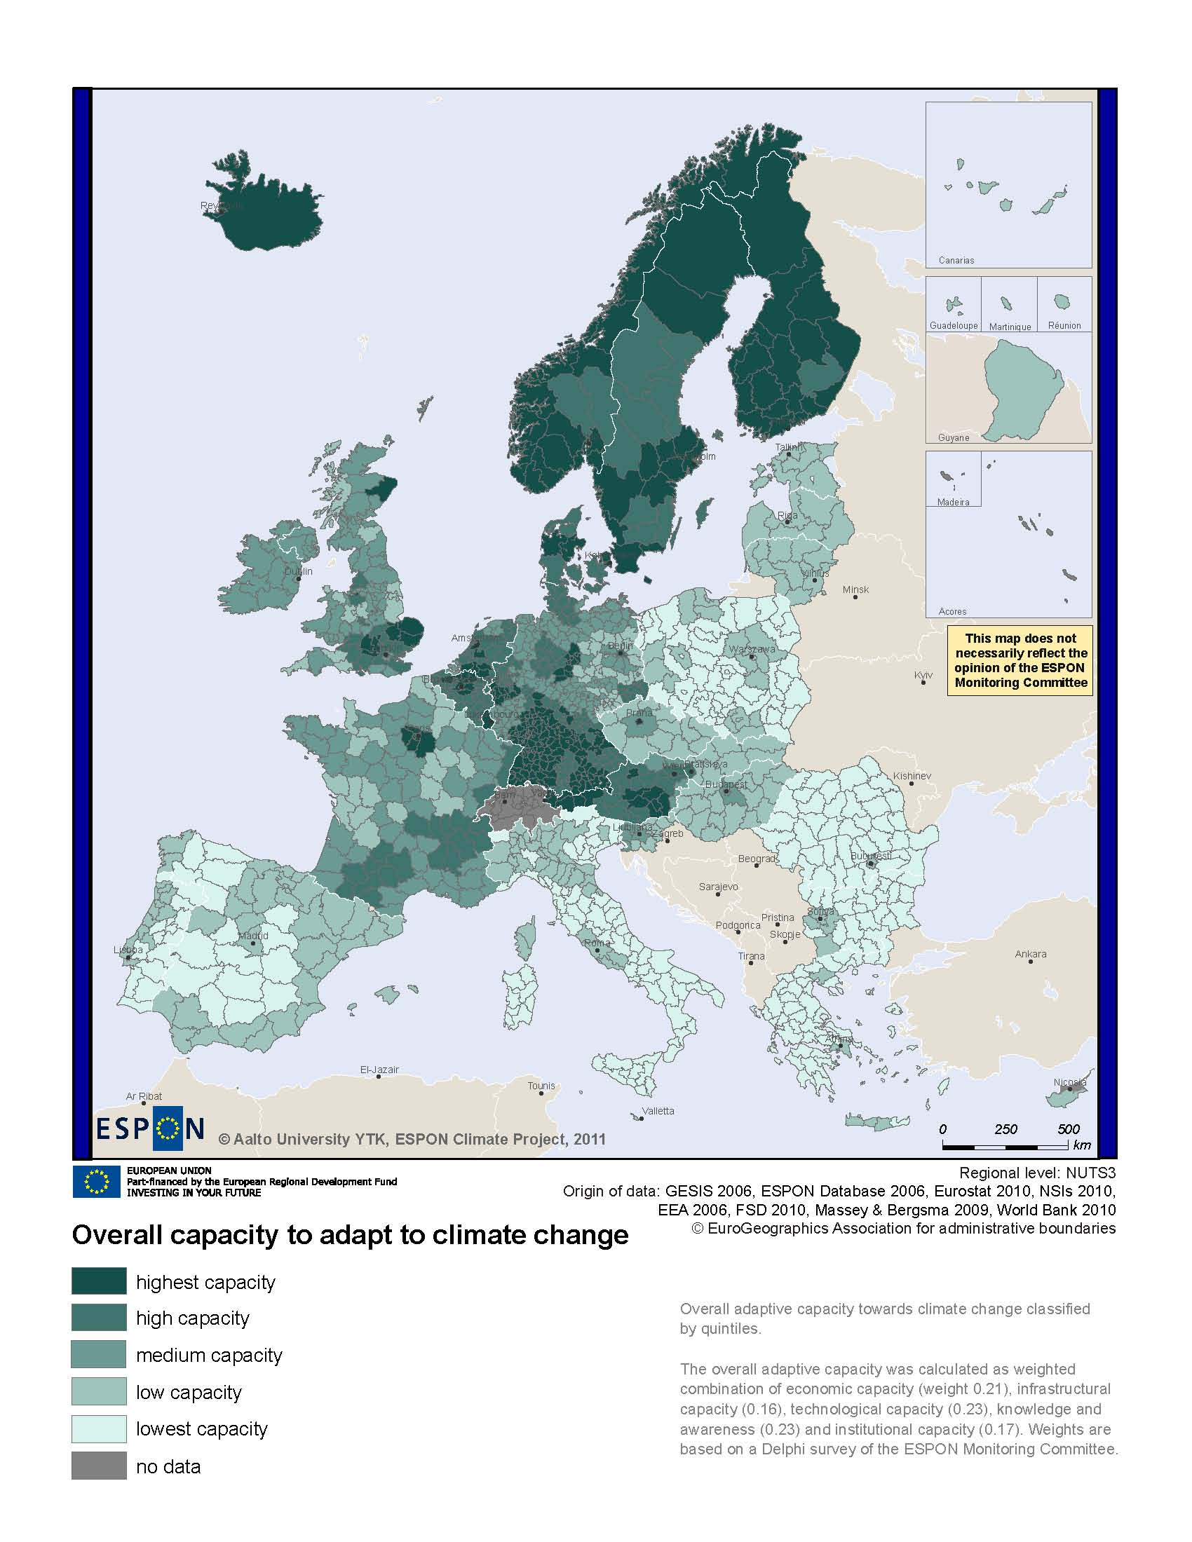
MAP 4 – Change in Labour Force 2005-2050 (ESPON DEMIFER project) for the TNC North West Europe

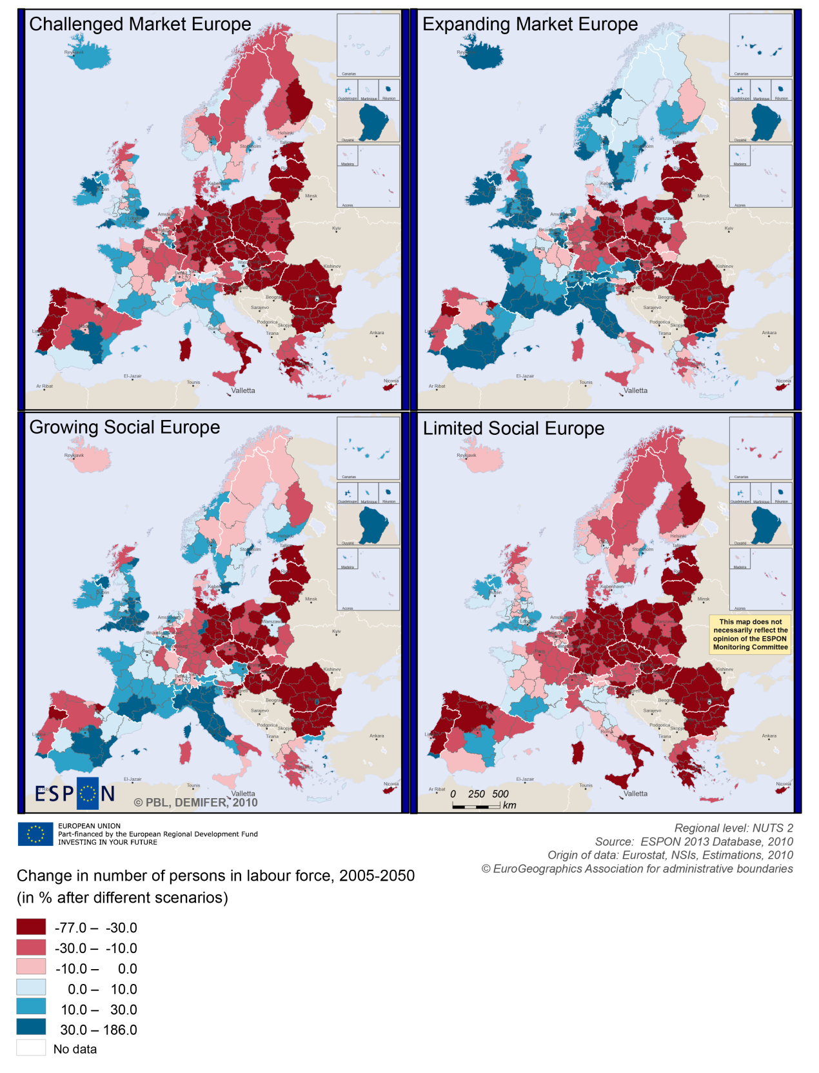

MAP 5 – Employment rate 2010 within the TNC North West Europe

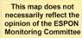
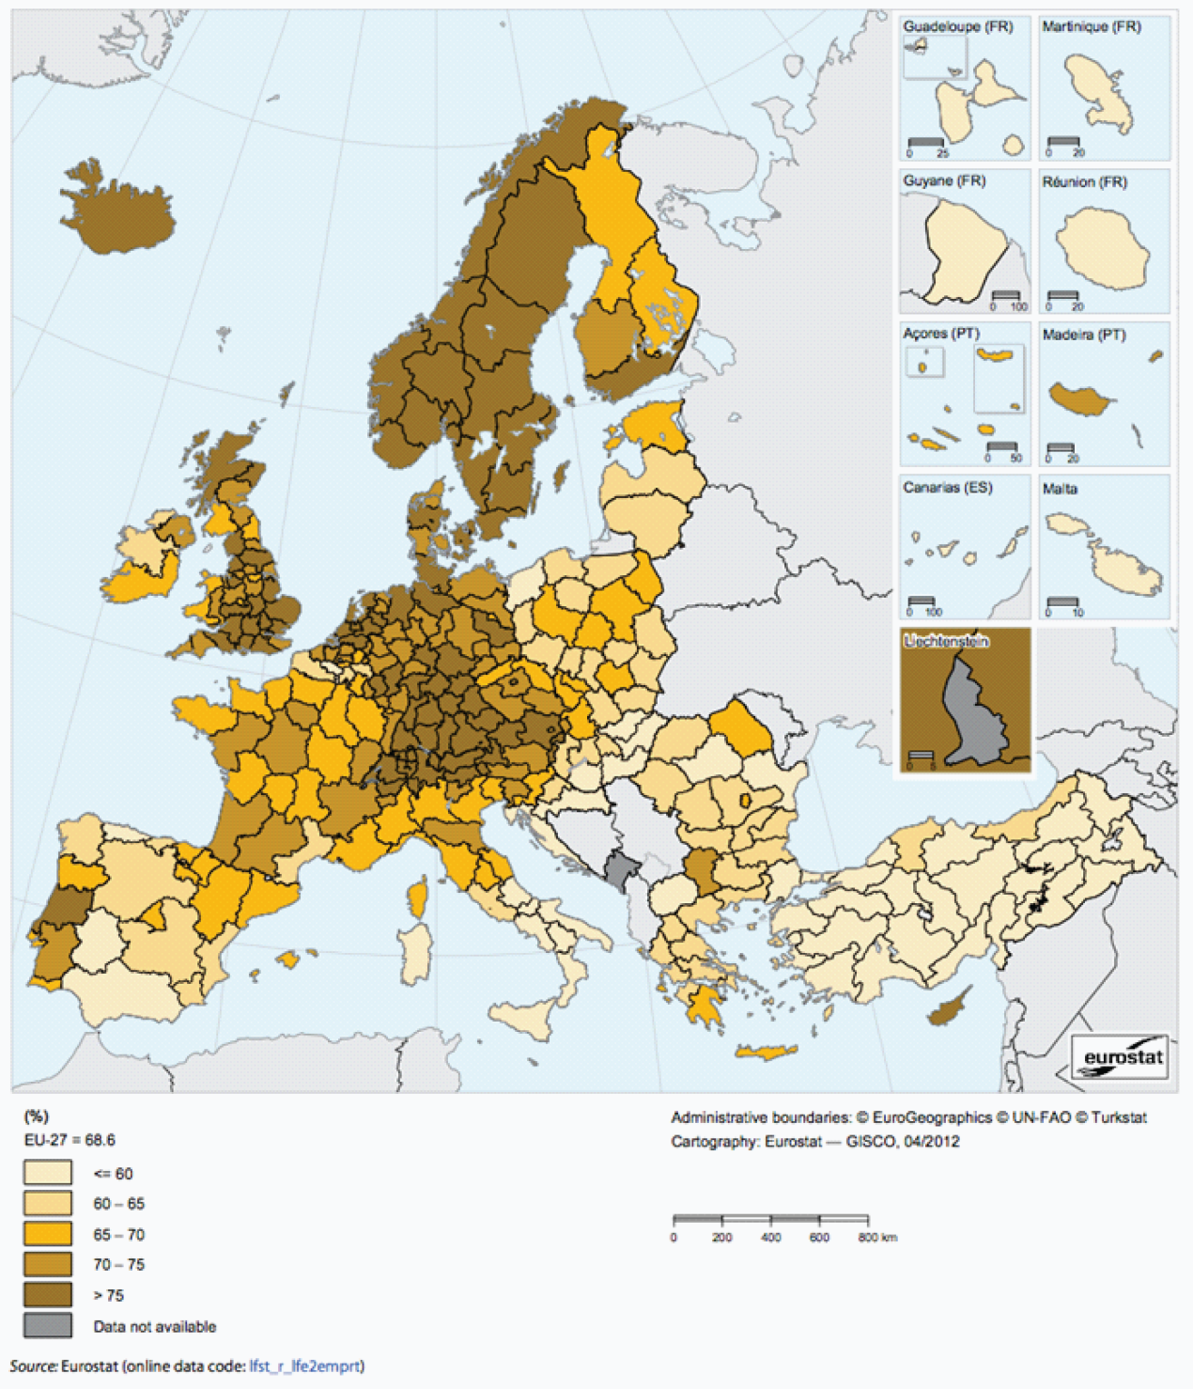

Territorial factors of interest for the programme area
Territorial cooperation programmes can make a difference for the future development of cross-border and transnational territories in Europe. Some of the factors can be analysed by European wide data sets and using some studies having specific maps, figures and tables concerning the areas of the cooperation region.
Besides a wide range of standard indicators frequently used in the context of European regional policies, ESPON has established various indicators which focus more on the territorial dimension. These indicators provide among others information on the development preconditions of an area. Two standard indicators in this field are rural-urban settings and accessibility.
The programme area of North West Europe comprises a number of the main metropolitan areas in Europe, which even play an important role in a worldwide perspective. Besides the global cities of London and Paris, major urban agglomerations stretch throughout Northwest Europe from Dublin and Greater Manchester, via London, large parts of Belgium and the Netherlands, major agglomerations areas along Ruhr and Rhine in Germany further to Switzerland. Indeed, North West Europe is more than other transnational cooperation areas characterised by a high degree of urbanisation, with many larger cities in close proximity. Furthermore, there are a large number of secondary growth poles. The high level of urbanity is both strength and in particular in environmental terms also a challenge for the programme areas.
- The area comprises only a limited number of regions characterised as rural areas in close proximity and a few regions rural regions of more remote character. The map illustrates also territorial differences within the programme area, basically showing a divide between the stretch of agglomerations largely describing the Blue Banana and more rural characteristics of large parts of the remaining programme area.
The programme area of North West Europe is furthermore characterised by good accessibility, both in terms of multimodal accessibility and possibilities for one-day business trips. The advantage comes certainly with challenges related to environmental impacts of transport, congestions and overheating. North West Europe hosts most spots with high accessibility values in Europe. Accordingly the programme area is characterised by well above average international accessibility. At the same time, there are considerable differences within the programme area. Good accessibility is too centred towards large urban agglomerations and major international airports. Many other regions of the programme area have considerably less favourable accessibility, and in some cases, e.g. the South-East of Ireland, these are even below the European average.
- With regard to geographic specific, the programme areas comprises in a European perspective, mainly the coastal areas along the channel, as well as mountainous areas mainly towards the Alps and in the UK. Northern Scotland and some fringes of Ireland are sparsely populated.

MAP 6 – Urban-rural typology of NUTS3 regions including remoteness (DG Regio) for the TNC North West Europe

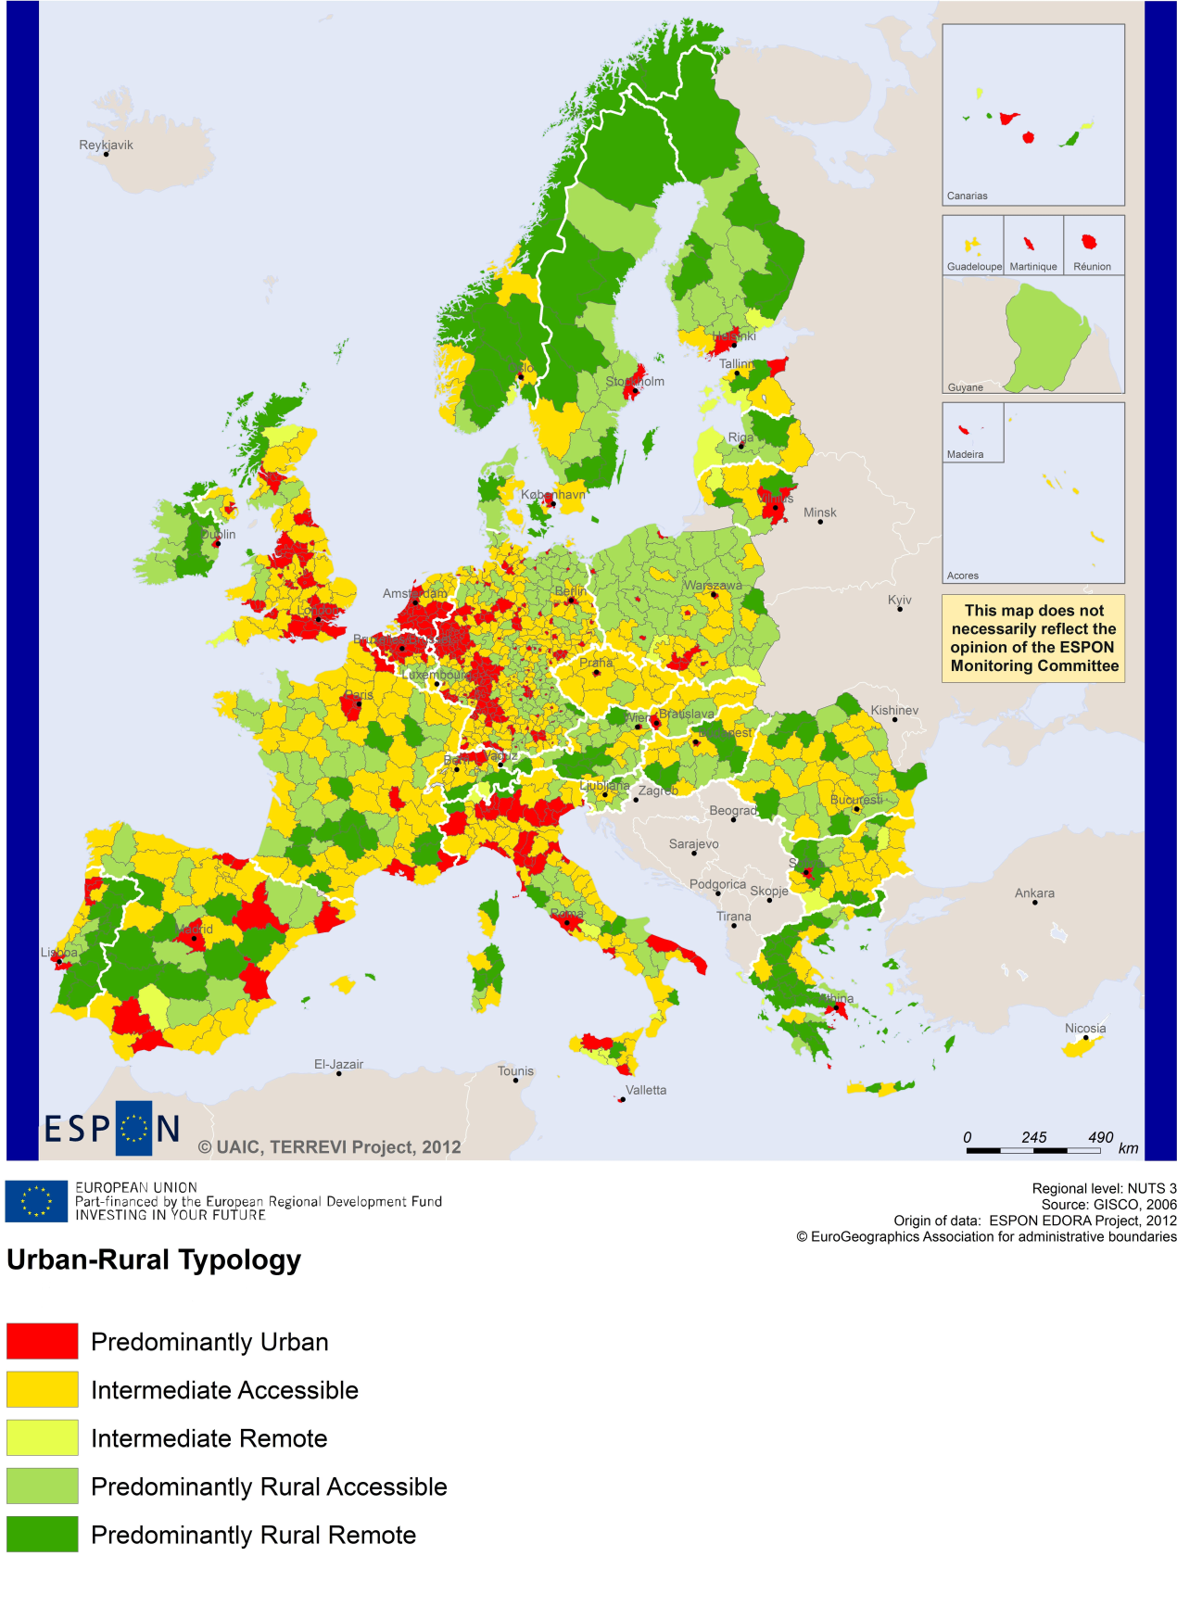

MAP 7 – Multimodal accessibilty (ESPON Accessibility Update) for the TNC North West Europe
“Potential Accessibility Multimodal” scores accessibility of NUTS 3 regions by road, rail and air relative to the European average in an Accessibility Index.
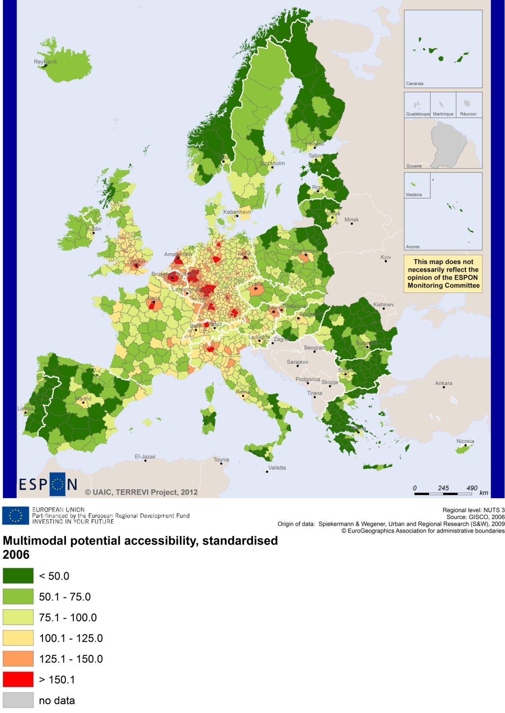

Recommended ESPON reading
ESPON provides an essential underpinning for translating into practice the calls for integrated and place-based approaches to economic development, when analysing a programme area or deciding about future programme priorities. ESPON has published a wide range of exciting reports providing valuable territorial evidence for future territorial cooperation initiatives.
The table below shows examples of relevant projects for the Cooperation Region. However, you have to study other ESPON reports as well in order to capitalise fully on the European information available for the transnational programming.
ESPON study | Topic | Content
EDORA | Rural areas | It provides evidence on the development opportunities of diverse types of European rural areas and reveals competitiveness options (see maps in Appendix 1).
CLIMATE | Climate change | It analyses how and to which degree climate change will impact on the competitiveness and cohesion of European regions and Europe as a whole (see from map 1 to 23).
TIPTAP | Territorial impact assessment | It provides a tool for the ex-ante assessment of territorial impacts of policies to deliver evidence on the territorial impact of policies (see from map 2.3.1 to 2.3.9).
CAEE | Agglomerati-on economies | It aims at a better understanding of the economic costs and benefits of large urban agglomerations (see figure 1).
TRANSMEC | European cooperation | It develops a method providing guidance on how ESPON results can add value to support territorial cooperation programmes (see map 27 and from map 36 to 39 on potential accessibility indicators). The method is applied for the Northwest-Europe cooperation area.
SEMIGRA | Rural migration | It identifies the main reasons and consequences of selective migration in rural regions in order to develop strategies for territorial development (see map 1, 4 and 5).
KIT | Innovation | It describes patterns and potentials of regions in terms of knowledge and innovation economy and explores development opportunities (see from map 3.1.1 to 4.4.1). It provides some case studies on Cambridge, Oxford, Cardiff and West Wales (see Draft Final Scientific Report, Vol. 2, 3).
SGPTD | Growth poles | It provides evidence about performance and roles of European secondary cities (see from figure 2 to 2.12 and the case studies of Cork and Leeds in the Scientific Report).
Furthermore, some of overall ESPON products of particular interest for territorial cooperation are:
ESPON Synthesis report “new evidence on smart, sustainable and inclusive territories” provides an easy to read overview on ESPON results available.
- ESPON Territorial Observations is a publication series, which on a few pages presents policy relevant findings deriving from latest ESPON research.
- ESPON 2013 Database provides regional information provided by ESPON projects and EUROSTAT.
- ESPON Hyperaltas allows comparing and analysing a region’s relative position at European, national and local scale for a wide range of criteria.
- ESPON MapFinder provides access to the most relevant ESPON maps resulting from ESPON projects and reports.
- ESPON Typologies provides nine regional typologies for additional analysis of regional data to be considered in the European context.
All ESPON reports and tools are freely available at
www.espon.eu

The ESPON 2013 Programme is part-financed by the European Regional Development Fund, the EU Member States and the Partner States Iceland, Liechtenstein, Norway and Switzerland. It shall support policy development in relation to the aim of territorial cohesion and a harmonious development of the European territory.

