South West Europe
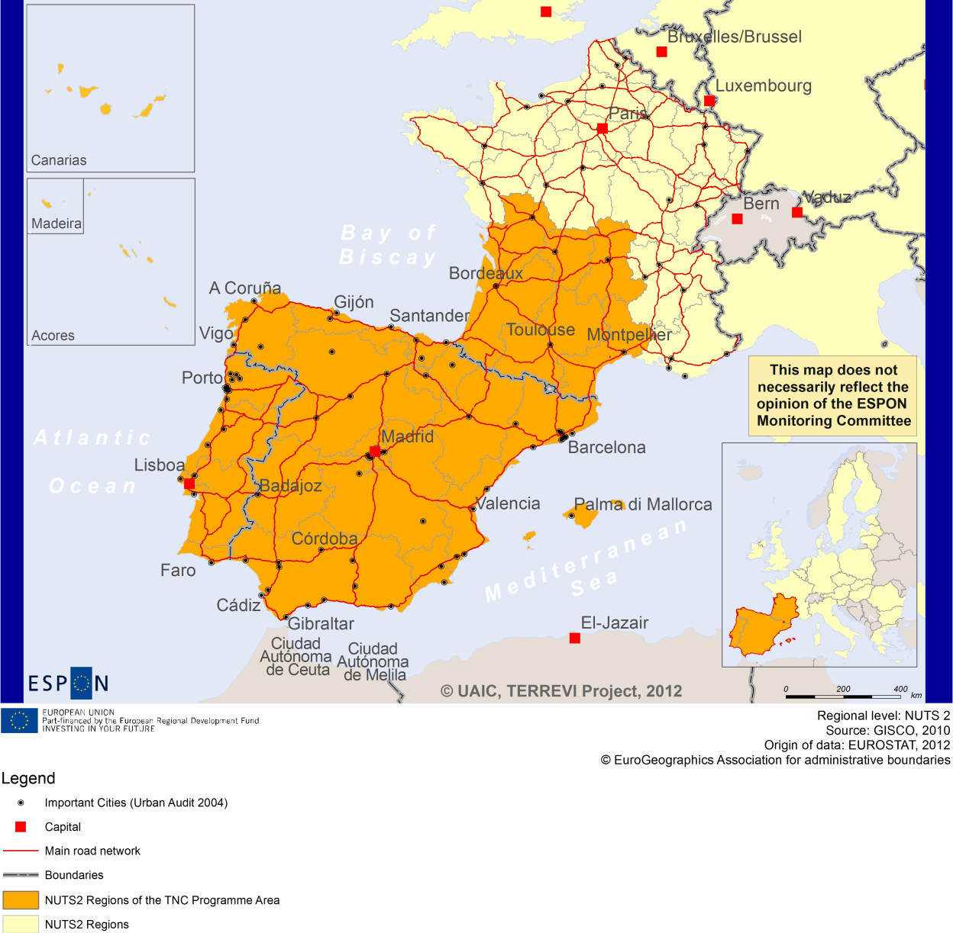

ESPON Project TERREVI
November 2012

Introduction
ESPON supports policy development in relation to the aim of territorial cohesion and a harmonious development of the European territory. It provides comparable information, evidence, analysis, and scenarios on territorial dynamics, which reveal territorial capitals and development potentials of regions and larger territories. Considering the programme area in its European context adds an important new perspective that can help shaping the programming and the places of implementing projects.
The ESPON TERREVI project focuses on producing evidence for Structural Funds programmes with the aim to support the development of the programmes to be carried out in the 2014-2020 period.
One milestone of this work consists in presenting selected ESPON research pieces in easy-to-understand factsheets for all territorial cooperation programme areas. The aim is to provide the reader with preliminary insight on types of territorial evidence ESPON holds at hand with regard to the possible investment priorities of future programmes. The factsheets certainly only give a first glimpse rather than fully present the work of the large number of ESPON projects that are currently underway. Likewise, each programme area includes diverse development potentials and challenges, which needs targeted information search. However, hopefully this factsheet will contain information, benchmarking the programme area in its larger, territorial context, that is of interest and help to better understand the programme area and to navigate within the richness of ESPON material available.
In addition to the programme factsheets there will be a number of specific programme case studies illustrating how ESPON material can be used to support the development of future programmes e.g. by giving a comparative European dimension to the envisaged SWOTs. These case studies will be carried out in early 2013
This factsheet is structured in three main parts. The first part presents a selection of indicators that help comparing the situation of the programme area in question with the European average, the average for all programme areas as well as the situation in the countries involved. The second part briefly presents the territorial factors of interest for the programme area. The final part offers guidance on the further use of ESPON results and tools. This is intended as an electronic publication so map quality is generally high to allow users to zoom into specific territories.
This factsheet does not necessarily reflect the opinion of the ESPON Monitoring Committee.

Europe 2020
Europe, with its member states and their regions, is more exposed to global shocks and international competition than at any time before. As the world becomes more interdependent this trend will continue and shape policy thinking across sectors, borders and geographical scales. At the same time, Europe is characterised by a large territorial diversity meaning that global developments can imply rather different development possibilities and challenges for different European regions and cities.
The differences are partly defined by major geographical structures such as urban systems, access and connectivity, the geographical specificity or population density. At the same time, the differences are also spelled out in the larger development trends that affect an area and the way and degree to which it is affected.
The data, indicators and territorial evidence provided by ESPON provides insight on both the main structures and larger territorial trends. The fine art is to identify what can actually be influenced by policy-making and, in particular, by place-based policy and territorial cooperation related to your programme area.
This chapter provides a selection of ESPON data related to Europe 2020 objectives of smart, sustainable and inclusive growth, giving also hints as regards the main thematic objectives envisaged in the draft regulations for the next period of EU Cohesion Policy. The Europe 2020 Strategy aims to enhance smart, sustainable and inclusive growth. This strategy has clear territorial dimensions. However, achieving these goals is challenging in the crisis-driven times. Furthermore, the economic disparities are growing as economic trends and the crisis have various impacts on different parts of Europe.
In the following the traffic light for each indicator represents how your programme territory compares to wider European medians where green = your programme area performs better for that indicator, yellow = similar, and red = worse.
The traffic lights below were created in order to graphically represent the situation of each analysed TNC Area compared to the one of the EU-27+4 space. The median value, calculated depending on the values registered for every NUTS 2/NUTS 3 region composing the programme area was used as the central value indicator. The median of the programme area was compared to the one computed for EU-27+4 territory.
EU 27+4 in traffic lights means the EU Member States as well as Iceland, Liechtenstein, Norway and Switzerland – the ESPON space.

Smart, Sustainable and Inclusive growth
Smart growth refers to developing an economy based on knowledge and innovation. In the framework of the Europe 2020 Strategy it means improving the EU's performance in education, research/innovation and digital society.
Sustainable growth refers to promoting a more resource efficient, greener and more competitive economy. Within the Europe 2020 Strategy it means e.g. building a more competitive low-carbon economy that makes efficient, sustainable use of resources, protecting the environment, reducing emissions and preventing biodiversity loss, capitalising on Europe's leadership in developing new green technologies and production methods, and introducing efficient smart electricity grids. In the framework of the Europe 2020 Strategy it means focus on competitiveness, resource efficiency, climate change and biodiversity.
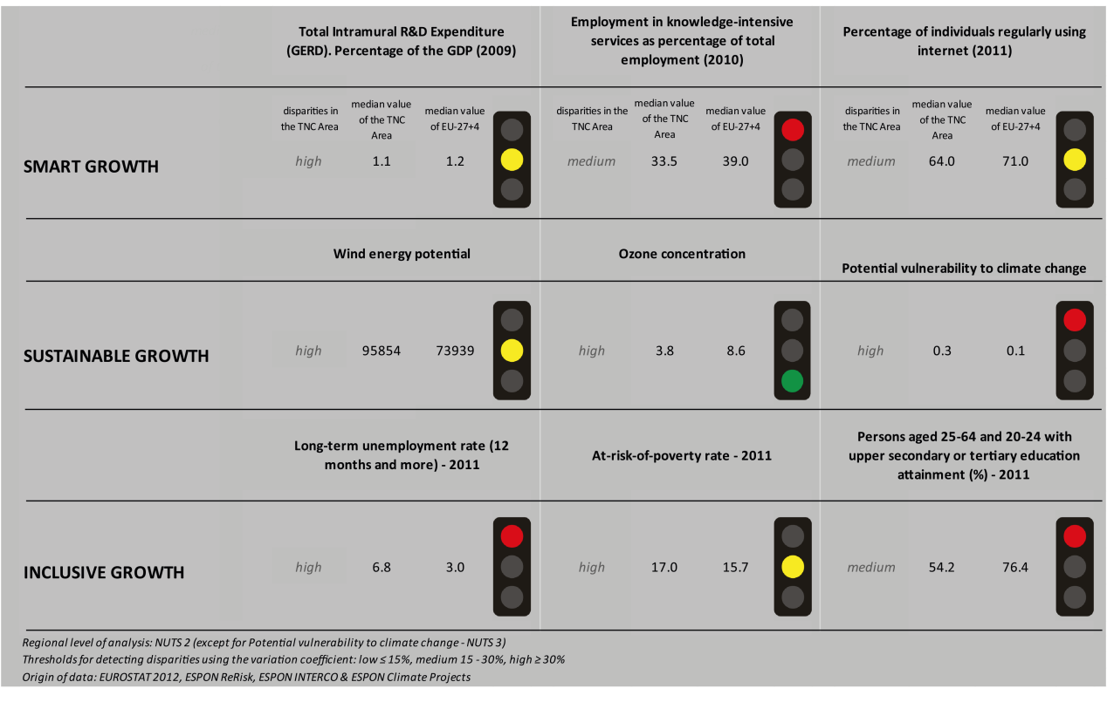
Inclusive growth refers to fostering a high-employment economy delivering social and territorial cohesion. Within the Europe 2020 Strategy it means raising Europe’s employment rate, helping people of all ages anticipate and manage change through investment in skills & training, modernising labour markets and welfare systems, and ensuring the benefits of growth reach all parts of the EU. In short the key factors are employment and avoiding risk of poverty and social exclusion.
Looking at the indicators for smart growth, the South West TNC area performs similarly to the EU27+4 with regards to R&D expenditure and the number of persons regularly using the internet. With regards to employment in knowledge-intensive services, the TNC area has more negative values than the EU27+4.
Using the taxonomy of the KIT project, Map 1 shows a rather similar situation in terms of patterns of innovation across the area. In fact, the regions included in the South West area are mainly qualified as smart and creative diversification areas or smart technological application areas.
The indicators for sustainable growth vary for the South West TNC area. The wind energy potential of the South West area is similar to the EU27+4. The South West area has better results than the EU27+4 in terms of ozone concentration. However, it is more vulnerable to climate change than the EU27+4 although the diversity within the region is high.
The disparities within the South West TNC area are also striking when looking at Map 3 which highlights the adaptive capacity to climate change. While most of the French regions in the TNC area have a medium to high capacity to adapt to climate change, the regions in Portugal and Spain are qualified as having the lowest to low capacity to adapt to climate change with coastal regions in the south of Spain scoring slightly better than inner regions.
The TNC area is generally not affected in terms of fossil fuel consumption by the Directive on the promotion of clean and energy-efficient road transport vehicles. The exceptions are Aragon, Catalunia, the Comunidad Valenciana and the Comunidad de Madrid in Spain and Lisbon in Portugal.
In terms of inclusive growth, the long-term unemployment rate is higher in the South West TNC area than in the EU27+4. The disparities within the area however are high which can also be seen in Map 5. The map shows that the employment rate is higher in the French and Portuguese regions (65% to 75% and even above 75% in the Lisbon area), 65%-70% in the eastern regions of Spain, and low employment rates in the rest of Spain ranging from below 60% to around 65%.
The at-risk-of-poverty rate in the TNC area is similar to the EU27+4 and the share of persons aged 25-64 and 20-24 with upper secondary or tertiary education attainment is lower than in the EU27+4.

In all four ESPON DEMIFER scenarios (Map 4), Portugal and the northern regions of Spain seem to experience negative changes in labour forces. In the scenarios “Expanding Market Europe” and “Growing Social Europe” the French regions and the north and centre of Spain seem to experience positive changes in labour force. The French regions within the TNC area generally seem to experience more positive changes in labour force in all four case scenarios than the other regions of the South West area.

MAP 1 – Territorial Patterns of Innovation (ESPON KIT project) for the TNC South West Europe

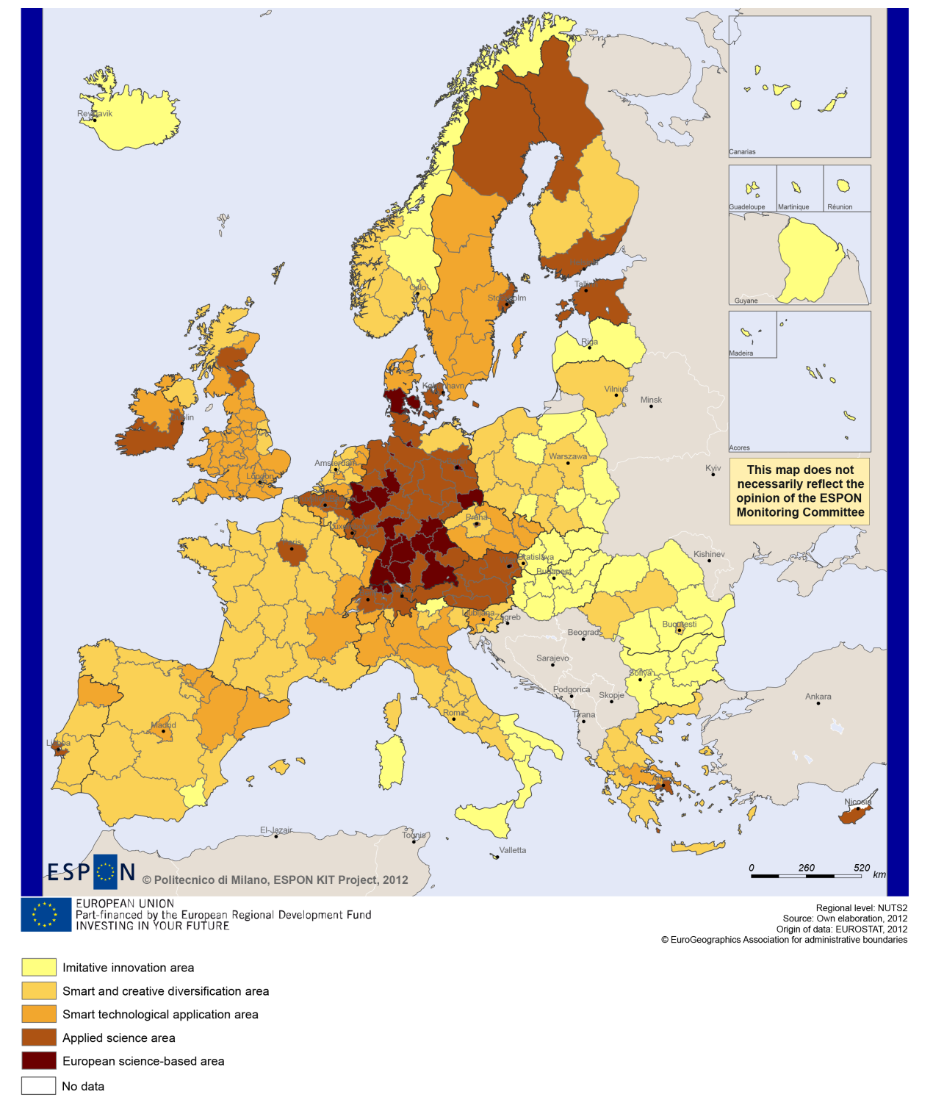

MAP 2 – Territorial impact on fossil fuel consumption of Directive on the promotion of clean and energy-efficient road transport vehicles (ESPON ARTS project) TNC South West Europe

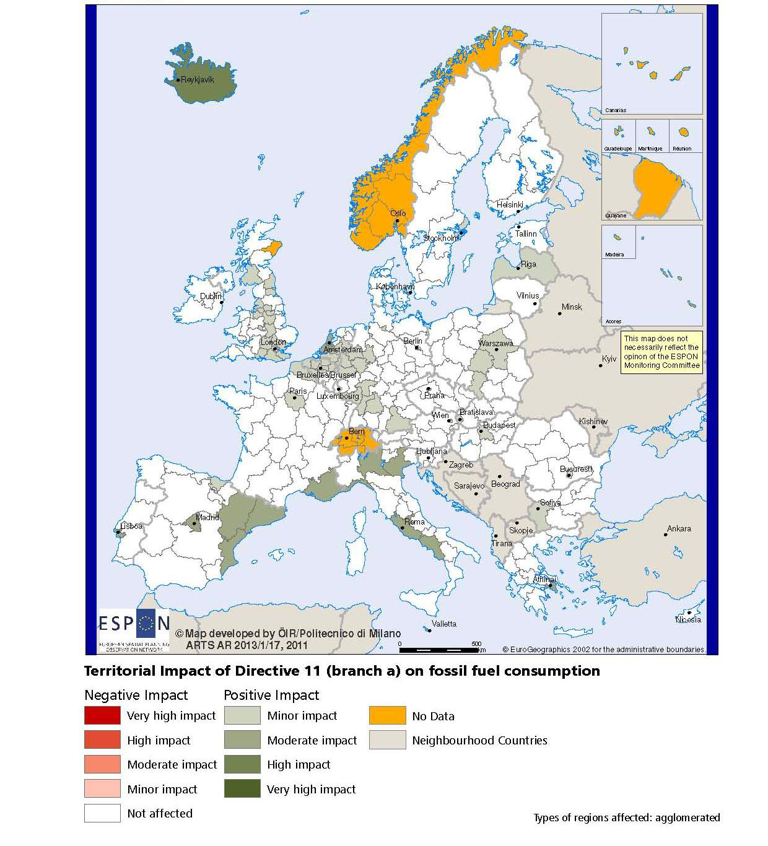

MAP 3 – Combined adaptive capacity to climate change (ESPON CLIMATE project) for the TNC South West Europe
“Adaptive capacity (adaptability)” to climate change indicates the ability or potential of a system to respond successfully to climate change and variability, and includes adjustments in behaviour, resources and technologies.
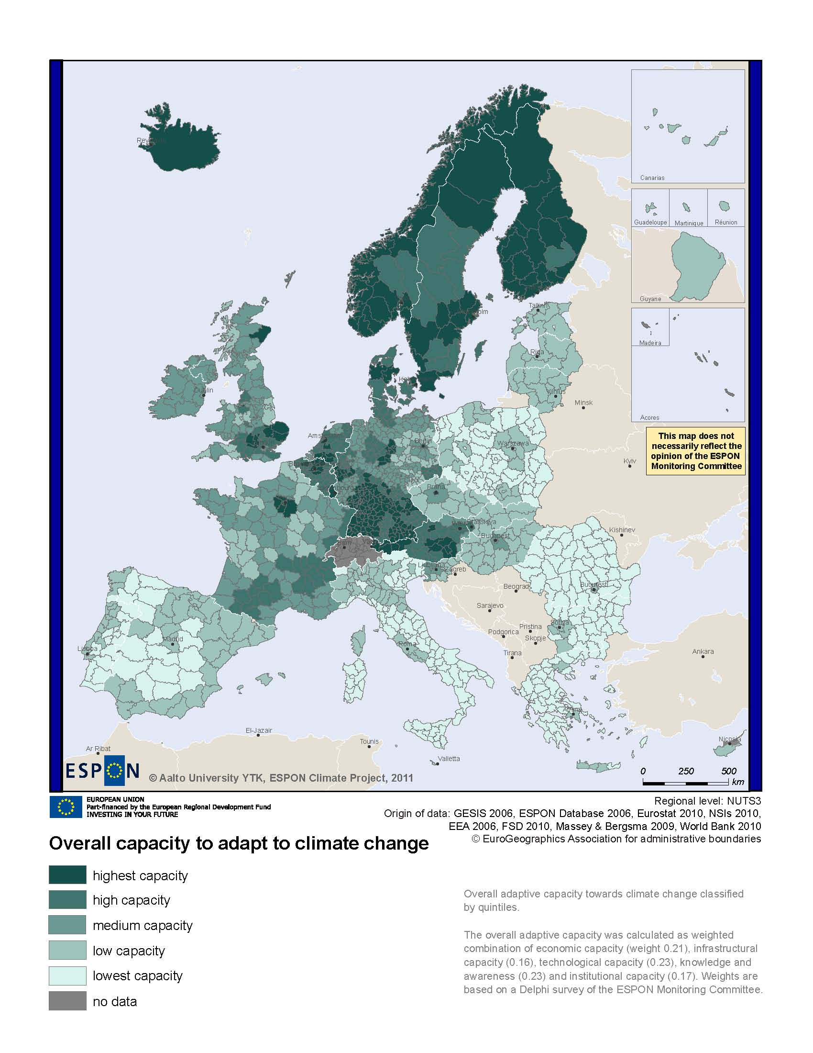
MAP 4 – Change in Labour Force 2005-2050 (ESPON DEMIFER project) for the TNC South West Europe

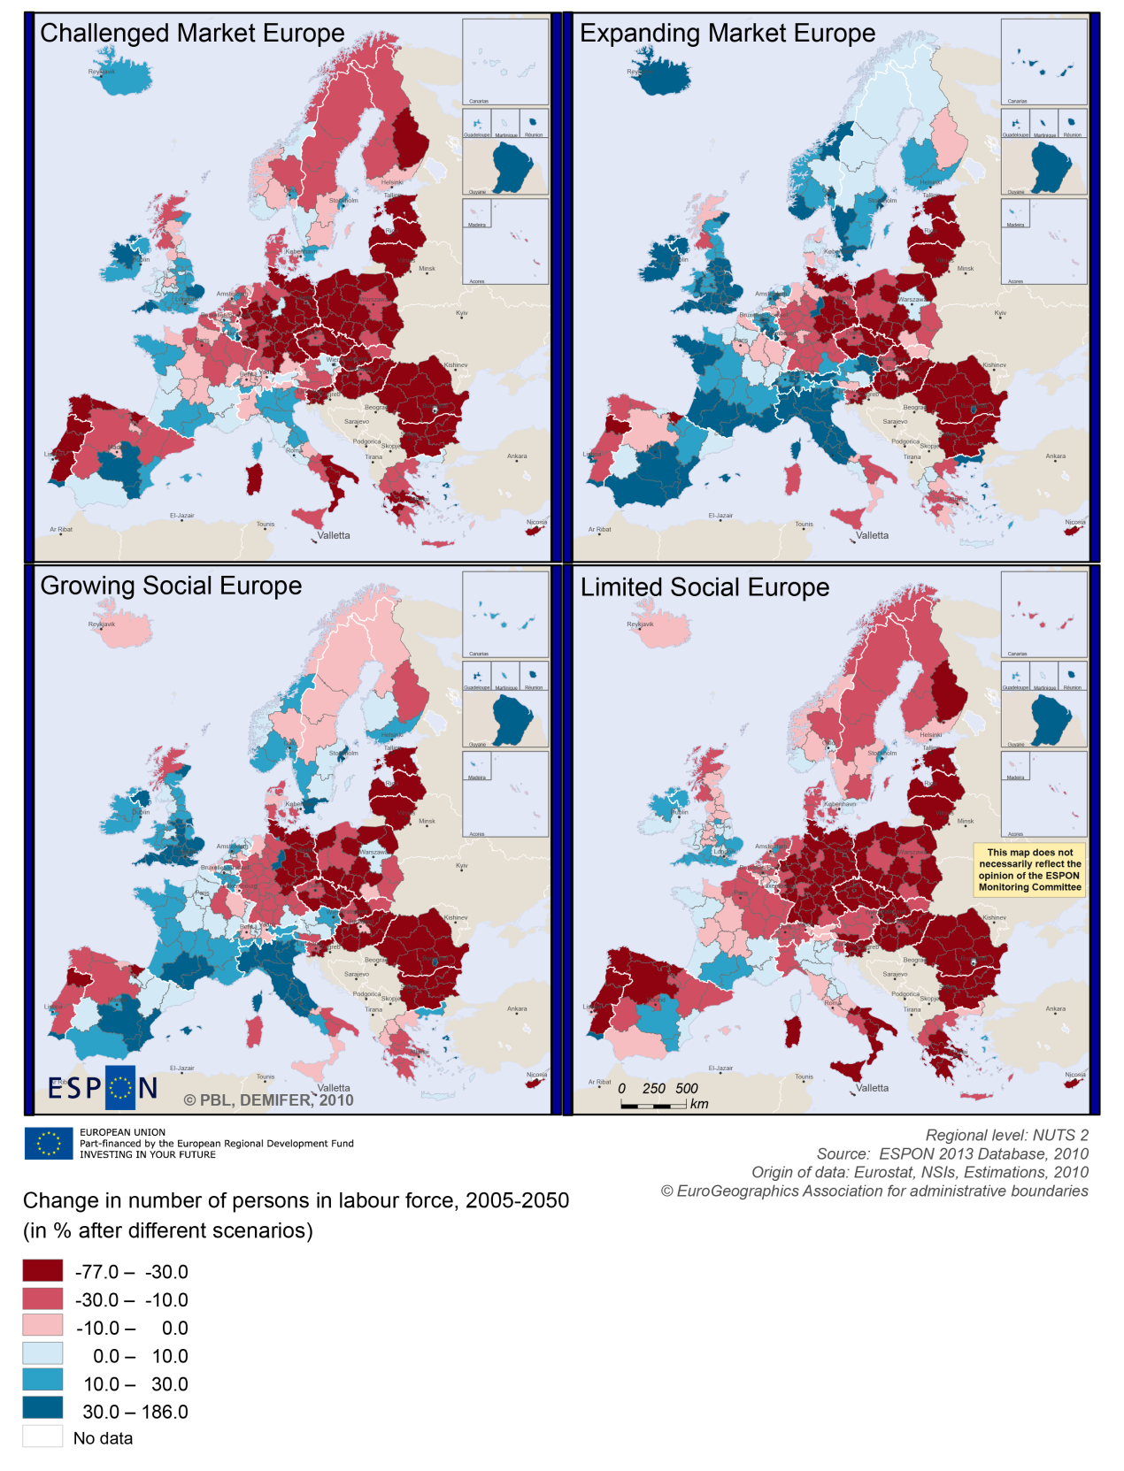

MAP 5 – Employment rate 2010 within the TNC South West Europe

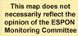
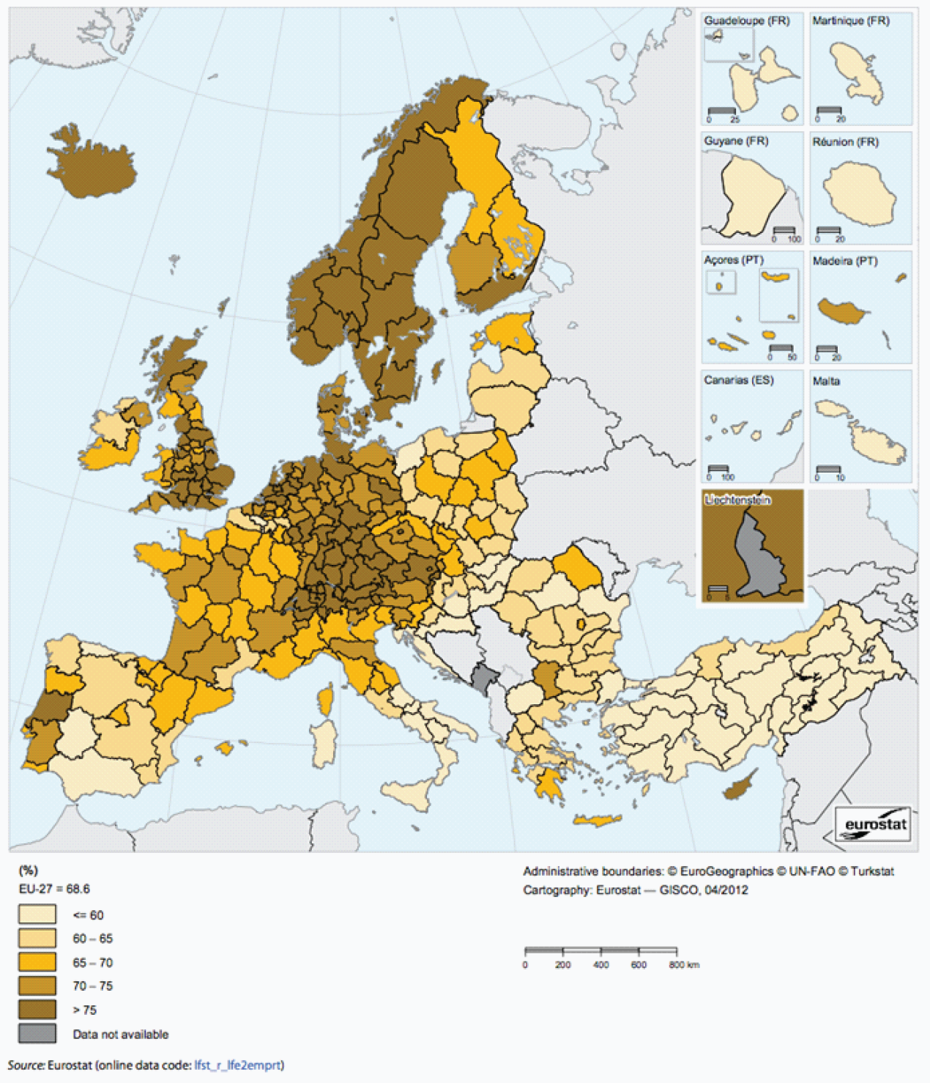

Territorial factors of interest for the programme area
Territorial cooperation programmes can make a difference for the future development of cross-border and transnational territories in Europe. Some of the factors can be analysed by European wide data sets and using some studies having specific maps, figures and tables concerning the areas of the cooperation region.
Besides a wide range of standard indicators frequently used in the context of European regional policies, ESPON has established various indicators which focus more on the territorial dimension. These indicators provide among others information on the development preconditions of an area. Two standard indicators in this field are rural-urban settings and accessibility.
The programme area of South West Europe comprises a number of the main metropolitan areas in Europe, which even play an important role in a worldwide perspective. In particular Madrid belongs to one of the global hubs in Europe, with special focus towards Latin America. Among the main cities of European importance in the programme area are Porto, Lisbon, Madrid, Valencia, Barcelona, Bilbao, Toulouse and Bordeaux. Furthermore, there are a large number of smaller growth poles in the programme area.
Along the coasts and around the urban centres there are also various intermediate regions close to a city. Furthermore the map shows that large parts of the programme area are characterised as rural, in a European perspective. Many of these rule areas are furthermore remote regions, i.e. in the Spanish inland and along the Portuguese-Spanish border.
The urban pattern is reflected in the multimodal accessibility, which for most parts of the region is below European average. Indeed, only the urban areas with larger international airports in the programme areas have good multimodal accessibility values (see map). This is also confirmed by the analysis of possibilities for one-day business trips within the European city network. These possibilities rely mainly on air connections and these are relatively good given the multimodal accessibility values. One-day business trips by train are mainly limited to domestic trips.
- With regard to geographic specificities, the programme area comprises in a European perspective, a large share of coastal and mountainous areas. As well as islands and various sparsely populated regions. The mountainous and coastal characteristics come with advantages and challenges. Although they do not come with specific economic structures, it appears that a significant proportion of those areas have high residential attractiveness. Many mountain and coastal areas are also characterised by relatively high levels of biodiversity and protected areas. Furthermore, coastal ecosystems provide not only food but habitats for diverse economic-valuable and other species, and mountains are the water towers of Europe. Last but not least, it has to be noted that coastal areas and islands are often particularly vulnerable to climate change.
The ESPON GEOSPECS project developed nexus models for mountain areas (Final Report page 49), coastal areas (page 103), sparsely populated areas (page 49) and islands (page 103). The models interlink defining features with relevant processes and territorial development opportunities and challenges. This is certainly of interest for the programme area.

MAP 6 – Urban-rural typology of NUTS3 regions including remoteness (DG Regio) for the TNC South West Europe

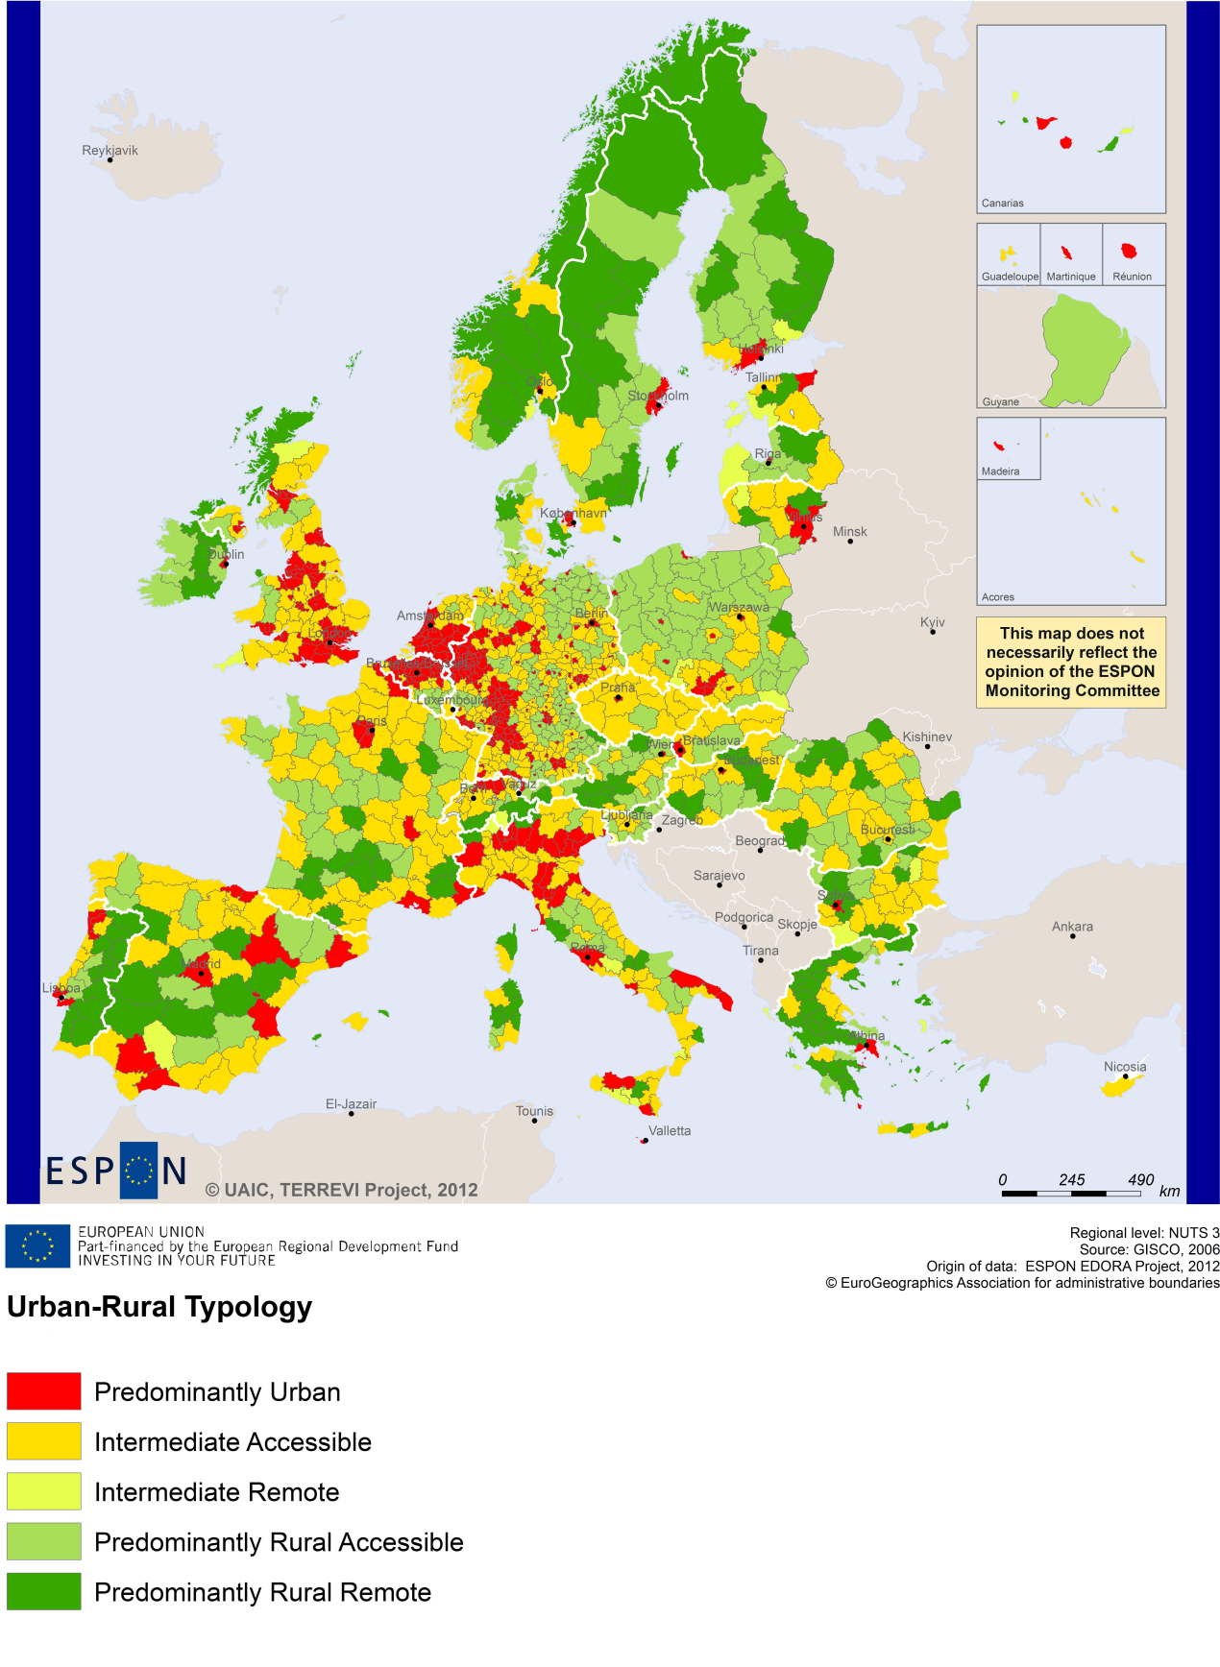

MAP 7 – Multimodal accessibilty (ESPON Accessibility Update) for the TNC South West Europe
“Potential Accessibility Multimodal” scores accessibility of NUTS 3 regions by road, rail and air relative to the European average in an Accessibility Index.
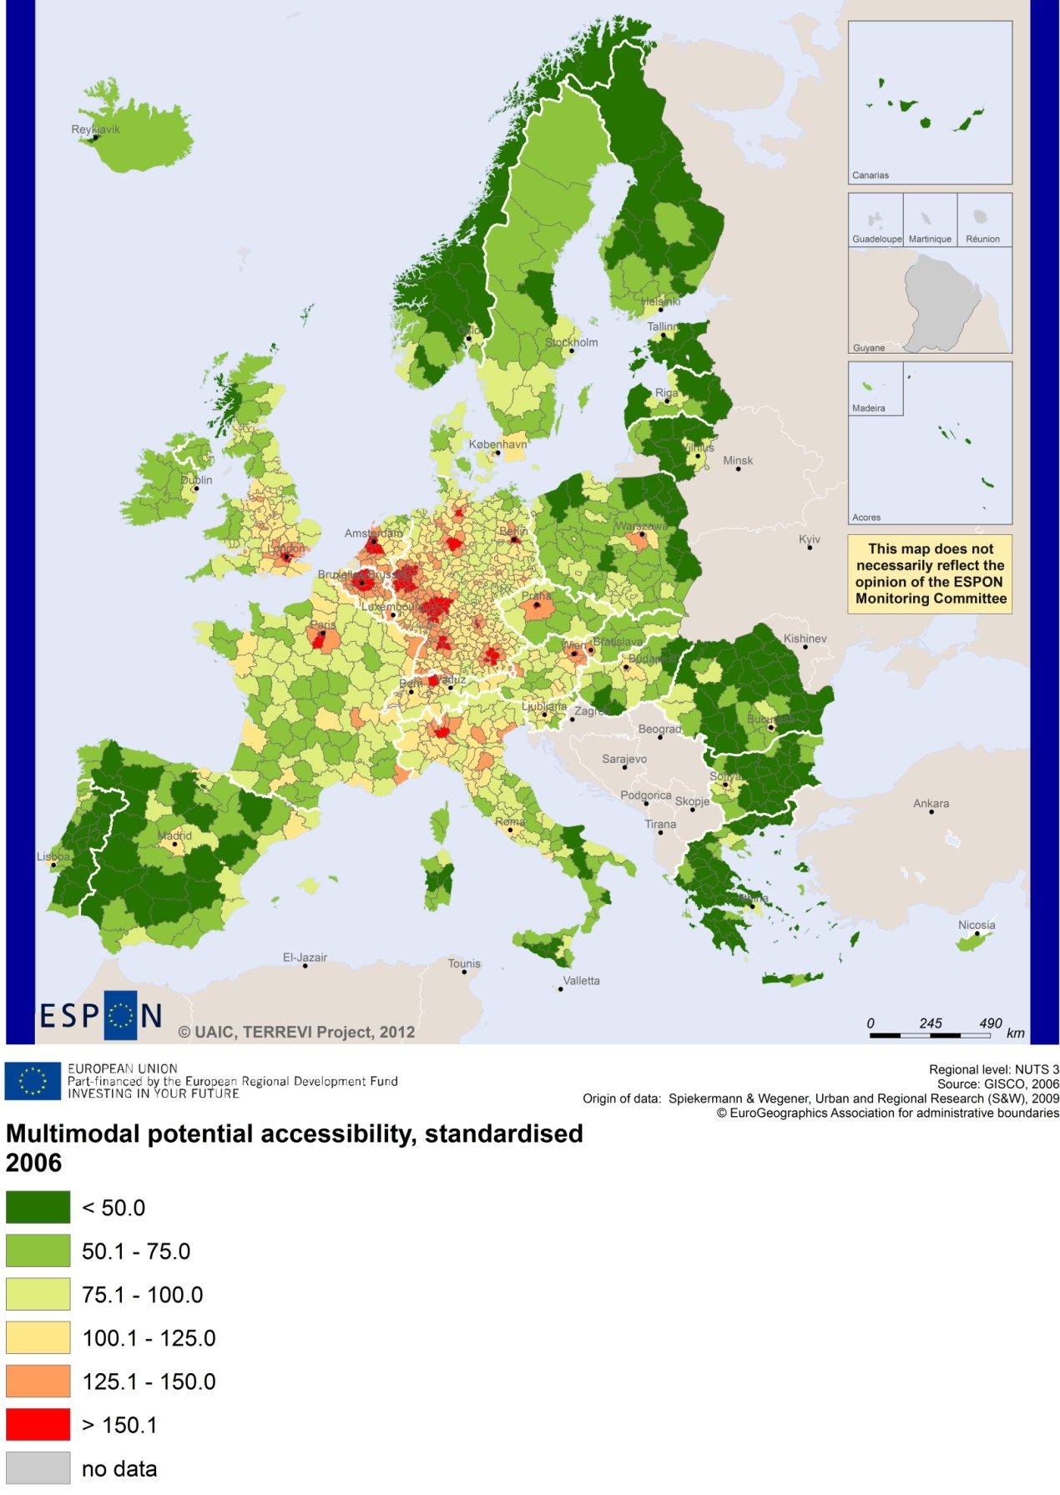

Recommended ESPON reading
ESPON provides an essential underpinning for translating into practice the calls for integrated and place-based approaches to economic development, when analysing a programme area or deciding about future programme priorities. ESPON has published a wide range of exciting reports providing valuable territorial evidence for future territorial cooperation initiatives.
The table below shows examples of relevant projects for the Cooperation Region. However, you have to study other ESPON reports as well in order to capitalise fully on the European information available for the transnational programming.
ESPON study | Topic | Content
CLIMATE | Climate change | It analyses how and to which degree climate change will impact on the competitiveness and cohesion of European regions (see maps 1 to 23). The study analysis some case studies incl. Coastal Mediterranean Spain and Balearic Islands (see map 1-12 of the Annex 4).
CAEE | Agglomeration economies | It aims at a better understanding the economic costs and benefits of large urban agglomerations (see figure 1). The study includes a case study on Barcelona (Appendix-C4).
SGPTD | Growth poles | It provides evidence on European secondary cities, their performance and functional roles in different parts of Europe (see from figure 2 to 2.12). The project focuses on Barcelona, in Spain, as a case study of the TNC area (see Annex 3.4).
FOCI | Cities | It identifies the driving forces of urban development. The project concerns among others Barcelona and Toulouse (see Chapter 9 of the Scientific Report).
ATTREG | Attractiveness | It provides a better understanding of the contribution of European regions’ and cities’ attractiveness to economic performance. It studies among the Algarve, Portugal (Annex 4/1).
GEOSPECS | Specific types of territories | It provides evidence on the challenges and development opportunities of specific types of territories (e.g. border areas, highly or sparsely populated areas). The report includes a case study of Central Spain in the Draft Scientific Report (Annex 29).
EUROISLANDS | Islands | It gives evidence on the divergence of island's situation from the European average and on existing policy measures for the islands. It includes a case study (see Annex III of the Final Report) on Mallorca.
SURE | Convergence regions | It seeks to understand why some convergence regions are unable to improve economic performance and competitiveness. The project focuses on Valencia, in Spain, as a case study (see in particular Chapter 3 of the Final Report).
DEMIFER | Demography | It provides evidence on the regional effects of migration on Europe's demographic future. The Deliverable 12/05 analyses the case of Cataluña.
ReRisk | Energy | It focuses on opportunities to support competitive and clean energy supplies for regions in Europe. The project provides a case study on Navarra in Spain.
SS-LR | Scenarios | The project develops and applies regional forecasting methodologies and instruments at the appropriate territorial scale, responding to functional local-regional territories. In particular the ESPON study concerns the province of Barcelona, and the Latin Arc (the Spanish part).
EATIA | Impact assessment | It tests the practical use of existing methods and tools for Territorial Impact Assessment. The study as a particular focus on Portugal (see Annex 3).
TPM | Territorial performance | The study establishes knowledge on how territorial impacts of these macro challenges translate at the regional level and how to deal with these challenges in an effective way. Two of the regional highlights of the project are Navarre and Cataluña.
KIT | Innovation | It describes patterns and potentials of regions in terms of knowledge and innovation economy and explores development opportunities (see from map 3.1.1 to 4.4.1).
Furthermore, some of overall ESPON products of particular interest for territorial cooperation are:
- ESPON Synthesis report “new evidence on smart, sustainable and inclusive territories” provides an easy to read overview on ESPON results available.
- ESPON Territorial Observations is a publication series, which on a few pages presents policy relevant findings deriving from latest ESPON research.
- ESPON 2013 Database provides regional information provided by ESPON projects and EUROSTAT.
- ESPON Hyperaltas allows comparing and analysing a region’s relative position at European, national and local scale for a wide range of criteria.
- ESPON MapFinder provides access to the most relevant ESPON maps resulting from ESPON projects and reports.
- ESPON Typologies provides nine regional typologies for additional analysis of regional data to be considered in the European context.
All ESPON reports and tools are freely available at
www.espon.eu

The ESPON 2013 Programme is part-financed by the European Regional Development Fund, the EU Member States and the Partner States Iceland, Liechtenstein, Norway and Switzerland. It shall support policy development in relation to the aim of territorial cohesion and a harmonious development of the European territory.

