Sweden – Norway
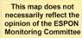
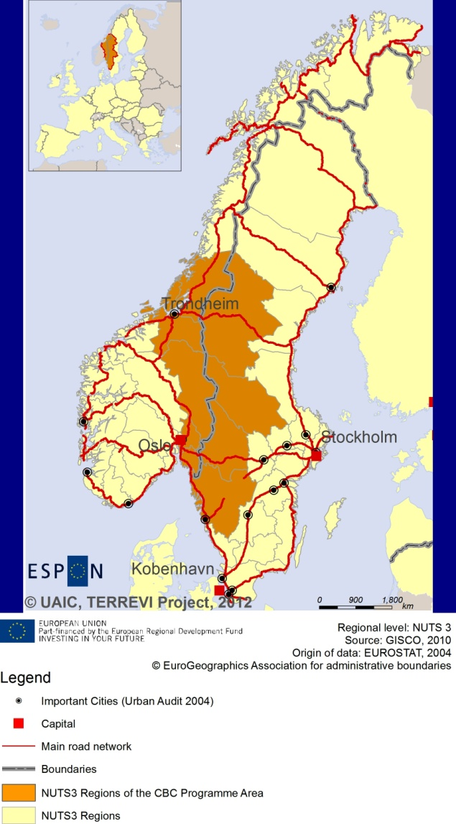

ESPON Project TERREVI
November 2012

Introduction
ESPON supports policy development in relation to the aim of territorial cohesion and a harmonious development of the European territory. It provides comparable information, evidence, analysis, and scenarios on territorial dynamics, which reveal territorial capitals and development potentials of regions and larger territories. Considering the programme area in its European context adds an important new perspective that can help shaping the programming and the places of implementing projects.
The ESPON TERREVI project focuses on producing evidence for Structural Funds programmes with the aim to support the development of the programmes to be carried out in the 2014-2020 period.
One milestone of this work consists in presenting selected ESPON research pieces in easy-to-understand factsheets for all territorial cooperation programme areas. The aim is to provide the reader with preliminary insight on types of territorial evidence ESPON holds at hand with regard to the possible investment priorities of future programmes. The factsheets certainly only give a first glimpse rather than fully present the work of the large number of ESPON projects that are currently underway. Likewise, each programme area includes diverse development potentials and challenges, which needs targeted information search. However, hopefully this factsheet will contain information, benchmarking the programme area in its larger, territorial context, that is of interest and help to better understand the programme area and to navigate within the richness of ESPON material available.
In addition to the programme factsheets there will be a number of specific programme case studies illustrating how ESPON material can be used to support the development of future programmes e.g. by giving a comparative European dimension to the envisaged SWOTs. These case studies will be carried out in early 2013.
This factsheet is structured in three main parts. The first part presents a selection of indicators that help comparing the situation of the programme area in question with the European average, the average for all programme areas as well as the situation in the countries involved. The second part briefly presents the territorial factors of interest for the programme area. The final part offers guidance on the further use of ESPON results and tools. This is intended as an electronic publication so map quality is generally high to allow users to zoom into specific territories.
This factsheet does not necessarily reflect the opinion of the ESPON Monitoring Committee.

Europe 2020
Europe, with its member states and their regions, is more exposed to global shocks and international competition than at any time before. As the world becomes more interdependent this trend will continue and shape policy thinking across sectors, borders and geographical scales. At the same time, Europe is characterised by a large territorial diversity meaning that global developments can imply rather different development possibilities and challenges for different European regions and cities.
The differences are partly defined by major geographical structures such as urban systems, access and connectivity, the geographical specificity or population density. At the same time, the differences are also spelled out in the larger development trends that affect an area, and the way and degree to which it is affected.
The data, indicators and territorial evidence provided by ESPON provides insight on both the main structures and larger territorial trends. The fine art is to identify what can actually be influenced by policy-making and, in particular, by place-based policy and territorial cooperation related to your programme area.
This chapter provides a selection of ESPON data related to Europe 2020 objectives of smart, sustainable and inclusive growth, giving also hints as regards the main thematic objectives envisaged in the draft regulations for the next period of EU Cohesion Policy. The Europe 2020 Strategy aims to enhance smart, sustainable and inclusive growth. This strategy has clear territorial dimensions. However, achieving these goals is challenging in the crisis-driven times. Furthermore, the economic disparities are growing as economic trends and the crisis have various impacts on different parts of Europe.
In the following the traffic light for each indicator represents how your programme territory compares to wider European and national medians where green = your programme area performs better for that indicator, yellow = similar, and red = worse.
In creating the traffic lights the median was used as central value indicator for all statistical variables due to its advantages (easy to interpret, it splits the statistical distribution in half) but especially due to the constraints linked to the impossibility of computing means for several indicators (Climate Change, Wind Energy Potential etc.). Therefore, a special attention should be given in reading the median values when the number of NUTS 2 regions is below 7. Using percentiles implies also a high dependence of the final results on the type of statistical distribution. This fact should be considered when establishing the relative position of a CBC Programme Area to a specific country.
EU 27+4 in Traffic Lights and box-plots means the EU Member States as well as Iceland, Liechtenstein, Norway and Switzerland – the ESPON space.

Smart growth
Smart growth refers to developing an economy based on knowledge and innovation. In the framework of the Europe 2020 Strategy it means improving the EU's performance in education, research/innovation and digital society.
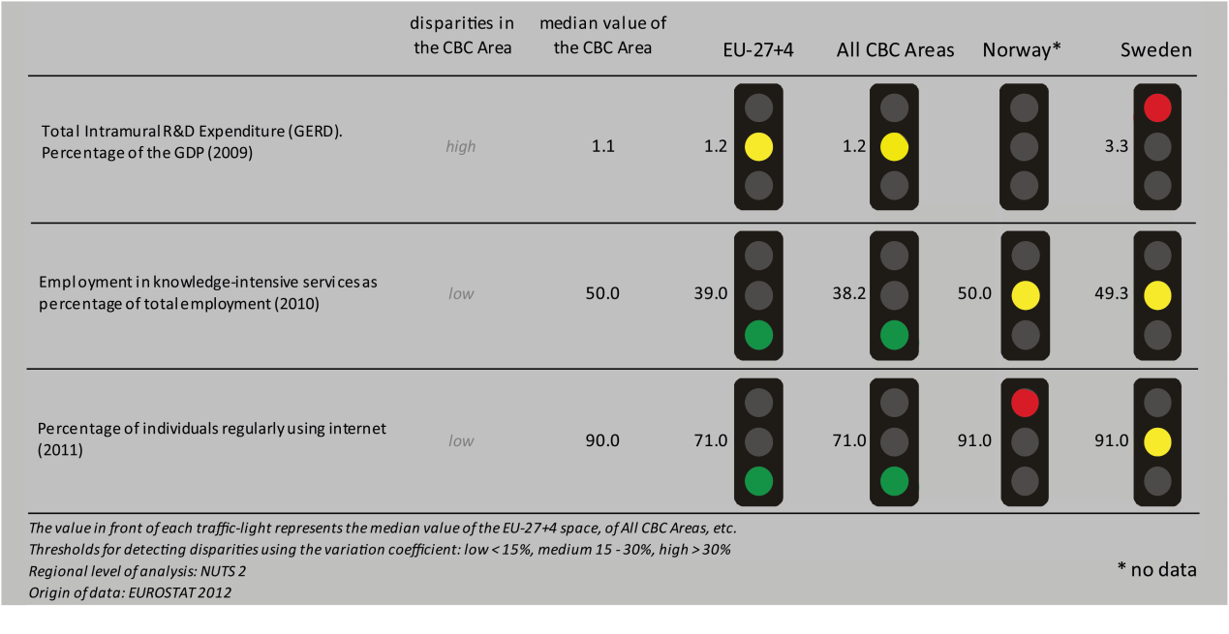
According to all indicators reported above, the Sweden – Norway CBC area performs at a not better level than the EU27+4 space and all CBC ones. Considering the objective of R&D expenditure of percentage of the GDP - one of the five headline targets in the Europe 2020 Strategy - the CBC area is in a similar position to the EU27+4 space and all CBC. Moreover, the CBC area is characterized by a high level of internal disparity and performs worse than Sweden.
Concerning the ratio of employment in knowledge-intensive service to the total employment in 2010, the CBC area has higher values than both the EU27+4 space and all CBCs; similar to Norway and Sweden. The distribution inside the CBC results in a low level of internal disparity.
In terms of the percentage of individuals regularly using internet in 2011, the CBC has higher values than the EU27+4 space and all CBCs, but it performs slightly worse than Norway and slightly better than Sweden, with a low internal disparity.
According to the classification of the KIT project, MAP 1 identifies the following territorial patterns of innovation, basically keeping up with national borders:
- ‘Smart and creative diversification area’ in the most of the Norwegian side. It is defined by a low degree of local diversified applied knowledge, internal innovation capacity, high degree of local competences, creativity and entrepreneurship, external knowledge embedded in technical and organizational capabilities;
- ‘Creative imitation area’, in the Norwegian part near Oslo. It is associated to a low knowledge and innovation intensity, entrepreneurship, creativity, a high attractiveness and a high innovation potential;
- ‘Smart technological application area’, in the Swedish side. It is defined by a high product innovation level, with a limited degree of local applied science and R&D endowment, and a high creativity which allows translating external basic science and applied science knowledge into innovation.
MAP 1 – Territorial Patterns of Innovation (ESPON KIT project) for the CBC Sweden - Norway

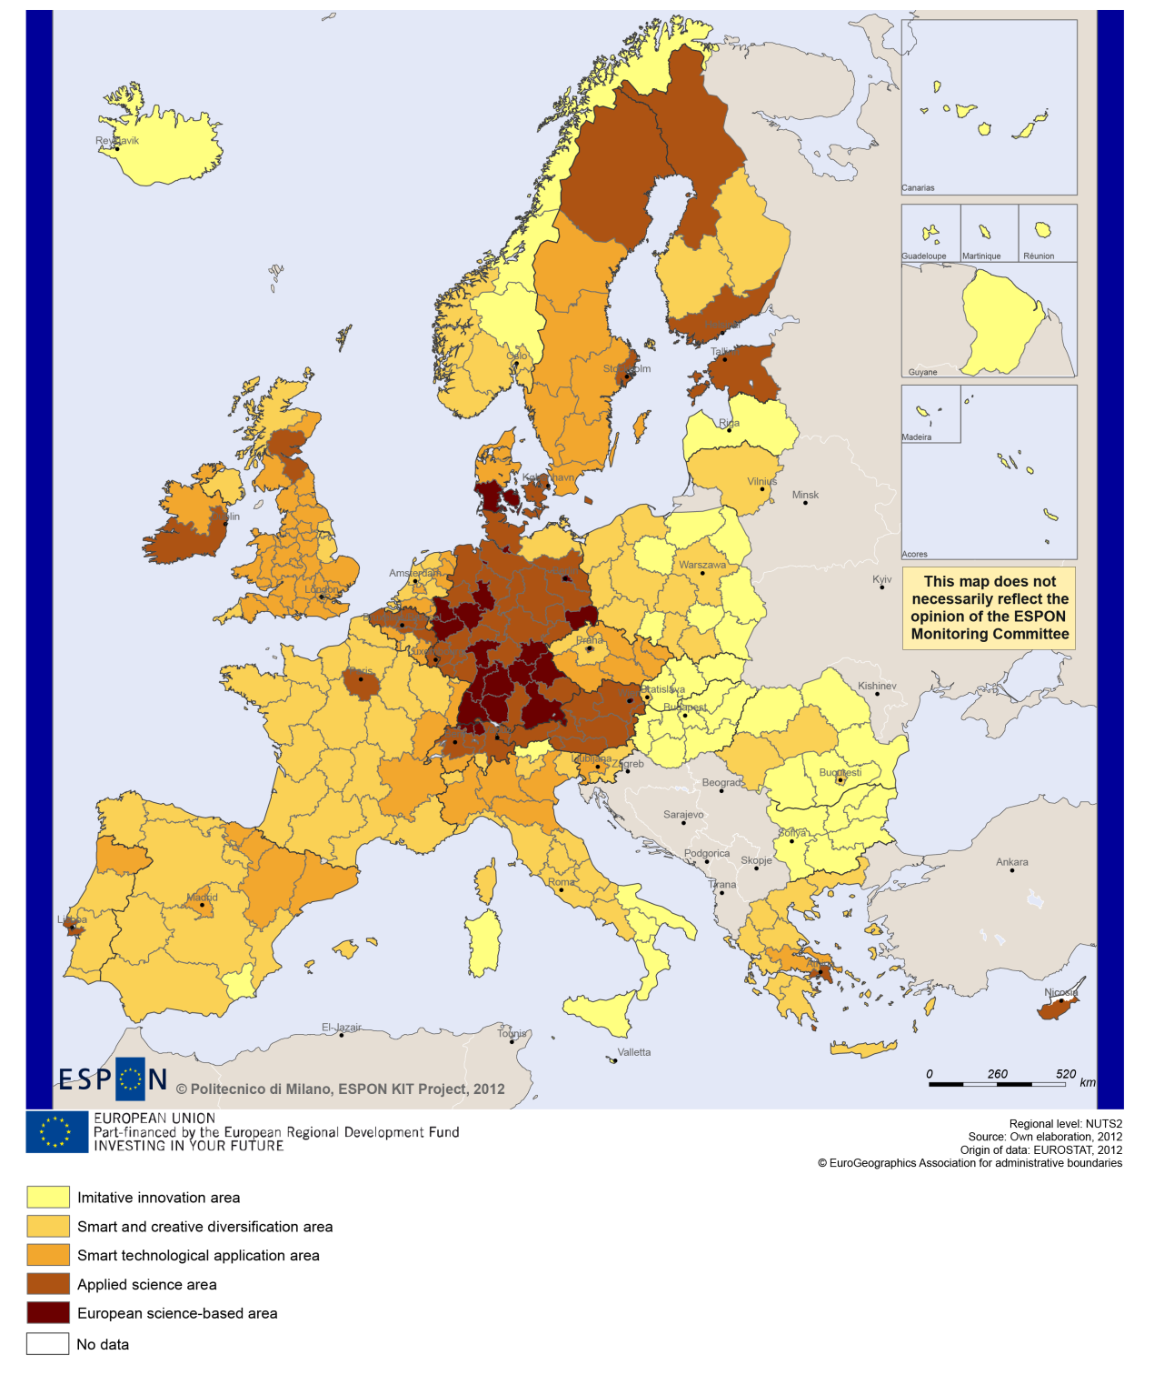

Sustainable growth
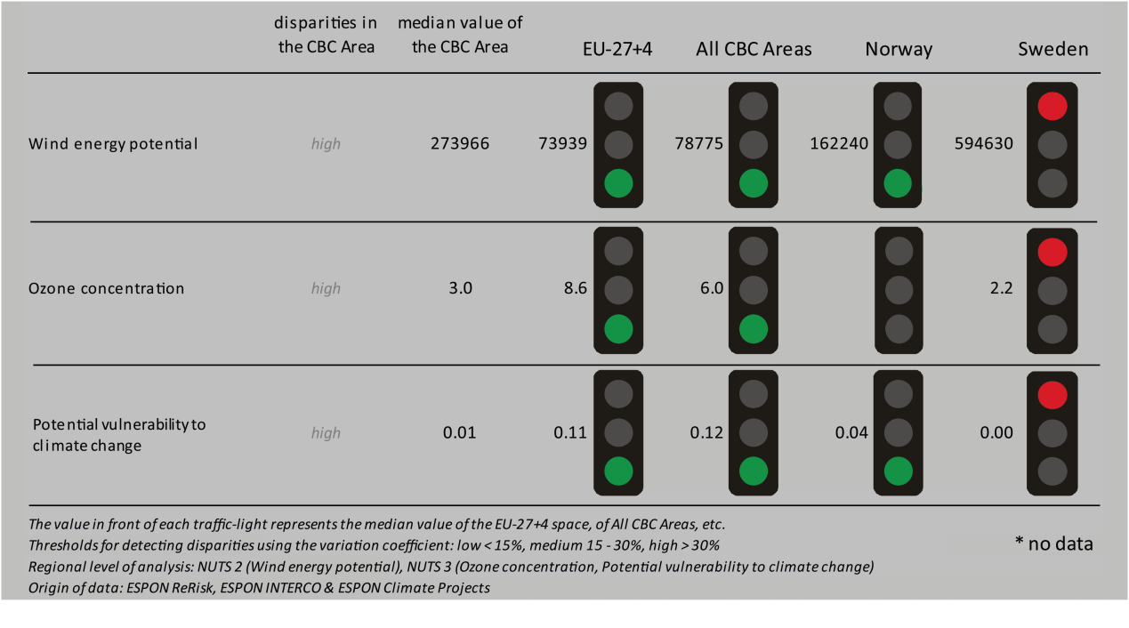
Sustainable growth refers to promoting a more resource efficient, greener and more competitive economy. Within the Europe 2020 Strategy it means e.g. building a more competitive low-carbon economy that makes efficient, sustainable use of resources, protecting the environment, reducing emissions and preventing biodiversity loss, capitalising on Europe's leadership in developing new green technologies and production methods, and introducing efficient smart electricity grids. In the framework of the Europe 2020 Strategy it means focus on competitiveness, resource efficiency, climate change and biodiversity.

The use of wind energy potential could be one of the cornerstones in building a competitive low-carbon economy in the EU. The CBC programme of Sweden – Norway shows a median value that is significantly higher in terms of wind energy potential, and significantly lower in terms of ozone concentration and the potential vulnerability to climate change than the EU-27+4 and the all CBC area values. With regard to all three indicators Sweden shows slightly stronger national values than the CBC median value, whereas the CBC area performs slightly better than Norway in general. All three indicators are characterised by high disparities within the CBC area.
Directive 11 has no territorial impact on fossil fuel consumption on the Swedish side of the border (MAP 2). Most NUTS3 regions of the Sweden – Norway CBC programme have a better than the EU average for combined adaptive capacity to climate change (BOX-PLOT 1), i.e. fall within the top 25% of all EU-27+4 and all CBC regions. In the national contexts, the level of adaptive capacity of NUTS3 border-regions to climate change is more or less evenly distributed around the national medians. Some regions perform considerably better than the national median values and some have a much weaker adaptive capacity to climate change, the Swedish region of Västra Götalands being the strongest and Jämtlands the ‘weakest’ performer in both national contexts.

MAP 2 - Territorial impact on fossil fuel consumption of Directive on the promotion of clean and energy-efficient road transport vehicles (ESPON ARTS project) for the CBC Sweden - Norway

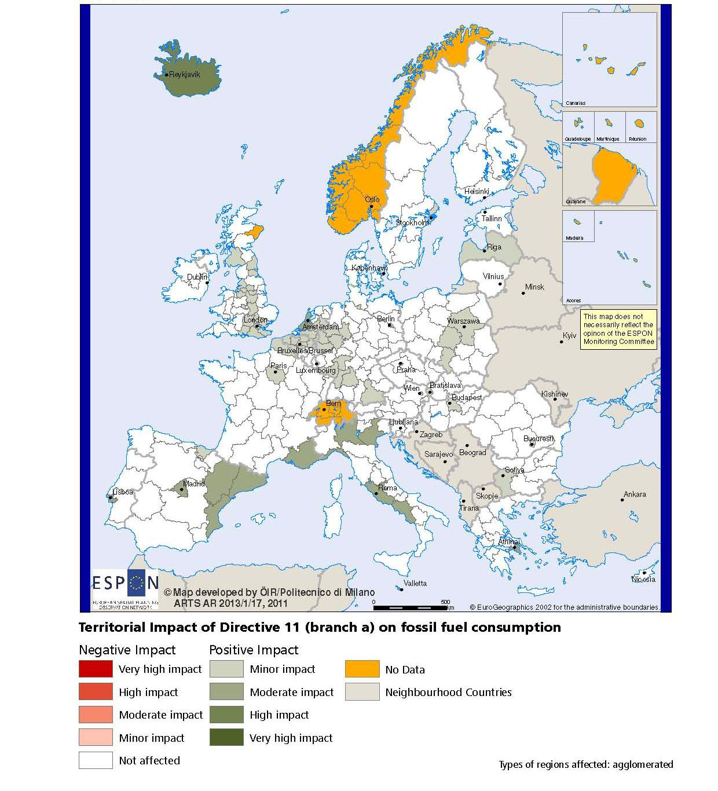

BOX-PLOT 1 – Combined adaptive capacity to climate change (ESPON CLIMATE project) for the CBC Sweden – Norway
“Adaptive capacity (adaptability)” to climate change indicates the ability or potential of a system to respond successfully to climate change and variability, and includes adjustments in behaviour, resources and technologies.
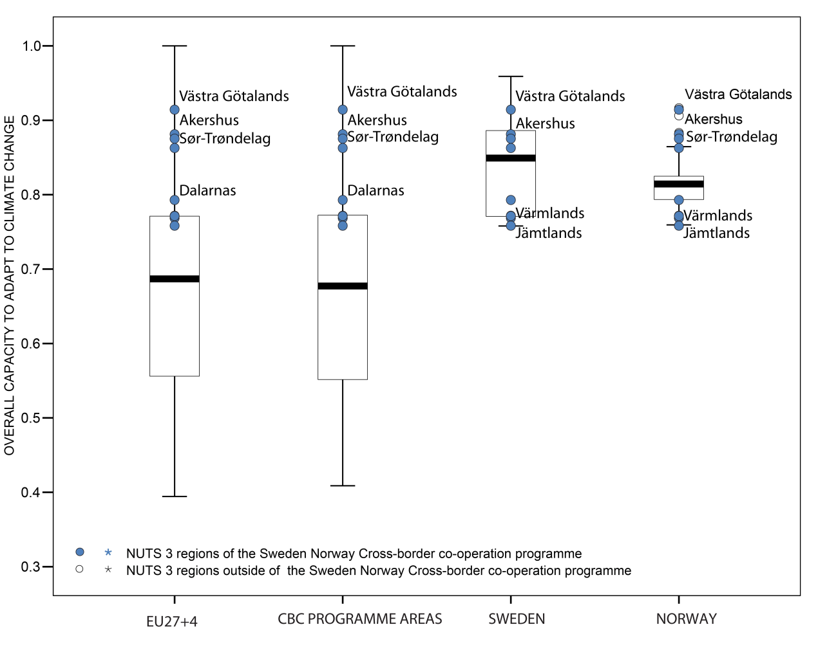

How to read the box-plots?
The box-plot is a statistical and mathematical tool used to visualize numerical data sets and to compare its statistical distribution.
Because it is used in exploratory analysis of databases, this representation is sensitive to the quality of the central value selected to explain the symmetry, shape and distribution variability. In the case of a box-plot, the most used central value is the median, because it has the quality of sectioning the data string into two halves, so that 50% of the cases will be above the central value and the other half will be below it. Since the purpose of the representation is to highlight outliers’ behavior, it uses a box that encompasses half of the cases, i.e. values that are in the range defined by the percentile of 25% and 75%. If a region has a value in this box then it can be considered that it has, according to the variable in question, a situation close to the average behavior of all regions analyzed.
When a region consistently deviates from the average profile of the analyzed territorial context, this behavior will be noted in the chart only when certain thresholds of statistical tolerances are exceeded, this being pointed in the diagram with segments perpendicular to the middle box, segments called the "whiskers".

Inclusive growth
Inclusive growth refers to fostering a high-employment economy delivering social and territorial cohesion. Within the Europe 2020 Strategy it means raising Europe’s employment rate, helping people of all ages anticipate and manage change through investment in skills & training, modernising labour markets and welfare systems, and ensuring the benefits of growth reach all parts of the EU. In short the key factors are employment and avoiding risk of poverty and social exclusion.
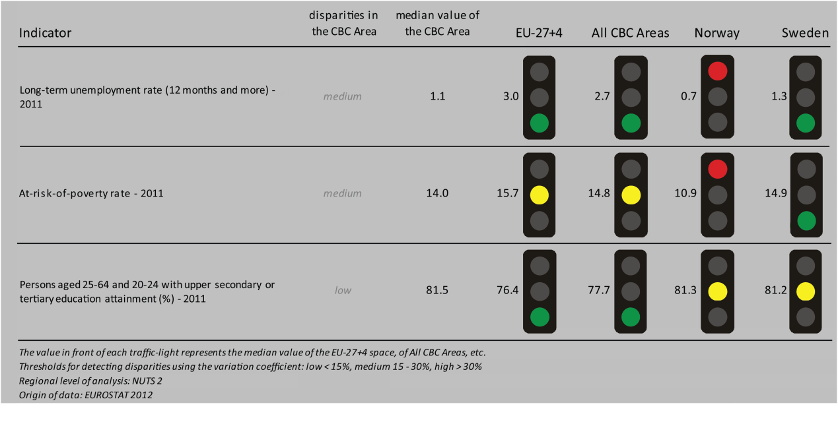
The Sweden – Norway CBC programme is characterised by strong employment indicators when compared to the EU-27+4 or all CBC areas. As far as long-term unemployment rate is concerned, the median value of the CBC area is substantially lower than the EU-27+4 and all CBC areas, and similar to that of the national values for Norway and Sweden. A smiliar picture emerges with regard to share of persons (aged 20-24 & 25-64) with upper secondary or tertiary education attainment. As far as people at risk of poverty are concerned the CBC area’s performance is closer to the EU-27+4 and the all CBC area level, and also similar to the relevant national values.

All four scenarios of the ESPON DEMIFER project with regard to the change in labour force until 2050 describe similar patterns with regard to the relative strength of the various NUTS3 border-regions. However, the extent of change and even the direction of change vary according to the different scenarios. The four scenarios predict labour force increase in the Northern border regions (only the ‘Limited Social Europe’ foresees minor reductions here) and in the Southern region of Akershus in Norway; whereas, most scenarios foresee labour force reductions in the region of Hedmark. Predictions for the Norvegian region of Østfold vary. Three of the scenarios expect the labour force to decrease in the majority of the Swedish NUTS3 border-regions, namely in the regions of Jämtlands, Värmlands, Dalarnas (only the ‘Expanding Market Europe’ scenario foresees minor increase here). In the Swedish border-region of Västra Götalands most scenarios (except the ‘Limited Social Europe’ scenario) predict an increase. Employment rates (2010) in those CBC NUTS3 regions where data was available (BOX-PLOT 2) are close to the median values of the EU-27+4, all CBC areas as well as the national value of Sweden.

MAP 3 – Change in Labour Force 2005-2050 (ESPON DEMIFER project) for the CBC Sweden - Norway

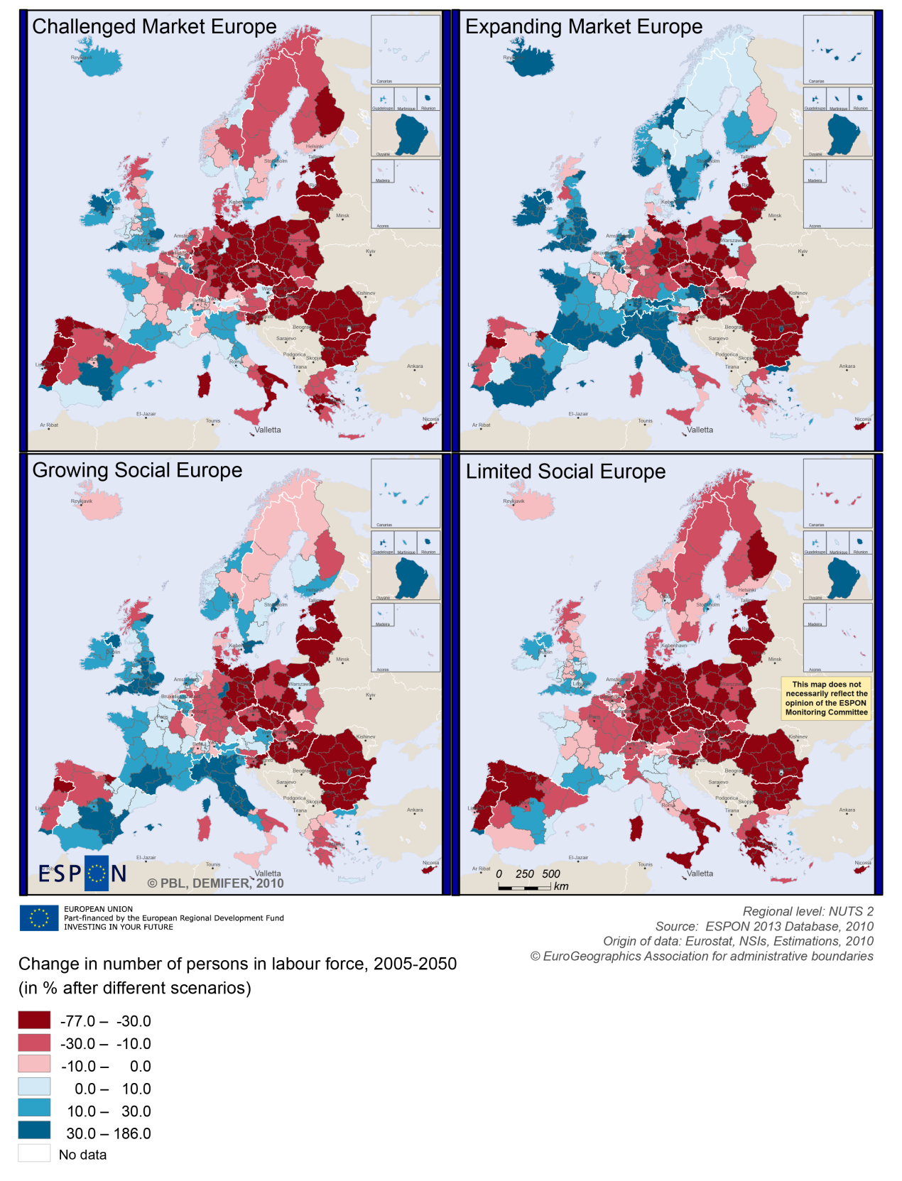

BOX-PLOT 2 – Employment rate 2010 within the CBC Sweden - Norway
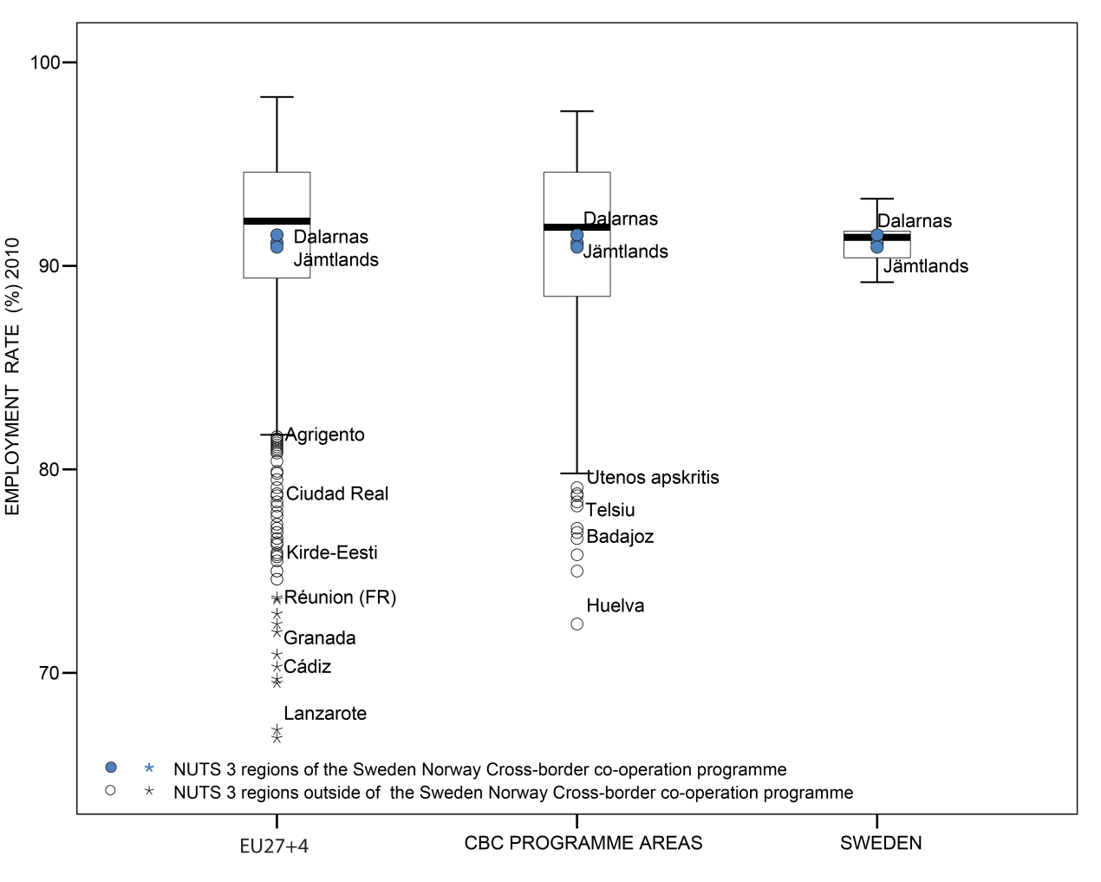

(see “How to read the box-plots?” on page 8)

Territorial factors of interest for the programme area
Territorial cooperation programmes can make a difference for the future development of cross-border and transnational territories in Europe. Some of the factors can be analysed by European wide data sets and using some studies having specific maps, figures and tables concerning the areas of the cooperation region. For the programme area ESPON TERCO is of particular interest. It comprises a case study focusing on a border region concerning the cooperation between Sweden, Norway and Scotland. The full case study including a lot of detailed analysis of the area and cooperation activities in the area is available in the annex to the (Draft) Final Report of the TERCO project. The below box provides only a short extract from the case study summary.
ESPON TERCO PROJECT – ANNEX TO THE DRAFT FINAL REPORT, PAGE 455-459:
Extracts from the text describing the programme area
Norway and Sweden have a long tradition of cooperation between many regions in the two countries. Both also have strong links in terms of high level cooperation on a wide range of issues.
The draft regulation for European territorial cooperation highlights the important role territorial cohesion plays in peripheral regions such as mountainous areas as well as coastal regions and sea basins (CEC 2011: 2). The programme area is large. While it includes urban centres in the South of Norway and Sweden, it is partly characterised by its vastness and the remoteness of large parts of the area. The geography of the region includes some of the most remote and inaccessible areas in Europe. The countries have extensive mountainous terrains, and large parts of the programme area are covered by forests and lakes, in particular in Sweden.
The natural geography, lack of transport links and dispersed settlements in large parts of the case study area restrict access.
The impact of this level of peripherality is complex. On the one hand it restricts internal and external movement of passengers, often making people more reliant on air travel and leading to higher transport costs for both goods and people. It also reduces labour market opportunities in certain sectors and restricts access to services. On the other hand, it also creates a competitive advantage for locally produced goods and services. Territorial cohesion can play an important role in such peripheral regions in terms of creating cross border synergies and developing viable services through economies of scale.
In a European perspective the programme area is rather remote with low population density. However, in a Nordic perspective it has to be noted that the programme includes some urban centres such as e.g. Trollhätten, Strömstad and Trondheim, as well as Oslo with a 20% regulation. Despite some urban spots most of the programme area is – in a European perspective – comprised by remote rural areas. The programme area has a number of geographic specificities such as coastal and mountainous regions and sparsely populated areas. With regard to these types of regions ESPON GEOSPECS has developed nexus models for mountainous and for coastal regions linking defining features via intermediary process to development challenges and opportunities
In terms of infrastructure and accessibility the map on multimodal accessibility shows that the links to Oslo and Gothenburg are important. However, the overall accessibility – in particular in the rural part of the areas – are below European average(see map). This is also reflected in the possibilities for one-day business trips within the European urban network. Indeed possibilities for one-day trips to larger urban centres beyond the Oslo, Gothenburg, Stockholm and maybe Copenhagen are limited for people living in the programme areas. At the same the area has comparable good ICT access.
MAP 4 – Urban-rural typology of NUTS3 regions including remoteness (DG Regio) for the CBC Sweden - Norway

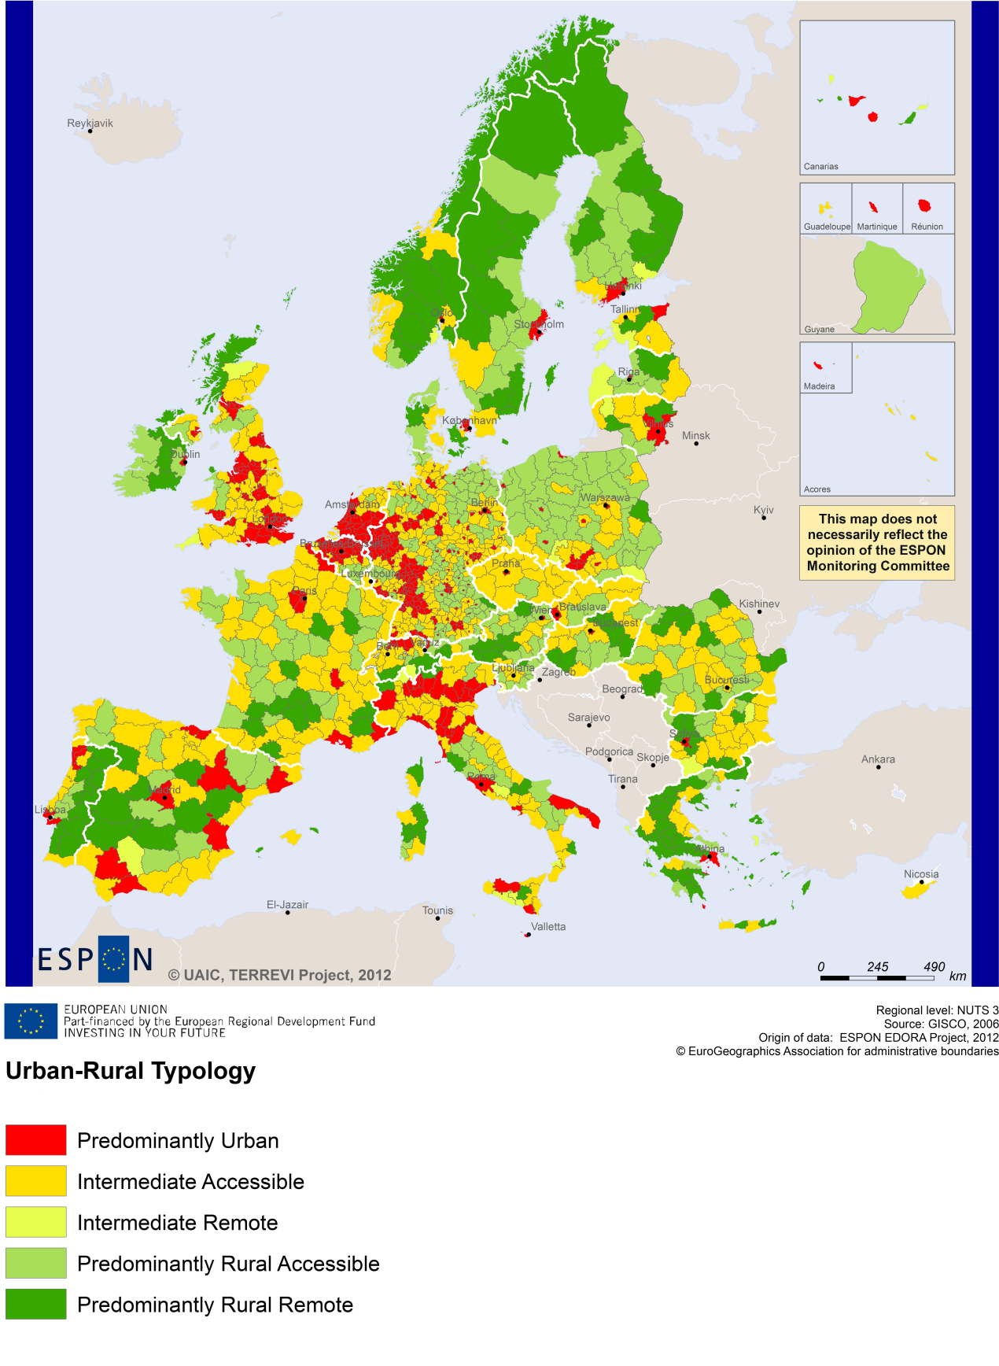
(Accessible=close to a city)

MAP 5 – Multimodal accessibilty (ESPON Accessibility Update) for the CBC Sweden – Norway
“Potential Accessibility Multimodal” scores accessibility of NUTS 3 regions by road, rail and air relative to the European average in an Accessibility Index.
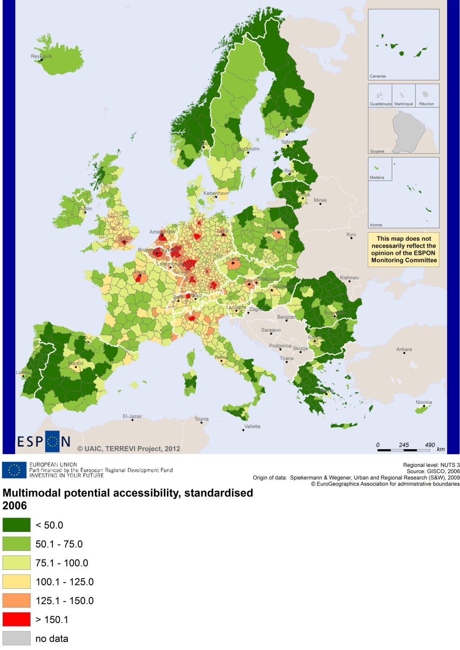

Recommended ESPON reading
ESPON provides an essential underpinning for translating into practice the calls for integrated and place-based approaches to economic development, when analysing a programme area or deciding about future programme priorities. ESPON has published a wide range of exciting reports providing valuable territorial evidence for future territorial cooperation initiatives.
The table below shows examples of relevant projects for the Cooperation Region. However, you have to study other ESPON reports as well in order to capitalise fully on the European information available for the cross-border programming.
ESPON study | Topic | Content
EDORA | Rural areas | It provides evidence on the development opportunities of diverse types of European rural areas and reveals competitiveness options (see maps in Appendix 1).
CLIMATE | Climate change | It analyses how and to which degree climate change will impact on the competitiveness and cohesion of European regions and Europe as a whole (see from map 1 to 23).
TIPTAP | Territorial impact assessment | It provides a tool for the ex-ante assessment of territorial impacts of policies to deliver evidence on the territorial impact of policies (see from map 2.3.1 to 2.3.9).
CAEE | Agglomerati-on economies | It aims at a better understanding of the economic costs and benefits of large urban agglomerations (see figure 1).
TRANSMEC | European cooperation | It develops a method providing guidance on how ESPON results can add value to support territorial cooperation programmes (see map 27 and from map 36 to 39 on potential accessibility indicators).
SEMIGRA | Rural migration | It identifies the main reasons and consequences of selective migration in rural regions in order to develop strategies for territorial development (see map 1, 4 and 5).
KIT | Innovation | It describes patterns and potentials of regions in terms of knowledge and innovation economy and explores development opportunities (see from map 3.1.1 to 4.4.1).
SGPTD | Growth poles | It provides evidence about performance and roles of European secondary cities (see from figure 2 to 2.12).
Furthermore, some of overall ESPON products of particular interest for territorial cooperation are:
- ESPON Synthesis report “new evidence on smart, sustainable and inclusive territories” provides an easy to read overview on ESPON results available.
- ESPON Territorial Observations is a publication series, which on a few pages presents policy relevant findings deriving from latest ESPON research.
- ESPON 2013 Database provides regional information provided by ESPON projects and EUROSTAT.
- ESPON Hyperaltas allows comparing and analysing a region’s relative position at European, national and local scale for a wide range of criteria.
- ESPON MapFinder provides access to the most relevant ESPON maps resulting from ESPON projects and reports.
- ESPON Typologies provides nine regional typologies for additional analysis of regional data to be considered in the European context.
All ESPON reports and tools are freely available at
www.espon.eu

The ESPON 2013 Programme is part-financed by the European Regional Development Fund, the EU Member States and the Partner States Iceland, Liechtenstein, Norway and Switzerland. It shall support policy development in relation to the aim of territorial cohesion and a harmonious development of the European territory.

