Inspire policy making by territorial evidence
ESPON 2013 Programme/ Newsletter No 34, 27 August 2013

Index
- ESPON Territorial Observation No. 8 “Regions Integrating Land and Sea”
- North Sea STAR Workshop "Energy and the North Sea Region", Netherlands, 16 September 2013
- TANGO Final Policy Seminar, Brussels, 29 October 2013
- New Reports: 1) Interim Report of ESPON Atlas on European Territorial Structures and Dynamics; 2) ESPON Annual Report 2012
- Calls for Tender are open
- Reminder Events: ESPON Scientific Conference in Luxembourg, 12-13 September 2013; ESPON at the Open Days in Brussels, 7-10 October 2013

Publication: ESPON Territorial Observation No. 8
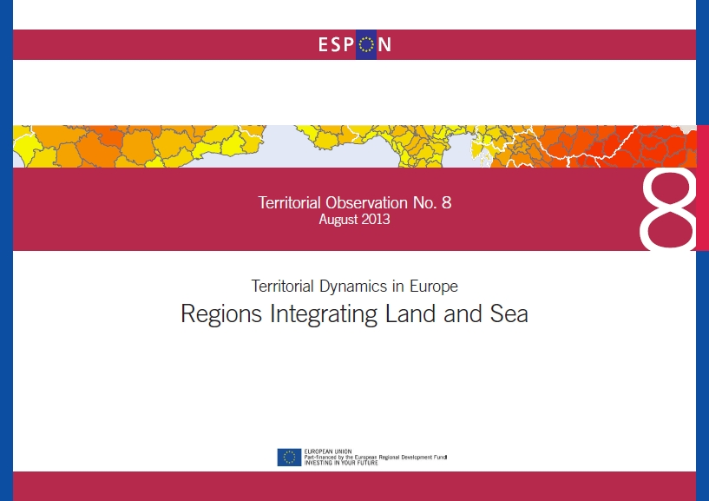
Territorial Dynamics in Europe - Regions Integrating Land and Sea
Europe’s seas have great potentials for contributing to achieving the objectives of the Europe 2020 Strategy, as regards economic growth and renewable energy. In recent years, the role and importance of maritime potentials has received increasing policy attention, as the idea of Blue Growth has developed.
ESPON Territorial Observation 8 “Regions Integrating Land and Sea” explores the diversity of maritime areas and focuses on land-sea interactions, including the role of the maritime economy, the land-sea flows and the environmental pressures.
Like other territorial potentials, the potentials for maritime development are not equally distributed across all parts of Europe.
The publication is now available at the ESPON Website: http://www.espon.eu/main/Menu_Publications/Menu_TerritorialObservations/TO8_August_2013.html

News from Projects

North Sea STAR Workshop "Energy and the North Sea Region"
TU Delft, Netherlands, 16 September 2013 - The ESPON North Sea STAR project is working with the Interreg IVb North Sea Region Programme Secretariat to evaluate energy themed projects within the 2007-2013 programme and provide recommendations as to how energy issues might be addressed in the forthcoming Interreg Vb programme.
As part of the activities, stakeholders from the North Sea Region (current and potential project beneficiaries) are invited to participate in a day of interactive discussions, considering energy policy scenarios for the North Sea region up to 2050 and exploring how these can be addressed through the NSR Operational Programme for 2014-2020.
The workshop will (1) help participants to gain a better understanding of current energy policies and programmes shaping the transition to a low carbon, resource efficient economy in the North Sea Region; (2) provide opportunities for networking with other NSR projects and potential project partners; (3) enable participants to influence the development of energy-related projects in the next Operational Programme.
For further information or to register to attend this event, please contact Lynne McGowan at the University of Liverpool (L.McGowan@liverpool.ac.uk)

TANGO Final Policy Seminar
Brussels, 29 October 2013 - The policy seminar shall present and discuss the findings of the ESPON project “Territorial Approaches for New Governance” (TANGO).
The project has delved deeply into the conceptualisation and operationalisation of territorial governance across Europe.
The ESPON TANGO project has assessed current trends in territorial governance and has developed a robust typology and a framework of good territorial governance practices. The required information has been gathered in particular through a dozen in-depth case studies.
A central goal of the project is to identify innovative and transferable practices of territorial governance across Europe. These have been synthesised in a policy-relevant guide for practitioners, policy and decision makers entitled “Towards Better Territorial Governance in Europe”.
This and other main policy relevant outcomes of the project will be presented and discussed in the seminar.
The seminar has three main objectives:
- To present some of the main findings of this applied research project within the ESPON framework.
- To involve the main target group of the “Towards Better Territorial Governance” guide, namely practitioners, policy and decision makers with a stake in territorial development.
- To discuss the results of the project in the light of current and future challenges in regards to territorial development and cohesion policy.
Registration for the event is possible by email at nordregio@nordregio.se. The number of participants is limited. Deadline to register is 11 October 2013.

New Reports
1) ATLAS: Interim Report of ESPON Atlas on European Territorial Structures and Dynamics
http://www.espon.eu/main/Menu_Projects/Menu_ScientificPlatform/ESPONAtlas.html
2) ESPON Annual Report 2012
ESPON published its 2012 Annual Report which provides an overview of the major achievements and activities performed by ESPON in its tenth year of existence. Download the report at the ESPON Website: http://www.espon.eu/main/Menu_Programme/Menu_ProgrammeRelatedDocuments/annualreports.html.

Two Calls for Tender are open
1) “ESPON Tools (2011-2014) - TIA Web application” - This Call aims at selecting a service provider able to develop a practical and user-friendly web application based on the "TIA quick check" developed by the ESPON ARTS project (Assessment of Regional and Territorial Sensitivity) allowing regional policy makers and practitioners to identify potential territorial impacts of new EU Legislations, Policies and Directives.
Deadlines: 6 September 2013 for requesting the documentation; 17 September 2013 for submitting the offers.
ESPON Website: http://www.espon.eu/main/Menu_Calls/Menu_Procurements/Menu_OpenProcurements/TIA-Web-application.html
2) “ESPON Update of Maps (2011-2014) - Travel time matrices on road, rail, air, and multimodal for 2001, 2006, 2011, 2014” - This Call aims at selecting a service provider able to perform the service contract which will contribute to increase the general body knowledge on the current state of accessibility by road, rail, air and intermodal in an enlarged Europe and its regions and therefore provide new evidence in the field of territorial development.
Deadlines: 6 September 2013 for requesting the documentation; 17 September 2013 for submitting the offers.
ESPON Website: http://www.espon.eu/main/Menu_Calls/Menu_Procurements/Menu_OpenProcurements/Update_of_Maps-Travel_time_matrices.html

Reminder Events

(1) ESPON Scientific Conference in Luxembourg
Luxembourg, 12-13 September 2013 - ESPON invites for a Scientific Conference on "Science in support of European Territorial Development and Cohesion" to discuss concepts, methodologies, indicators, tools, maps and models developed within the ESPON projects and the European scientific research community in the field of territorial development and cohesion. The conference is organised in cooperation with the scientific organisations AESOP, ECTP-CEU, ERSA, EUGEO, RSA and the University of Luxembourg.
Deadline to register is 4 September 2013 at 15h00. To register fill in the online form at the ESPON Website
http://www.espon.eu/main/Menu_Events/Menu_Conferences/form_sc-conference_13091213.html

(2) ESPON at the OPEN DAYS 2013
Brussels, 7-10 October 2013 - This year ESPON will contribute to the Open Days with workshops and a joint exhibition in cooperation with INTERACT, INTERREG IVC and URBACT, as follows:
(1) ESPON Workshop “How to make regions and cities more resilient to economic crisis” Tuesday 8 October 2013, 11h15 – 13h00
(2) Joint Workshop “More jobs, better cities and regions: how can cities and regions best create and support more and better jobs? Lessons from inter-regional cooperation” Tuesday 8 October 2013, 14h30 – 17h00
(3) Speech at the Workshop “Territorial Impact Assessment: a tool for better lawmaking and territorial cohesion” Wednesday 9 October 2013, 11h15 - 13h00
(4) ESPON at the Exhibition “100 EUrban solutions” 7-10 October 2013.
Registration is open. More reading at the ESPON Website.
http://www.espon.eu/main/Menu_Events/Menu_ESPONatEvents/opendays13100710.html
Sign-up and communicate
If you find the ESPON Newsletter interesting and useful, please tell others to sign-up by subscribing online at the ESPON Website, link: http://www.espon.eu/main/Menu_Press/Menu_Subscribe/contactform.html
More information
The ESPON 2013 Programme is part-financed by the European Regional Development Fund, the EU Member States and the Partner States Iceland, Liechtenstein, Norway and Switzerland.
It shall support policy development in relation to the aim of territorial cohesion and a harmonious development of the European territory. ESPON shall support Cohesion Policy development with European wide, comparable information, evidence, analyses and scenarios on framework conditions for the development of regions, cities and larger territories. In doing so, it shall facilitate the mobilisation of territorial capital and development opportunities, contributing to improving European competitiveness, to the widening and deepening of European territorial cooperation and to a sustainable and balanced development.
The Managing Authority responsible for the ESPON 2013 Programme is the Ministry of Sustainable Development and Infrastructures, Department for Spatial Planning and Development of Luxembourg. More information: www.espon.eu Follow ESPON on Twitter, Linkedin, RSS feed
ESPON Coordination Unit
4, rue Erasme LU-1468 Luxembourg
Phone: +352 42 59 91 4700 Fax: +352 42 59 91 4701 www.espon.eu

